

FALKIRK COUNCIL CHILDREN'S SERVICES

PARENT COUNCIL

FINANCIAL GUIDELINES



# 1. INTRODUCTION

These financial guidelines are to help Parent Councils follow good bookkeeping practice and ensure that the administration payments, made by the Authority to a Parent Council to enable it to operate and carry out its function under the Scottish Schools (Parental Involvement) Act 2006, are properly recorded and accounted for.

Resources Finance Team at Falkirk Council Children's Services produce these guidelines and can provide advice on most aspects of Parent Council financial procedures. The guidelines may be reviewed and updated as necessary – if there is anything you feel would be a helpful addition, please contact us.

## FINANCE AND RESOURCES

|  |  |
| --- | --- |
| Address | Children's Services  Suite 1A  The Falkirk Stadium  4 Stadium Way  Falkirk  FK2 9EE |
| Telephone | 01324 506600 |
| E-mail | [AdminSupportcs@falkirk.gov.uk](mailto:AdminSupportcs@falkirk.gov.uk) |

This guidance was updated in October 2014 and supercedes any previous version.

**The guidance and blank supporting documents are available to view and download from the Parent Council page of the Falkirk Council website. An excel workbook of spreadsheet templates is also available on request from Finance and Resources.**

# 2. BANK ACCOUNT

All Parent Councils should open a bank account in their own name. The bank will need a copy of the minute establishing the Parent Council and election of office bearers. All accounts should be set to operate with a minimum of 3 signatories, normally the treasurer and 2 other members of the Council. The annual administration payment will be made to this bank account.

## 2.1 Operating the Bank Account

The bank mandate should specify that 2 of 3 signatories are required to authorise any transaction. The signatories should be members of the Parent Council. Both cheque signatories are responsible for the cheques that they sign.

Where possible, payments should be by cheque rather than cash. This provides evidence of individual transactions on the bank statement. You should write details of the amount, date and payee on the cheque book stub.

Parent Councils should not borrow money or use overdraft facilities.

Blank cheques should never be signed and all cheques must be fully completed with the date, the payee and the amount in words and figures.

Cancelled cheques should be held in the cheque book and ‘cancelled’ written across the cheque.

All income received should be banked intact without delay and a brief description should be recorded on the pay-in slip stub.

Finance and Resources must be advised of any change to the Parent Council’s Bank Account or Treasurer’s details. A Treasurer or Bank Account form should be completed (see Appendices 1&2). Please retain a copy and send the original to the Resources Finance Team.

## 2.2 Bank Statement

A bank statement should be requested for the last day of each month and also for the accounting year end of 31st July each year. The bank statement should be checked for:

* bank charges
* bank interest received
* valid direct debits and standing orders
* cheques issued
* deposits /bankings made

Any item on the bank statement, but not in the cash book will need to be written into the cash book before undertaking the bank reconciliation.

## 2.3 Bank Reconciliation

Each month the Treasurer should compare the bank statement with the cash book to make sure the figures agree - that is each entry on the bank statement agrees to an entry in the cash book.

A bank reconciliation should be completed each month as the bank statement arrives (see Appendix 3). An excel spreadsheet template can also be provided on request from Finance and Resources.

Bank charges, taxes or interest on funds on a bank statement will be a reconciling item between the cash book and the bank statement.

Please note that deposits can take a few days before they appear on the bank statement and cheque payments can take several weeks before they appear on the statement. Any cheques that have not cleared through the bank statement after 6 months should be investigated as they will no longer be valid.

# 3. BOOK KEEPING PROCEDURES

## 3.1 Cash Book

The cash book is the main financial record for the Parent Council. There may only be a few transactions per year but they must all be recorded. Cash books can be purchased from any stationers. (Appendix 4) gives an example of a cash book. An excel spreadsheet template is also available on request from Finance and Resources.

The cash book should record each transaction (date, transaction description, and monetary amount), keep a running balance of the amount of money available and each transaction cross referenced to supporting documentation e.g. cheque numbers, pay-in slips, invoices or receipts.

The left hand side of the cash book is used to record all the income items e.g. the administration payment received from the Authority, donations received, fundraising income and bank interest.

The right hand side of the cash book is used to record all expenditure e.g. bank charges, tax on interest, payments to clerk, postages.

All copies of invoices and vouchers must be held on file as supporting documentation.

It may be necessary for you to keep separate records for specific funding strands such as a fundraising event or external money secured for a specific use.

The cash book should be totalled monthly and a cash book balance calculated.

The cash book is the source for production of the annual income and expenditure statement.

## 3.2 Income

A Parent Council can raise funds by any means other than borrowing and can receive gifts. In addition they can enter into contracts and agreements. It cannot purchase or own land and buildings. A Parent Council can decide how it expends any sums it has received by way of fund raising or gifts. Larger donations such as Lottery funding or similar may have conditions attached to the donation (ie funding for a specific purchase or spent within a limited time). Parent Councils should be in agreement of these and ensure any conditions can be properly met before applying for funding.

Income will also be received from Falkirk Council for the annual administration payment, the amount of which is calculated on the number of pupils on school(s) roll(s). The amount will be confirmed annually by letter to the Chairperson. This payment is paid in full on approval of the prior year audited accounts. The preparation of these is detailed in section 4.

Administration Payments will be made direct into the Parent Council’s bank account by BACS. Transfer and notification of the payment (remittance advice) will be sent to the Treasurer. Parent Councils should not presume receipt of this payment and should check their bank account before arranging expenditure.

As stated in the Scottish Schools (Parental Involvement) Act 2006 Team 11, the administrative allocation made by the Authority is to enable a Parent Council to operate and carry out their functions and meet its:

* administrative expenses (including any expenses incurred in the appointment of a clerk)
* expenses for training its members, and
* other costs incurred in carrying out its functions under the Act.

The Treasurer should issue a receipt for all income collected or received. Receipts should be sequentially numbered and this reference number also be recorded in the cash book. Two-part receipt books can be purchased from stationery shops. The details of the transaction should be entered into the cash book immediately and any cash banked without delay.

All monies received should be banked intact rather than paying expenses out of this money. This results in the cash book reflecting accurately the transactions that have actually taken place.

## 3.3 Expenditure

Payments for goods and services should be supported by a suppliers invoice.

Invoices should be addressed to the Parent Council and not to the school.

The invoice should be retained and filed in date order with the cheque number written on it to cross reference it to the cash book.

Other expenditure payments for which an invoice is not available should be supported by an expenditure voucher and signed as received by the person receiving the payment along with a cheque signatory. See (Appendix 5).

## 3.4 Petty Cash

If cash is required for petty cash expenditure a cheque should be cashed. Any expenditure should be recorded and have supporting vouchers e.g. till receipts. Petty cash floats should be kept to a minimum. The Treasurer is responsible for the petty cash which should be kept in a locked, secure location. If cash is handed over in advance to a person to make a purchase, a record should be kept of such advances and be receipted by the person advanced the money and cross referenced to the purchase and/or return of advanced funds. See (Appendix 5).

## 3.5 Payment to Parent Council Clerks

Parent Councils can pay a small fee (Honorarium) to Clerks, but only if they are not a Parent Council member. Clerks who are Parent Council members cannot be paid. This would therefore exclude Office Bearers and/or Bank Account authorised signatories from receiving payment if they also act as the Clerk. However, it is recognised that the member numbers of some smaller Parent Councils may necessitate the need for dual duties. Where this involves a Clerk to whom payment will be made, please contact Finance & Resources in advance for further guidance.

Fees to Clerks must be approved at the annual Parent Council Meeting. At the end of each year an annual statement (Appendix 6), showing the payments made to clerk(s) must be completed, signed and submitted to Resources Finance Team. A copy must be retained by the Parent Council for tax purposes.

The Parent Council should remind Clerks that it is their responsibility to submit details of any payments they receive to Her Majesty’s Revenue and Customs (HMRC) for their personal tax purposes.

## 3.6 Payments to School (via School Fund)

A Parent Council can decide how it expends any sums it has received by way of fund raising or gifts. As such a Parent Council can choose to make payments to the school at any time out of this income. If a Parent Council chooses to do this they should make a cheque payable to the School and pass this to the School Office for this to be banked in the School Fund Account.

# 4. AUDITED ACCOUNTS

The Parent Council should produce a statement of accounts at the end of the accounting year for all transactions from 1st August to 31 July. These accounts must be in the specified format (Appendix 7). An excel spreadsheet template is also available on request from Finance and Resources. The accounts should be submitted to Resources Finance Team by 30th September of year each.

The statement of accounts should be audited by someone independent of the Parent Council with suitable financial knowledge.

The audited statement of accounts should be formally approved at the Annual Parent Council Meeting (this should be minuted) and confirmed by the Chairperson on the checklist.

A completed Audited Accounts checklist (Appendix 9), signed by the Treasurer, Auditor and Chairperson should accompany the Statement of Accounts and if appropriate, Treasurer form (Appendix 1) Bank Account form (Appendix 2), Payment to Clerk form (Appendix 6) and/or Transfer of Surplus Balance form (Appendix 8 - see section 6). A copy Bank statement, covering the year end 31st July should also be provided. Should your bank not produce a statement on 31st July, more than one may need to be submitted so the balance on the actual year end date can be proven. If you are unable to obtain a full bank statement we will accept a certificate of balance. We may also be able to accept a bank screen print or temporary statement, however if you wish us to consider this please note that the print must clearly identify the account holder and be stamped and signed by your bank to confirm the closing balance as at 31st July – a “date printed” may not be sufficient. The supporting documents are listed on the audited accounts checklist as a reminder and blank pdf versions are available online.

**Please note that Children's Services cannot issue Parent Councils with the following year’s administration payment until prior year audited accounts have been received and approved. In this respect, Parent Councils are advised to retain a percentage of their administration allocation to enable them to operate until they receive their next administration payment from the Authority (see section 6 – surplus funds). There will be no administration payment made to Parent Councils who have not submitted accounts by 31st March.**

# 5. ROLE OF THE AUDITOR

It is the role of the appointed auditor to:

* Check that the money spent by the Parent Council is within the terms of the Council’s role, rights and responsibilities (you may need to refer to the Parent Council’s constitution).
* Ensure that adequate bookkeeping arrangements are in place.
* Check that all money received has been banked.
* Check that all payments are recorded and have supporting vouchers.
* Check that all income and expenditure is correctly analysed in the cash book.
* Initial the Accounts and sign the checklist.
* Report any findings to the Parent Council and make recommendations for improving the Parent Council’s bookkeeping.

In respect of the above, a copy of these guidelines should be made available to your Auditor.

# 6. SURPLUS FUNDS

At year end, surplus funds may be identified – some or all of which you may decide to transfer to the school(s)’ budget(s).

Councils who wish to transfer surplus funds to the school budget should complete a Surplus Balance Transfer Form (Appendix 8). An excel spreadsheet template is also available on request from Finance and Resources. This, and a cheque made payable to **‘**Falkirk Council**’** should be submitted with youraudited accounts. Finance and Resources will allocate the surplus funds transfer to the school’s budget on your behalf.

Surplus funds are those which can be clearly identified as excess to requirements. When calculating any surplus, the Parent Council should ensure that sufficient funds are retained to enable it to function properly, e.g. to cover cash requirements for the Parent Council until the next year’s administration payment is made. This payment is only made when the audited accounts are approved and in this respect, a Parent Council is advised to retain at least 20% of the administration payment received during the year. Any surplus fund expenditure should be detailed in the following year’s statement of accounts.

# 7 OTHER MATTERS

## 7.1 Taxation Implications

The guidance to the Scottish Schools (Parental Involvement) Act 2006 (paragraph 24) advises that it is not anticipated that any tax will be payable on any fundraising activities carried out by the Parent Council as they are not considered to be trading entity. You may be able to benefit from tax-free interest from your Bank but this may be dependant on the type of account held. Please contact your Bank for further information.

**7.2 Retention of Records**

Parent Councils should retain all financial records for a minimum of 7 years.

## 7.3 Summary of Appendices

Appendix 1 Change of Treasurer form

Appendix 2 Change of Bank Account form

Appendix 3 Sample Monthly Bank Reconciliation

Appendix 4 Sample Cash Book

Appendix 5 Expenditure and Petty Cash Vouchers

Appendix 6 Payment to Clerk form

Appendix 7 Sample Statement of Accounts

Appendix 8 Sample Surplus Balance Transfer form

Appendix 9 Audited Accounts checklist

PARENT COUNCIL CHANGE OF TREASURER FORM

Parent Council Name

Previous Treasurer’s Name

New Treasurer Details: Name

Address

Post Code

Telephone Number

Email address

Treasurer Signature Print Name

Date

Date

Chairperson Signature

Print Name

### PLEASE RETURN COMPLETED FORM TO FINANCE TEAM

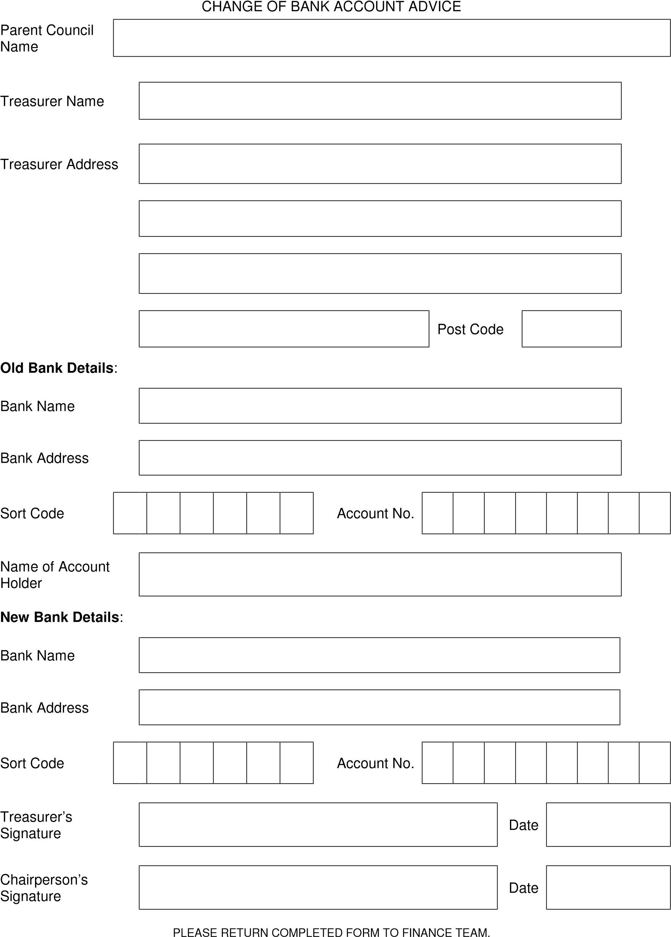

SAMPLE PARENT COUNCIL MONTHLY BANK RECONCILIATION

PARENT COUNCIL NAME

Bank reconciliation as at 31 / 08 / 09

|  |  |  |
| --- | --- | --- |
|  | **£** | **£** |
| **Balance per bank statement**  **Plus Lodgements not credited**  *income paid in, but not yet credited to bank account* |  | 391.69 |
| Date of lodgement  / /  / /  / / | Amount |  |

|  |  |  |
| --- | --- | --- |
| **Less Unpresented Cheques** *cheques issued but not yet debited to bank account* |  | 391.69 |
| Date Issued | Amount |  |
| 000006 (payment to Clerk) 31 / 08 / 09  / /  / / | 20.00 |  |

**Adjusted Bank Balance**

20.00

**371.69**

**371.69**

**Balance Per Cash Book**

|  |  |
| --- | --- |
| Treasurer Signature | Date |

Appendix 4

Parent Council

**SAMPLE CASH BOOK**

for period 1/08/09 to 31/08/09

|  |  |
| --- | --- |
| **Cash Book balance c/fwd** | **371.69** |

|  |  |  |  |  |  |  |
| --- | --- | --- | --- | --- | --- | --- |
| **Date** | **Description** | **Ref** | **Total** | **Admin.**  **Payment** | **Fundraising** | **Other** |
|  |  |  | £ | £ | £ | £ |
| 01/08/2009 | B/fwd |  | 90.55 |  |  |  |
|  |  |  |  |  |  |  |
| 11/08/09 | Disco |  | 50.00 |  | 50.00 |  |
| 15/08/09 | Admin Payment |  | 250.00 | 250.00 |  |  |
| 31/08/09 | Bank interest |  | 1.17 |  |  | 1.17 |
|  |  |  |  |  |  |  |
|  |  |  |  |  |  |  |
|  |  |  |  |  |  |  |
|  |  |  |  |  |  |  |
|  |  |  |  |  |  |  |

|  |  |  |  |  |  |  |
| --- | --- | --- | --- | --- | --- | --- |
| **Total** |  |  | **301.17** | **250.00** | **50.00** | **0.00** |

**INCOME** 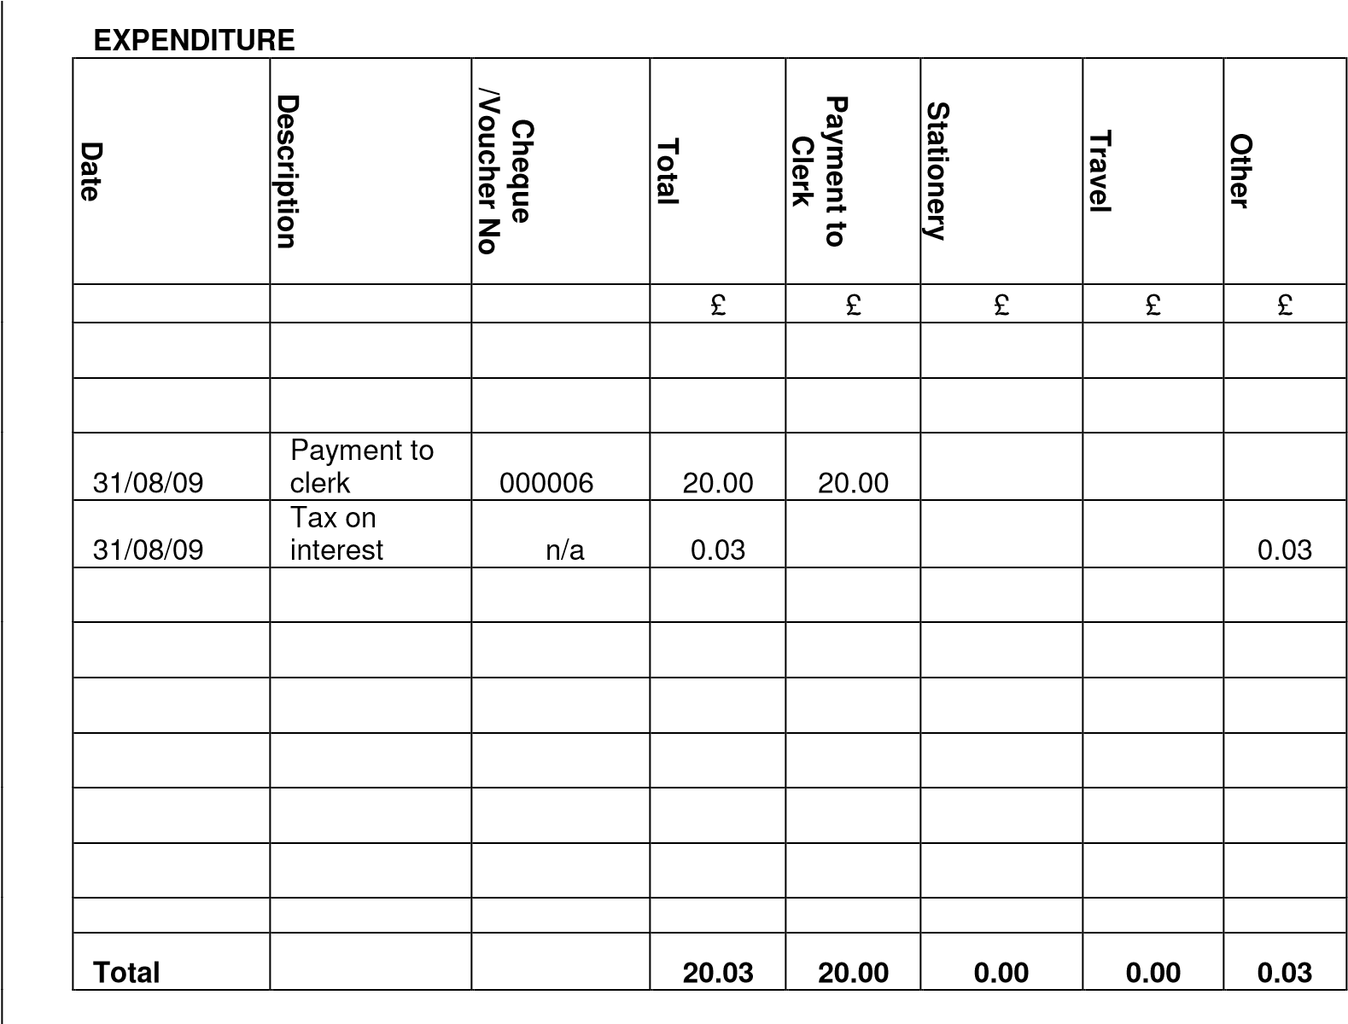

|  |  |
| --- | --- |
| **Cash Book Balance b/fwd** | **90.55** |
| Total Income | 301.17 |
| Less Total Expenses | 20.03 |

October 2014

Appendix 5

### **Expenditure Voucher**

*for all payments for which an invoice is unavailable*

Parent Council Name

Voucher Number

*EX*

Date

Paid to (name and address)

Cheque

Amount £ No

Details

Signed (by the Treasurer)

Signed (by the recipient)

**P**

**etty Cash Voucher**

Parent Council Name

Voucher Number

*PC*

Date

Paid to (name and address)

Amount £

Details

Signed (by the Treasurer)

Signed (by the recipient)

PARENT COUNCIL PAYMENT TO CLERK FORM

Parent Council Name

Clerk Name

Clerk Home Address

National Insurance No.

Total Amount Received from 01/08/ to 31/03/ £

|  |  |
| --- | --- |
| Clerk Signature | Date |

*show amounts paid in financial years for tax purposes*

£

01

/04/

to

31

/07/

Total

£

Treasurer Signature

Print Name

Date

PLEASE PROVIDE A COPY TO THE CLERK FOR THEIR PERSONAL TAXATION RETURN.

RETAIN A COPY FOR YOUR RECORDS AND FORWARD ORIGINAL TO FINANCE TEAM

#### SAMPLE STATEMENT OF ACCOUNTS

PARENT COUNCIL NAME

ACCOUNTS FOR YEAR ENDED 31 / 07 / _10__

|  |  |  |
| --- | --- | --- |
| Balance Brought Forward at 01 / 08 / _09__  **Add income** |  | 90.55 |
| Administration Payments | 250.00 |  |
| Fundraising | 50.00 |  |
| Bank Interest | 1.17 | 301.17 |

£

|  |  |  |
| --- | --- | --- |
| **Less Expenditure** |  |  |
| Clerk's Payments | 20.00 |  |
| Bank Charges  Course Fees  Stationery  Postage/Photocopying  Surplus Balance Transfer | 0.03 |  |
| Other - specify |  | 20.03 |

**Balance Carried Forward at 31 / 07 / _10__**

**3**

**71.69**

|  |  |
| --- | --- |
| **Bank Reconciliation** | **£** |
| Balance per bank statement as at 31 / 07 / _10__ | 391.69 |

Plus Lodgements not credited

Less Unpresented Cheques

Clerk Payment 20.00

20.00

**371.69**

**Cash Book Balance**

**Auditor's Initials**

**Please retain a copy and forward the original statement of accounts to Finance Team with an audited accounts checklist and other required supporting documents**

PARENT COUNCIL SURPLUS BALANCE TRANSFER FORM

Parent Council Name

Closing Balance as at 31st July ____ £ 371.69 A

Less 20% of *Administration* *Payment* £ 50.00 B

|  |  |
| --- | --- |
| £ | 321.69 |
| £ | 300.00 |

A-

Amount available to transfer to transfer to school B=C

***must be less***

***than C***

Surplus balance to be transferred* ***above*** *to Falkirk Council and then allocated to your school(s)*

School (s)

Date of Parent Council Meeting at which decision was made

Chairperson Signature

Print Name Date

PLEASE RETAIN A COPY AND FORWARD THE ORIGINAL TO FINANCE TEAM WITH A CHEQUE PAYABLE TO FALKIRK

##### COUNCIL FOR THE BALANCE * TO BE TRANSFERRED

PARENT COUNCIL AUDITED ACCOUNTS CHECKLIST

Parent Council Name Year end date

Please find enclosed Accounts for the above.

|  |
| --- |
| As **Treasurer**, I confirm the following:  (please tick)   1. Copy Bank statement to cover year end of 31st July is enclosed * 2. Payment to Clerk is a nil return***or***   Payment to Clerk form has been completed, original enclosed *   1. The accounts have been audited and are a true record of the business of the above Parent Council Treasurer Signature   Print Name Date |
| As **Auditor**, I confirm I have seen the Parent Council Financial Guidelines, audited and initialled the enclosed accounts. They are a true record of the business of the above Parent Council.  Auditor Signature  Print Name Date |
| As **Chairperson**, I confirm the following:  (please tick)   1. The enclosed accounts have been approved at AGM 2. Treasurer details are unchanged   ***or***  Treasurer details require amendment – form completed and original enclosed *   1. Surplus balance transfer is a nil return***or***   Surplus balance form has been completed, original and surplus balance cheque enclosed *   1. Bank details are unchanged***or***   Bank details require amendment – form completed and original enclosed *  Chairperson Signature  Print Name Date |

##### THE TREASURER SHOULD RETAIN A COPY OF THE ACCOUNTS AND FORWARD THE ORIGINAL WITH ALL

RELEVANT ACCOMPANYING DOCUMENTS (*as marked with an asterix \**) TO FINANCE TEAM

October 2014