Falkirk Council – Development Services Roads and Development Unit

Assessment for Traffic Calming on Public Roads within Falkirk Council

Considered at Environment and Community Safety Committee on 12th May 2009 Approved at Policy and Resources Committee on 2nd June 2009
May 2009

Contents

Executive Summary page 2

- Introduction page3

- Assessment of Traffic Calming Schemes page 5

- Conclusion page 11

Executive Summary
Since Local Government re-organisation in 1996, Falkirk Council has implemented a number of traffic calming schemes. The schemes have been successful in reducing traffic speeds and lowering accident rates, but, feedback from the public, Local Members, emergency services, bus companies and other services within Falkirk Council has been mixed. This prompted the start of a review which is now complete and has promoted the need for a new policy and revised assessment process.

Studies were carried out on before and after accident statistics as part of the review for schemes already in place. There was a clear indication that, on implementation of schemes, accident statistics were on average reduced by around 50%. This figure was established from the study of historical data and comparing accident rates taken before and after the introduction of traffic calming schemes in the Falkirk Council area and across the country. Another clear benefit was that the severity of accidents that did occur was reduced.

There is a proven benefit in road safety terms for all road users and the review has highlighted the need to target accident reduction as the prime objective of any future schemes. This data led approach aims to ensure value for money. The assessment process for prioritising traffic calming schemes has been formulated from the need to target the reduction in accidents, provide value for money and to meet the visions of Central Government and Falkirk Council in providing a modern, safe and sustainable transport network.

The assessment process utilises site specific data to highlight, prioritise and evaluate schemes requiring treatment. This will ensure that schemes with high accident rates are given a higher priority. The review also concluded, in line with recent guidance from the Scottish Government on speed limits that A and B class and other strategic urban roads would not be subject to conventional traffic calming. The review also concluded that a threshold was required to ensure that only roads where a measurable benefit could be achieved are taken forward to construction. The assessment process has 2 distinct stages illustrated on the flow chart on page 13.

The provision of traffic calming links very closely with the stated duties and aims of the Council. Accordingly, the Council’s policy on Traffic Calming is:-

“The Council will promote the implementation of Traffic Calming measures in support of it’s Corporate Goals and Values and Local Transport Strategy when sections of the public road meet the criteria set out in the “Assessment for Traffic Calming on Public Roads within Falkirk Council”.

Introduction

  - “The Assessment of Traffic Calming on Public Roads within Falkirk Council” sets out the procedure to highlight, prioritise and evaluate sections of the public urban road which demonstrate a need for traffic calming works. This forms part of a continuing pro-active approach to road safety engineering within Falkirk Council.
  - The Department of Transport’s Local Transport Note 1/07 March 2007 titled Traffic Calming is an all encompassing document. It covers relevant legislation and the design, effectiveness and installation (including signing and lighting) of measures. The process of design and implementation of schemes within Falkirk Council will be carried out in line with the guidance and legislation provided and referred to within the LTN 1/07. An assessment methodology is not provided within the LTN 1/07. This document details the methodology for assessing the need and producing a prioritised list of traffic calming schemes for implementation within Falkirk Council.

  - The Council’s vision for transport, detailed in Falkirk Council Development Services’ Local Transport Strategy 2006-2009 sets out the Council’s overarching transport vision, as follows:

“Provide a transport network both within the Council area and linking to surrounding areas, which allows people a reasonable choice of travel options as part of a safe, reliable, convenient, accessible and sustainable transport system. To enable people to travel when and where they wish, regardless of their level of income, physical ability or access to a car. To achieve a transport system that caters for the car, but is not dominated by it.”
  - It is recognised by the Government and Falkirk Council that the public road is not just a road network for sole use by motorised vehicles. Within the urban limit priority cannot be given to minimising vehicular journey times at the cost of road safety and the promotion of more sustainable forms of transport. The consensus is to ensure that the public road network is recognised as part of the public realm. Promotion of traffic calming to improve road safety reducing the frequency and severity of accidents is the priority of any scheme. The additional benefit are:

    - Reduce traffic speeds
    - Improve people’s quality of life
    - Introduce crossing facilities improving links within communities
    - Improve accessibility to public transport, local shops, public services for pedestrians, disabled persons, the elderly and infirm
    - Improve safety for cyclists
    - Improve street lighting

  - The Road Traffic Act 1988 section 39 places a statutory duty on roads authorities such as Falkirk Council to carry out studies of road accidents and to take measures that appear appropriate to prevent accidents. Implementing traffic calming projects is considered to be one way of addressing this duty. LTN 1/07 should be viewed as best practice on traffic calming schemes.

  - During the review of traffic calming the Scottish Government issued guidance on the setting of speed limits which requires Councils to review the speed limits on all A and B class roads by 2011. The guidance also clarified that strategic routes with in urban areas should have a 30 mph limit. The review of traffic calming has concluded that A and B class and other strategic routes should not be subject to traffic calming but accident data will be analysed to assess whether accident remedial measures are required.

  - The assessment process utilises site specific data to highlight, prioritise and evaluate schemes requiring treatment. This will ensure that schemes with a high accident history are given a higher priority. The review also concluded that a trigger level should be set. This trigger would ensure that only locations where a measurable benefit could be achieved would be taken forward to construction. The assessment process has 2 distinct stages.

Assessment of Traffic Calming Schemes

The Assessment Process
  - The process has 2 stages allowing a comprehensive study of the personal injury accident data available over a 10 year period on public roads within communities across the Council area. When requests or enquiries are received relating to traffic calming works, the results of the assessment can be checked and the outcome relating to the section of road communicated accordingly.

2 Stage 1 – Assessment
  - Accident statistics are available for all public roads within Falkirk Council. Prioritisation is necessary to target those locations that clearly demonstrate a need for this specialist treatment. This stage in the process is a straight comparison based on number of accidents recorded over a 10 year period per kilometre of road. It is proposed to take forward to stage 2 of this assessment process those sites which have the highest accident rates per kilometre and demonstrate a need for further investigation.

2.3.1 The stage 1 assessment is carried out on all the Council’s urban roads. Accident data is available for all our roads and with the addition of a length field a priority listing can be obtained.

The review of traffic calming concluded that, taking cognisance of Government advice
A & B class roads and other strategic routes should not be traffic calmed. Any A and
B class or other strategic routes which feature as priorities should not be considered for T C and should not go forward to stage 2. These locations should be subject to more detailed accident investigation analysis with a view to identifying accident remedial measures.

  - The assessment process should be repeated every 5 years. Each assessment is capable of highlighting a sufficient number of schemes to form a 5 year programme of implementation works. Repeating the assessment at the end of a 5 year period provides a facility to:
    - monitor the effectiveness of existing schemes
    - benchmark the effectiveness of schemes implemented in the future
    - highlight further schemes for inclusion in a further programme of works
    - highlight schemes requiring other forms of treatment
The stage 1 assessment can also be used to quickly consider any ad hoc requests for T C. Should an ad hoc request have a high rating it will be taken forward to the stage 2 assessment and if warranted, after site specific analysis, can be slotted into an existing programme.

  - It is recognised that of all the roads assessed it is likely that the final shortlist, taken forward to a programme for implementation, will be among the top priority sites listed in this initial stage. These sites will have the highest number of accidents and are likely to score highly in stage 2. It follows that a large representation of sites in stage 2 is not required. It is recommended that 15 sites are carried forward to stage 2. This would be subject to the accident data demonstrating inconsistencies and demanding a greater number of sites to be taken forward. The number of sites taken forward to the more detailed stage 2 assessment will be reviewed in light of experience by comparing the priorities from stage 1 and 2.

  - Stage 1 of the assessment process should also be used to investigate the effectiveness of existing traffic calming schemes. As part of the study of the data provided as part of stage 1, close inspection of the existing sites should be made to ensure there are no concerns relating the levels of accidents that may be occurring following implementation. In the event of the data showing an increase in the rate of accidents further investigation will be required to establish the cause with a view to addressing the problem where possible. There could be many reasons for accident rates changing including:

    - Failure of the scheme to improve the levels of road safety
    - Changes in vehicular traffic flow
    - Increased use of road by vulnerable road users increasing accident risk
    - Poor maintenance of the traffic calming features reducing effectiveness

In the unlikely event of the accident rate increasing, the scheme will be studied closely to highlight any modification that may contribute to improving the situation.

Stage 2 – Assessment
  - The stage 2 process will produce, after detailed survey and analysis, a list of priority sites to be taken forward to implementation. It is likely that all sites assessed in this stage will have an accident history that may demonstrate a need for traffic calming or another form of road safety engineering works.

  - It is recognised that the number of sites to be implemented will be influenced by the available budget. It is considered sufficient to take steps to highlight and prioritise schemes for inclusion in a 5 year programme as part of this assessment.

  - The criteria used to assess each scheme are:
    - Accidents
    - Speed
    - Vehicle flow
    - Pedestrian generators (potentially hazardous locations within scheme)
    - Severance (the number and category of pedestrians crossing the road)
A score for each scheme will be formulated, using the above criteria, to generate a prioritised list of schemes.
  - Pedestrian and vehicular traffic counts and speed measurements will be obtained for each site.

  - Accident statistics require to be more detailed for this stage in the assessment. The data should show extensive information for each accident including:

    - Weather conditions
    - Directions of travel for vehicles/pedestrians
    - Description of incident
    - Time of incident
    - Number of casualties and severity
  - It may be proved on investigation of each site at this stage, that traffic calming is not the most suitable option or that the site is unable to accommodate traffic calming. In these circumstances the site should be considered for inclusion in an alternative programme for implementing road accident reduction measures and removed from this assessment.

    - On completion of the assessment at this stage, each site will be ranked in order of priority.

3.8 During the review it was established that there should be a threshold below which it is difficult to demonstrate that a measurable road safety benefit can obtained. This threshold is based on the assessment of all the data gathered relating to the previous traffic calming schemes implemented by Falkirk Council. It also takes account of Government targets for accident reduction. The threshold has been established at a score of 80 points. The effect of this is that priority schemes with a priority score above 80 would go forward to implementation in line with available budget. When schemes with a priority score below 80 came to the top of the list for implementation then a new assessment would be triggered starting from stage 1. This threshold may require to be reviewed following the publication of the Government’s anticipated Road Safety Strategy for Scotland.

Criterion utilised to assess Traffic Calming Schemes

Criterion | Range Priority |  | Factor
1. Vehicle speed (85th percentile) | 0-5 | 10
Desirable speeds 20 mph Residential | 6-10 | 15
- speed limit other roads | 11-15 | 20
 | 16-20 | 25
2. Vehicle Flow veh/hour | per 100 | 1
Per 100 vehicles for peak hours | Over 1000 | 10
3. Accident level, vehicle occupants | fatal | x6
(personal injury accidents/km | serious | x4
Over 10 year study period) | slight | x2
Accident level, vulnerable road users | fatal | x7
(personal injury accidents/km | Serious | x5
over 10 year study period) | slight | x3
4. Pedestrian generators | school entrances | 6
(this list is not exclusive) | bus stops | 3
 | community centres | 3
 | doctor surgeries  elderly, nursing | 3
 | homes | 3
 | hospitals | 3
 | elderly lunch clubs, nurseries, play groups etc. | 3
5. Severance | 0–20 second wait | 0
(Difficulty crossing the road) | 20-60 second wait | 5
Waiting time | over 60 sec wait | 10
% vulnerable pedestrians (child / elderly | over 10% | 5

Assessment of Example Site
  - A section of public road requires to be assessed for traffic calming. It is located within the urban limit and has a 30 mph speed limit. The following information is gathered to allow a stage 1 assessment to be carried out:

    - 11 serious and 16 slight accidents have been recorded in the 10 year study period
    - The road is measured at 950 metres long
Accident per kilometre = 27 X 1000 = 28.42
950
During the full assessment of roads within Falkirk Council 28.42 accidents per kilometre is judged to rate highly against other sections of road. The levels of accidents used are compatible with schemes already treated with Traffic Calming. In a full scale assessment this would be taken forward to stage 2.
  - The factors to be used for assessment at stage 2 are listed below together with those figures collated to assess the example site:

Factor | Data | Score
85% percentile speed | 37 | 15
Vehicle flow | 2500 | 10
Severance (no vulnerable pedestrians) | 70 sec wait | 10
Accidents (no vulnerable casualties) | 11 serious | 44
 | 16 slight | 32
Potentially hazardous crossing locations | x2 Bus stops | 6
 | Hospital | 3
 | Library | 3
TOTAL SCORE FOR SITE |  | 123

In normal circumstances this figure would be compared against other schemes under consideration. This example is likely to feature as a priority.

Flow Chart for Traffic Calming Assessment

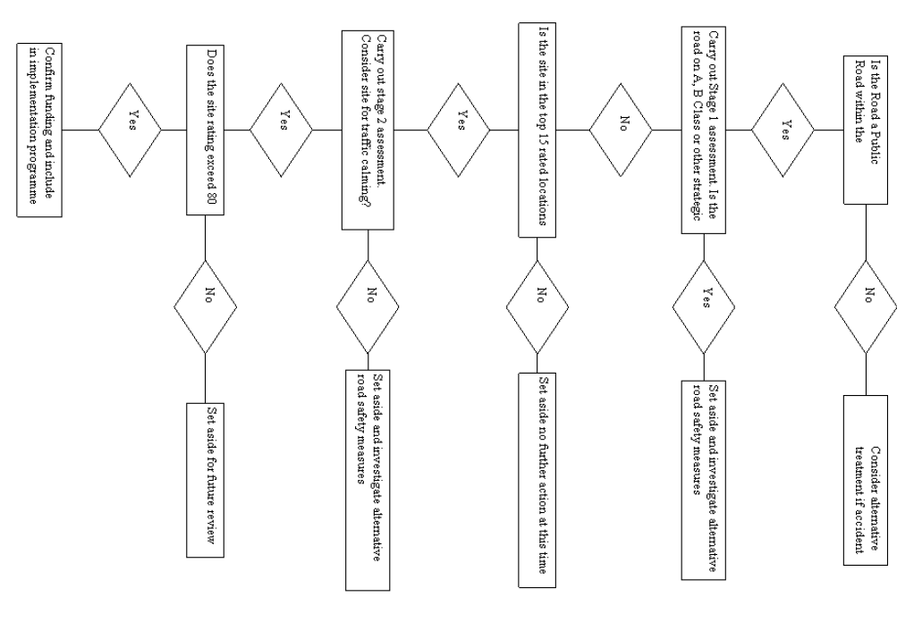

Conclusion

The Road Traffic Act 1988 section 39 places a statutory duty on Falkirk Council, as roads authority to carry out studies of road accidents and to take measures that appear appropriate to prevent accidents. It has already been stated in this document that the United Kingdom’s road safety record is one of the best in the world. The Department of Transport have set targets for reductions in road accidents to be achieved by 2010. They are expressed as a national average and 6 accidents a year is Falkirk Council’s derived accident reduction target.
Traffic calming in comparison to other treatments can prove costly and difficult to justify on the reduction of accidents alone. The assessment presents an opportunity to establish modern traffic calming as an invaluable treatment for the effective reduction of accidents at highlighted locations, while offering additional benefits outlined in paragraph 1.4. The assessment methods used will highlight and target sites where high numbers of road accidents have been recorded. During the study there is potential to highlight alternative measures to address a road accident problem.
Repeating the assessment on a 5 yearly basis is a way of re-assessing the roads that have not been traffic calmed and monitoring theses schemes already implemented. This serves to prioritise further schemes for implementation.
Traffic calming remains useful in fulfilling the Council’s legislative obligation to reduce accidents and if designed in accordance with modern guidelines should offer other significant benefits for all road users. The treatment will continue to receive emotive reactions in certain circumstances. A clear, comprehensive and concise assessment can be relied upon to defend, support and communicate a consistent approach to traffic calming. Successful schemes demonstrating value for money have already been implemented in Falkirk Council and this assessment will prioritise the introduction of further schemes.

