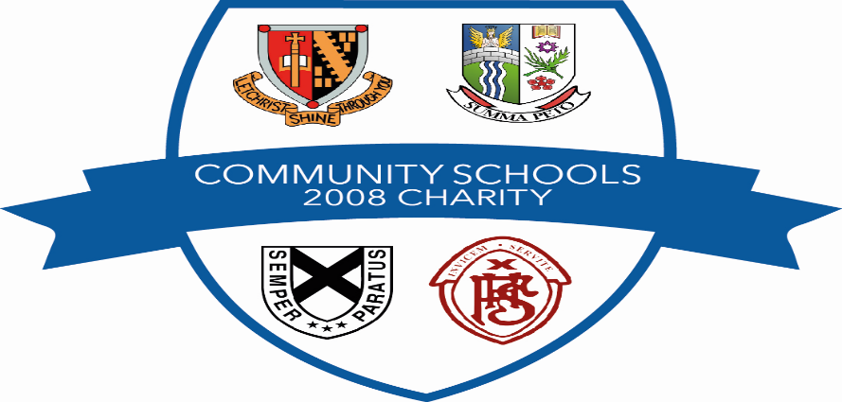
GRANT APPLICATION FORM GUIDANCE NOTE

The following guidance is provided for local groups or individuals considering applying for a grant to the Community Schools 2008 Charity.

The maximum level of grants awarded is a maximum of £2000, with the exception of an annual Community Project Award which considers larger projects and applications from the wider community/multi-group organisations, details of the annual Community Project awards will be advertised in the local press.

Applications must meet the Charity’s purpose which is:

(1) To advance education within the Falkirk Council area;

(2) To provide or assist in the provision for recreation and other leisure time occupation for the benefit of the general public.
Conditions of Applications:

  - Groups or individuals applying for a grant should provide information on the financial contribution being made by the individual or group concerned.

  - Only one grant application award will be made per group/individual per financial year. Any secondary schools submitting an application must ensure that it is vetted, prioritised and agreed by pupils/SMT.

  - Applications from Schools Parent Councils/Parent Teachers Associations must be endorsed by the school (via the headteacher).

  - All application awarded grants must submit receipts/proof of purchase.

List of items considered not eligible for Grants:

  - Assistance with school trips or overseas travel.

  - Applications for trainer/coach education and individual study or where other funding bodies provide funding e.g. Sports Council provide grants for coaching qualifications

  - Funding to pay for or subsidise the costs of fund raising events.

  - Funding to pay for operational costs e.g. hire / let / rent of premises.

