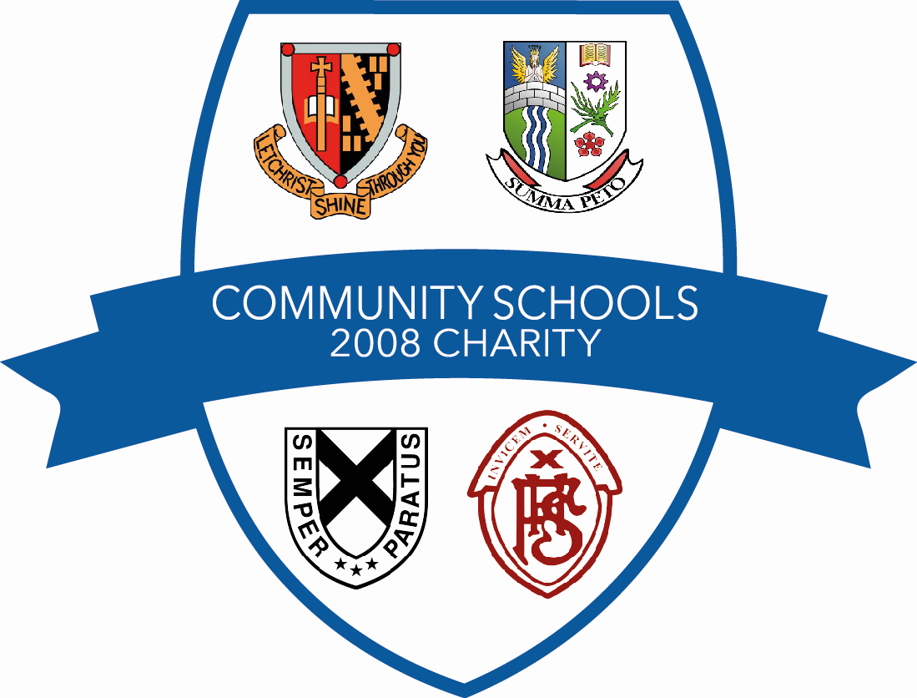

GRANT APPLICATION FORM
Name of Organisation/Group:
Once completed, please return the application form to:
c/o Children’s Services
Falkirk Stadium, 4 Stadium Way,
Falkirk, FK2 9EE

Community Schools 2008 Charity is a company limited by guarantee, registered in Scotland (Company Number SC319676) having its registered office at Falkirk Stadium, 4 Stadium Way, Falkirk, FK2 9EE and is registered as a charity with the Office of the Scottish Charity Regulator (No SC038221).

FOR OFFICIAL USE ONLY
Date received |  | Reference No.
We will use this form to decide whether your organisation will receive funding from the Community Schools 2008 Charity Grant Scheme.

When completing this form please TYPE where possible, or write in BLOCK CAPITALS and in black ink. Remember to sign and date the form before returning it. Please keep a photocopy of your application form.

Title (Mr, Mrs, Miss, Ms):
First name:
Surname:
Name of Organisation / School / Club etc:

Email address:
Address:

Postcode:

Position within organisation:

Please state the level of grant you are requesting:  (NOTE MAXIMUM GRANT IS £2,000) | £
Financial details of funds raised/being contributed to the project by your organisation. | £
Total cost of the project | £

Bank Account Information (if applicable).

Account name:
Bank name and address:

Bank sort code:
Account number:
Building Society role number:

What are your group’s main activities? You may want to include a draft programme.

What size of group membership do you have?

What will the funding be used for?
Please specify ALL equipment/supplies/services which will be purchased and provide a detailed cost breakdown of the individual items.

What difference do you hope the grant will make to your project/organisation? i.e. what will you be able to do if you got the grant that you cannot do now? (maximum 300 words)

Declaration and Terms and Conditions

Before you submit your application you must read and agree to the following Terms and Conditions of the Award. One signatory for the group should then sign the declaration, which confirms that the organisation understands and agrees to the Terms and Conditions.

- The Award

  - We will use the Award as described in our application form. Any changes must be agreed in writing and in advance by the Charity.

  - We understand that we may be asked to produce regular progress reports on the use of the Award. We also understand that a final report must be completed and submitted to the Charity within 3 months of all Award expenditure being incurred.

  - We agree that in any publicity or public presentation about the funding it is essential to include an indication that the project was supported by the Charity.

- The Organisation

  - We will advise the Charity in writing of any changes to our bank or building society bank account.

  - We understand that the Charity may make public information about our Award.

  - Please submit a copy of your organisations constitution, if you have one.

Declaration by Main Contact

I confirm that the information I have given on this application form is accurate and complete. I acknowledge that if I give misleading or inaccurate statements on behalf of the group or organisation we may not receive any grant or it may be withdrawn and have to be refunded to Community Schools 2008 Charity.

I confirm that I have read and that I understand and accept the Terms and Conditions of the Award.

PLEASE PRINT:
Title  (Mr, Mrs, Ms, Miss): |  | This must be completed by the same person as named above.
First name:
Surname:
Signature:
Date:

PLEASE NOTE THAT APPLICATIONS CANNOT BE PROCESSED UNTIL ALL OF THE NECESSARY DOCUMENTS ARE RECEIVED BY THE COMMUNITY SCHOOLS 2008 CHARITY GRANT’S COMMITTEE

