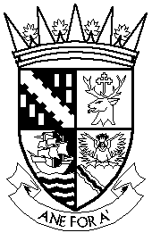  FALKIRK COUNCIL LICENSING BOARD | Licensing Unit  Falkirk Council  The Foundry  4 Central Park  Central Boulevard  Larbert, FK5 4RU  Telephone: 01324 501575  e-mail: licensing@falkirk.gov.uk  DX 556562

APPLICATION FOR CHANGE TO PERSONAL LICENCE

CHANGE OF NAME

DETAILS OF APPLICANT

Personal Licence No.
Name (as detailed on personal licence)
Address

Postcode
Telephone No. | Landline Mobile

DETAILS OF NAME CHANGE

Name changed to
Reason for change
Signature of Personal Licence Holder
Date

DO NOT WRITE IN THE SHADED AREA

Fee - £25.00
Note: the original Personal Licence must be returned with this form.

Your privacy is important to us. You can find out how we deal with your personal information here
http://www.falkirk.gov.uk/privacy/law-licensing/licensing/

For use by the Licensing Board only

Application checklist

Date received
Fee amount
Receipt number
Received by (INITIALS)

