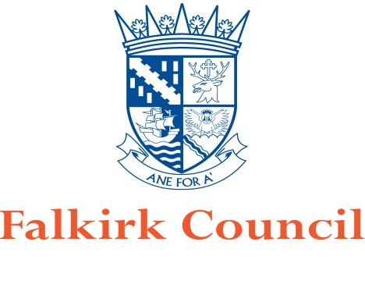
Alcohol Management Plan
Event Organiser

Name of Event

Date of Event

Date Document Completed

Document Author

Document Version Number

Contents
Page No.
3 | Information
4 | Applicants Details
4 | Details of Event
5 | Person Authorising the Sale of Alcohol
6 | Stewarding Details
7 | Layout Plan
8 | Alcohol Dispense Area(s)
9 | Policies
10-11 | Licensing Objectives
11 | Supporting Information
12 | Annex 1

INFORMATION

Please read the following information before completing this document.

Before completing this document applicants should refer to the Licensing Board’s statement of licensing policy.

The Board’s policy advises that all applications for occasional licences, in relation to large scale events, and associated documents should be submitted 4-6 months prior to the event as the application may be required to be considered by the Board rather than under delegated powers. The applicant should also arrange with the Licensing Team to have a debrief after the event. The policy refers to a large scale event where the capacity exceeds 1000. Please see point 6.7 to 6.20 for further details.

Please note that if you are submitting this document along with your occasional licence there is no requirement for the statement of licensing objectives to be completed which is attached to the form.

The most up-to-date version of the policy can be found at Falkirk Council’s website: www.falkirk.gov.uk

Other Considerations
You may require to apply for licences for your event under other legislation. It is your responsibility to ensure that you or the organiser of the event does so within the stipulated timescales.

Applicants Details
(Complete the details of the individual who has applied for an occasional licence, in connection with the event)

Name

Address

Contact Number

Email Address

Details of Event
(Provide information regarding the area(s) to be licensed)

What is the Event?
(Community gala day, charity event, Music Concert, fireworks night, etc.)

Location of Event?

Location Description?
(Indoor/outdoor, within a building, grassed area, etc.)

Date(s) of Event?

Start/Finish Time of Event?

Estimated number of people anticipated at the event.

Conditions of Entry
(Invitation/tickets/wrist bands/pay on entry etc.)

How many alcohol outlets will be in operation?
(All outlets should be shown on your layout plan.)

Person Authorising Sales of Alcohol

Name

Address

Contact Number(s)

Email Address
(use block capitals)

Details of Personal Licence

(Name of Issuing Authority, Date of Issue and
Licence Number.)

Stewarding Details

Will stewarding being provided? | Yes/No

If yes, provide details of the company that is providing stewarding.

Name and address of company/individual providing stewarding?

Contact telephone number?

How many stewards will be required?

Are they SIA Registered? | Yes/No
Brief Description of Roles and Responsibilities

Provide details on the Stewards' communication and if they will be stationed at the alcohol outlets:

Layout Plan

A layout plan will be required to be submitted along with this document. The plan should clearly identify the area(s) where the event is taking place and should be of a scale (1:100mm). The plan should include the following:

- Area(s) to be used to dispense alcohol
- Area(s) to be used for consumption of alcohol
- Structures such as stages, marquees, tents etc
- Location of any food vendors
- Location of activities (other than the sale of alcohol) taking place throughout the site
- All entrance and exit points, including emergency exits and fire points
- Toilets]
- First Aid/Welfare Point
- Boundary line around the proposed site (state the method used to secure the area such as fencing, etc)
- Location of any car parking that may be provided

Alcohol Dispense Area(s)
How are the bars identified (name/numbered)

Bar ___________________________________

Details of Bar
Description of Bar
(Attach Photo)

Number of Staff Serving Alcohol?

What level of training do they have?

What method of communication will be used between bar staff and management of the event?
How is this referred to on your layout plan?

Use annex 1 if there is any more than one area being used to dispense alcohol.

Provide a brief description of how the bar(s) will be managed and controlled paying attention to the queuing system and the dispensing method of alcohol.

Policies

Age Verification (Provide details of your age verification policy)

Refusal of the sale of alcohol (Provide details of your refusal policy)

Drugs/Substance Misuse (Provide details of your policy)

Dispersal Policy (Provide details of your Policy)
Licensing Objectives
Provide a statement on how you will protect the Licensing Objectives.

Preventing Crime and Disorder

Security Public Safety

Preventing Public Nuisance

Protecting and Improving Public Health
Protecting Children and Young Persons from Harm

Supporting Information
Provide any other useful information in connection with the event and the sale and consumption of alcohol.

For example,

- Staff will be subject to a briefing/debriefing
- Refusal logs/stewards logs will be in operation
- Location of any quiet areas/safe areas

Annex 1

Bar ___________________________________

Details of Bar
Description of Bar
(Attach Photo)

Number of Staff Serving Alcohol?

What level of training do they have?

What method of communication will be used between bar staff and management of the event?
How is this referred to on your layout plan?

Note: - If more outlets are operating at the event, photocopy the page and submit details when submitting.

