Falkirk Council
Housing Market Refresh

INTRODUCTION
The first stage of the Housing Need and Demand Assessment (HNDA) is to identify the functional housing market area. Functional Housing Market Areas as defined in SPP3 Consultative Draft as “a geographical area which is relatively self-contained in terms of housing demand”. However, these are not rigid boundaries as there will always be moves between market areas. Market area boundaries can also change as a result of new development, infrastructure and consumer choices. This housing market area refresh will help understand whether earlier assumptions remain appropriate.
In practice, housing market areas can be identified in a number of ways:
- Using predefined boundaries
- Origin based and destination self-containment.
- Centre to periphery household flows; and
- Using local knowledge

The Scottish Government does not recommend one approach over another and recognises that different approaches are required in different areas. In order to ensure consistency with previous work undertaken on identifying the functional housing market area, origin based and destination self-containment will be looked at.
The evidence presented in this report is required to fulfil Core Process 2 in order to achieve “robust and credible” status from the CHMA.
CORE PROCESS 2
The Housing Market Areas have been agreed with the Housing Market Partnership and are considered in the production of all core outputs.

The Falkirk Housing Market Area
Work undertaken by Newhaven in 2007 found that within the Falkirk housing market there are five identifiable areas that are large and distinct enough to support separate housing needs analysis.
The five identifiable areas are:
- Bo’ness
- Denny and Bonnybridge
- Wider Falkirk
- Grangemouth
- Braes and Rural South
Within the Wider Falkirk, there is a sub-area which includes both the Larbert Stenhousemuir and Rural North Local plan areas.

Figure 1: Falkirk Housing Sub Market Areas
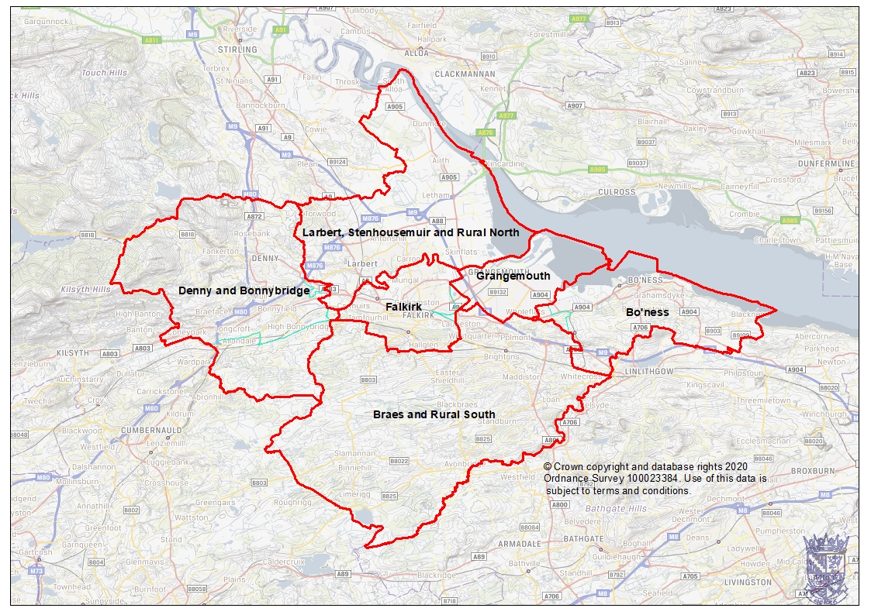

Purpose of the Housing Market Refresh
Background
The refresh of the housing market areas is necessary to ensure that the next Falkirk Council HNDA can be prepared with the appropriate geographical outputs. The emphasis is on clarifying whether the housing market areas agreed in 2007 and then in 2009 have changed.
The purpose of this refresh is to:
- Determine whether any statistical evidence exists to warrant a change to present housing market boundaries.
- Determine the extent and nature of any cross-boundary housing market areas;
- Draw a set of coherent functional market area boundaries across the Falkirk area including any cross-boundary market areas.

Method
The approach used different types of analyses which included;
- Origin-based destination analysis – analysis of Sasines data for 2014, 2015. 2016 and 2017 to understand the origins of house moves to destinations within the previously defined housing market areas. This indicates levels of self-containment and the significance of functional relationships with neighbouring authorities and market areas;
- Use of local knowledge – this uses the professional expertise and local knowledge of staff working within the team.

Cross-boundary Interactions
No housing market is 100% self-contained as people who can buy property will do so in various places for different reasons. This means that there are also some house moves between housing market areas, including across local authority boundaries. There are specific Housing Sub Market Areas that have interactions with specific local authorities. The Denny/Bonnybridge Housing Sub Market area has links to North Lanarkshire and Stirling. The Bo’ness Housing Sub Market Area has close links to West Lothian.

Sasines Data Cleansing
The Sasines data was cleansed prior to the analysis to remove errors so that only those sales categorised as person to person and company new build were included. Only sales over £25,000 and under £1,000,000 were included. Any entry which did not have an origin was also excluded as this made it impossible to determine where the origin of the move was.

Origin based containment analysis of Falkirk Council area Update

Background

An update of origin based containment was undertaken for all of the time period 2006 to 2009 and can be seen in Table 3. In total, 69% of house sales in Falkirk Council area come from buyers who are resident in Falkirk Council area therefore this supports the previous analysis by Newhaven which describes Falkirk Council as self-contained.
As shown in the following table, the strongest link with neighbouring Council areas exists between West Lothian and Edinburgh, followed by Stirling and North Lanarkshire. However over 10% of buyers come from other Council areas within Scotland.
In 2014 it was decided to undertake a refresh which would look at Sasines data for 2010-2013. In total 72.7% of sales in the Council area came from people already living in the area which makes the area a self-contained area. Most sales from other local authorities are from West Lothian, Edinburgh and Stirling.
A further update has now taken place for sales between 2014-2017, with this analysis finding that a total of 72.2% of sales in Falkirk came from people already living in the area. Most sales from other local authorities are from West Lothian, Edinburgh and Stirling. Sales from North Lanarkshire have more than halved since the original analysis was undertaken.

Table 1: Annual number of sales and origin of purchaser by selected local authority area
Purchaser Council | 2006-09 No. | 2006-09 % | 2010-13 No. | 2010-13 % | 2014-17 No. | 2014-17 %
Falkirk | 7,998 | 69.0% | 4,724 | 72.7% | 7088 | 72.2%
Rest of Scotland | 1,167 | 10.1% | 634 | 9.8% | 1019 | 10.4%
Edinburgh | 615 | 5.3% | 224 | 3.4% | 407 | 4.1%
West Lothian | 567 | 4.9% | 366 | 5.6% | 464 | 4.7%
North Lanarkshire | 449 | 3.9% | 175 | 2.7% | 166 | 1.7%
Stirling | 397 | 3.4% | 215 | 3.3% | 338 | 3.4%
Rest of UK | 338 | 2.9% | 132 | 2.0% | 279 | 2.8%
Outside UK | 48 | 0.4% | 25 | 0.4% | 52 | 0.5%
Total | 11,586 | 100% | 6,495 | 100% | 9813 | 100%
Source: Scottish Government LHS data pack house sales 2006-13

Local Authority Level Movements
There were 9,813 moves to Falkirk between 2014-2017 with a known origin. The majority of these (7,088, 72.2%) originated within Falkirk itself. Figure 2 and Table 2 shows that there is generally strong self-containment in the housing sub market areas. The lowest self-containment levels are found in Grangemouth (57%) and Falkirk (50%) and the highest in Bo’ness (75%) and Denny & Bonnybridge (73%). Therefore Falkirk continues to be made up of six functional housing sub market areas and there is no evidence to suggest it has changed to become one single market area.

Figure 2: Level of self-containment by housing sub market area
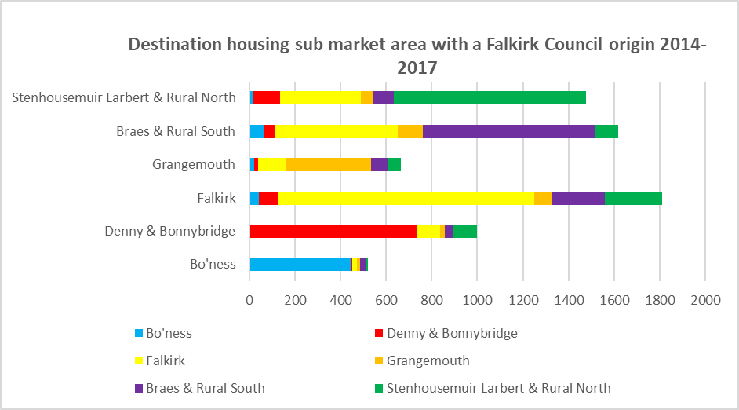
Source: Registers of Scotland with further processing by Scottish Government

Table 2: Level of self-containment by housing sub market area
Area | Bo'ness | Denny & Bonnybridge | Falkirk | Grangemouth | Braes & Rural South | Stenhousemuir Larbert & Rural North
Bo'ness | 75% | 1% | 7% | 4% | 10% | 3%
Denny & Bonnybridge | 0% | 73% | 9% | 2% | 5% | 12%
Falkirk | 1% | 5% | 50% | 5% | 24% | 16%
Grangemouth | 2% | 3% | 12% | 57% | 17% | 9%
Braes & Rural South | 2% | 3% | 19% | 6% | 63% | 7%
Stenhousemuir Larbert & Rural North | 1% | 8% | 18% | 4% | 7% | 62%
Total | 7% | 14% | 26% | 9% | 23% | 21%
Source: Registers of Scotland with further processing by Scottish Government

Community Planning Locality Based Movements
The Falkirk Community Planning Partnership is committed to Locality Planning. This is an approach based on developing strong local partnerships to identify and address area-specific issues.
However, in line with legislation, the Local Housing Strategy is based on a Housing Need and Demand Assessment. The Assessment identifies sub housing market areas rather than localities.
Sub housing markets are areas where households currently live or work and, if they wished to move, where they would look for alternative housing. If housing need is identified in a sub market, it is reasonable to assume that the household would expect to meet that need in the same sub market.

Both the Housing sub-market areas and the SOLD localities were mapped and it is shown below. Generally, sub housing market areas align to the locality areas - the exception being Braes and Rural South and Stenhousemir, Larbert and Rural North. In relation to Braes & Rural South, part of this area is within the Central and East locality. In terms of Stenhousemuir, Larbert & Rural north, the Skinflats area is seen as being in East locality instead of West locality.

Figure 3: Housing Sub Market Areas and Community Planning Areas
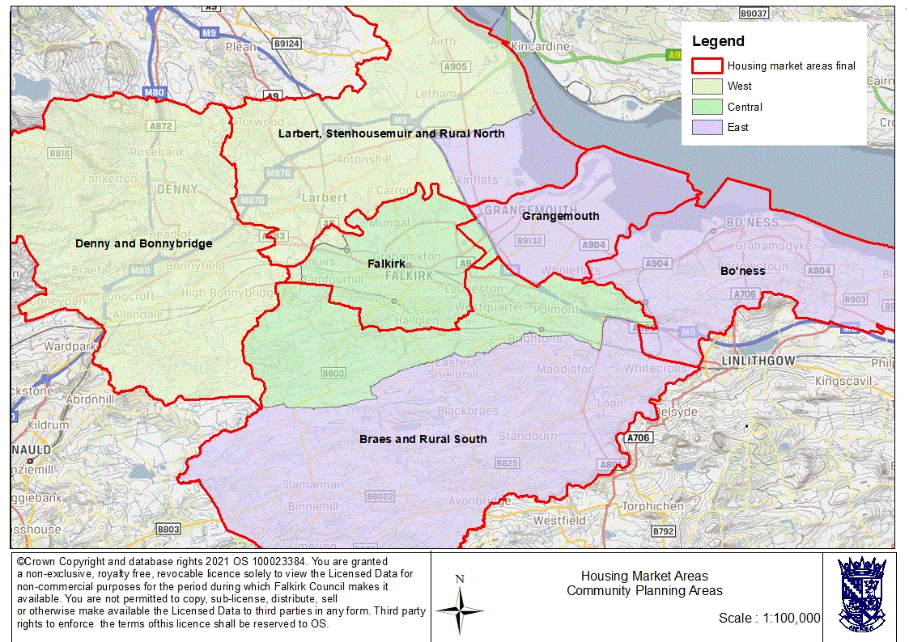

Analysis has also been undertaken to look at movement not just between the housing sub market areas but also the SOLD localities. There are three localities in the Falkirk Council area:
- East Locality (Bo'ness and Blackness, Grangemouth and Upper Braes)
- Central Locality (Falkirk North, Falkirk South and Lower Braes)
- West Locality (Denny and Banknock, Bonnybridge and Carse, Kinnaird and Tryst)
Each locality has around 50,000 residents. Analysis was undertaken on the 9,813 moves to Falkirk between 2014-2017 with a known origin to look at the destination of these sales in relation to the SOLD localities. The analysis shows that the highest level of self-containment was found in Central locality at 65%, with East and West locality both at 61%.
Figure 4: Self-containment within Community Planning Areas
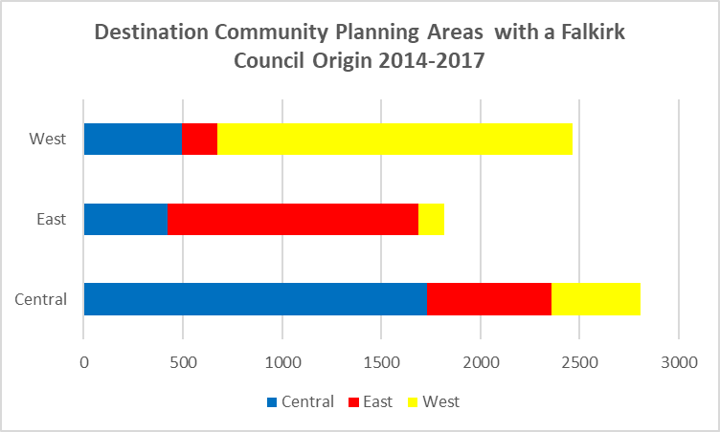
Source: Registers of Scotland with further processing by Scottish Government

Sales by Housing Sub Market Area

Bo’ness
When looking at sales from within the council area, the self-containment levels in Bo’ness is 75% which is slightly higher than the 71% for the last HNDA. There were a total of 596 sales in the Bo’ness area between 2014-2017 where the area of origin was known. Figure 5 looks at the origin of sales in the Bo’ness area and includes those that live within and outwith the Council area. It highlights that 47% of sales in Bo’ness are to people who live in the area which is just one percentage point increase on the analysis undertaken for the last HNDA. It also highlights that the scale of moves originating from other housing market sub areas in Falkirk is relatively weak (between 1% and 3%).
Figure 5 also shows that 17% of sales are to people from neighbouring West Lothian Council and 12% from the City of Edinburgh Council. When compared to analysis undertaken for the last HNDA it highlights that there has been a reduction of 7 percentage point reduction in the number of sales from West Lothian but the number of sales from Edinburgh have stayed the same.

Figure 5: House Sales in Bo’ness by Area of Origin 2014-2017
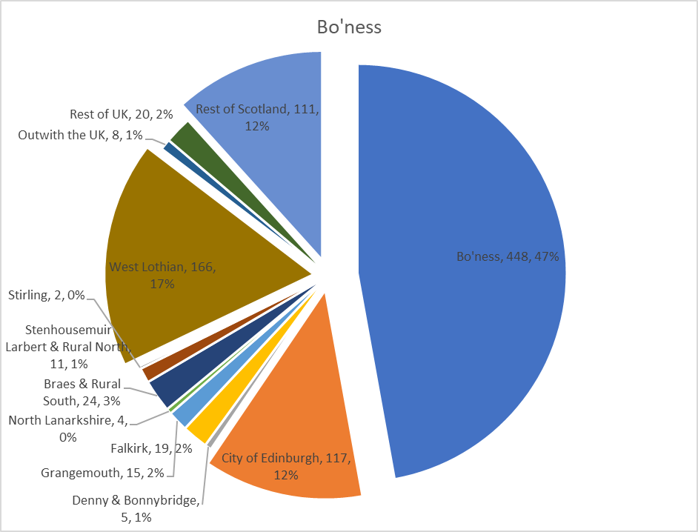
Source: Registers of Scotland with further processing by Scottish Government

Denny & Bonnybridge
When looking at sales from within the council area, the self-containment levels in Denny & Bonnybridge is 73% which is slightly lower than the 75% found in the last HNDA. Figure 6 looks at the origin of sales in the Denny & Bonnybridge area and includes those that live within and outwith the Council area. It highlights that 49% of sales are from the Denny & Bonnybridge area which is a 4 percentage point decrease on analysis undertaken for the last HNDA. It also highlights that the scale of moves originating from other housing market sub areas in Falkirk is relatively weak (between 0% and 7%).
Figure 6 also shows that 15% are to people from neighbouring Stirling at 11% and from the rest of Scotland at 15%. When compared to analysis for the previous HNDA it shows that that sales from the rest of Scotland have increased by 3 percentage points and sales from Stirling have increased by 5 percentage points. In comparison the number of moves from North Lanarkshire in the previous HNDA accounted for 10% of all sales, this compares to 5% for 2014-2017 sales.

Figure 6: House Sales in Denny & Bonnybridge by Area of Origin 2014-2017
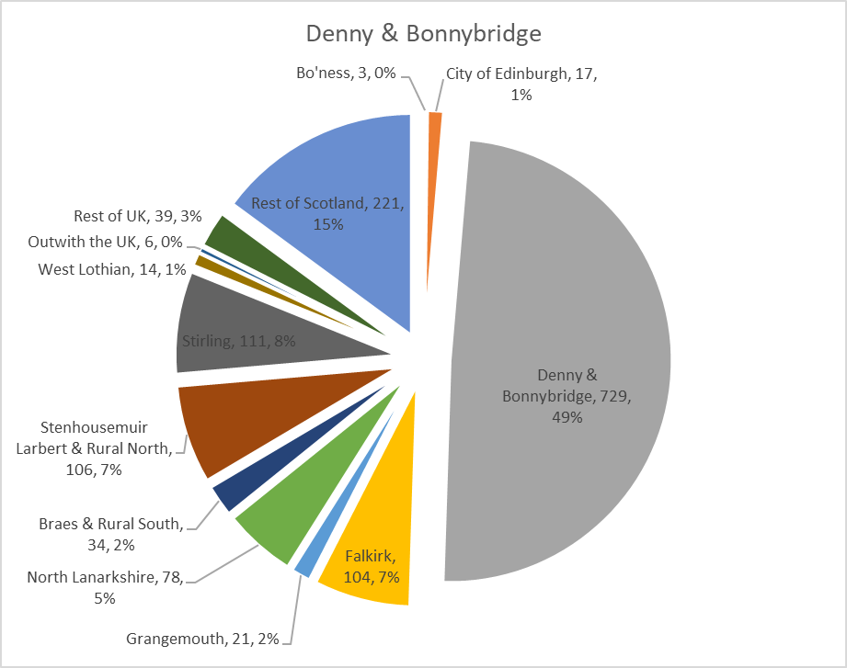
Source: Registers of Scotland with further processing by Scottish Government

Falkirk
When looking at sales from within the council area, the self-containment levels in Falkirk is 50% which is an increase from the 47% found in the last HNDA. Figure 7 looks at the origin of sales in the Falkirk area and includes those that live within and outwith the Council area. It highlights that 47% of sales is from the area itself which is a 4 percentage point decrease on analysis undertaken for the last HNDA.
The scale of sales originating from other housing sub market areas is relatively small 2-4%, apart from Stenhousemuir, Larbert & Rural North at 11%, Braes & Rural South at 10%. This is an increase on analysis undertaken for the last HNDA which were 9% and 8% respectively. There are also a relatively high number of buyers coming from the rest of Scotland at 9% but this is a 4 percentage point decrease on analysis undertaken for the last HNDA.

Figure 7: House Sales in Falkirk by Area of Origin 2014-2017
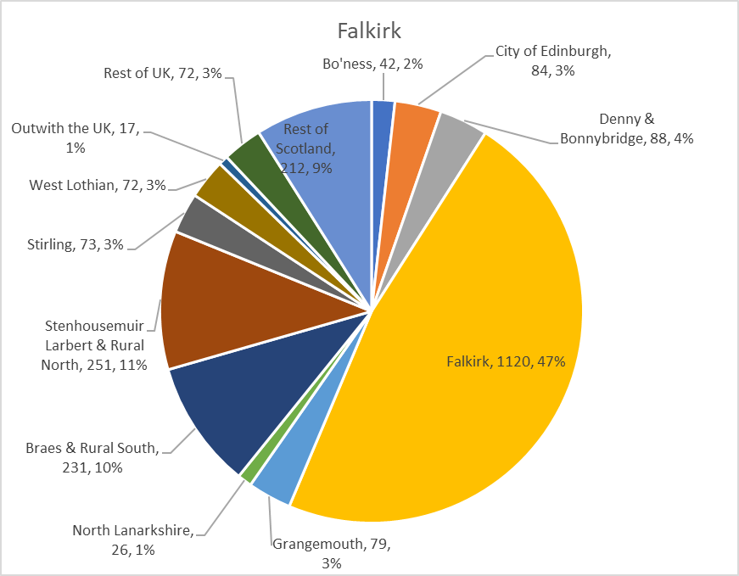
Source: Registers of Scotland with further processing by Scottish Government

Grangemouth
When looking at sales from within the council area, the self-containment levels in Grangemouth are 57%, which is a decrease on the 64% found in the last HNDA. Figure 8 looks at the origin of sales in the Grangemouth area and includes those that live within and outwith the Council area. It highlights that 44% of sales are from the Grangemouth area, which is a 5 percentage point decrease on analysis undertaken for the last HNDA. There were also a number of sales from Falkirk at 15%, Braes & Rural South at 9% and Stenhousemuir, Larbert and Rural North at 7%. This shows a small change from the analysis undertaken for the previous HNDA with the number of sales from Falkirk and Braes & Rural South increasing by 1 percentage point and those from Stenhousemuir, Larbert and Rural North increasing by 2 percentage points.
Moves from neighbouring council areas were relatively small ranging from 2-4%.

Figure 8: House Sales in Grangemouth by Area of Origin 2014-2017
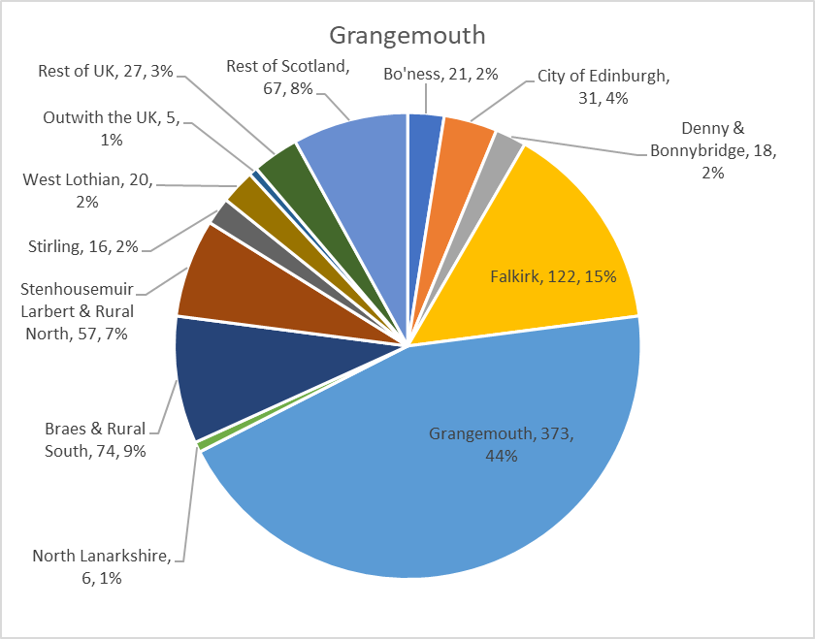
Source: Registers of Scotland with further processing by Scottish Government

Braes & Rural South
When looking at sales from within the council area, the self-containment levels in Braes & Rural South is 63%, which is a slight decrease on the 64% found in the last HNDA. Figure 9 looks at the origin of sales in the Braes & Rural South area and includes those that live within and outwith the Council area. It highlights that 34% of sales are from the Braes & Rural South area which is the same as analysis undertaken for the previous HNDA. It also shows that there were a significant number of sales at 24% from Falkirk which is a 2 percentage point decrease in analysis undertaken for the last HNDA.
This compares to sales from other housing market areas which range from 2%-5%. Moves from neighbouring council areas were also relatively small apart from West Lothian which was 7%.

Figure 9: House Sales in Braes & Rural South by Area of Origin 2014-2017
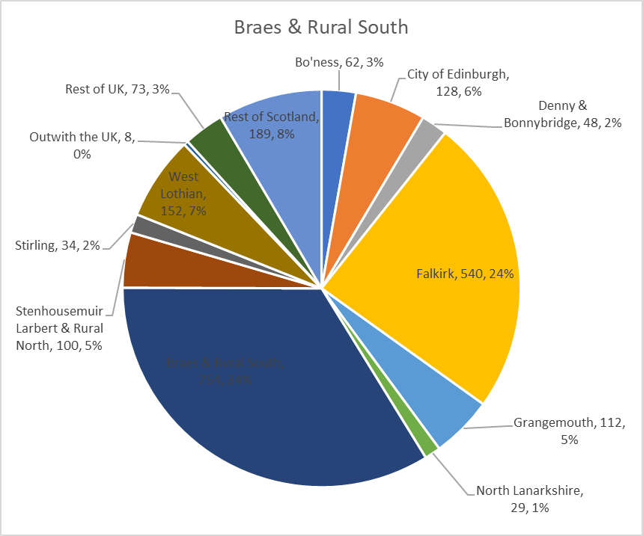
Source: Registers of Scotland with further processing by Scottish Government

Stenhousemuir, Larbert & Rural North
When looking at sales from within the council area, the self-containment levels in Stenhousemuir, Larbert & Rural North is 62%, which is lower than the 71% found in the last HNDA. Figure 10 looks at the origin of sales in the Stenhousemuir, Larbert & Rural North area and includes those that live within and outwith the Council area. It highlights that 43% of sales are from Stenhousemuir, Larbert & Rural North which is a 2 percentage point increase on analysis undertaken for the last HNDA.
There are also a number of sales at 18% from Falkirk which is a 2 percentage point decrease on the previous HNDA. This compares to sales from other housing market areas which range from 1%-6%. In terms of neighbouring local authorities, the highest number of sales were from Stirling at 5% and the rest of Scotland at 11%. This is a 1 percentage point decrease on the last HNDA.

Figure 10: House Sales in Stenhousemuir, Larbert & Rural North by Area of Origin 2014-2017
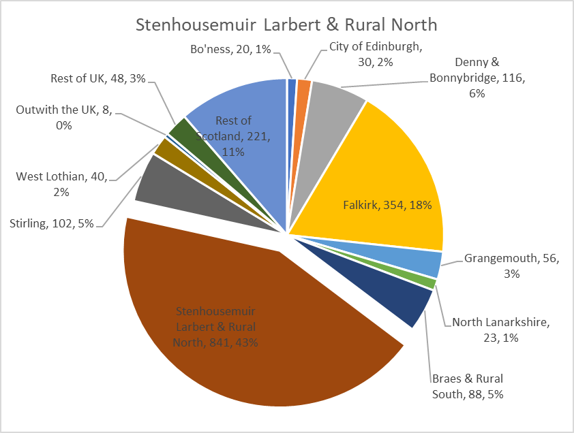
Source: Registers of Scotland with further processing by Scottish Government

House Sales in Neighbouring Local Authorities to Buyers from Falkirk Council
This section looks at sales in other neighbouring local authorities to buyers from the Falkirk Council area. The Sasines data was cleansed prior to the analysis to remove errors so that only those categorised as person to person and company new build were included. Only sales over £25,000 and under £1,000,000 were included (apart from Edinburgh where sales under £2,000,000 were considered). Any entry which did not have an origin was also excluded as this made it impossible to determine where the origin of the move was.

West Lothian Council
There was a total of 10,847 sales made in West Lothian between 2014 and 2017. A total of 2.06% of sales came from the Falkirk area which is just about the same as when analysis was undertaken for the last HNDA. When looking at the sales with a Falkirk Council origin, the majority of sales came from the Bo’ness area at 41% and then Braes & Rural South at 26%.

Table 3: House Sales in West Lothian originating from Falkirk 2014-2017
Housing Market Area | 2014-2017 | % of all sales from Falkirk | % of all sales in West Lothian
Bo'ness | 92 | 41% | 0.85%
Denny & Bonnybridge | 8 | 4% | 0.07%
Falkirk | 43 | 19% | 0.40%
Grangemouth | 9 | 4% | 0.08%
Braes & Rural South | 57 | 26% | 0.53%
Stenhousemuir Larbert & Rural North | 14 | 6% | 0.13%
Total | 223 | 100% | 2.06%
Source: Registers of Scotland with further processing by Scottish Government

City of Edinburgh
There was a total of 42,373 sales made in Edinburgh between 2014 and 2017. A total of 0.42% of sales came from the Falkirk area, this is slightly less than the 0.5% when this analysis was undertaken for the last HNDA. When looking at the sales that had Falkirk Council origin the majority came from Bo’ness (29%), Falkirk (27%) and Braes & Rural South (21%).

Table 4: House Sales in Edinburgh originating from Falkirk 2014-2017
Housing Market Area | 2014-2017 | % of all sales from Falkirk | % of all sales in Edinburgh
Bo'ness | 51 | 29% | 0.12%
Denny & Bonnybridge | 11 | 6% | 0.03%
Falkirk | 47 | 27% | 0.11%
Grangemouth | 2 | 1% | 0.00%
Braes & Rural South | 38 | 21% | 0.09%
Stenhousemuir Larbert & Rural North | 28 | 16% | 0.07%
Total | 177 | 100% | 0.42%
Source: Registers of Scotland with further processing by Scottish Government

Stirling
There was a total of 5,919 sales made in Stirling between 2014 and 2017. A total of 4.29% of sales came from the Falkirk area, this is the same as previous analysis undertaken for the last HNDA. In terms of sales that had a Falkirk Council origin, the majority at 33% came from Stenhousemuir, Larbert & Rural North and 26% from Denny & Bonnybridge.

Table 5: House Sales in Stirling originating from Falkirk 2014-2017
Housing Market Area | 2014-2017 | % of all sales from Falkirk | % of all sales in Stirling
Bo'ness | 9 | 4% | 0.15%
Denny & Bonnybridge | 66 | 26% | 1.12%
Falkirk | 51 | 20% | 0.86%
Grangemouth | 8 | 3% | 0.14%
Braes & Rural South | 36 | 14% | 0.61%
Stenhousemuir Larbert & Rural North | 84 | 33% | 1.42%
Total | 254 | 100% | 4.29%
Source: Registers of Scotland with further processing by Scottish Government

North Lanarkshire
There were 13,330 sales made in North Lanarkshire between 2014 and 2017. A total of 1.23% of sales came from the Falkirk area, this is lower than the 1.4% when analysis was undertaken for the last HNDA. When the sales with Falkirk Council as the origin were looked at the majority at 49% came from Denny & Bonnybridge.

Table 6: House Sales in North Lanarkshire originating from Falkirk 2014-2017
Housing Market Area | 2014-2017 | % of all sales from Falkirk | % of all sales in North Lanarkshire
Bo'ness | 8 | 5% | 0.06%
Denny & Bonnybridge | 81 | 49% | 0.61%
Falkirk | 24 | 15% | 0.18%
Grangemouth | 4 | 2% | 0.03%
Braes & Rural South | 21 | 13% | 0.16%
Stenhousemuir Larbert & Rural North | 26 | 16% | 0.20%
Total | 164 | 100% | 1.23%
Source: Registers of Scotland with further processing by Scottish Government

The role of new build housing
The role of new build housing can be important in influencing mobile demand. A total of 1, 439 new build properties were considered to establish the degree of influence they have on levels of self-containment between 2014 and 2017. New build sales in Braes and Rural South and Stenhousemuir, Larbert & Rural North represent 25% and 22% of sales between 2014 and 2017 whereas in Denny & Bonnybridge and it represented 15% of sales and Falkirk and Bo’ness 7%.

Figure 11: Number of new and second hand sales 2014-2017
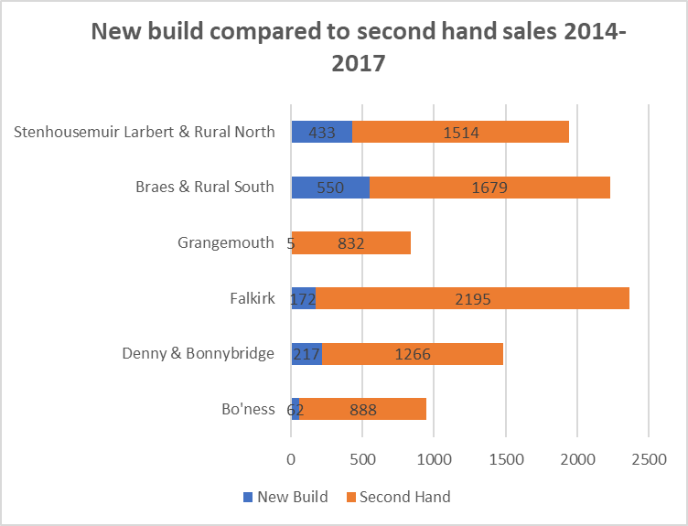
Source: Registers of Scotland with further processing by Scottish Government
Table 7 shows that 28% of new build buyers and 28% of all buyers come from outwith the Falkirk Council area. Analysis undertaken for the last HNDA showed 28% of new build buyers were from outwith the area and 26% for all sales.
There were only a handful of new build sales in the Grangemouth area due to the planning constraints, including restrictions on development from major hazard sites and flood risk which limit the potential of the area for growth. Table 6 shows that 60% of new build sales were from external buyers but this is due to the small number of new build properties sold which has skewed the figures.
The table does highlight that the Bo’ness area had the highest percentage of sales to external buyers at 35%. The table also shows that there are a higher number of sales to external buyers of new build properties in Stenhousemuir, Larbert & Rural North than for all sales.

Table 7: Percentage of new build and second hand sales from outwith Falkirk
Sub Area | External buyer new build sales | External buyer all sales
Bo'ness | 35% | 45%
Denny & Bonnybridge | 32% | 33%
Falkirk | 19% | 23%
Grangemouth | 60% | 21%
Braes & Rural South | 26% | 28%
Stenhousemuir, Larbert & Rural North | 31% | 24%
Total | 28% | 28%
Source: Registers of Scotland with further processing by Scottish Government

Differences between the previous HNDA and work undertaken for this refresh
Comparing the analysis on origin based sales undertaken for the last couple of HNDAs there has been overall an increase in self-containment levels. The level of self-containment has increased from 66% in 2002-2006 to 69% in 2006-2009 and then increased further to 73% in analysis undertaken for 2010-2013 in the last HNDA. Work undertaken for this HNDA and on sales from 2014-2017 show that self-containment is at 72%, a slight decrease on analysis undertaken for the last HNDA.
Looking in more detail at sales within the six housing sub market areas there are a number of areas that saw an increase in the level of self-containment, notably Bo’ness (4 percentage points) and Falkirk (10 percentage points). There were two sub areas that saw a notable decrease in the level of self-containment and these are Grangemouth (7 percentage points) and Stenhousemuir, Larbert and Rural North (9 percentage points).
When looking at specific sub areas there are some notable findings in some sub areas. In the Bo’ness area the number of buyers from West Lothian has decreased by 7 percentage points whereas the percentage from Edinburgh has remained the same at 12%. In the Denny and Bonnybridge area the number of sales where the origin was North Lanarkshire has fallen by 5 percentage points but the number from Stirling has seen a 5 percentage point increase. In the Falkirk area there has been a 2 percentage points increase in the number of sales from Larbert, Stenhousemuir and Rural North and also Braes and Rural South. In Grangemouth there has been a small increase of 1 percentage points in sales from buyers from Falkirk and Braes & Rural South and 2 percentage point increase from Stenhousemuir, Larbert & Rural North. In the Braes and Rural South area the number of sales from buyers whose origin is the Falkirk area has decreased by 2 percentage points. Within Stenhousemuir, Larbert and Rural North the number of sales from the Falkirk area has fallen by 2 percentage points.

Conclusions
The analysis of the six housing sub market areas in Falkirk has shown that there are some relationships with housing market areas outwith the Falkirk area. None of the relationships between the housing market areas are significant enough to justify the merger of market areas. The housing sub market areas identified by Newhaven Research in 2007 and then updated in 2009 remain. The origin based self-containment analysis indicated that buyers come from other areas notably Edinburgh, West Lothian and North Lanarkshire.

The origin based analysis for the different sub areas indicated the following;
- Bo’ness – Most buyers come from the sub area and then West Lothian followed by Edinburgh
- Denny and Bonnybridge – Most buyers come from the sub area and then Stirling
- Falkirk – Most buyers come from the sub area and then Stenhousemuir, Larbert and Rural North closely followed by Braes and Rural South
- Grangemouth – Most buyers come from the sub area followed by Falkirk and then Braes and Rural South
- Braes and Rural South – Most buyers come from the sub area and then Falkirk.
- Stenhousemuir, Larbert and Rural North – Most buyers come from the sub area and then Falkirk.

Falkirk Council (2010) Identifying the Housing Market pp7-8

