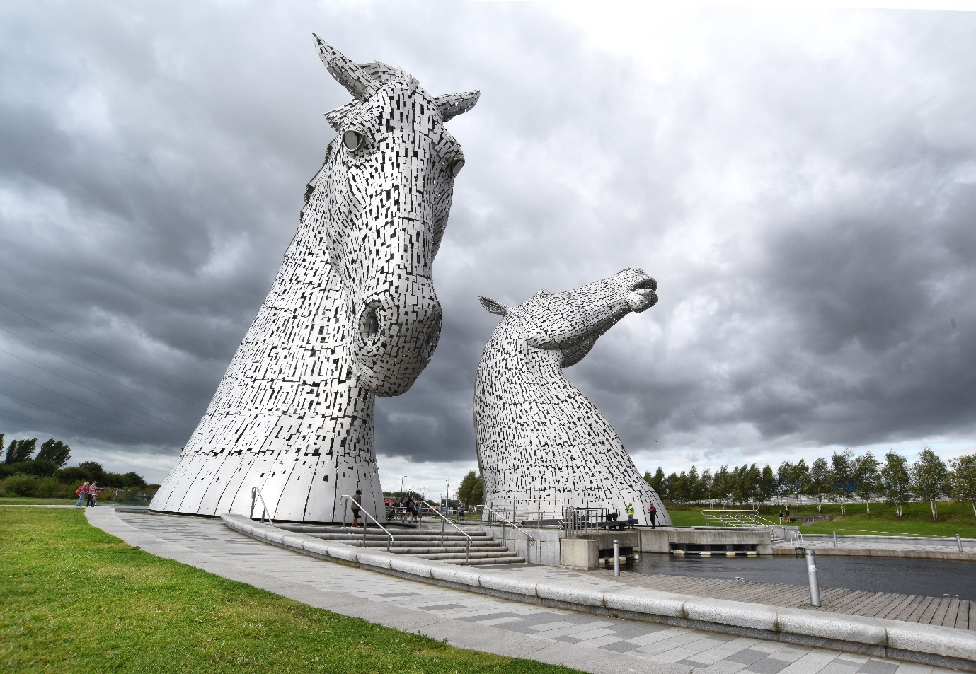

Falkirk Council Housing Need and Demand Assessment

**Signatories**

The following named senior housing and planning managers from Falkirk Council have signed this document confirming that they have jointly produced this HNDA and agreed the Core Outputs. This statement is in fulfilment of the requirements of Core Process 6 as detailed in the HNDA Manager’s Guide 2020.

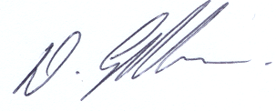

|  |  |
| --- | --- |
| Signature | Signature |
| Kenny Gillespie  Head of Housing and Communities  21/6/22 | Michael McGuinness  Head of Growth, Planning and Climate  4/8/22 |

Contents

|  |  |  |
| --- | --- | --- |
|  | **SUMMARY HNDA OUTPUTS TEMPLATE** | 1-4 |
|  |  |  |
| **1.** | **Introduction** | 5-11 |
|  | Purpose of the HNDA | 5 |
|  | Core Outputs and Processes | 5 |
|  | Governance and Consultation | 8 |
|  | Quality Assurance | 8 |
|  | Housing Market Areas | 9 |
|  | Equality Considerations | 11 |
|  | Limitations | 11 |
|  | Consultation | 11 |
|  |  |  |
| **2.** | **Key Housing Market Drivers** |  |
|  | Introduction | 12 |
|  | Population | 12 |
|  | Population Projections | 16 |
|  | Household Projections | 17 |
|  | House Sales and Prices | 20 |
|  | Private rents | 25 |
|  | Social rented rents | 29 |
|  | Income | 31 |
|  | Mortgages | 34 |
|  | Employment by Occupation | 36 |
|  | Travel to Work Areas | 38 |
|  | Gross Value Added | 38 |
|  | Employment and Unemployment | 40 |
|  | Economic Inactivity | 41 |
|  | Areas of Multiple Deprivation | 43 |
|  | Key Issues and Implications for LHS & LDP | 44 |
|  |  |  |
| **3.** | **Stock** |  |
|  | Introduction | 47 |
|  | Physical Characteristics | 47 |
|  | Social Rented Stock | 54 |
|  | Private Rented Stock | 56 |
|  | Short Term Lets | 56 |
|  | HMOs | 57 |
|  | Disrepair and BTS Housing | 58 |
|  | Stock Occupancy | 62 |
|  | Lets and Turnover | 67 |
|  | Demand for Social Housing | 69 |
|  | In situ Solutions | 72 |
|  | Key Issues and Implications for LHS & LDP | 76 |
|  |  |  |
| **4.** | **Estimating Future Need and Demand** |  |
|  | Introduction | 79 |
|  | Demography | 80 |
|  | Existing Need | 81 |
|  | Income Growth & Distribution | 82 |
|  | Affordability and House Prices | 83 |
|  | Affordability Rental Prices | 84 |
|  | Scenario Testing | 85 |
|  | Tool Results | 86 |
|  | Key Issues and Implications for LHS & LDP | 91 |
|  |  |  |
| **5.** | **Specialist Provision** |  |
|  | Introduction | 93 |
|  | Accessible and Adapted Housing | 95 |
|  | Wheelchair Housing | 102 |
|  | Non-permanent and Transitional Housing | 109 |
|  | Supported Housing Provision | 119 |
|  | Care and Support Needs for Independent Living | 124 |
|  | Site Provision | 139 |
|  | Key Issues and future requirements re LHS & LDP | 146 |
|  |  |  |
|  | **Appendices** |  |
|  | Appendix 1 – Housing Market Refresh |  |
|  | Appendix 2 – HNDA Tool Methodology |  |

**Key Findings Template: Estimate of Additional (New) Future Housing Units**

**Existing Need and Years to Clear Existing Need**

|  |  |  |  |
| --- | --- | --- | --- |
| Total Households with Existing Need | 370 | Number of Years to Clear Existing Need | 10 |

Source: CHMA’s Housing Need and Demand Assessment tool v4.0.

**Total number of new households over the projection period by Migration Projection**

| **Projections Period 2022-2041** | **Principle Projection** | **Low Migration Projection** | **High Migration Projection** |
| --- | --- | --- | --- |
| Total number of new households over the projection period | 7,333 | 6,340 | 8,217 |

Source: CHMA’s Housing Need and Demand Assessment tool v4.0.

**Total households over the projection period who may afford 2022-2026**

| **2022-2026** | **Scenario 1** | **Scenario 2** | **Scenario 3** | **Scenario 4** |
| --- | --- | --- | --- | --- |
| Owner Occupation | 162 | 163 | 152 | 173 |
| Private Rent | 80 | 80 | 75 | 85 |
| Below Market rent | 93 | 92 | 85 | 99 |
| Social Rent | 131 | 131 | 124 | 138 |
| **Total additional future units** | **466** | **466** | **436** | **495** |

Source: CHMA’s Housing Need and Demand Assessment tool v4.0.

**Total households over the projection period who may afford 2027-2031**

| **2027-2031** | **Scenario 1** | **Scenario 2** | **Scenario 3** | **Scenario 4** |
| --- | --- | --- | --- | --- |
| Owner Occupation | 139 | 141 | 122 | 156 |
| Private Rent | 69 | 69 | 60 | 77 |
| Below Market rent | 77 | 79 | 69 | 87 |
| Social Rent | 117 | 114 | 104 | 126 |
| **Total additional future units** | **402** | **402** | **355** | **446** |

Source: CHMA’s Housing Need and Demand Assessment tool v4.0.

**Total households over the projection period who may afford 2032-2036**

| **2032-2036** | **Scenario 1** | **Scenario 2** | **Scenario 3** | **Scenario 4** |
| --- | --- | --- | --- | --- |
| Owner Occupation | 137 | 139 | 116 | 155 |
| Private Rent | 66 | 68 | 57 | 75 |
| Below Market rent | 78 | 78 | 65 | 89 |
| Social Rent | 75 | 71 | 59 | 85 |
| **Total additional future units** | **356** | **356** | **297** | **405** |

Source: CHMA’s Housing Need and Demand Assessment tool v4.0.

**Total households over the projection period who may afford 2037-2041**

| **2037-2041** | **Scenario 1** | **Scenario 2** | **Scenario 3** | **Scenario 4** |
| --- | --- | --- | --- | --- |
| Owner Occupation | 122 | 126 | 101 | 143 |
| Private Rent | 61 | 62 | 50 | 72 |
| Below Market rent | 67 | 68 | 54 | 79 |
| Social Rent | 66 | 61 | 49 | 78 |
| **Total additional future units** | **317** | **317** | **254** | **372** |

Source: CHMA’s Housing Need and Demand Assessment tool v4.0.

**Cumulative Total at the End of the Projection Period 2022-2041**

| **2022-2041** | **Scenario 1** | **Scenario 2** | **Scenario 3** | **Scenario 4** |
| --- | --- | --- | --- | --- |
| Owner Occupation | 2801 | 2841 | 2454 | 3139 |
| Private Rent | 1378 | 1400 | 1209 | 1545 |
| Below Market rent | 1579 | 1580 | 1366 | 1768 |
| Social Rent | 1946 | 1882 | 1681 | 2135 |
| **Total additional future units** | **7703** | **7703** | **6710** | **8587** |

Source: CHMA’s Housing Need and Demand Assessment tool v4.0.

Please note, the use of rounding when displaying the Housing Estimate figures results in small discrepancies between the individual units required and totals, as well as totals compared to the Cumulative Total At End of Projection Period figures.

## **Introduction**

### **Purpose of the HNDA**

A Housing Need and Demand Assessment (HNDA) is an important evidence base required by the Scottish Government to inform the preparation of Local Housing Strategies (LHS), under the Housing (Scotland) Act 2001, and the preparation of Local Development Plans (LDP’s), under the Town and Country Planning (Scotland) Act 1997 (as amended).

This document provides estimates of future housing need and demand in Falkirk over the 5 years to 2026, based on looking at a range of evidence to inform projections on new household formation and the existing needs experienced by current households.

This document has been prepared in accordance with the Scottish Government Centre for Housing Market Analysis (CHMA) HNDA Managers Guide 2020 and HNDA Practitioners Guide 2014 Version 4.0. To support local authorities, undertake the estimates within the HNDA the Scottish Government has developed the HNDA Tool. The tool aims to reduce the cost and complexity of the process and to bring together sources of national data together in a way which supports consistency in approach to estimating housing need and demand. Version 4.0 of the Tool has been used for this HNDA.

The HNDA will underpin the following key areas of housing policy and planning.

* Housing Supply Target (HST) – to inform the setting of a HST for use in the LHS and Development Plan (NPF4 & LDP). The HST sets out the amount and type of housing to be delivered over the period of both plans,
* Stock Management – to assist understanding of the current and future demand for housing by size, type, tenure, and location in order to optimise the provision, management and use of stock. This in turn feeds into policy and planning decisions about future stock in the LHS,
* Housing Investment – to inform future housing investment decisions, for example through Strategic Housing Investment Plans (SHIPs),
* Specialist Provision – to inform the provision and use of specialist housing and housing-related services to enable independent living for all, as expressed in policy in the LHS and to inform planning decisions e.g., land for gypsy/travellers,
* Geographic distribution of land – to inform the spatial allocation of land through the Development Plan for new housing at both Housing Market Area level and Local Authority level.

HNDA Guidance requires the CHMA to appraise the process and methodology of the Falkirk Council HNDA as being “robust and credible”. The Guidance identifies four Core Outputs and six Core Processes which need to be completed in order to achieve “robust and credible” status. Table 1.1 details the Core Outputs and Processes and their location within the HNDA. A template summarising the key findings is provided at the start of the HNDA in fulfilment of Core Process 5. The HNDA report closely follows the structure and approach described in the HNDA Practitioners Guide (2020).

**Table 1.1: Core outputs and processes**

|  |  |  |
| --- | --- | --- |
| **Core Output** | **Requirement** | **Chapter** |
| Output 1: | Key housing market drivers | Ch 2 |
| Output 2: | Estimate a RANGE of additional future housing units | Ch 4 |
| Output 3: | Specialist provision | Ch 5 |
| Output 4: | Housing stock profile, pressures & management issues | Ch 3 |
| Process 1: | A Housing Market Partnership (HMP) has overseen production of the HNDA and other stakeholders have been appropriately engaged with via consultation. | Ch 1 |
| Process 2: | Housing Market Areas have been agreed with the Housing Market Partnership and are considered in the production of all core outputs. | Ch1 |
| Process 3: | The methodology, limitations and quality control mechanisms are given full technical explanation. | Ch 1 |
| Process 4: | Assumptions, judgements and scenarios are well reasoned and transparent. | Ch 4 |
| Process 5: | Key findings have been summarised, at the start of the HNDA, using the Key Findings Template provided by the CHMA. | P 1&2 |
| Process 6: | HNDAs have been officially signed-off by the Head(s) of Housing and the Head(s) of Planning or the designated senior official, prior to submission to the CHMA. | P i |

### **Governance and Consultation**

The HNDA was produced by the Council’s Housing Strategy Team with close consultation with colleagues in planning through the HNDA Working Group. The HNDA process is overseen and formally approved by the Falkirk Strategic Housing Group

which constitutes the local Housing Market Partnership. The Strategic Housing Group is the main body for delivery of the HNDA and is the main group for housing strategy and includes:

* Places Services (Planning), Transformation, Communities and Corporate Services (Housing)
* Registered Social Landlords,
* Homes for Scotland,
* Falkirk Council Social Work Services,
* CVS Falkirk,
* Scottish Government More Homes Division North & East Area Office
* Private Housebuilders

The purpose of the group is to support strategic planning through the development of the HNDA and LHS and address issues, challenges, and statutory responsibilities for the housing service.

The Strategic Housing Group is supported by the HNDA Working Group which comprises the Strategy and Development Co-ordinator, Senior Strategy Officer, Policy & Planning Officer, Senior Planning Officer and Information and Research staff.

### **Quality Assurance**

The Falkirk Strategic Housing Group has aimed to undertake the HNDA and present the findings in a clear and methodical manner. The Strategic Housing Group agreed in principle that secondary data, including statistically robust and validated national data sets would be the preferred choice of data source subject to triangulation and validation where possible. Primary data from the Council’s information systems has also been used, this data has been cleaned and checked by the HNDA Working Group. Final drafts of the individual chapters of the HNDA have also been subject to thorough proof-reading to ensure both narrative and figures are accurate.

In developing the scenarios for the HNDA Tool, the HNDA Working Group has worked together to devise different options and then consulted with the Strategic Housing Group for the final decision. Minutes of the Strategic Housing Group are available on request.

Information on house sales is obtained from the Data pack provided to local authorities by the CHMA. This information is derived from the Registers of Scotland with further processing undertaken by the Scottish Government.

Information is also provided by RSLs in the area via a Proforma they are asked to complete by the Council annually. This looks at information on waiting lists, stock, SHQS etc. Guidance for completing the proforma is sent to each RSL to ensure consistency.

The Council has its own private rented database which has been in use since 2005. Information on properties available for let are collected from Zoopla, Right Move and Gumtree on a fortnightly basis.

Minimum information is needed before populating the database and this includes property type, property size, address/town, agent and monthly rent. A member of staff inputs the information on to the database. All staff are trained before populating the database. It is important to note that this database is not comprehensive as it probably does not include all properties for rent in the Falkirk Council area. Information from the database is used to give an indication of the rents charged by area and size and to give an indication of the number of properties advertised for rent.

The properties advertised for rent are also checked with the Landlord Registration team to ensure the properties advertised are also registered. The information is used for housing options interviews to give applicants an idea of the costs of renting privately.

### **Housing Market Areas**

Scottish Planning Policy (2014, para 111) defines a Housing Market Area (HMA) as a “geographical area where the demand for housing is relatively self-contained”. However, these are not rigid boundaries as there will always be moves between market areas. Market area boundaries can also change as a result of new development, infrastructure and consumer choices. Housing Market Areas are areas where households either currently live or work and, if they wished to move, areas where they would search for alternative accommodation. Therefore, if housing need is identified in a particular housing market area, it is reasonable to assume that the household would expect to meet that need in the same area.

Work undertaken by Newhaven in 2007[1] identified that there are six housing submarket areas within the Falkirk area:

* Bo’ness
* Denny and Bonnybridge
* Falkirk
* Grangemouth
* Braes and Rural South
* Larbert, Stenhousemuir & Rural north

**Figure 1.1: Housing submarket areas**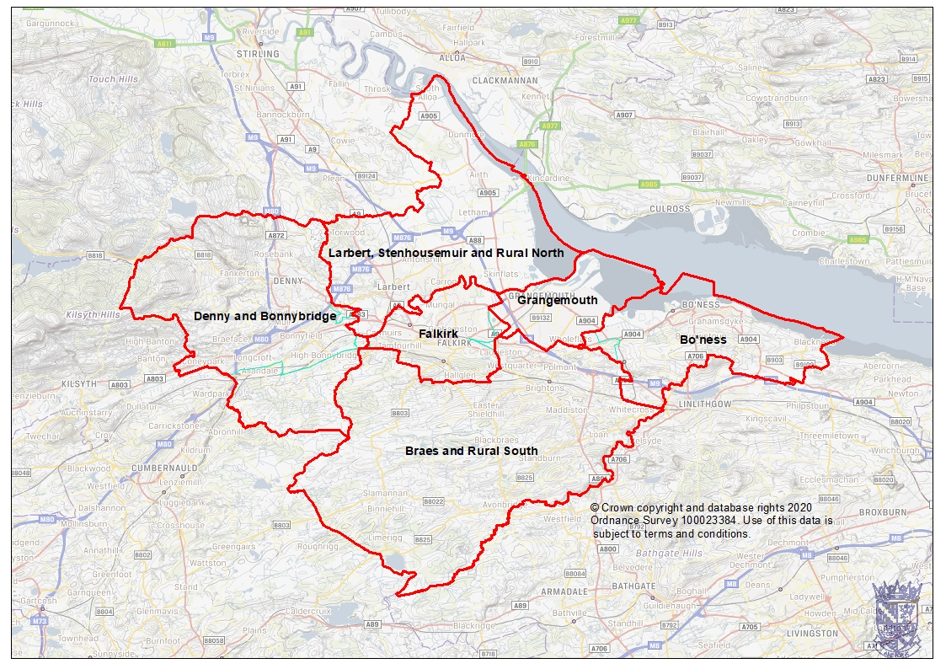

A refresh of the housing market areas was undertaken to ensure that this HNDA can be prepared with the appropriate geographical outputs. The purpose of this refresh was to:

* Determine whether any statistical evidence exists to warrant a change to present housing market boundaries.
* Determine the extent and nature of any cross-boundary housing market areas;
* Draw a set of coherent functional market area boundaries across the Falkirk area including any cross-boundary market areas.

The approach used different types of analyses which included.

* Origin-based destination analysis – analysis of Sasines data for 2014, 2015. 2016 and 2017 to understand the origins of house moves to destinations within the previously defined housing market areas. This indicates levels of self-containment and the significance of functional relationships with neighbouring authorities and market areas.
* Use of local knowledge –professional expertise and local staff knowledge working within the team.

The refresh found no significant changes in housing market activity to justify any change in the boundary between the six housing submarket areas. In April 2021 the Falkirk Strategic Housing Group approved the conclusions of HNDA Housing Market Refresh. This paper sets out the methodology and assumptions underpinning the definition of 6 distinct HMAs within Falkirk.

### **Equality Considerations**

In preparing this HNDA consideration has been given to the requirements of the Equality Act 2010[2], particularly around evidence on the Specialist Provision requirements of local populations which is described in more detail in Chapter 5.

The HNDA evidence-base will contribute to the Equalities Impact Assessment (EQIA) for the LHS and Development Plan. During the course of drafting the HNDA, particularly around Specialist Provision, age, disability, sex, and ethnicity have been considered as these are the main protected characteristics which have an impact on housing need and demand.

### **Limitations**

There are some limitations to the report due to the difficulty in obtaining data sets. In particular there is limited information available on house conditions in the private sector as the sample size used in the Scottish House Conditions Survey for the Falkirk area is too small. An overall figure for BTS is available for the Council but is not broken down by any of the categories also due to the small sample size.

Any gaps identified for the Specialist Housing chapter are listed for each of the categories.

### **Consultation**

No additional consultation has been undertaken outwith the Strategic Housing Group other than specific work undertaken with gypsy travellers. Additional public consultation will be undertaken for the LHS and the LDP.

## **Chapter 2 - Key Housing Market Drivers**

### **Introduction**

This chapter provides an overview and insight into the market drivers in Falkirk as described in ‘Core Output 1’ of the Housing Need and Demand Assessment Toolkit:

|  |
| --- |
| **Core Output 1: Key Housing Market Drivers**: Identifies the key factors driving the local housing market. This should consider household formation, population and migration, housing affordability including income, house prices, rent levels, access to finance and key drivers of the local and national economy. This analysis should reflect the data that have been inputted to the HNDA Tool and the choice of scenarios that are chosen to run the Tool. |

This chapter will identify the key factors driving the local housing market in Falkirk and will include information on household formation, population and migration, housing affordability including income, house prices, rent levels, access to finance and key drivers of the local and national economy. This analysis will help to understand local housing market dynamics and will also help inform which demographic, economic and affordability scenarios are run in the HNDA Tool produced by the Scottish Government’s Centre for Housing Market Analysis (CHMA).

At the end of the section there is a key issues table which considers the impact that local demographic, affordability, and economic trends have on the future level of housing need and demand.

### **Demography**

This section will provide an analysis of the demographic profile of the area and also the projection of both population and households at the local authority level. This analysis relies on the 2011 Census and 2018 based population and household projections prepared by the National Records of Scotland (NRS). Falkirk Council has accepted the Principal 2018 population and subsequent household projections by NRS.

### **Population**

The population of Falkirk in 1981 stood at 145,146. It then declined slowly until 1996 when it stood at 143,040. Since then, it has steadily increased and the population by mid-2018 was 160,340, a 10.5% increase since 1981. The NRS 2018 mid-year population projections indicate the population of Falkirk will continue to rise, with a 6% rise estimated in the 25 years between 2018 and 2043 which will mean a population of 169,962 by 2043.

These projections are lower than the last HNDA which were based on 2012 projections which saw an increase of nearly 10% in Falkirk in the 25-year period from 2012 to 2037. Overall, the population growth is slower than 2012 as natural change is projected to continue to fall over the projection period, with the number of deaths exceeding births each year. As natural population decline is projected to become more negative year on year, this offsets the projected increase in the population due to positive net migration and leads to slower population growth.

#### **Chart 2.1: Actual and Projected Population of Falkirk 1981-2043**

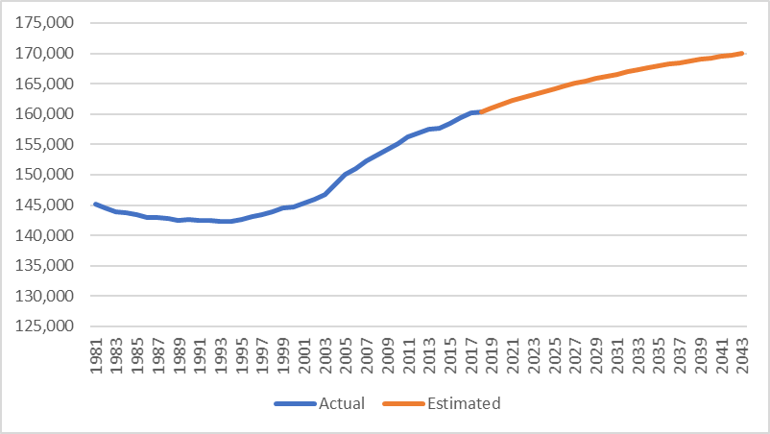

Source: National Records of Scotland

### **Components of Population Change**

Population change is driven by two main components, natural change, and net migration. Natural change is the number of births minus the number of deaths. If there are more births than deaths, the population will grow. Net migration is the number of people moving into an area minus the number of people leaving an area. Since 2016 there have been more deaths than births in Falkirk and the area has relied on net migration for the increase in the population.

Chart 2.2 shows the net migration into Falkirk for the last 10 years and highlights the peaks and troughs in terms of the numbers with the lowest being in 2013 when net migration was only 357.

#### **Chart 2.2: Net migration to Falkirk 2010-2019**

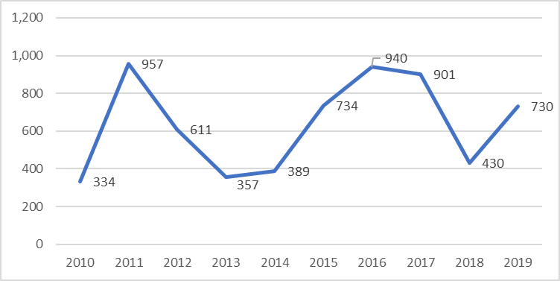

Source: National Records of Scotland

When the origin of migration over the last 10 years to Falkirk is looked at Chart 2.3 clearly shows that the majority are from within Scotland itself and this has fluctuated between 41% and over 100%. Migration from overseas made up 27% of net migration in 2010 but this has fallen to 5% for the last two years, probably as a result of Brexit.

#### **Chart 2.3: Origin of new migration to Falkirk 2010-2019**

Chart of Net migration to Falkirk 2010-2019


Source: National Records of Scotland

Migration will drive the projected increases in population in Falkirk over the next 25 years. Table 2.1 shows the projected components of population change in Falkirk between 2018 and 2043 and highlights there will be 9,986 (26%) more deaths than births in those 25 years. This is due to the “baby boomer” generation reaching the end of their life. The projected net migration is estimated to be 19,163, with the majority (66%) of this coming from migration from the rest of Scotland.

#### **Table 2.1: Components of population change Mid 2018-2019 and Mid 2018-2043**

|  |  |  |
| --- | --- | --- |
| **Year** | **Mid 2018-2019** | **Mid 2018-2043** |
| Estimated population 30 June 2018 | 160,340 | 160,340 |
| Births | 1,477 | 38,106 |
| Deaths | 1,703 | 48,092 |
| Natural change | -226 | -9,986 |
| Estimated net migration | 730 | 19,163 |
| Other changes | 46 | 445 |
| Estimated population 30 June 2019 | 160,890 |  |
| Population mid-2043 |  | 169,962 |
| **Population change** | **Number** | **%** |
|  | 550 | 0.3 |
|  | 9,622 | 6 |

Source: National Records of Scotland

**Population by Age Group**

Table 2.2 shows the population for the Falkirk area by sex and age group as of June 2020. It shows the area has an estimated population of 160,890. In terms of the breakdown by age, the largest age group is the 45-64 age group with 29% of the population which is slightly higher than 27.5% for Scotland as a whole. Generally, the 65+ age group for Falkirk and Scotland as a whole are similar with 18.9% of the Falkirk population in that age group and 19.1% for Scotland as a whole.

**Table 2.2: Population of Falkirk by age group 2020**

|  |  |  |  |  |  |
| --- | --- | --- | --- | --- | --- |
| Age Groups | Male | Female | All people | Falkirk % Of population | Scotland % of Population |
| 0 to 15 | 14,472 | 13,640 | 28,112 | 17.5 | 16.9 |
| 16 to 24 | 8,274 | 7,301 | 15,575 | 9.7 | 10.5 |
| 25 to 44 | 19,435 | 20,654 | 40,089 | 24.9 | 26.1 |
| 45 to 64 | 22,857 | 23,808 | 46,665 | 29 | 27.5 |
| 65 to 74 | 8,244 | 8,948 | 17,192 | 10.7 | 10.6 |
| 75 and over | 5,569 | 7,688 | 13,257 | 8.2 | 8.5 |
| Total | 78,851 | 82,039 | 160,890 | 100 | 100 |

Source: National Records of Scotland

### **Ethnicity**

In terms of ethnicity the largest percentage of the Falkirk population identify themselves as White Scottish at just over 91% of the Falkirk area as a whole as shown in Table 2.3. The Bo’ness area has the smallest percentage of people who identify themselves as White Scottish at 89.5% and Denny the largest at 93.1%. There are a higher percentage of people from a White Polish (1.4%) and White Other (2%) background in Bo’ness than the average for the area. There is a higher percentage of people from an Asian background in Falkirk, at 1.9% than the overall average but a lower percentage in Bo’ness at 0.6%.

#### **Table 2.3: Population by Ethnicity and Housing Submarket Area**

|  |  |  |  |  |  |  |  |  |  |
| --- | --- | --- | --- | --- | --- | --- | --- | --- | --- |
| Ethnicity | White Scottish | White Other British | White Irish | White Gypsy/ Traveller | White Polish | White Other | Asian | Other ethnic group | Total |
| Bo'ness | 13,986 | 869 | 75 | 12 | 221 | 308 | 101 | 47 | 15,619 |
| Denny Bonnybridge | 24,954 | 1,016 | 176 | 28 | 85 | 141 | 293 | 118 | 26,811 |
| Falkirk | 34,586 | 1,594 | 262 | 38 | 493 | 471 | 728 | 335 | 38,507 |
| Grangemouth | 16,147 | 603 | 80 | 14 | 175 | 114 | 142 | 98 | 17,373 |
| Braes & Rural South | 26,943 | 1,680 | 139 | 33 | 61 | 243 | 380 | 156 | 29,635 |
| Stenh'muir, Larbert & Rural North | 25,816 | 1,263 | 150 | 20 | 45 | 196 | 429 | 126 | 28,045 |
| Total No. | **142,432** | **7,025** | **882** | **145** | **1,080** | **1,473** | **2,073** | **880** | **155,990** |
| % | **91.30%** | **4.50%** | **0.60%** | **0.10%** | **0.70%** | **0.90%** | **1.30%** | **0.60%** | **100%** |

Source: National Records of Scotland 2011 Census, Table LC2101SC

To look at the age group by housing submarket area the 2011 census information needs to be looked at. Table 2.4 shows the population of Falkirk by age group and housing submarket area and highlights that the largest area in terms of population is Falkirk, and the smallest is Bo’ness and Grangemouth. Looking at the housing submarket areas and age groups, it highlights how similar the housing submarket areas are in terms of the proportion within each age group.

**Table 2.4: Falkirk Population by housing submarket area and age group**

|  |  |  |  |  |  |  |  |
| --- | --- | --- | --- | --- | --- | --- | --- |
|  | 0-15 yrs | 16-29 yrs | 30-49 yrs | 50-64 yrs | 65-74 yrs | 75+ | Total |
| Bo'ness | 17% | 16% | 29% | 21% | 10% | 7% | 15,619 |
| Denny & Bonnybridge | 19% | 16% | 30% | 20% | 9% | 6% | 26,811 |
| Falkirk | 17% | 17% | 30% | 19% | 9% | 8% | 38,507 |
| Grangemouth | 17% | 18% | 28% | 19% | 10% | 9% | 17,373 |
| Braes & Rural South | 19% | 17% | 30% | 20% | 9% | 6% | 29,635 |
| Stenhousemuir/Larbert & Rural North | 20% | 15% | 31% | 20% | 8% | 6% | 28,045 |
| Falkirk Total | **18%** | **16%** | **30%** | **20%** | **9%** | **7%** | **155,990** |
| Scotland Total | **17%** | **19%** | **20%** | **21%** | **16%** | **8%** | **5,295,403** |

Source: NRS Census Table QS103SC

### **Population Projections**

Table 2.5 highlights the projected changes between the different age groups in the next 25 years. As of 2018, Falkirk had a total population of 160,340 with the largest age group falling within the working age brackets of 35-44 years (25%) and 45-59 years (23%). The younger age groups of 0-15 years represent 18% of the total population, while those over the age of 65 represents 19% of the population.

The population over the next 25 years is expected to increase by 6%. It shows that the majority of age groups between 0-59 years will see a fall with the biggest fall projected to be in the 5-11 age group at 14%. There will however, in stark contrast, be a substantial increase in the 75-84 and the 85+ age group at 76% and 92% respectively.

#### **Table 2.5: 2018 Population by age Group and 2043 Projected Population by Age Group**

|  |  |  |  |  |
| --- | --- | --- | --- | --- |
| **Age  Group** | **2018** | **2043** | **Difference**  **No.** | **Difference**  **%** |
| 0-4 yrs | 8,175 | 7,932 | -243 | -3% |
| 5-11 yrs | 13,111 | 11,280 | -1,831 | -14% |
| 12-15 yrs | 6,944 | 6,464 | -480 | -7% |
| 16-19 yrs | 6,777 | 6,422 | -355 | -5% |
| 20-24 yrs | 8,926 | 7,960 | -966 | -11% |
| 25-44 yrs | 40,050 | 40,580 | 530 | 1% |
| 45-59 yrs | 36,624 | 34,406 | -2,218 | -6% |
| 60-64 yrs | 9,727 | 10,852 | 1,125 | 12% |
| 65-74 yrs | 17,049 | 20,699 | 3,650 | 21% |
| 75-84 yrs | 9,683 | 17,083 | 7,400 | 76% |
| 85+ | 3,274 | 6,284 | 3,010 | 92% |
| **All** | **160,340** | **169,962** | **9,622** | **6.0%** |

Source: NRS 2018 population projections

Chart 2.4 highlights that there are differences between Scotland and Falkirk in terms of population projections by age group with a bigger decline in the 0-4 age group in Scotland and a slight projected increase in the 25-44 age group in Falkirk. For the older age groups between 60+ years the Falkirk area sees a bigger projected increase than the Scotland area as a whole. Overall, though the Falkirk Area population is projected to increase by 6% but Scotland by 3%.

### **Household Projections**

Household projectionsare produced by the National Records of Scotland every two years and they show how many additional households would form if assumptions based on previous demographic trends in population growth and household formation were to be realised. Projections do not factor in the effect of coronavirus (COVID-19) or attempt to predict the impact of political or economic circumstances.

The principal population projection produced by the National Records of Scotland (NRS), uses assumptions about fertility, mortality and migration which are thought to be the most likely to occur over the next 25 years. However, a range of variant projections are also produced. The low and high migration variant population projections use the same assumptions about fertility and mortality as the principal population projection but assume varied levels of migration to and from Falkirk. Table 2.6 shows the percentage increase in households between 2018 and 2043 is 13.2% for the principal projection. This compares with 11.6% for the low migration variant and 14.5% for the high migration variant.

#### **Table 2.6: Household Projections for Falkirk by Variant**

|  |  |  |  |  |  |
| --- | --- | --- | --- | --- | --- |
| Area | 2018 | 2028 | 2043 | Change (%) 2018-2028 | Change (%) 2018-2043 |
| Low Migration | 72,267 | 76,470 | 80,685 | 5.80% | 11.60% |
| Principal Projection | 72,267 | 76,692 | 81,790 | 6.10% | 13.20% |
| High Migration | 72,267 | 76,917 | 82,774 | 6.40% | 14.50% |

Source: NRS 2018 Household Projections

The first part of the HNDA Tool requires choices to be made between the high migration, principal and low migration household projection variants, depending on the scenario. All three variants will lead to an increase in households in the area. This was discussed with the Strategic Housing Group and it was decided that all three would be run through the Tool.

The 2018 principal projection suggests that the number of households in Falkirk will increase by 9,523 (13%) between 2018 and 2043. This is on average an increase of 380 households every year. These household projections are lower than the 2012 projections used in the last HNDA where the number of households was expected to increase by 10,979 (16%) in the 25 years between 2012 and 2037.

#### **Chart 2.4: Population Projections for Falkirk and Scotland by Age Group 2018-2043**

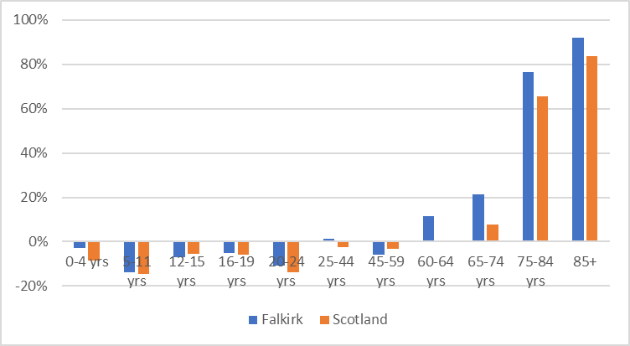

Source: National Records of Scotland

### **Household Projections**

Household projectionsare produced by the National Records of Scotland every two years, and they show how many additional households would form if assumptions based on previous demographic trends in population growth and household formation were to be realised. Projections do not factor in the effect of coronavirus (COVID-19) or attempt to predict the impact of political or economic circumstances.

The principal population projection produced by the National Records of Scotland (NRS), uses assumptions about fertility, mortality and migration which are thought to be the most likely to occur over the next 25 years. However, a range of variant projections are also produced. The low and high migration variant population projections use the same assumptions about fertility and mortality as the principal population projection but assume varied levels of migration to and from Falkirk. Table 2.6 shows the percentage increase in households between 2018 and 2043 is 13.2% for the principal projection. This compares with 11.6% for the low migration variant and 14.5% for the high migration variant.

#### **Table 2.6: Household Projections for Falkirk by Variant**

|  |  |  |  |  |  |
| --- | --- | --- | --- | --- | --- |
| Area | 2018 | 2028 | 2043 | Change (%) 2018-2028 | Change (%) 2018-2043 |
| Low Migration | 72,267 | 76,470 | 80,685 | 5.8% | 11.6% |
| Principal Projection | 72,267 | 76,692 | 81,790 | 6.1% | 13.2% |
| High Migration | 72,267 | 76,917 | 82,774 | 6.4% | 14.5% |

Source: NRS 2018 Household Projections

The first part of the HNDA Tool requires choices to be made between the high migration, principal and low migration household projection variants, depending on the scenario. All three variants will lead to an increase in households in the area. This was discussed with the Strategic Housing Group and it was decided that all three would be run through the Tool.

#### **Chart 2.5: 2018 Based Principal Household projections.**

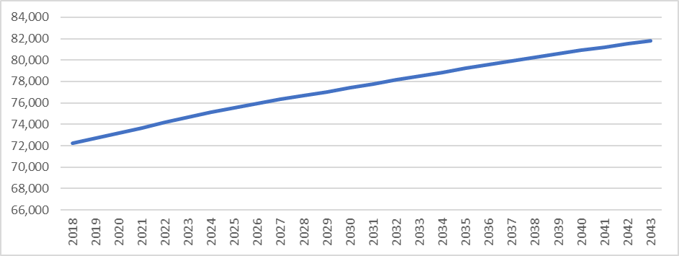

Source: National Records of Scotland

### **Household Projections by Age Group**

Household projections have also been produced for each local authority by the age of the head of the household, see Table 2.7. This provides an idea of how projected households will look, which has implications for the type of housing that should be provided in the future. It shows that overall, between 2018 and 2043 there is projected to be a 13% increase in households in Falkirk compared to 10% nationally. The most noticeable differences between Scotland and Falkirk is that there is projected to be a higher decrease in the 16-29 age group in Scotland at 13% compared to 8% in Falkirk. There is also projected to be higher increases in the older age groups in Falkirk with a 14% increase projected for the 60-74 age group compared to 2% nationally and 83% for the 75+ age group compared to 74% nationally.

The 2018 principal projection suggests that the number of households in Falkirk will increase by 9,523 (13%) between 2018 and 2043. This is on average an increase of 380 households every year. These household projections are lower than the 2012 projections used in the last HNDA where the number of households was expected to increase by 10,979 (16%) in the 25 years between 2012 and 2037.

#### **Table 2.7: Household projections by age group of head of household 2018 and 2043, Falkirk and Scotland**

|  |  |  |  |  |  |  |
| --- | --- | --- | --- | --- | --- | --- |
| **Age Group** | **Falkirk**  **2018** | **Falkirk**  **2043** | **Falkirk**  **% Change** | **Scotland**  **2018** | **Scotland**  **2043** | **Falkirk**  **% Change** |
| 16-29 | 6,027 | 5,532 | -8% | 258,182 | 225,455 | -13% |
| 30-44 | 17,073 | 17,501 | 3% | 583,083 | 594,875 | 2% |
| 45-59 | 23,267 | 22,047 | -5% | 741,597 | 723,386 | -2% |
| 60-74 | 15,608 | 17,862 | 14% | 535,442 | 547,855 | 2% |
| 75+ | 10,291 | 18,847 | 83% | 358,970 | 623,168 | 74% |
| **Total** | **72,266** | **81,789** | **13%** | 2,477,276 | 2,714,739 | 10% |

Source: National Records of Scotland

The projections in Table 2.8 by household type show that one person and two person households make up the majority of households in Falkirk at 33% in 2018. Between 2018 and 2043 there are projected to be:

* 21.1% more one person households in Falkirk, compared to 16.4% nationally.
* 19.6% more two person households in Falkirk, compared to 12.7% nationally.
* 1.9% increase in 3+ adult households, compared to 0.4% nationally.
* A negligible increase in one adult and one child household and a decrease of 1.4% in 2+ adults and 1+ child households in Falkirk compared to a decrease of 0.5% and 1.6% respectively.

#### **Table 2.8: Household Projections by Household Type 2018 and 2043**

|  |  |  |  |  |  |  |
| --- | --- | --- | --- | --- | --- | --- |
| **Household Type** | **Falkirk 2018** | **Falkirk 2043** | **Falkirk % Difference** | **Scotland 2018** | **Scotland 2043** | **Scotland % Difference** |
| 1 adult | 23,525 | 28,497 | 21.10% | 892,687 | 1,038,718 | 16.40% |
| 1 adult, 1+ children | 4,454 | 4,462 | 0.20% | 154,526 | 153,705 | -0.50% |
| 2 adults | 23,649 | 28,278 | 19.60% | 774,680 | 873,144 | 12.70% |
| 2+ adults, 1+ children | 14,473 | 14,270 | -1.40% | 445,241 | 438,149 | -1.60% |
| 3+ adults | 6,166 | 6,283 | 1.90% | 210,141 | 211,023 | 0.40% |

Source: National Records of Scotland

### **Household Size**

Table 2.9 shows the projections for household size in the next 25 years and highlights that both Falkirk and Scotland are expected to see a decline. In Falkirk there is projected to be a 7% fall in household size from 2.20 to 2.05 people per household and from 2.15 to 2.03 in Scotland.

The projected decrease in household size is due to people living in smaller households or alone. One person households are projected to have the largest increase mainly due to the growth in the number of older people as older people are more likely to live alone or in smaller households.

#### **Table 2.9: Projected household size 2012-2037**

|  |  |  |  |  |  |  |  |  |
| --- | --- | --- | --- | --- | --- | --- | --- | --- |
| **Area** | **2018** | **2023** | **2028** | **2033** | **2038** | **2043** | **Overall Change 2018-2028** | **Overall Change 2018-2043** |
| **Falkirk** | 2.2 | 2.17 | 2.14 | 2.11 | 2.08 | 2.05 | -0.15 | -7% |
| **Scotland** | 2.15 | 2.11 | 2.08 | 2.06 | 2.03 | 2 | -0.15 | -7% |

Source: National Records of Scotland

### **Affordability**

### **Affordability Trends**

This section will look at key information sources relevant to accessing different tenures of housing and their affordability. The key information sources include.

* Private house sales - information from CHMA, Registers of Scotland
* Private rents - Local housing allowance rates, Scottish Government private rented information, Council’s own database.
* Social rents – Council information system and Scottish Housing Regulator
* Income data – HNDA Tool, NOMIS annual survey of hours and earnings

**House Sales and Prices**

This section looks at private house sales information from Registers of Scotland[3] Property Market Report 2020-2021 and also Data Pack information on house sales supplied by the CHMA. Information from the Data Pack on sales over £25,000 and under £1,000,000 was used for this analysis. The analysis will look at sales within the six housing sub market areas and will look at second hand and new build sales, lower quartile and median sales information as well as the total number of sales.

Chart 2.6 shows the number of residential house sales in the last 10 years and highlights they have increased by 36% which is the same percentage increase as Scotland as a whole. The peak of market activity took place in 2016-2017 when there were 3,050 sales in total.

#### **Chart 2.6: Volume of residential sales in Falkirk 2010-2020**

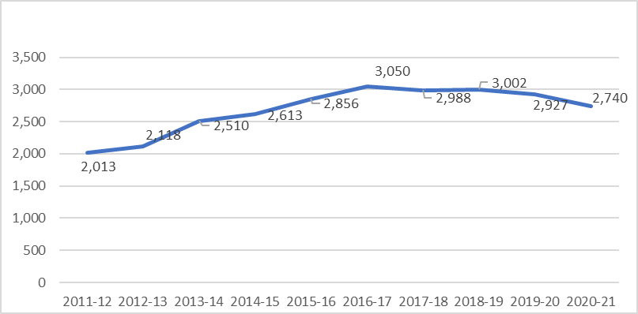

Source: Registers of Scotland Property Market Report 2020/21

In terms of the average residential property price in Falkirk, Chart 2.7 highlights the changes in the last decade. In 2020/21 the average house prices in Falkirk was £160,344 compared to £194,100 for Scotland. House prices for Scotland as a whole have always been higher than the Falkirk average. The difference between the average Scottish house price and that of Falkirk has reduced over the decade with average house prices in Falkirk in 2011-12 at 78% of the Scottish average but this has increased to 83% in 2020-2021. Average house prices in Falkirk have increased by 30% in the last decade compared to 24% for Scotland. For Falkirk prices have increased by around 3.4% annually.

#### **Chart 2.7: Average house prices in Falkirk compared to Scotland 2011-2021**

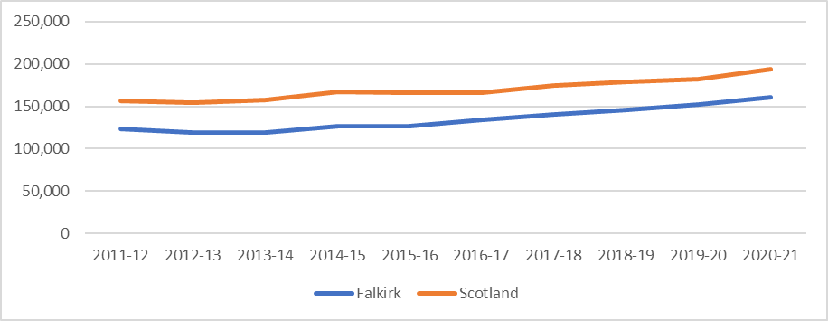Source: Registers of Scotland Property Market Report 2020/21

As house prices have increased more in Falkirk in the last 10 years compared to Scotland it is was decided that Trend growth and moderately high growth would be run through the HNDA Tool.

In terms of new build house prices, Chart 2.8 shows that the average price of a new build properties in Falkirk in 2020-2021 was £237,458 which is £77,114 higher than the average price of all house sales. In comparison the average new build price for Scotland as a whole in 2020-2021 was £268,140 for Scotland, £74,040 higher than the overall average house price. Where Scotland has seen a steady increase in new build average prices over the last 10 years, apart from a very small fall in 2018-2019, the trajectory for Falkirk has not been as smooth. In Falkirk prices rose from 2011-12 but fell in 2014-15 and then again in 2015-16. They rose again but fell in 2018-19 and 2019-20. Over the last decade, Falkirk has seen a 22% increase in the average new build price whereas Scotland has seen a 30% increase. New build property sales in Falkirk make up a between 11-14% of all residential sale transactions.

The number of new build residential properties increased from 252 sales in 2011-2012 to a peak of 434 sales in 2016-2017. Since then, the number of sales has fluctuated to a low of 204 in 2020-2021 which will be due to the impact of COVID 19 restrictions.

#### **Chart 2.8: Average new build house prices in Falkirk compared to Scotland 2022-2021**

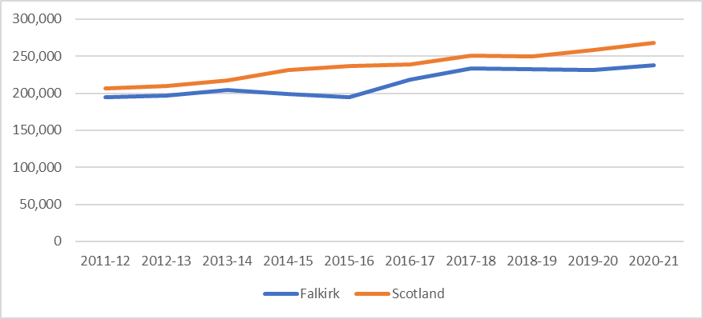

Source: Registers of Scotland Property Market Report 2020/21

### **House Sales Information by Housing Submarket Area**

To better understand trends within the six different housing submarket areas in Falkirk, data from the LHS Data Pack which was supplied by the CHMA was analysed. This next section will look at the number of sale as well as lower quartile and median house prices by the six housing submarket areas.

### **Number of Sales by Housing Submarket Area**

Chart 2.9 shows the number of residential sales by housing sub market area between 2008 until 2017. It highlights the 43% drop in sales between 2008 and 2009 across all areas, the highest fall was seen in Denny and Bonnybridge at 55% and the lowest in Braes and Rural South at 30%.

Since 2009 there has been a steady increase in the number of sales, with an 83% increase in the 8 years to 2017. The largest increase in the number of sales can be seen in Denny and Bonnybridge at 153% and the lowest in Falkirk at 52%.

#### **Chart 2.9: Number of house sales by Housing Market Sub Area 2008-2017**

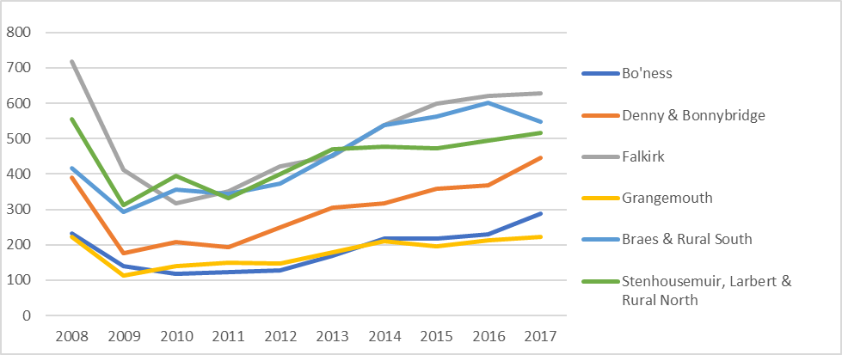Source: Registers of Scotland with further processing by Scottish Government

Chart 2.10 shows house prices between 2008 and 2017 for the Council area as a whole. Overall lower quartile house prices have fallen 4% in that time, median house prices have increased by 7% and mean house prices by 5%.

Chart 2.11 shows the lower quartile price of house sales in the Falkirk area by housing submarket area. It highlights that between 2008 and 2012 overall lower quartile house prices in the council area fell but between 2013 and 2017 there was an increase in prices. Overall lower quartile prices have fallen by 4% but there are differences between the different housing submarket areas with Grangemouth seeing a 20% fall but Braes and Rural South seeing a 9% increase.

#### **Chart 2.11: Lower Quartile House Prices by Housing Submarket Area 2008-2017**

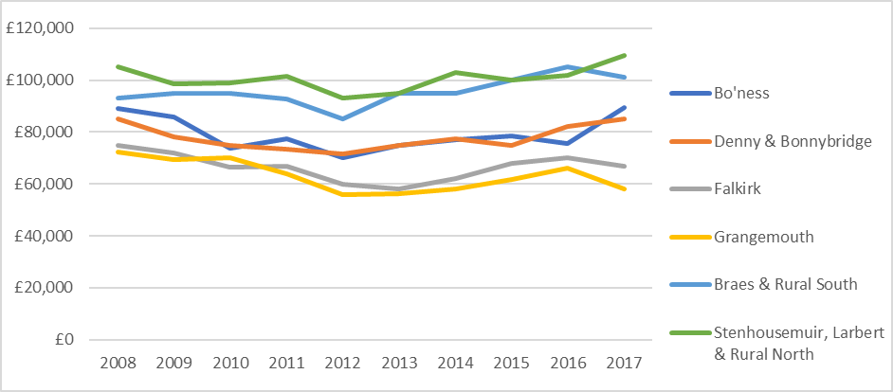

Source: Registers of Scotland with further processing by Scottish Government

Chart 2.12 shows the median house prices by housing submarket area and highlights that overall median house prices have increased by 7% in the Council area. There are differences between the different housing submarket areas with Denny and Bonnybridge seeing a 20% increase but Grangemouth seeing a 9% fall.

#### **Chart 2.12: Median House Prices by Housing Market Sub Areas 2008-2017**

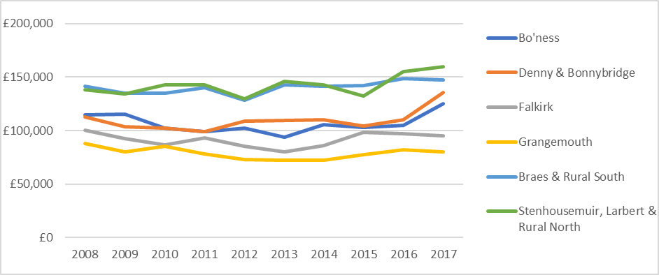

Source: Registers of Scotland with further processing by Scottish Government

House prices in Falkirk between 2013 and 2017 really fluctuated with some years seeing increases of over 4% and other years less than 1%. Overall, there has been an annual increase of 2.5%. Comparing Falkirk and Scotland average house prices between 2011 and 2020 from Registers of Scotland[4], Falkirk average house prices increased by 27% and Scotland by 21%. As house prices have increased more in Falkirk in the last 10 years compared to Scotland it is was decided that Trend Growth (1.6%) and Moderately High growth (2.3%) would be run through the Tool.

### **Help to Buy**

The Help to Buy (Scotland) Affordable New Build is a Scottish Government scheme to help first time buyers and existing homeowners to buy an affordable new build home up to the value of £200,000 from a participating home builder. It has been running since 2013 and provides help of up to 15% of the purchase price of an affordable new build home.

There are two types of Help to Buy (Scotland) scheme:

* Affordable New Build scheme
* Smaller Developer scheme

Both work in the same way but applications for the Help to Buy (Scotland): Affordable New Build scheme closed on 5 February 2021.

Table 2.10 shows the number of people in the Falkirk area that have been helped through the scheme and highlights how the number has halved between 2016-2017 and 2019-2020. The average purchase price has increased in those 4 years by £3,100.

#### **Table 2.10: The number of people receiving funding through the Help to Buy Scheme and the average price paid.**

|  |  |  |
| --- | --- | --- |
| Year | Average Purchase price | Number of Sales |
| 2016-2017 | £170,200 | 140 |
| 2017-2018 | £170,400 | 80 |
| 2018-2019 | £168,900 | 80 |
| 2019-2020 | £173,300 | 70 |

Source: Scottish Government administrative data

### **House Completions**

Chart 2.13 shows the number of private sector house completions by year and highlights how the number fell quite dramatically from the highs of 955 completions in 2005/06 to the lowest number of 196 in 2011/12. The number of completions started increasing from 2011/12 to a high of 513 in 2016/17 but they then fell again in 2017/18 to 382 but rose again in 2018/19.

#### **Chart 2.13: Number of Private Sector House Completions in Falkirk 2005-2019**

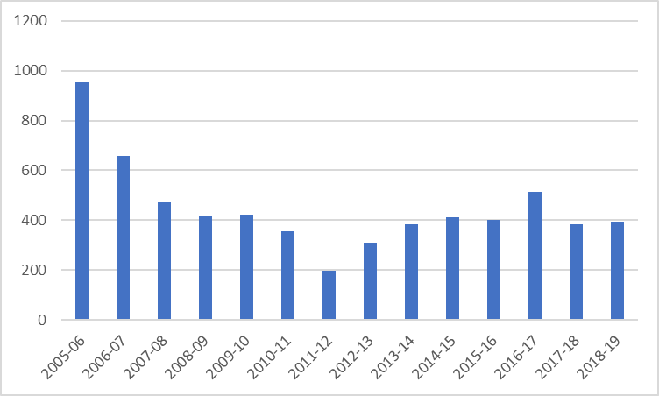

Source: NB2 returns by local authorities to the Scottish Government, Communities Analysis Division (Housing Statistics)

### **Private Rents**

The private rented sector in Falkirk makes up around 8% of the stock which is lower than the Scotland average of 14%. It is seen as an important part of the housing market allowing people flexibility in where they can live and also allowing them to live in areas, they can’t afford to buy in.

### **Average Private Rents by Broad Rental Market Area**

Table 2.11 uses data from the Rent Service Scotland database. This database is used to meet the needs of determining annual Local Housing Allowance levels and Local Reference Rent and is broken down by Broad Rental Market Area (BRMA). Falkirk is included in the Forth Valley BRMA.

Table 2.11 shows the average rent for the Forth Valley area between 2017-2020 by bedroom size. It highlights those average rents are lower in the Forth Valley area compared to those nationally for the majority of years and most bedroom sizes. Overall, there has been an increase in average rents across both Scotland and Forth Valley in the 4 years and in all sized properties. Compared to Scotland as a whole, Forth Valley has seen the biggest increase in average rents of three (16%) and four (18%) bedroom properties. The biggest increase was seen in Forth Valley for 4-bedroom properties which saw a 18% increase in average rents compared to 17% for Scotland.

#### **Table 2.11: Average private rented sector rents for Forth Valley and Scotland by bedroom size 2015-2019**

|  |  |  |  |  |  |  |  |  |
| --- | --- | --- | --- | --- | --- | --- | --- | --- |
|  | **Forth Valley 2017** | **Forth Valley 2018** | **Forth Valley 2019** | **Forth Valley 2020** | **Scotland 2017** | **Scotland 2018** | **Scotland 2019** | **Scotland 2020** |
| 1 Bed Shared | £357 | £371 | £345 | £373 | £350 | £366 | £373 | £400 |
| 1 Bed | £415 | £428 | £438 | £439 | £501 | £510 | £519 | £542 |
| 2 Bed | £563 | £589 | £596 | £614 | £643 | £652 | £668 | £689 |
| 3 Bed | £752 | £783 | £801 | £893 | £787 | £855 | £857 | £844 |
| 4 Bed | £1,095 | £1,148 | £1,207 | £1,343 | £1,143 | £1,278 | £1,325 | £1,342 |

Source: Scottish Government Private Sector Rent Statistics

Chart 2.14 shows that the average rent for a two-bedroom property in Forth Valley has been lower in the last 10 years compared to Scotland. The average rent for a 2 bedroom has increased by 25% for Scotland and 21% for the Forth Valley area.

#### **Chart 2.14: Two-bedroom average monthly rent**

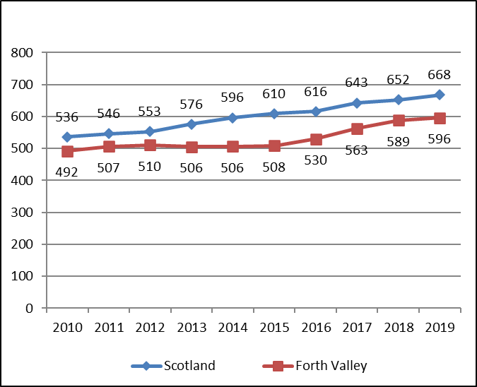

Source: Scottish Government Private Sector Rent Statistics

### **Private Rented Database**

The Forth Valley BRMA covers Forth Valley (Stirling, Clackmannanshire, and Falkirk Councils). Stirling with its university has a very different private rented sector in comparison to Falkirk. In order to triangulate with more local information, the Strategy and Development team within the Council have been collecting information since 2005 on the properties advertised for rent on web sites such as Zoopla, Right Move and Gumtree. A database was set up to collect data on the number of bedrooms, property type and the monthly rent for each property advertised. The database is unable to collate all properties for rent in the area but gives a good indication on the average rent for different property sizes and types and for the different housing submarket areas.

### **Average Rent by bedroom Size**

Table 2.12 shows the average rent for the last five years by bedroom size and highlights that the overall average rent has increased by 14%. The biggest increase was seen for 2-bedroom properties where the increase was 18% and the lowest was for 4-bedroom properties at 9%. Comparing the average rents to the Forth Valley BMRA highlights those rents for all bedroom sizes are lower in Falkirk.

#### **Table 2.12: Average Monthly Rent by Bedroom Size 2017-2021**

|  |  |  |  |  |  |
| --- | --- | --- | --- | --- | --- |
| Bedroom Size | 2017 | 2018 | 2019 | 2020 | 2021 |
| 1 Bed | £376 | £389 | £402 | £411 | £432 |
| 2 Bed | £479 | £465 | £510 | £541 | £566 |
| 3 Bed | £619 | £584 | £637 | £679 | £716 |
| 4 Bed | £866 | £908 | £879 | £901 | £942 |
| 5 Bed | £1,329 | £1,500 | £1,306 | £1,400 | - |
| Total | **£489** | **£481** | **£520** | **£530** | **£559** |

Source: Falkirk Council Private Rent Database

Table 2.13 shows the average rent over the last five years by housing submarket area. It shows that in most years the highest average rents were seen in Braes and Rural South and Stenhousemuir, Larbert and Rural North, although in 2020 Denny and Bonnybridge have higher average rents than Braes and Rural South. It also highlights the wide variations in rent increases with Grangemouth seeing a 20% increase and Denny and Bonnybridge a 5% increase.

#### **Table 2.13: Average rent by housing submarket area 2017-2021**

|  |  |  |  |  |  |
| --- | --- | --- | --- | --- | --- |
|  | 2017 | 2018 | 2019 | 2020 | 2021 |
| Bo'ness | £475 | £443 | £518 | £490 | £501 |
| Denny & Bonnybridge | £528 | £453 | £533 | £666 | £555 |
| Falkirk | £465 | £445 | £504 | £496 | £547 |
| Grangemouth | £447 | £650 | £478 | £524 | £535 |
| Braes & Rural South | £545 | £528 | £553 | £566 | £613 |
| Stenhousemuir, Larbert & Rural North | £563 | £547 | £593 | £637 | £625 |
| Total | **£489** | **£481** | **£520** | **£530** | **£556** |

In terms of rents for the Forth Valley BRMA, these have seen between 2% and 8% increases annually but in the last 4 years around 4.7% increase annually. When information on private rents for the Falkirk area alone is looked at, some years have seen a 5% increase in rents and other have seen a fall but overall there has been around an annual increase of around 2.9%. It was decided by the Strategic Housing Group that the same scenarios that were chosen for house prices would be chosen for rental price rises to be run through the HNDA Tool and they are trend growth and moderately high growth.

### **Local Housing Allowance Rates 2017-2021**

Local housing allowance (LHA) is the way that housing benefit is calculated and paid to tenants of private landlords. Local housing allowance can help towards the cost of rent and some service charges that are condition of living in a property. It does not cover charges for heating, hot water, lighting, laundry or cooking. Local housing allowance does not apply to council housing or homes managed by registered social landlords.

Table 2.14 shows the LHA rates for the last 4 years and highlights the rate stayed the same between 2017-2019 but in 2019/20 only the shared 1 bed rate saw an increase. The rate finally increased across all bedroom sizes in 2020/21, with the 4-bedroom rate seeing the biggest increase at 17% and 1 bedroom the lowest at 8%.

#### **Table 2.14: Housing Allowance Rates 2017/18-2020/21**

|  |  |  |  |  |  |
| --- | --- | --- | --- | --- | --- |
|  | Shared | 1 | 2 | 3 | 4 Bed |
| 20/21 Monthly LHA Rates | £296.48 | £363.60 | £460.28 | £598.36 | £874.52 |
| 19/20 Monthly LHA Rates | £257.00 | £335.64 | £414.24 | £506.32 | £727.20 |
| 18/19 Monthly LHA Rates | £249.52 | £335.64 | £414.24 | £506.32 | £727.20 |
| 17/18 Monthly LHA Rates | £249.52 | £335.64 | £414.24 | £506.32 | £727.20 |

Source: Scottish Government (Rent Service Scotland)

### **Private Rents compared to LHA Rate**

Table 2.15 shows LHA rates for 2020/2021 compared to average rents from the Strategy Team’s Private Rented Database (PRD). It highlights that the LHA rates are lower than the average rents in the area. The biggest difference can be seen in two-bedroom properties where the average rent is 18% higher than the LHA rate. There is a 13% difference between the LHA rates and one- and three-bedroom average rents and a 3% difference for four bedrooms. Where rent is higher than the LHA payable, the tenant must make up the difference. This means it is increasingly hard for private renters to access homes where the rent is within the LHA rate, increasing the risk of homelessness.

#### **Table 2.15: Private Rents Compared to LHA Rates**

|  |  |  |  |  |
| --- | --- | --- | --- | --- |
| Property Type | 20/21 Monthly  LHA Rates | 2020 Falkirk Council PRD | Difference (£) | Difference (%) |
| Shared | £296.48 | - | - | - |
| 1 | £363.60 | £411 | £47.40 | 13 |
| 2 | £460.28 | £541 | £80.72 | 18 |
| 3 | £598.36 | £679 | £80.64 | 13 |
| 4 bed | £874.52 | £901 | £26.48 | 3 |

Source: Falkirk Council Private Rent Database, Scottish Government (Rent Service Scotland)

### **Private Rents Compared to Income**

Table 2.16 looks at the average rent charged in the different housing submarket areas and compares it to the lower quartile income in these areas to give an idea of the affordability of the rents. It highlights that overall, 38% of income is spend on renting privately in the Council area. There are differences between the different area with the cheapest area being Bo’ness, where 33% of income is spend on rent and the least affordable area being Denny and Bonnybridge where 53% of income is spent on rent.

Using the affordability ratio of 4 (25%), and the average rent of £530 for the Falkirk area as a whole, a household would need a minimum income of £25,440 a year to afford to meet their housing needs in the private rented sector. When income data in the HNDA Tool is looked at, this represents income at the 46th decile. This means that 45% of households in Falkirk would not be able to afford private sector rents in Falkirk.

#### **Table 2.16: Affordability of renting for Lower Income Households by Housing Submarket Area**

|  |  |  |  |  |
| --- | --- | --- | --- | --- |
| Area | Average Rent per Month | Average rent per Year | LQ Income | % LQ income to housing costs |
| Braes & Rural South | £566 | £6,792 | £19,760 | 34% |
| Falkirk | £496 | £5,952 | £14,560 | 41% |
| Denny & Bonnybridge | £666 | £7,992 | £15,080 | 53% |
| Bo'ness | £490 | £5,880 | £17,680 | 33% |
| Grangemouth | £524 | £6,288 | £13,000 | 48% |
| Stenhousemuir Larbert & Rural North | £637 | £7,644 | £19,760 | 39% |
| Overall | **£530** | **£6,360** | **£16,640** | **38%** |

Source: Falkirk Private rented database, HNDA Tool

### **Falkirk Council Rents**

Falkirk Council has the 6th lowest average rent of all the local authorities in Scotland. Table 2.17 shows Falkirk Council rents by property size over the last five years. It highlights that the highest rent increase has been seen in one and two-bedroom properties where rents have increased by 22% and the lowest for four-bedroom properties where the rent has increased by 15%.

#### **Table 2.17: Falkirk Council rents by Bedroom Size 2015-2020**

|  |  |  |  |  |  |  |
| --- | --- | --- | --- | --- | --- | --- |
| Bedrooms | 15/16 | 16/17 | 17/18 | 18/19 | 19/20 | % Increase In 5 Years |
| 1 | £42.36 | £43.77 | £46.32 | £48.25 | £51.62 | 22% |
| 2 | £47.70 | £51.29 | £53.04 | £54.99 | £58.19 | 22% |
| 3 | £57.74 | £60.74 | £62.95 | £65.37 | £68.09 | 18% |
| 4 | £65.98 | £68.62 | £71.10 | £73.73 | £76.13 | 15% |
| 5 | £75.40 | £78.27 | £81.53 | £84.44 | £87.35 | 16% |

Source: Falkirk Council Information Systems

### **RSL Rents**

Table 2.18 shows the average weekly rent by general needs housing provider in the Council area. These are average rents for the provider’s stock in the Falkirk council area. It highlights that overall, Paragon Housing Association and Weslo Housing Management have the lowest average rent whereas Castle Rock Edinvar have the highest rents. Falkirk Council rents are lower than RSL rents across all property sizes.

#### **Table 2.18: Average Weekly Rents 2019/20 for RSLs Providing General Needs Housing**

|  |  |  |  |  |  |
| --- | --- | --- | --- | --- | --- |
|  | 1  bed | 2  Bed | 3  Bed | 4+  Bed | Overall Average Rent |
| Castle Rock Edinvar Housing Association Ltd | £87 | £93 | £110 | Null | £93 |
| Kingdom Housing Association Ltd | Null | £85 | £99 | Null | £86 |
| Link Group Ltd | £76 | £90 | £98 | £114 | £83 |
| Loretto Housing Association Ltd | £90 | £87 | £92 | £108 | £91 |
| Paragon Housing Association Ltd | £67 | £76 | £87 | £109 | £79 |
| Weslo Housing Management | £71 | £78 | £86 | £111 | £82 |
| Falkirk Council | £58 | £68 | £76 | £87 | £69 |

Source: Scottish Housing Regulator, Null highlights the provider does not have stock of this house size in the Falkirk area.

### **Affordability of Social Rents**

Table 2.19 shows the weekly rent charged by the main general needs stock providers in the area and compares it to the weekly lower quartile income for the area. It estimates that 22% of income for Falkirk Council tenants is spent on rent and is the lowest amount of the providers shown in Table 2.19. The highest amount of income spent on rent is 30% and that is by Castle Rock Edinvar tenants.

#### **Table 2.19: Affordability of social renting in Falkirk for Lower Income Households**

|  |  |  |  |
| --- | --- | --- | --- |
| Landlord Name | Average weekly rent | Average weekly LQ income | % LQ income to housing costs |
| Castle Rock Edinvar Housing Association Ltd | £95.97 | £320 | 30% |
| Falkirk Council | £71.46 | £320 | 22% |
| Kingdom Housing Association Ltd | £88.06 | £320 | 28% |
| Link Group Ltd | £85.03 | £320 | 27% |
| Loretto Housing Association Ltd | £93.99 | £320 | 29% |
| Paragon Housing Association Ltd | £81.48 | £320 | 25% |

Source: Scottish Housing Regulator, CHMA

### **Income**

Household income data from Herriot Watt University and the David-Simmonds Consultancy is available via the HNDA Tool and it’s broken down into the Council area and also the six housing submarket areas as shown in Table 2.20. It shows that the median income for the Falkirk Council area is £28,080. There are however variations with households in Grangemouth earning a median income of £21,320 and those in Braes and Rural South and Stenhousemuir, Larbert and Rural North earning £33,280. This is a difference of £11,960 or 56%.

There are also significant differences between the income of Falkirk residents falling within the lowest 10% bracket and the highest 10% bracket. Across the local authority this differential equates to over £58,240 (85%). The lowest incomes can be found in Grangemouth at £8,320 but the highest is found in Stenhousemuir, Larbert and Rural South at £76,960. Overall, for all income bands Grangemouth has the lowest household incomes.

**Table 2.20: 2018 Income Estimates by Decile and Housing Submarket Area**

|  |  |  |  |  |  |
| --- | --- | --- | --- | --- | --- |
|  | Lowest 10% below | 30% | Median | 70% | Highest 10% above |
| Braes & Rural South | £12,480 | £21,840 | £33,280 | £47,840 | £75,400 |
| Falkirk | £9,360 | £16,640 | £24,440 | £36,920 | £62,920 |
| Denny & Bonnybridge | £11,440 | £19,760 | £29,640 | £43,680 | £70,200 |
| Bo'ness | £9,360 | £16,640 | £26,520 | £39,520 | £66,040 |
| Grangemouth | £8,320 | £14,560 | £21,320 | £32,240 | £54,080 |
| Stenhousemuir Larbert & Rural North | £12,480 | £21,840 | £33,280 | £47,840 | £76,960 |
| Falkirk Council | £10,400 | £18,200 | £28,080 | £41,600 | £68,640 |

Source: Heriot Watt University Estimates extracted from HNDA Toolkit

Income data for full time employees is also available from the Office of National Statistics. This information uses data from the annual survey of hours and earnings and is shown in Table 2.21. It highlights the median, mean and lower quartile income for Falkirk for the last six years and compares it to Scotland as a whole. For the majority of years incomes in Falkirk are lower than those in Scotland with the widest disparity seen in mean incomes. In terms of the increase in incomes over the six years Falkirk saw a 12% increase in median income and Scotland 15%, this was reversed for mean income with Falkirk seeing a 15% increase and Scotland 12% but for lower quartile incomes Falkirk saw a 19% increase and Scotland 15%.

#### **Table 2.21: Average, median and lower quartile income levels**

|  |  |  |  |  |  |  |
| --- | --- | --- | --- | --- | --- | --- |
|  | **Falkirk Median** | **Scotland Median** | **Falkirk Mean** | **Scotland  Mean** | **Falkirk Lower Quartile** | **Scotland Lower Quartile** |
| 2015 | 26,984 | 27,711 | 29,228 | 32,482 | 19,174 | 19,969 |
| 2016 | 28,248 | 27,998 | 31,110 | 33,120 | 19,984 | 20,208 |
| 2017 | 27,859 | 28,365 | 30,503 | 33,489 | 20,175 | 20,719 |
| 2018 | 29,327 | 29,275 | 31,991 | 34,563 | 21,971 | 21,489 |
| 2019 | 29,838 | 30,000 | 31,762 | 35,263 | 21,669 | 21,891 |
| 2020 | 30,109 | 31,836 | 33,596 | 36,434 | 22,737 | 23,058 |

Source: NOMIS ONS annual survey of hours and earnings - resident analysis

Median incomes in Falkirk are similar to Scotland as a whole. Over the last 5 years, there have been fluctuations but generally median incomes have increased overall by around 2.2% annually. It was agreed by the Strategic Housing Group that the two scenarios below would be chosen to run through the Tool, moderate real terms growth and no real terms growth.

There is no evidence to suggest that income distribution across Falkirk will or has changed, and for this reason no change in income distribution was chosen for the HNDA Tool.

### **Affordability for First Time Buyers**

According to research from the Bank of Scotland[5], the number of first-time buyers in Scotland rose to 33,558 in 2019, an increase of more than 90% from 17,580 a decade ago.

First-time buyers still account for 50% of all property purchases with a mortgage in Scotland, up from 38% in 2009. The Bank of Scotland also looked at the average price of first-time buyer properties and in Falkirk in 2019 it was £134,576, compared to £152,728 in Scotland. The average earnings of first-time buyers in Falkirk in 2019 was £32,016 compared to £35,487 in Scotland.

By September 2020 the Bank of Scotland[6] was reporting that the number of first-time buyers in Scotland was at a seven-year low, falling over a third (35%) since 2019, due to the pandemic.

The cost of a first home has risen 42% in the last decade, with the average price of a first-time buyer property increasing from £108,774 in 2010, to £154,449 in 2020. Scottish first-time buyers are putting down deposits, averaging £31,257 in 2020, which is 27% higher than 2010. However, deposits as a percentage of the property price continue to slide from their peak of 23% a decade ago, to 20% in 2020. The average age of a first-time buyer continues to rise gradually, from 29 a decade ago to 31 in 2020.

### **Affordability Ratios**

The conventional indicators of affordability have been house price to income ratios, expressed here by mortgage size as a multiplier of a buyers stated household income.

Chart 2.15 shows the findings of analysis on house price to earnings ratios between 2010 and 2020. Median and lower quartile house prices from the Scottish Government data pack for all house sales in the Falkirk Council area were used. Median and lower quartile income data from the annual survey of hours and income was also used. The chart shows that:

* In Falkirk the lower quartile ratios have fallen from 4.2 in 2010 to 3.7 in the last decade.
* Median ratios have also seen a fall, from 5.2 to 4.4 in the last decade.
* Median house prices have increased by 4% but incomes have increased by 24%.
* Lower quartile house prices have fallen by 6% but incomes have increased by 22%.

#### **Chart 2.15: Ratio of House Price to Income 2010-2020**

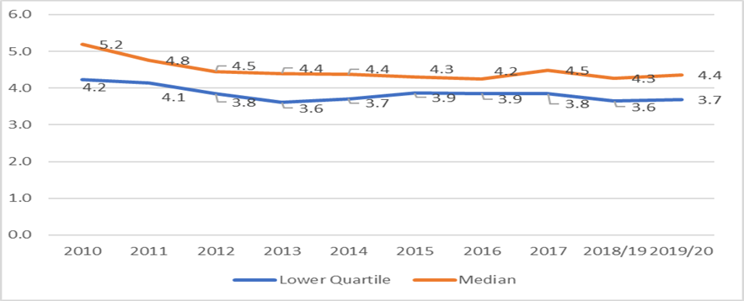

Source: Registers of Scotland with further processing by Scottish Government, NOMIS ONS annual survey of hours and earnings - resident analysis. Properties of less than £20K and more than £1m have been removed from the analysis as they would skew the data.

The Tool is set up to analyse affordability (incomes divided by house prices and rent prices) at the 25th percentile of income, house prices and rental prices. The 25th percentile has been chosen because, historically, this is seen to represent where First Time-Buyers enter this housing market, where housing need and demand is most critical. It was decided by the Strategic Housing Group to keep it at 25% in the Tool as there was no evidence locally that it should be changed.

The default in the Tool has been set at 60% for those that can afford to buy in the market, the proportion that actually go on to do so. This assumes, of those who can afford mortgage repayments, only 60% also have the deposit to actually go on to buy. This was discussed by the Strategic Housing Group and it was decided that the default of 60% would remain as there is no evidence locally that it should be changed.

### **Mortgages**

### **Loan-to-value Mortgage Rate**

Loan to Value (LTV) is the maximum mortgage loan you can take out as a percentage of the property value. This is really important for first time buyers as many mortgage providers will have a maximum LTV that they are prepared to offer.

Chart 2.16 shows the loan to value mortgage rate for first time buyers for the last four year. It highlights that the rate increased from 79.6% in quarter three of 2016 to 82.8% of the same quarter in 2019. This means the deposit required by first time buyers has fallen from 20.4% to 17.2%. Since then, the rate has fallen and in quarter three of 2020 it stood at 78.3% which means larger deposits for first time buyers. This fall in the rate is due to a reduction in new lending at high loan to value mortgages across the country since March 2020 when the country went into lockdown due to the COVID pandemic. The UK House Price Index[7] shows that the average first-time buyer property price in Scotland in quarter three of 2020 was £127,000.

#### **Chart 2.16: Loan to Value for First Time Buyers**

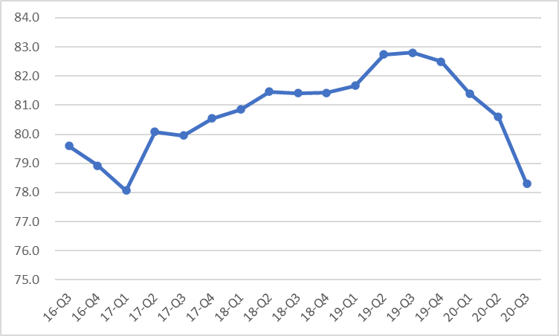

Source: <https://www.ukfinance.org.uk/data-and-research/data/mortgages/regional-lending-trends>

### **Interest Rates**

Chart 2.17 shows the changes in the Bank of England base rate over the last 47 years. The base rate at the moment is 0.1% and is the lowest it has been at any time in the last 47 years. In 2007[8], the Bank of England interest rate was around 5.5%. In December 2008, the Monetary Policy Committee (MPC) dropped the base rate to 2%. The MPC dropped it again to 0.5% in 2009 where it remained for around seven years. In August 2016, Bank of England rate was at its lowest ever point: 0.25%.

The global outbreak of coronavirus forced the UK Government to take drastic steps to stem the economic impact by slashing the base rate twice in March 2020, down to 0.1%. A low Bank of England rate encourages people to borrow money because it's less expensive for them to repay. The less you spend repaying debts, the more money you can spend elsewhere. More spending makes for a more buoyant economy.

#### **Chart 2.17: Changes in the Bank of England Base Rate 1973-2020**

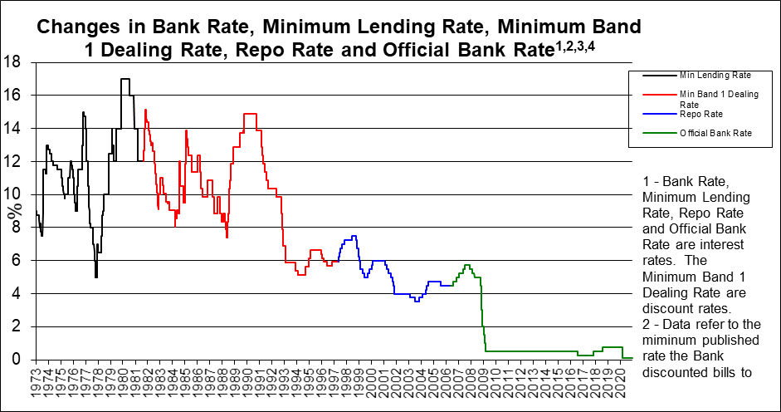

Source: Bank of England - <http://www.bankofengland.co.uk/statistics/rates/baserate.xls>

**Economic Trends**

### **Introduction**

This section considers key economic indicators comparing the Falkirk area with Scotland, including Gross Value Added (GVA) as well as unemployment and employment statistics.

Historically the Falkirk economy was dominated by the [iron](https://en.wikipedia.org/wiki/Ironworks) and [steel](https://en.wikipedia.org/wiki/Steel) industry, underpinned by the [Carron Company](https://en.wikipedia.org/wiki/Carron_Company) in nearby [Carron](https://en.wikipedia.org/wiki/Carron,_Falkirk). Within the last fifty years, heavy industry has waned, and the economy relies increasingly on retail and tourism. Many Falkirk residents are also employed within the [petrochemicals](https://en.wikipedia.org/wiki/Petrochemicals) sector based in [Grangemouth](https://en.wikipedia.org/wiki/Grangemouth) where there is an [agglomeration](https://en.wiktionary.org/wiki/agglomeration) of such industries underpinned by the [Ineos](https://en.wikipedia.org/wiki/Ineos) (formerly [BP](https://en.wikipedia.org/wiki/BP)) oil refinery located there. Falkirk remains the home of [Alexander Dennis](https://en.wikipedia.org/wiki/Alexander_Dennis); the largest bus production company in the United Kingdom.

In the past 20 years, the Falkirk area has seen dramatic developments which have transformed its landscape and economy. These include the Falkirk Wheel, Calendar House in Falkirk, Bo’ness & Kinneil Railway, the Hippodrome in Bo’ness and the Helix and Kelpies in Falkirk, all of which have had major impact on the social, cultural, and economic future of the area and which continue to bring a wealth of opportunities to increase tourism.

### **Employment by Occupation**

Table 2.22 shows employment by occupational group between October 2019 and September 2020. It highlights that Falkirk, compared to Scotland and the UK, has a smaller percentage of people employed as directors, managers and in professional occupations. It also highlights the slightly higher percentage in administrative, skilled traded, caring and leisure as well as sales and customer service and around the same in process plant and machine operatives.

#### **Table 2.22: Employment by Occupational Group (Oct 2019-Sep 2020)**

|  |  |  |  |  |
| --- | --- | --- | --- | --- |
| Group | Falkirk No | Falkirk % | Scotland % | Great Britain % |
| SOC 2010 Major Groups 1-3 | **32,300** | **41.4** | **46.4** | **49.2** |
| 1. Managers, Directors and Senior Officials | 6,100 | 7.8 | 9.2 | 11.5 |
| 2. Professional Occupations | 18,100 | 23.2 | 22.7 | 22.3 |
| 3. Associate Professional and Technical | 8,100 | 10.4 | 14.4 | 15.2 |
| SOC 2010 Major Groups 4-5 | **16,700** | **21.4** | **19.4** | **19.5** |
| 4. Administrative and Secretarial | 9,900 | 12.7 | 9.5 | 9.9 |
| 5. Skilled Trades Occupations | 6,800 | 8.7 | 9.8 | 9.5 |
| SOC 2010 Major Groups 6-7 | **16,400** | **21** | **18.1** | **15.9** |
| 6. Caring, Leisure and other Service Occupations | 9,400 | 12 | 10.1 | 9 |
| 7. Sales and Customer Service Occupations | 7,000 | 9 | 8 | 6.9 |
| SOC 2010 Major Groups 8-9 | **12,600** | **16.1** | **16.1** | **15.3** |
| 8. Process Plant and Machine Operatives | 6,900 | 8.9 | 6 | 5.6 |
| 9. Elementary Occupations | 5,600 | 7.2 | 10.1 | 9.7 |

Source: ONS Annual Population Survey. Note: Numbers and % are for those 16+, % of population of all persons in employment.

Chart 2.18 shows the proportion of people aged 16+ in employment by broad industrial group. It highlights that Falkirk has a higher proportion of people working in manufacturing and banking, finance and insurance and a lower proportion working in public administration, education, and health. The high proportion working in manufacturing will be due to the Ineos refinery and petrochemical site in Grangemouth.

#### **Chart 2.18: Proportion of people aged 16+ in employment by broad industrial group 2019**

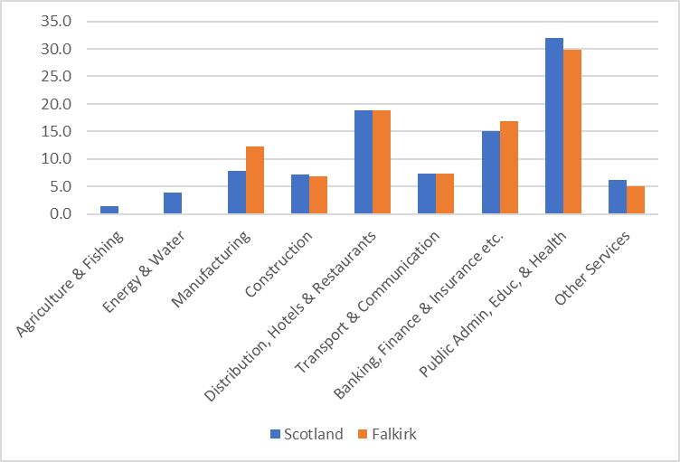

<https://www.gov.scot/publications/scotlands-labour-market-people-places-and-regions-background-tables>

### **Travel to Work Areas**

Information on travel to work flows in and out of Falkirk uses data from the 2011 Census and is shown in Chart 2.19. It shows a total inflow of commuters from UK local authorities into Falkirk of 14,184 and a total outflow of 26,736. Overall, there is a net decrease in population of 12,552 people.

Of those commuting to work in Falkirk from other UK local authorities, the majority are from either Stirling (19%) or North Lanarkshire (17%). The majority of out commuting is to Stirling and Edinburgh at 23%.

**Chart 2.19: Travel to Workflows**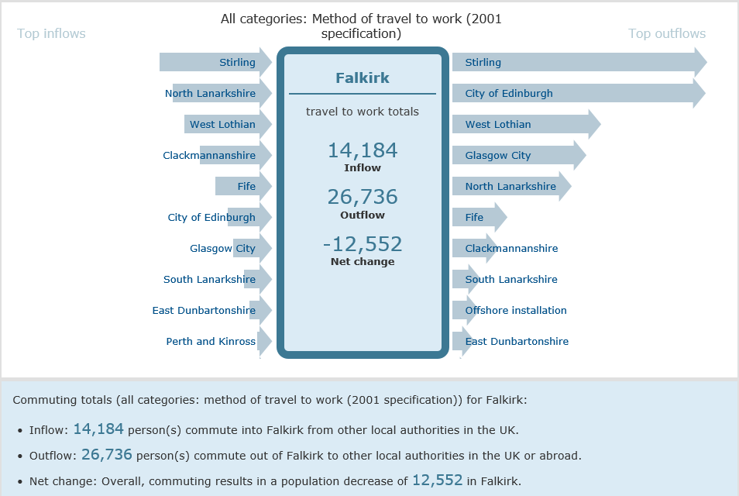

Source: ONS, Census 2011, Location of usual residence and place of work by method of travel to work

**Economic Growth (GVA)**

Gross value added (GVA) is a measure in economics of the value of goods and services produced in an area, industry or sector of an economy. In national accounts GVA is output minus intermediate consumption; it is a balancing item of the national accounts' production account. It is generally regarded as the best measure of the sum of economic activity within an area.

GVA data is provided for local authorities by the Scottish Government and is set out in Table 2.23 and provides time series information for Falkirk from 2008 to 2018. It shows a small decline of 2% in the number of those in employment over the period and a decline in the total number of employees of 7%. The most noticeable change between 2008 and 2018 is the difference in the total turnover which has fallen by 42%. As a result, the GVA per Head of population has fallen from an average of £54,151 in 2008 to £45,842 in 2018, representing a 15% decrease in productivity over the period.

#### **Table 2.23: GVA Data for Falkirk**

|  |  |  |  |  |  |
| --- | --- | --- | --- | --- | --- |
| Year | Total  Employment (Th's) | Total  Employees (Th's) | Total  Turnover £m | GVA at Basic Prices £m | GVA per Head £ |
| 2008 | 45.2 | 43.1 | 15,023.3 | 2,447.6 | 54,151 |
| 2009 | 43.2 | 41.3 | 10,300.4 | 1,918.7 | 44,439 |
| 2010 | 40.0 | 39.0 | 11,165.7 | 2,180.2 | 54,528 |
| 2011 | 42.4 | 40.9 | 12,711.7 | 1,011.5 | 23,868 |
| 2012 | 40.8 | 39.7 | 8,747.2 | -432.2 | -10,603 |
| 2013 | 42.2 | 41.0 | 6,861.0 | 2,052.3 | 48,665 |
| 2014 | 44.2 | 43.2 | 7,204.6 | 1,929.5 | 43,685 |
| 2015 | 44.1 | 43.1 | 8,304.7 | 1,883.1 | 42,671 |
| 2016 | 45.3 | 44.2 | 7,004.6 | 1,654.5 | 36,487 |
| 2017 | 44.4 | 43.4 | 8,189.0 | 1,958.3 | 44,137 |
| 2018 | 46.1 | 45.3 | 8,780.2 | 2,115.3 | 45,842 |

Source: Scottish Government, Scottish Annual Business Statistics 2020

Chart 2.20 provides information on GVA per Head for Falkirk compared with Scotland as a whole over the same time period. For both geographies the trend was very different up until 2013. Falkirk in particular saw a huge decrease in GVA per head in 2011 and 2012. This was due to a decline in the GVA at basic prices in wholesale retail and repairs and also wholesale trade, except for motor vehicle and motorbikes. Since 2013 the pattern has been similar; dropping until 2016 and then gradually increasing to 2018. The GVA per Head for Falkirk was 9% higher than the Scottish average in 2008 but in 2018 was almost £6,707 less or 13% lower.

#### **Chart 2.20: GVA per Head for Falkirk Compared to Scotland**

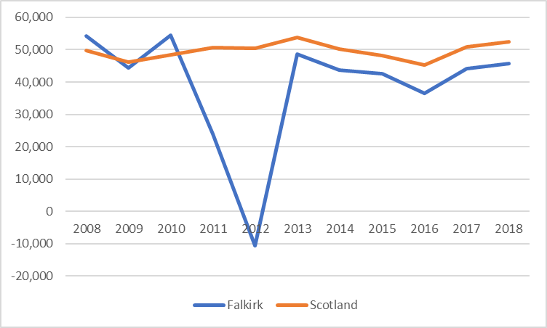

Source: Scottish Government, Scottish Annual Business Statistics 2020

In June 2020 KPMG modelled Scotland GVA per local authority, they considered four alternative scenarios for the timing of the recovery from COVID 19, based on different potential dates of the pandemic being eradicated in the UK. At the time of writing their main scenario assumed that a vaccine will be available from July 2021. Table 2.24 is an extract of the table showing neighboring and central belt authorities. This shows that within the KPMG scenario Falkirk fares slightly better than neighboring authorities in 2020 (apart from West Lothian).

#### **Table 2.24: KPMG modelled Scotland GVA per local authority.**

|  |  |  |  |  |
| --- | --- | --- | --- | --- |
| Local authority | 2018 GVA, £ million (nominal) | 2019 | 2020 | 2021 |
| Clackmannanshire | 797 | 1.40% | -6.50% | 3.30% |
| City of Edinburgh | 21,173 | 1.10% | -6.40% | 2.60% |
| Falkirk | 3,500 | 1.20% | -5.80% | 3.30% |
| Fife | 7,190 | 0.90% | -7.20% | 3.80% |
| Glasgow City | 23,360 | 1.20% | -6.70% | 3.40% |
| Stirling | 2,750 | 1.40% | -8.20% | 3.20% |
| West Lothian | 4,567 | 1.70% | -5.00% | 3.60% |
| Scotland | 142,121 | 1.20% | -6.80% | 3.40% |

Source: <https://www.falkirk.gov.uk/services/business-investment/policies-strategies/covid-impact-recovery.aspx#grossdomesticproductgdpandgrossvalueadded>

### **Employment and Unemployment**

### **Employment Rates in Falkirk**

Chart 2.21 compares the employment rate in Falkirk to Scotland as a whole between 2004 and 2019. Employment rates are defined as a measure of the extent to which available labour resources (people available to work) are being used. They are calculated as the ratio of the employed to the working age population (aged 16-64). Apart from a slight rise in 2016, the employment rate in Falkirk has been in decline since 2015, falling to 74.1% in 2019. This compares to Scotland which has seen the rate rising steadily since 2013 and in 2019 was 74.8%

In 2019 there were 76,700 people over the age of 16 in employment in Falkirk in 2019, a decrease of 1.7% on the previous year and a decrease of 0.6% since 2008.

#### **Chart 2.21: Employment rate of Falkirk compared to Scotland 2008-2019**

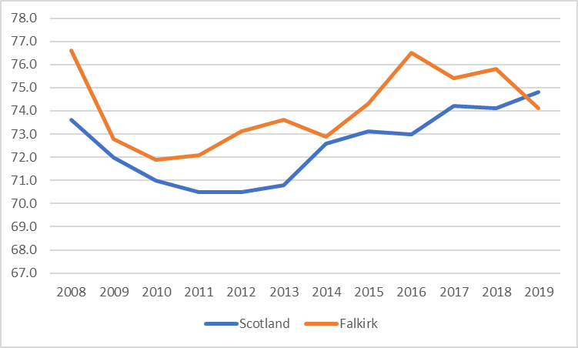

<https://www.gov.scot/publications/scotlands-labour-market-people-places-and-regions-background-tables/>

### **Employment Rate by Age Group**

Table 2.25 shows the employment rate by age group for Falkirk compared to Scotland between 2015 and 2019. It highlights that youth employment (16-24) is higher in Falkirk compared to the national average. The employment rate in Falkirk for the 25-34 and the 35-49 age group is lower for most years in comparison to Scotland as a whole. The opposite is true for the 50-64 age group where the employment rate is higher for Scotland than Falkirk for most years.

#### **Table 2.25: Employment rate by age group in Scotland 2015-2019**

|  |  |  |  |  |  |  |  |  |
| --- | --- | --- | --- | --- | --- | --- | --- | --- |
|  | **16-24 Scotland** | **16-24 Falkirk** | **25-34 Scotland** | **25-34 Falkirk** | **35-49 Scotland** | **35-49 Falkirk** | **50-64 Scotland** | **50-64 Falkirk** |
| **2015** | 56.4 | 60.5 | 80.5 | 79.4 | 82.4 | 85.4 | 68.6 | 67.6 |
| **2016** | 55.9 | 64.4 | 80.9 | 79.1 | 81.8 | 86.2 | 68.7 | 71.7 |
| **2017** | 59.3 | 69 | 82 | 82.7 | 82.2 | 81.6 | 69.6 | 68.1 |
| **2018** | 57.2 | 62.6 | 80.6 | 83.5 | 83.7 | 85.7 | 69.7 | 68.1 |
| **2019** | 57.9 | 60.4 | 81.6 | 78.9 | 84 | 84.1 | 70.5 | 67.9 |

<https://www.gov.scot/publications/scotlands-labour-market-people-places-and-regions-background-tables>

### **Economic Inactivity Rate**

Another good indicator of the performance of the Labour Market is the level of economic inactivity. Economically inactive people are those without a job who are not seeking work and/or are not available to start work in the next two weeks. The main economically inactive groups are students, people looking after family and home, long term sick and disabled, temporarily sick and disabled, retired people and discouraged workers.

Chart 2.22 shows economic inactivity in Falkirk compared to Scotland as a whole. It shows that proportion in Scotland is higher than in Falkirk at between 22.6% in 2008 but has increased to 23.3%. In comparison, Falkirk started at a low of 20.6% in 2008 but had increased to 22.5% in 2019. The rate has followed the employment rate, with the inactivity rate falling in 2014 as the employment rose and increasing in 2016 as the employment rate fell.

#### **Chart 2.22: Economic Inactivity in Scotland and Falkirk 2008-2019**

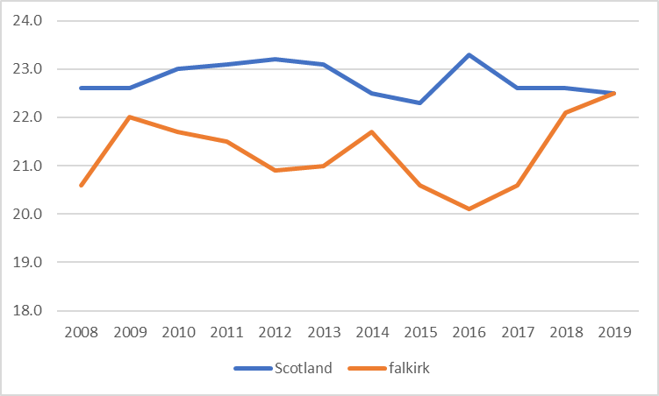

Source: NOMIS

### **Unemployment Rate**

The unemployment rate is the share of people actively looking for work that were unable to secure employment relative to the total labour force. Chart 2.23 shows the unemployment rate between 2008 and 2019. It shows that Falkirk has followed the same trajectory as Scotland. The unemployment rate in Falkirk has been falling from a high of 8.6% in 2011 to 3.7% in 2019. The rate for Scotland in 2019 was 3.5%.

Higher unemployment rates were seen as a sign of a struggling economy while lower rates were interpreted as a sign of a stronger economy. However, the unemployment rate can decrease for two reasons that imply very different performance: 1) people are finding work, which is positive; or 2) potential workers are dropping out of the labour force and not looking for work anymore, which is usually negative.

Since 2016 the employment rate in Falkirk has been falling but instead of the unemployment rate increasing it has instead fallen. The rate of economic inactivity has also fallen at the same time which is probably due to a decline in labour market participation due to an ageing population.

#### **Chart 2.23: Unemployment rate of Falkirk compared to Scotland 2008-2019**

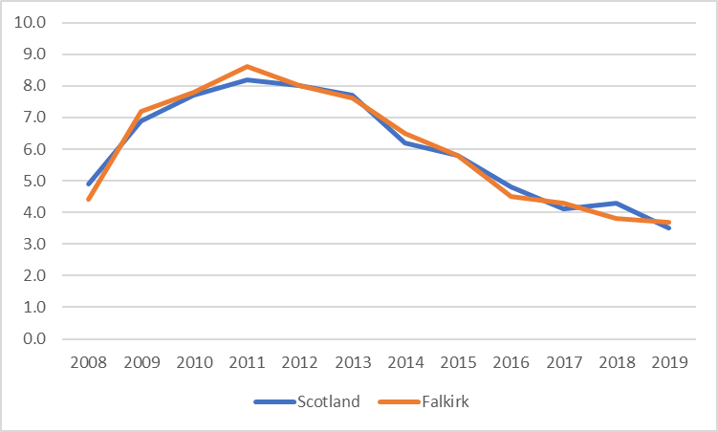

Source: <https://www.gov.scot/publications/scotlands-labour-market-people-places-and-regions-background-tables/>

Table 2.26 shows the claimant count as of February for the last six years for Falkirk, Scotland the UK. Under Universal Credit a broader span of claimants are required to look for work than under Jobseekers Allowance and can be seen in the increase in the number of claimants. The number of claimants has risen by 81% in the last year in Falkirk which is slightly lower than the Scottish figure of 86% and the UK figure of 115%. This is no doubt due to the impact of COVID 19 on the economy. Although the number of claimants has increased in Falkirk, the percentage of claimants is lower at 5.8% than nationally which is 6.1%.

#### **Table 2.26: Claimant Count February 2016-2021**

|  |  |  |  |  |  |  |
| --- | --- | --- | --- | --- | --- | --- |
| **Date** | **Falkirk No.** | **Falkirk %** | **Scotland No.** | **Scotland %** | **UK No.** | **UK %** |
| Feb – 16 | 2,305 | 2.3 | 79,735 | 2.3 | 760,480 | 1.9 |
| Feb – 17 | 2,365 | 2.3 | 81,720 | 2.3 | 765,510 | 1.9 |
| Feb - 18 | 2,570 | 2.5 | 86,695 | 2.5 | 835,810 | 2.1 |
| Feb - 19 | 3,430 | 3.4 | 104,935 | 3 | 1,032,935 | 2.5 |
| Feb - 20 | 3,300 | 3.2 | 114,605 | 3.3 | 1,225,855 | 3.0 |
| Feb - 21 | 5,980 | 5.8 | 213,325 | 6.1 | 2,636,630 | 6.5 |

Source: ONS Claimant Count & Age. Note: % is the No. of claimants as a proportion of resident population of area aged 16-64 and gender

### **Areas of Multiple Deprivation**

The Scottish Index of Multiple Deprivation (SIMD) measures relative deprivation and does not provide information on absolute levels of deprivation. Deprived does not just mean “poor” or “low income” but can also mean that people living in these areas have fewer resources and opportunities, health and education outcomes or poor access to services.

According to the 2020 Scottish Index of Multiple Deprivation (SIMD), 15 per cent of Falkirk council residents (24,575) are currently living in the most deprived 20 per cent of areas in Scotland. Falkirk ranks as the 13th most deprived out of the 32 local authorities in Scotland. There are 214 date zones in the Council area and Table 2.27 shows the number of data zones by housing submarket area and percentage deprived and highlights:

* 35 datazones are in the worst 20% in Scotland, an increase of 2 from 2016
* 5 datazones are in the worst 5% - one more than 2016
* 9 datazones are in the worst 6-10% - one less than 2016
* 11 datazones are in the worst 16-20% - two more than 2016

#### **Table 2.27: Number of Datazones in Worst 20% by Housing Submarket Area**

|  |  |  |  |  |  |
| --- | --- | --- | --- | --- | --- |
| **Housing Submarket Area** | **5%** | **6-10%** | **11-15%** | **16-20%** | **Total** |
| Bo'ness | 0 | 0 | 0 | 1 | 1 |
| Denny & Bonnybridge | 1 | 0 | 2 | 1 | 4 |
| Falkirk | 3 | 4 | 6 | 8 | 21 |
| Grangemouth | 1 | 4 | 0 | 0 | 5 |
| Braes & Rural South | 0 | 1 | 1 | 1 | 3 |
| Stenhousemuir, Larbert & Rural North | 0 | 0 | 1 | 0 | 1 |
| **Total** | **5** | **9** | **10** | **11** | **35** |

Source: SIMD 2020, Scottish Government 2020

|  |  |
| --- | --- |
| **LHS & Development Plan** | **Key Issues Identified in the HNDA** |
| Demographic issues for the local housing market (s) | * Falkirk has an increasing population; this has been the case since the mid-1990s. The NRS 2018 population projections indicate a rise of 6% between 2018 and 2043 which will result in a population estimate of 169,962 by 2043. The projected percentage increase in households between 2018 and 2043 is 13% for the principal projection. The 2018 principal projection suggests that the number of households in Falkirk will increase by 9,523 (13%) between 2018 and 2043. This is on average an increase of 380 households every year. This will mean an annual need for new build housing in the future. * The population is ageing with the majority of age groups between 0-59 years expected to see a fall between 2018 and 2043, with the largest fall expected to be in the 5-11 age group at 14%. There will however in stark contrast be a substantial increase in the 75-84 and the 85+ age group at 76% and 92% respectively, this compares to 66% and 84% nationally. The population of Falkirk is expected to age at a higher rate than the national average. Building suitable new homes and supporting the adaptation of the existing housing stock will be critical as the population ages. As the majority of older people own their own homes and live in them as they get older, the suitability of mainstream housing is therefore likely to have a greater impact on the ageing population. * The majority of working age groups are projected to see a decline between 2018-2043. An implication of an ageing population and an increase in life expectancy and a decline in working age groups is that there may be a lower proportion of individuals to pay taxes, work and provide care for those who need it. * Single person households are the largest household category in Falkirk and this is expected to increase as there is an projected to be a 7% fall in household size from 2.20 to 2.05 people per household and from 2.15 to 2.03 in Scotland in the next 25 years. This will mean a need for one and two bedroom properties. It should be noted that there is an acute need for larger family homes in the Council area. * Migration is driving expected increases in population in Falkirk. The projected net migration is estimated to be 19,163, with the majority of this coming from the rest of Scotland. |
| Affordability issues for the local housing market (s) | * The average house prices in Falkirk are historically lower than national levels. The average house price in Falkirk in 2020-2021 was £160,344, compared to £194,100 for Scotland as a whole. The difference between the average price in Falkirk and nationally has reduced over the last decade with average house prices in Falkirk in 2011-12 at 78% of the Scottish average but this has increased to 83% in 2020-2021.The average price of a new build property in Falkirk in 2020-2021 was £237,458 which is £77,114 higher than the average price of all residential properties * When looking at housing sub market areas and house sales between 2014-2017, the highest increase was in Denny and Bonnybridge at 41% and the lowest in the Braes and Rural South at 2%. In terms of lower quartile prices for this HNDA, there has been an overall increase of 7% between 2014-2017. The Bo’ness area has seen the biggest increase at 16% whereas Grangemouth has not seen any increase. In terms of median prices for this HNDA, there has been an overall increase of 9% between 2014-2017. The Denny & Bonnybridge area has seen the highest increase at 23% and the Braes and Rural South the lowest at 4%. Affordability is a real issue across all the housing sub market areas making it very difficult for some households to access owner occupation. * The private rented sector in Falkirk is smaller than Scotland as a whole. making up 9% of dwellings locally. It is an important part of the housing market allowing people flexibility in where they can live and also allowing them to live in areas, they can’t afford to buy in. Average rents are lower in the Forth Valley BRMA area compared to those nationally for the majority of years and most bedroom sizes. When looking at average rents in the Falkirk Council area, they have increased by 14% since 2017. Affordability can be an issue in this sector too, especially with large deposits needed. Overall 38% of income is spend on renting privately in the Council area. Using the average rent of £530 for the Falkirk area as a whole, 45% of households in Falkirk would not be able to afford private sector rents in Falkirk. * Falkirk Council has the 6th lowest average rent of all the local authorities in Scotland and it’s estimated that 22% of tenant’s income is spent on rent * It has become apparent that there needs to be more intermediate housing options available for households in the area such as shared equity and mid-market rent and these discussions are taking place with our partners and will continue in the future. * The HNDA Tool 2018 income estimates show that the median income for the Falkirk Council area is £28,080. There are however variations with Grangemouth households earning a median income of £21,320 whilst those in Braes and Rural South and Stenhousemuir, Larbert and Rural North earning £33,280. Incomes in Falkirk are generally lower than the national average. * The lower quartile prices of second hand properties is usually used to determine affordability for first time buyers. In Falkirk in 2017 it was £77,500 and the lower quartile income was, according to the HNDA Tool, £16,640. If an income multiplier of 3.9 is used there are affordability issues for first time buyers in Falkirk |
| Economic issues for the local market (s) | * Falkirk is located between the large employment hubs of Glasgow and Edinburgh, and the smaller hub of Stirling, and as a result there are large outflows of commuters from Falkirk in all three directions. in 2011 of the 63,000 residents of Falkirk that were in employment, just under 27,000 or a very high 43 percent commuted elsewhere to work. It’s only partially offset by the opposite movement of 14,000 workers travelling into the region from elsewhere. This means Falkirk isn’t self-contained in labour market terms. * In terms of GVA, Falkirk has underperformed the national economy over the previous decade. Falkirk’s economy is dominated by manufacturing activity, mostly linked to the petrochemical industry associated with Grangemouth refinery, and also transport which includes both pipeline and tanker operations. Falkirk, compared to Scotland and the UK, has a smaller percentage of people employed as directors, managers and in professional occupations. * In employment terms Falkirk outperformed Scotland with the employment rate higher than the national figure for more than a decade. Since 2015 the employment rate has been falling in Falkirk and in 2019 was below the Scottish rate for the first time in many years. In terms of unemployment, the area has followed the same trajectory as Scotland with unemployment falling since 2011 to 3.7% in 2019, slightly higher than the Scottish average of 3.5%. |

## **Chapter 3 – Stock**

### **Introduction**

This chapter will consider what existing stock is available to meet the housing needs of the local population and will identify any under-supply or surplus of certain types of housing. This will demonstrate where the existing housing stock may be pressured and where the stock may need to be managed in order to meet the housing needs of the local population. The types and number of in-situ solutions used will also be evidenced. Stock will be considered by size, type, condition, occupancy, concealed households and turnover (relets and voids). These will be considered by tenure and location as appropriate.

This chapter uses published data sources such as the Scottish House Conditions Survey and 2011 Census as well as data from local information systems.

This chapter must satisfy **Core Output 4** in order to gain robust and credible status.

|  |
| --- |
| **Housing Stock Profile, pressures and management issues:**  Consider what existing housing stock is available to meet the housing needs of the local population. This should identify any under-supply or surplus of certain types of housing. This will demonstrate where the existing housing stock may be pressured and where stock may need to be managed in order to meet the housing needs of the local population. The types and number of in-situ solution used should be evidenced. Stock should be considered by size, type, condition, occupancy, concealed households and turnover (relets and voids). These should be considered by tenure and location as appropriate. |

This chapter is split into four sections. The first section will look at stock characteristics such as an estimate of the total stock in the area, property size and house type. The second section will look at stock conditions, considering the Scottish Housing Quality Standard and energy efficiency. The third section looks at stock pressures and will look at occupancy, concealed households, and turnover within Council and RSL stock. The last section looks at stock management and in-situ solutions such as adaptations and extensions.

### **Physical Characteristics**

Falkirk contains 75,226 dwellings, which is a 6.7% increase since 2009 as shown in Chart 3.1. This is slightly higher than the national increase of 6.5%.

#### **Chart 3.1: Number of dwellings in Falkirk 2009-2019**

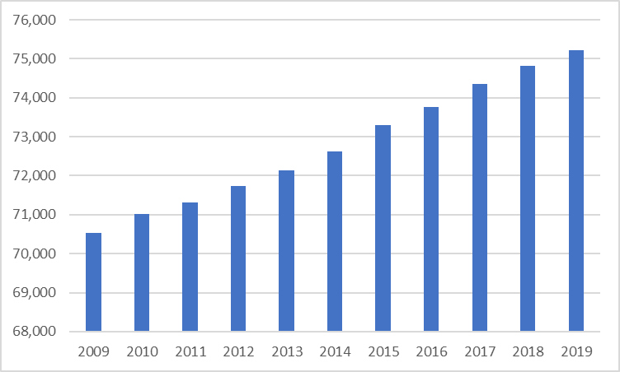

Source: NRS Estimates of Households and Dwellings in Scotland, 2019

### **Stock by location and all tenures**

The most comprehensive information on the breakdown of stock by tenure is available from the 2011 Census which is now very dated. According to the 2011 Census, the majority of households in the Falkirk Council area are owner occupiers, 65% compared to 62% nationally, see Table 3.1. A further 27% are socially rented which is higher than the national figure of 24%. Private renters make up 8% which is much lower than the Scottish figure of 14%.

At the housing submarket level 73% of households own their property in the more affluent areas of Braes and Rural South and Stenhousemuir, Larbert and Rural North while a lower proportion of 57% in Falkirk and Grangemouth. In terms of the percentage in the social rented sector, the Grangemouth area has the highest levels at 36% and the Stenhousemuir, Larbert and Rural North the lowest at 19%.

In terms of the private rented sector, the highest levels of private renting can be seen in Falkirk at 12% and the lowest in Denny & Bonnybridge and Braes and Rural South at 6%.

#### **Table 3.1: Stock by Tenure and Housing Submarket Area**

|  |  |  |  |  |  |  |
| --- | --- | --- | --- | --- | --- | --- |
| **Area** | **Owned**  **No.** | **Owned %** | **Social Rented No.** | **Social Rented %** | **Private Rented  No.** | **Private Rented %** |
| Bo'ness | 4,499 | 64% | 1,895 | 27% | 629 | 9% |
| Denny and Bonnybridge | 7,482 | 66% | 3,154 | 28% | 655 | 6% |
| Falkirk | 10,364 | 57% | 5,707 | 31% | 2,167 | 12% |
| Grangemouth | 4,859 | 57% | 3,017 | 36% | 598 | 7% |
| Stenhousemuir, Larbert and Rural North | 8,426 | 73% | 2,211 | 19% | 899 | 8% |
| Braes and Rural South | 8,851 | 73% | 2,611 | 21% | 707 | 6% |
| **Falkirk Total** | **44,481** | **65%** | **18,595** | **27%** | **5,655** | **8%** |
| **Scotland Total** | **1,470,986** | **62%** | **576,419** | **24%** | **325,372** | **14%** |

Source: 2011 Census, Table QS405SC

An estimate of stock by tenure for 2018 was produced by the Scottish Government using information from Housing Statistics Annual Returns, stock figures from the Scottish Housing Regulator, and Scottish Household Survey data and is shown in Table 3.2. It shows that owner occupation remains the main tenure although it has fallen slightly from 65% to 62% and the private rented sector has increased slightly from 8% to 9%. Social rent makes up 27% of the tenure which is the same as the census information.

#### **Table 3.2: Estimated stock of dwellings by tenure for Falkirk: 2018**

|  |  |  |  |
| --- | --- | --- | --- |
|  | **No.** | **% Falkirk** | **% Scotland** |
| Vacant Dwellings | 1,500 | 2 | 4 |
| Owner occupied | 46,500 | 62 | 59 |
| Private rented | 6,750 | 9 | 14 |
| Social rent LA | 16,500 | 22 | 12 |
| Social rent RSL | 3,750 | 5 | 11 |
| **Total dwellings** | **75,000** | **100** | **100** |

Source: Scottish Government, stock estimates by tenure

### **Changes in Housing Tenure**

Chart 3.2 shows the changes in housing tenure in Falkirk and Scotland between 1991 and 2011. It shows that the social rented sector in Falkirk has reduced by 23 percentage points in the last twenty years. This is mainly due to the impact of the RTB which has meant a loss of 10,651 social housing dwellings. In Comparison there has been a 16-percentage point fall in Scotland as a whole.

There has been a bigger increase in the owner-occupied sector in Falkirk compared to nationally with a 17% increase compared to 10% nationally.

The private rented sector in Falkirk is smaller compared to Scotland as a whole with it making up 8% of the tenure in 2011 compared to 14% nationally. This sector in Falkirk has increased by 6% in the last 20 years but most of the growth has been seen in the last ten years with an increase of 4425 private rented dwellings in the area. This compares to Scotland which has seen a 7% increase in the private rented stock.

**Chart 3.2: Changes in Tenure 1991-2011**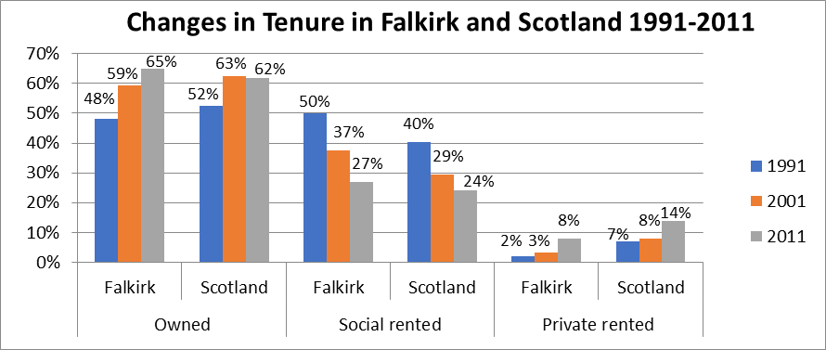

Source: 1991, 2001 & 2011 Census

### **Stock by House Type**

Table 3.3 shows stock profile of the Falkirk area by house type and tenure and is taken from the 2011 Census. It highlights that houses make up the majority of properties at 70% of the total stock in the Falkirk Flats make up the remaining 30% of the stock which is lower than the national average of 37%. There are significant differences between the different tenures with The owner occupied sector having significantly less flats at 16% compared to 56% for social rented and 57% for private rented. There are very few detached properties in the social rented sector at 2% compared to 31% in the owner occupied sector and 11% in the private rented sector.

#### **Table 3.3: Stock by tenure and house type**

|  |  |  |  |  |  |  |  |
| --- | --- | --- | --- | --- | --- | --- | --- |
| **House Type** | **Owned No.** | **Owned %** | **Social Rented No.** | **Social Rented %** | **Private Rented No.** | **Private Rented %** | **Total** |
| Detached | 13,636 | 31% | 299 | 2% | 617 | 11% | 14,552 |
| Semi-detached | 13,912 | 31% | 3,386 | 18% | 890 | 16% | 18,188 |
| Terraced | 9,755 | 22% | 4,576 | 25% | 913 | 16% | 15,244 |
| Flat/Other | 7,179 | 16% | 10,334 | 56% | 3,235 | 57% | 20,748 |
| **Total** | **44,482** | **100%** | **18,595** | **100%** | **5,655** | **100%** | **68,732** |

Source: 2011 Census, Table DC4406SC

As shown in Table 3.4, there are differences between the different housing submarket areas with 52% of stock in Grangemouth being flats and 46% in Falkirk but only 17% in Braes and Rural South. There are a higher number of semi-detached properties in the Falkirk Council area, 26% compared to 22% nationally. Again, there are differences between the different areas with the lowest number in Grangemouth at 16% and the highest in Stenhousemuir, Larbert and Rural North and Braes and Rural South at 33%. In terms of detached properties, the same high numbers are seen in Stenhousemuir, Larbert and Rural North and Braes and Rural South at 30% and 32% respectively and the lowest numbers in Grangemouth at 6%.

#### **Table 3.4: Stock by house type and Housing Sub Market Area**

|  |  |  |  |  |
| --- | --- | --- | --- | --- |
| **Area** | **Detached** | **Semi-detached** | **Terraced** | **Flat & Other** |
| Bo'ness | 20% | 29% | 26% | 25% |
| Denny and Bonnybridge | 23% | 28% | 29% | 19% |
| Falkirk | 14% | 21% | 18% | 46% |
| Grangemouth | 6% | 16% | 27% | 52% |
| Stenhousemuir, Larbert and Rural North | 30% | 33% | 19% | 18% |
| Braes and Rural South | 32% | 33% | 18% | 17% |
| **Falkirk Total** | **21%** | **26%** | **22%** | **30%** |
| **Scotland Total** | **22%** | **22%** | **19%** | **37%** |

More up to date information is available from NRS small area statistics on the property types in the Falkirk area. This information is taken from the assessor’s portal and is produced by NRS. This information is from 2017 as information on property type is not available in future years. Table 3.5 shows that 30% of the housing stock in Falkirk is flatted accommodation which is the same as the census information. Detached and semi-detached houses make up 42% of the stock compared to 47% in the census and terraced houses now make up 24% of the stock compared to 22% in the census. There are just over 3,000 properties where the property type is unknown which may explain the differences in the stock figures.

#### **Table 3.5: Number of properties in Falkirk by house type**

|  |  |  |
| --- | --- | --- |
| **House Type** | **No.** | **%** |
| Detached | 14,424 | 19% |
| Semi-detached | 17,013 | 23% |
| Terraced | 17,647 | 24% |
| Flat | 22,239 | 30% |
| Unknown | 3,135 | 4% |
| **Total** | **74,458** | **100%** |

Source: NRS Dwelling estimates and characteristics of dwellings, by 2011 Data Zone, 2017

### **Stock by Size**

Table 3.6 shows the size of dwellings in the area by tenure with information from the 2011 Census. The definition of a room does not include bathrooms, toilets, halls or landings, or rooms that can only be used for storage. All other rooms, for example kitchens, living rooms, bedrooms, utility rooms, studies and conservatories are counted within the census definition. In terms of the differences between the number of rooms, the owner-occupied sector has considerably more properties with 5+ rooms compared to both the social rented and private rented sector. This compares to the private rented and social rented sector where the majority of properties have 4 rooms or less.

#### **Table 3.6: Stock by Tenure and number of rooms**

|  |  |  |  |  |  |  |
| --- | --- | --- | --- | --- | --- | --- |
|  | **Owned No.** | **Owned %** | **Social Rented No.** | **Social Rented%** | **Private Rented No.** | **Private Rented %** |
| 1-2 rooms | 495 | 1% | 882 | 5% | 390 | 7% |
| 3 rooms | 1,940 | 4% | 3,746 | 20% | 994 | 18% |
| 4 rooms | 10,287 | 23% | 8,368 | 45% | 2,438 | 43% |
| 5 rooms | 13,446 | 30% | 4,667 | 25% | 1,077 | 19% |
| 6 rooms | 7,530 | 17% | 690 | 4% | 369 | 7% |
| 7+ rooms | 10,784 | 24% | 242 | 1% | 387 | 7% |
| **Total** | **44,482** | **100%** | **18,595** | **100%** | **5,655** | **100%** |

Source: 2011 Census Table DC4404

Table 3.7 highlights that like Scotland as a whole, the majority of properties have four rooms. There are slightly more properties with 5 rooms and 3 rooms in the Falkirk Council area compared to that nationally. In terms of the housing submarket areas, the Grangemouth area has less dwellings with 6 or more rooms which reflects the main house type in the area which is flats. Conversely areas such as Braes and Rural South and Stenhousemuir, Larbert and Rural North have more dwellings with 6 or more rooms as they have a higher number of detached and semi-detached properties.

#### **Table 3.7: Stock by Number of Rooms and Housing Submarket Area**

|  |  |  |  |  |  |  |
| --- | --- | --- | --- | --- | --- | --- |
| Sub Area | 1-2 Rooms | 3 rooms | 4 rooms | 5 rooms | 6 rooms | 7+ Rooms |
| Bo'ness | 3% | 10% | 30% | 31% | 13% | 14% |
| Denny & Bonnybridge | 2% | 7% | 27% | 33% | 13% | 17% |
| Falkirk | 3% | 14% | 36% | 24% | 10% | 13% |
| Grangemouth | 3% | 13% | 42% | 26% | 9% | 7% |
| Braes & Rural South | 2% | 6% | 25% | 28% | 16% | 24% |
| Stenhousemuir Larbert & Rural North | 2% | 7% | 24% | 29% | 15% | 24% |
| Falkirk Total | **3%** | **10%** | **31%** | **28%** | **12%** | **17%** |
| Scotland | **4%** | **13%** | **29%** | **24%** | **12%** | **17%** |

Source: 2011 Census, Table QS407SC

More recent information on the number of rooms that properties have in the area has been taken from the assessor’s portal and is produced by NRS. Information on the number of rooms is only available up until 2017. In the Assessors’ Portal, rooms are defined as the number of habitable rooms (usually bedrooms and living rooms). This is different to the census definition, which includes kitchens. Table 3.8 shows that the majority of properties had 3 rooms at 36% and then 4 rooms at 31%.

#### **Table 3.8: Number of properties in Falkirk by number of rooms**

|  |  |  |
| --- | --- | --- |
| Number of Rooms | No. | % |
| 1 room | 505 | 1% |
| 2 rooms | 6,560 | 9% |
| 3 rooms | 26,551 | 36% |
| 4 rooms | 23,392 | 31% |
| 5 rooms | 7,568 | 10% |
| 6 rooms | 4,342 | 6% |
| 7+ rooms | 2,351 | 3% |
| Unknown | 3,189 | 4% |
| Total | **74,458** | **100%** |

Source: NRS Dwelling estimates and characteristics of dwellings, by 2011 Data Zone, 2017

### **Stock by Age**

Using information on age of properties from the SHCS and stock information from NRS, Table 3.9 shows that an estimated 58,375 (78%) properties were built post 1945, above the national average of 70%.

#### **Table 3.9: Stock by age**

|  |  |  |  |  |
| --- | --- | --- | --- | --- |
| **Area** | **Pre 1945**  **%** | **Pre 1945**  **No.** | **Post 1945**  **%** | **Post 1945**  **No.** |
| **Falkirk** | 22.4% | 16,851 | 77.6% | 58,375 |
| **Scotland** | 30.4% | 801,609 | 69.6% | 1,835,262 |

Source: 2017-2019 Scottish House Conditions Survey, NRS Estimates of Households and Dwellings in Scotland, 2019

The age of social rented stock is available from the Scottish Housing Regulator and Table 3.10 shows Council and RSL stock broken down by age. It highlights that the majority of council stock is post war housing at 42%. The majority of RSL stock is post 1982 at 48% compared to only 4% of council stock.

#### **Table 3.10: Council and RSL stock by age of stock**

|  |  |  |  |  |
| --- | --- | --- | --- | --- |
| **Stock Age** | **Falkirk Council No.** | **Falkirk Council %** | **RSL Stock No.** | **RSL Stock %** |
| Pre-1919 | 174 | 1% | 266 | 7% |
| 1919-1944 | 4,677 | 28% | 36 | 1% |
| 1945-1964 | 7,008 | 42% | 734 | 20% |
| 1965-1982 | 4,168 | 25% | 860 | 24% |
| Post-1982 | 609 | 4% | 1,748 | 48% |
| **Total** | **16,636** | **100%** | **3,644** | **100%** |

Source: Scottish Housing Regulator, Stock data all social landlord’s complete dataset 2020-2021

Age of stock is an important indicator of energy-efficiency as older properties are less energy efficient than newly constructed properties and are more likely to be in poorer condition. There is no up to date information available on the age of owner occupied and private rented properties in the area. The only information available is from 2009 and is from the Council’s all tenure house conditions survey. The percentages in Chart 3.3 are indicative rather than precise due to information being so old. It shows that in Falkirk 60% of owner occupied properties were built from 1965+ and 11% are pre 1919. The private rented sector has the highest percentage of pre 1919 properties at 27% but also has a high percentage of post 1982 properties at 36%. Only 3% of Council stock was built pre 1919 but 37% was built between 1919-1944.

#### Chart 3.3: Age of stock

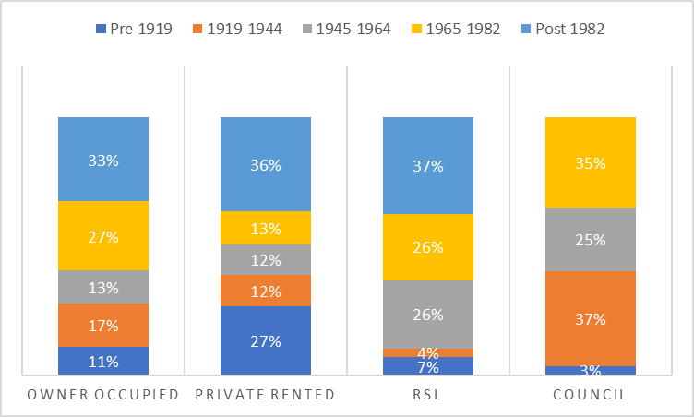

Source: Falkirk Council All Tenure House Conditions Survey 2009

Table 3.11 shows the stock information from the house conditions survey in 2009 broken down by age and housing sub market area. It highlights that only 10% of the overall stock is pre 1919 but the Falkirk area has a higher percentage at 15% and Bo’ness at 12%. The Grangemouth area has a higher than average percentage of stock built in the 1919-1944 and 1945-1964 and a much lower percentage built post 1982. Stenhousemuir, Larbert and Rural North has a higher than average number of properties built post 1982 as does Denny and Bonnybridge.

#### **Table 3.11: Stock by Age and Housing Sub Market Area**

|  |  |  |  |  |  |
| --- | --- | --- | --- | --- | --- |
|  | Pre 1919 | 1919-1944 | 1945-1964 | 1965-1982 | Post 1982 |
| Bo'ness | 12% | 23% | 15% | 34% | 16% |
| Denny & Bonnybridge | 8% | 20% | 15% | 25% | 33% |
| Falkirk | 15% | 20% | 14% | 28% | 24% |
| Grangemouth | 6% | 29% | 34% | 21% | 10% |
| Braes and Rural South | 8% | 20% | 11% | 34% | 27% |
| Stenhousemuir, Larbert & Rural North | 7% | 15% | 13% | 27% | 38% |
| Total | **10%** | **21%** | **16%** | **28%** | **25%** |

Source: Falkirk Council All Tenure House Conditions Survey 2009

### **Social Rented Stock**

As of April 2021, there were 20,276 social rented properties in the Council area, as shown in Table 3.12. The majority of the social rented stock in the area is general needs housing at 16,826 (83%) properties. There are 2,000 (9.9%) properties that are ambulant disabled. These are properties for people with mobility issues but who don’t use a wheelchair all the time.

The Council owns the majority of stock at 82% of the total. The table also shows the RSLs operating in the Falkirk area and the stock for each provider. It highlights that there are thirteen in total with four only providing general needs housing and the other nine providing a mix of general needs and supported or specialist housing. The main providers are Weslo, Link and Paragon housing association who altogether own 76% of the RSL stock. Weslo completed a successful tenant ballot regarding the transfer of engagement to Link.  From June 2021 Weslo will be part of the Link Group.

#### **Table 3.12: Social rented stock by provider and type of provision**

|  |  |  |  |  |  |  |  |  |
| --- | --- | --- | --- | --- | --- | --- | --- | --- |
| **Landlord name** | **General Needs** | **Sheltered** | **Very**  **Sheltered** | **Amenity** | **Wheel chair** | **Ambulant disabled** | **Other[9]** | **Total** |
| Ark HA Ltd | 1 | 0 | 0 | 0 | 0 | 0 | 0 | 1 |
| Bield House  & Care | 3 | 0 | 0 | 0 | 1 | 0 | 151 | 155 |
| Blackwood | 0 | 0 | 0 | 14 | 15 | 8 | 0 | 37 |
| Cairn HA Ltd | 11 | 0 | 0 | 44 | 0 | 0 | 0 | 55 |
| Castle Rock  Ed HA | 95 | 0 | 0 | 0 | 0 | 0 | 0 | 95 |
| Falkirk Council | 13,877 | 205 | 27 | 401 | 189 | 1,937 | 0 | 16,636 |
| Hanover HA | 13 | 136 | 0 | 47 | 0 | 0 | 0 | 196 |
| Horizon HA | 40 | 0 | 0 | 0 | 30 | 19 | 0 | 89 |
| Key HA | 51 | 0 | 0 | 0 | 8 | 12 | 0 | 71 |
| Kingdom HA | 41 | 0 | 0 | 4 | 2 | 0 | 1 | 48 |
| Link Group | 1,233 | 0 | 0 | 0 | 13 | 24 | 152 | 1,422 |
| Loretto HA | 130 | 0 | 0 | 0 | 0 | 0 | 0 | 130 |
| Paragon HA | 858 | 0 | 0 | 0 | 0 | 0 | 0 | 858 |
| Weslo HM | 473 | 0 | 0 | 0 | 0 | 0 | 0 | 473 |
| **Total** | **16,826** | **341** | **27** | **510** | **258** | **2,000** | **304** | **20,266** |
| **%** | **83.0%** | **1.7%** | **0.1%** | **2.5%** | **1.3%** | **9.9%** | **1.5%** | **100%** |

Source: Scottish Housing Regulator, Stock data all social landlord’s complete dataset 2020-2021

The majority of the social rented stock is made up of houses at 42% of all the stock and then tenemental and 4-in-a-block flats at 20% of the stock as shown in Table 3.13.

#### **Table 3.13: Social rented stock in Falkirk by house type**

|  |  |  |
| --- | --- | --- |
| **House Type** | **No.** | **%** |
| House | 8,484 | 42% |
| High rise | 979 | 5% |
| Tenement | 4,137 | 20% |
| 4 in a block | 4,009 | 20% |
| Other flat | 2,667 | 13% |
| **Total** | **20,276** | **100%** |

Source: Scottish Housing Regulator, Stock data all social landlord’s complete dataset 2020-2021

When the size of properties in the social rented sector is looked at in detail in Table 3.14, it shows that 51% of the stock is made up of 2-bedroom properties, 20% is 1 bedroom and 26% are 3 bedrooms. It also highlights the small number of 4+ bedroom properties with only 562 in total in the social rented sector.

#### **Table 3.14: Social rented stock in Falkirk by bedroom size**

|  |  |  |
| --- | --- | --- |
| House Size | No. | % |
| Studio | 144 | 1% |
| 1 bed | 3,994 | 20% |
| 2 bed | 10,388 | 51% |
| 3 bed | 5,188 | 26% |
| 4+ bed | 562 | 3% |
| Total | **20,276** | **100%** |

Source: Scottish Housing Regulator, Stock data all social landlord’s complete dataset 2020-2021

### **Private Rented Stock by Housing Sub-Market Area**

Table 3.15 shows that there are 6,684 landlord registered properties in the Falkirk council area in August 2021. The majority are located in the Falkirk housing submarket area at 41%. The majority of landlords only have one property at 75% of the landlords registered. When this is compared to information from the landlord register for the last HNDA, there has been an increase of 1% in registered properties.

#### **Table 3.15: Number of landlord registered properties by Housing Submarket Area, August 2021**

|  |  |  |
| --- | --- | --- |
| **Area** | **No** | **%** |
| Bo'ness | 656 | 10% |
| Braes & Rural South | 754 | 11% |
| Denny & Bonnybridge | 838 | 13% |
| Falkirk | 2,729 | 41% |
| Grangemouth | 741 | 11% |
| Stenhousemuir, Larbert & Rural North | 966 | 14% |
| **Total** | **6,684** | **100%** |

Source**:** Landlord Register, August 2021

### **Short Term Lets**

Research on the use of short term lets in Scotland found that the number increased dramatically from 2016[10]. This increase brought financial benefits to hosts and economic benefits, but it has reduced the availability of residential accommodation and impacted on the quality of life of other residents. In terms of Falkirk, the research found that it had one of the lowest number of listings in May 2019 at 113 in total which was 0.35% of the total for Scotland as is shown in Table 3.16.

#### **Table 3.16: Short term let listings for Falkirk in May 2019**

|  |  |  |  |  |  |
| --- | --- | --- | --- | --- | --- |
| Council Area | Entire home/apt | Private room | Shared room | Total  (May 2019) | % Of Total |
| Falkirk | 71 | 42 | 0 | 113 | 0.35 |

Source: Research into the impact of short-term lets on communities across Scotland, Scottish Government, 2019

Under new legislation, all local authorities will be required to establish a short-term let licensing scheme by October 2022. Existing hosts and operators will have until 1 April 2023 to apply for a licence for each property that they operate as a short-term let. This may have an impact on the number of short term lets in Falkirk in the future with owners reverting back to long term renting.

### **Houses in Multiple Occupancy (HMO)**

HMOs exist in the private rented sector and can play a role in accommodating household types such as young working people, students, lower income households, economic migrants and those who are at risk of homelessness. The number of houses in multiple occupancy in Falkirk as of 31st March each year is shown below highlighting numbers falling steadily over the last 10 years with a 49% fall in total.

When the data is looked at for 2019 there are only 4 flats or houses with an HMO license and the rest are sheltered housing or hostel accommodation. A reduction in the number of HMOs reduces the housing options of young people and people on lower incomes looking for accommodation.

#### **Table 3.17: Number of HMO Licenses at the end of March 2010-2019**

|  |  |
| --- | --- |
|  | **Falkirk** |
| 2010 | 41 |
| 2011 | 43 |
| 2012 | 40 |
| 2013 | 35 |
| 2014 | 34 |
| 2015 | 34 |
| 2016 | 29 |
| 2017 | 26 |
| 2018 | 29 |
| 2019 | 21 |

Source: Scottish Government Housing Statistics Annual Return of HMO, 2019

**Stock Conditions**

Information on stock condition by tenure is available from the Scottish House Conditions Survey. The Scottish House Condition Survey (SHCS) is the single largest housing research project in Scotland, and the only national survey to look at the physical condition of Scotland's homes as well as the experiences of householders. The Falkirk Council Analysis used in this paper is an average of the period 2017-2019. It should be noted that this information is based on a small sample, for Falkirk it is based on a survey of 166 households.

**Dwelling Characteristics**

A summary of the age, house type and house size of housing stock in Falkirk is summarised in Table 3.18. It highlights that stock profile in Falkirk is different from Scotland as a whole. The majority of Falkirk stock was built post 1945 at 78% compared to 70% for Scotland. Falkirk also has a lower number of flats and a higher number of 3+ bedroom properties.

#### **Table 3.18: Summary of dwelling characteristics: Age, size and house type**

|  |  |  |  |  |  |  |
| --- | --- | --- | --- | --- | --- | --- |
| **Area** | **Pre 1945** | **Post 1945** | **House** | **Flat** | **1 or 2 bedrooms** | **3 or more bedrooms** |
| Falkirk | 22% | 78% | 72% | 28% | 42% | 58% |
| Scotland | 30% | 70% | 64% | 36% | 50% | 50% |

Source: 2017-2019 Scottish House Conditions Survey

**Disrepair and Below Tolerable Standard Housing**

Table 3.19 shows property condition by tenure in Falkirk and Scotland as a whole. There is information missing for the Falkirk area with regards to Below Tolerable Standard (BTS) as the sample is so small that the estimate is not reliable. It does though give an indication of BTS properties for all the stock in the Falkirk area which is 2% or 1,440 properties. This is the same as the national average. This is an increase on the last HNDA which used the 2011/13 SHCS where for the overall stock it was 1%.

In terms of any disrepair in Falkirk this is at 73% for all stock which is slightly higher than Scotland as a whole at 71%. This is a 7% fall from the last HNDA when it was 80%. Disrepair is more prevalent in the social rented sector in Falkirk at 92% compared to 76% in Scotland.

In terms of urgent disrepair in the Falkirk area, Table 3.19 shows that for the overall stock the percentage is higher at 40% compared to 28% for Scotland. When this is broken down by tenure it shows that the percentage of urgent disrepair in the social rented stock is higher in Falkirk at 48% than the national average of 26% and also in owner occupier stock at 35% compared to 26% nationally.

When urgent disrepair for this HNDA is compared to the findings of the last HNDA which used the 2011-13 SHCS, there has been an increase of 3% in urgent disrepair in all stock in Falkirk. In terms of tenure, urgent disrepair in owner occupied properties has stayed the same at 35% but social housing has seen an increase in urgent disrepair of 10% since the last HNDA. The sample size for the private rented sector was also too small in 2011/13. Falkirk has one of the highest percentages of properties with urgent disrepair in all its stock, only two other authorities in Scotland have a higher percentage.

In terms of any urgent disrepair to critical elements, the Falkirk average for all stock is higher at 34% than the national average of 20%. When it is broken down by tenure, the percentage of urgent disrepair to critical elements in the social rented stock is significantly higher in Falkirk at 42% compared to 20% nationally and also higher in the owner-occupied stock at 29% compared to 18% nationally.

When the findings for urgent disrepair to critical elements is compared to the last HNDA which used the 2011/13 SHCS, there has been a fall from 58% of all stock to 34% of all stock. When tenure is looked at, disrepair to critical elements in owner occupied stock has fallen by 20% and by 31% in social rented stock. The sample size for the private rented sector was also too small in 2011/13. Falkirk has one of the highest percentages of properties with urgent disrepair to critical elements in all its stock, only two other authorities in Scotland have a higher percentage.

#### **Table 3.19: BTS, Any, Urgent and Extensive Disrepair and Urgent Disrepair to Critical Element in Falkirk Compared to Scotland by Tenure**

|  |  |  |  |  |  |
| --- | --- | --- | --- | --- | --- |
| **Key Condition Indicators** | **BTS** | **Any Disrepair** | **Urgent Disrepair** | **Any Urgent Disrepair to Critical Elements** | **Extensive Disrepair** |
| Owner Occupier Falkirk | * | 63% | 35% | 29% | 7% |
| Owner Occupier Scotland | 1% | 67% | 26% | 18% | 5% |
| Social Housing Falkirk | * | 92% | 48% | 42% | 4% |
| Social Housing Scotland | 1% | 76% | 29% | 20% | 6% |
| Private Rented Falkirk | * | * | * | * | * |
| Private Rented Scotland | 3% | 80% | 38% | 30% | 9% |
| All Stock Falkirk | 2% | 73% | 40% | 34% | 7% |
| All Stock Scotland | 2% | 71% | 28% | 20% | 6% |

Source: Scottish House Conditions Survey 2017-2019, * sample size too small to give a reliable estimate

Table 3.20 highlights house conditions by age of dwelling and also by house type. It highlights that flat rather than houses are more likely to be in disrepair. The difficulty in arranging common repairs in mixed tenure blocks could be a factor in this, as it remains difficult for the local authority and our RSL partners and private owners to arrange common works when there is no majority agreement to proceed. Older stock is also more likely to be in disrepair than post 1945 stock. For all the indicators of disrepair, properties in Falkirk are estimated to have more disrepair than properties in Scotland as a whole.

#### **Table 3.20: BTS, Any, Urgent and Extensive Disrepair and Urgent Disrepair to Critical Element in Falkirk compared to Scotland by Age of Dwelling and House Type**

|  |  |  |  |  |  |
| --- | --- | --- | --- | --- | --- |
|  | **BTS** | **Any Disrepair** | **Urgent Disrepair** | **Any Urgent Disrepair to Critical Elements** | **Extensive Disrepair** |
| Pre 1945 Falkirk | 9% | 88% | 53% | 50% | 14% |
| Pre 1945 Scotland | 3% | 84% | 38% | 29% | 8% |
| Post 1945 Falkirk | 0% | 69% | 37% | 30% | 5% |
| Post 1945 Scotland | 1% | 65% | 24% | 16% | 5% |
| Flat Falkirk | 5% | 84% | 38% | 31% | 5% |
| Flat Scotland | 1% | 78% | 25% | 18% | 5% |
| House Falkirk | * | 69% | 48% | 44% | 12% |
| House Falkirk | 2% | 66% | 34% | 24% | 8% |
| All Stock Falkirk | 2% | 73% | 40% | 34% | 7% |
| All Stock Scotland | 2% | 71% | 28% | 20% | 6% |

Source: Scottish House Conditions Survey 2017-2019, * sample size too small to give a reliable estimate

#### **Table 3.21: BTS, Any, Urgent and Extensive Disrepair and Urgent Disrepair to Critical Element in Falkirk compared to Scotland by Household Type**

|  |  |  |  |  |  |
| --- | --- | --- | --- | --- | --- |
|  | **BTS** | **Any Disrepair** | **Urgent Disrepair** | **Any Urgent Disrepair to Critical Elements** | **Extensive Disrepair** |
| Older Households Falkirk | * | 73% | 37% | 29% | 5% |
| Older Households Scotland | 1% | 65% | 25% | 18% | 3% |
| Families Falkirk | * | 65% | 39% | 33% | * |
| Families Scotland | 1% | 71% | 29% | 19% | 7% |
| Other Households Falkirk | 3% | 79% | 45% | 33% | 12% |
| Other Households Scotland | 2% | 74% | 31% | 22% | 7% |
| All Stock Falkirk | 2% | 73% | 40% | 34% | 7% |
| All Stock Scotland | 2% | 71% | 28% | 20% | 6% |

Source: Scottish House Conditions Survey 2017-2019, * sample size too small to give a reliable estimate

**Stock Failing Scottish Housing Quality Standard**

Table 3.22 shows the percentage of stock failing Scottish Housing Quality Standard (SHQS) by age of property, property type and tenure and compares Falkirk to Scotland as a whole. It highlights that 36% of all the stock in Falkirk failed to meet SHQS compared to 41% nationally. There is a higher percentage of Pre 1945 Falkirk stock failing to meet SHQS at 60% compared to 52% nationally whereas 29% of Falkirk Post 1945 stock failed to meet SHQS compared to 37% nationally. When stock failing SHQS by property type is looked at for Falkirk, flats (55%) are more likely to fail rather than houses (28%) and this is also true for Scotland as a whole.

When the amount of stock failing to meet SHQS is broken down by tenure it highlights that less owner-occupied stock in Falkirk failed to meet SHQS at 30% compared to 41% nationally but 41% of social rented stock failed to meet SHQS in Falkirk compared to 38% nationally.

When the percentage of stock failing the SHQS is compared to the last HNDA which used the 2011/13 SHCS, the amount of overall stock failing has fallen from 44% to 36%. When tenure is looked at, the amount of owner-occupied stock failing has fallen from 42% to 30% and social rented housing has fallen from 52% to 41%.

#### **Table 3.22: Percentage of Stock Failing the overall SHQS.**

|  |  |  |  |  |
| --- | --- | --- | --- | --- |
|  | **Falkirk**  **No.** | **Falkirk**  **%** | **Scotland**  **No.** | **Scotland**  **%** |
| % of LA | 26,000 | 36 | 1,027,000 | 41 |
| Pre-1945 | 10,000 | 60 | 390,000 | 52 |
| Post 1945 | 16,000 | 29 | 637,000 | 37 |
| Flats | 11,000 | 55 | 402,000 | 45 |
| Houses | 15,000 | 28 | 625,000 | 39 |
| Owner-occupied | 14,000 | 30 | 625,000 | 41 |
| Social Housing | 8,000 | 41 | 241,000 | 38 |
| Private Rented | * | * | 161,000 | 52 |

Source: Scottish House Conditions 2017-2019, * The sample in Falkirk is too small for a reliable estimate

The Scottish Housing Regulator (SHR) is responsible for monitoring compliance of the social housing sector with the SHQS. Table 3.23 shows information on Council and RSL stock in the area and whether the stock meets SHQS. The stock figures are from the Scottish Housing Regulator from October 2019 and the SHQS statistics from the 2019/2020 return so may not match up. The table shows that 98% of the social rented stock in the area does meet SHQS. The stock that doesn’t meet SHQS is mainly due to abeyances or exemptions and work is ongoing to improve these remaining properties. There are also a significant number of abeyances due to non-participation by private owners, where the Council is not in the majority.

This is in stark contrast to the non-compliance reported through the Scottish House Condition Survey, which is 41%. There are some differences between the SHR and the SHCS in the way data for assessing the standard is collected and reported which make the headline rates not immediately comparable. Abeyances and exemptions are not taken into account by the SHCS as it is not feasible to collect this kind of information in the survey. In addition, despite the high quality of the physical survey, there are challenges in detecting the presence of cavity wall insulation in all cases.

Given the information published by the Scottish Housing Regulator is based on detailed inspection regimes by landlords, the quality of this information is likely to be far greater than the data reported through the SHCS which has in comparison a low sample size.

#### **Table 3.23: Social rented Stock by Provider Meeting SHQS**

|  |  |  |  |
| --- | --- | --- | --- |
| **Landlord name** | **Stock as at Oct 2019** | **Stock meeting the SHQS (at end of the reporting year, March 2020)** | **% Meeting SHQS** |
| Falkirk Council | 16,404 | 16143 | 98% |
| Ark Housing Association Ltd | 1 | 1 | 100% |
| Barony Housing Association Ltd | 1 | 0 | 0% |
| Bield Housing & Care | 155 | 154 | 99% |
| Blackwood Homes and Care | 37 | 37 | 100% |
| Cairn Housing Association Ltd | 56 | 54 | 96% |
| Castle Rock Edinvar Housing Association Ltd | 70 | 84 | 120% |
| Hanover (Scotland) Housing Association Ltd | 196 | 196 | 100% |
| Horizon Housing Association Ltd | 89 | 89 | 100% |
| Key Housing Association Ltd | 71 | 71 | 100% |
| Kingdom Housing Association Ltd | 48 | 48 | 100% |
| Link Group Ltd | 1,418 | 1,423 | 100% |
| Loretto Housing Association Ltd | 131 | 131 | 100% |
| Paragon Housing Association Ltd | 847 | 727 | 86% |
| Weslo Housing Management | 473 | 434 | 92% |
| **Total** | **19,997** | **19,592** | **98%** |

Source: Scottish Housing Regulator, Stock data all social landlord’s complete dataset 2020-2021, Charter return 2019-2020

### **Stock Pressures**

This section will identify where stock is pressured and where stock is in low demand. Both overcrowded and concealed households are considered likely to generate a need for additional housing as they are unlikely to be counted within the household projections and will not release a home for use by another household when they move on.

### **Occupancy**

Occupancy rating indicates whether a household’s accommodation is overcrowded or under-occupied by comparing the actual number of rooms available to the household based on the number of rooms required. In the section which follows, we will mainly use census data to provide an illustration of under-occupancy and overcrowding in Falkirk.

### **Stock by Occupied and Unoccupied Properties**

Table 3.24 shows information from the 2011 Census on the number of household spaces broken down by those that are occupied and those that are vacant and those classified as second homes. 1,694 properties or 2.4% of the total stock is classified as vacant, with the majority of vacant stock to be found in the Falkirk area at 3.1% and then Grangemouth at 2.9%. There are 383 properties classified as second homes at 0.5% of the total stock. The majority of second homes are found in Falkirk at 1.4% of the stock in that area. In comparison to the Scotland as a whole there is a higher percentage of occupied stock in Falkirk and a lower percentage of second homes.

#### **Table 3.24: Occupied, Second Homes and Vacant stock.**

|  |  |  |  |
| --- | --- | --- | --- |
| **Area** | **Occupied household spaces  %** | **Unoccupied household spaces: Second home/ holiday accomm %** | **Unoccupied household spaces:  Vacant %** |
| Bo'ness | 98.10% | 0.20% | 1.60% |
| Denny & Bonnybridge | 97.20% | 0.50% | 2.30% |
| Falkirk | 95.60% | 1.40% | 3.10% |
| Grangemouth | 96.90% | 0.20% | 2.90% |
| Stenhousemuir Larbert & Rural North | 98.10% | 0.20% | 1.80% |
| Polmont & Rural South | 97.90% | 0.10% | 2.10% |
| Falkirk Total | 97.10% | 0.50% | 2.40% |
| Scotland Total | 95.90% | 1.50% | 2.60% |

Source: 2011 Census, Table QS417SC

More up to date information on occupied and vacant stock is shown in Table 3.25. It highlights that the percentage of occupied dwellings is almost the same as the 2011 census figures at 97.5%, albeit slightly higher. The percentage of vacant dwellings is the same at 2.4% and the percentage of second homes has decreased to 0.1% compared to 0.5% in the census. When these figures are compared to Scotland, Falkirk has a higher percentage of occupied dwellings and lower percentage of vacant dwellings and second homes.

#### **Table 3.25: Occupied, Vacant and Second Home Stock**

|  |  |  |  |  |
| --- | --- | --- | --- | --- |
| **Dwelling Type** | **Falkirk No.** | **Falkirk**  **%** | **Scotland No.** | **Scotland**  **%** |
| Occupied dwellings | 73,356 | 97.5% | 2,527,761 | 95.9% |
| Vacant dwellings | 1,783 | 2.4% | 84,632 | 3.2% |
| Second homes | 87 | 0.1% | 24,478 | 0.9% |
| **Total** | **75,226** | **100%** | **2,636,871** | **100%** |

Source: Council Tax base return 2019; National Records of Scotland 2019 neighbourhood level collection of council tax information

### **Underoccupancy**

Table 3.26 shows information from the 2011 Census and highlights that 22% of households in Falkirk meets the basic standard in terms of occupancy, compared to 25% nationally. There are differences between the different housing submarket areas with a higher percentage in Falkirk (26%) and Grangemouth (28%) meeting the basic standard and a lower percentage in Braes & Rural South and Stenhousemuir, Larbert and Rural North at 17%.

It also highlights that 32% of households in Falkirk are under occupying by 1 room compared to 28% nationally and 40% are under occupying by two rooms compared to 38% nationally. In terms of households under occupying by more than two rooms, the highest percentages can be found in the Braes and Rural South (51%) and Stenhousemuir, Larbert and Rural North (50%).

#### **Table 3.26: Occupancy and Under-Occupancy by Housing Submarket Area**

|  |  |  |  |
| --- | --- | --- | --- |
| **Sub Area** | **Meets the Basic Standard  %** | **1 room more than basic standard  %** | **2 or more rooms than basic Standard %** |
| Bo'ness | 22% | 31% | 40% |
| Denny & Bonnybridge | 20% | 32% | 43% |
| Falkirk | 26% | 34% | 33% |
| Grangemouth | 28% | 38% | 27% |
| Stenhousemuir Larbert & Rural North | 17% | 28% | 50% |
| Braes & Rural South | 17% | 27% | 51% |
| **Falkirk Area** | **22%** | **32%** | **40%** |
| **Scotland** | **25%** | **28%** | **38%** |

Source: 2011 Census, Table QS408SC

Information on under occupancy from the SHCS shown in Table 3.27 highlights that 41% of households in the area are exceeding the minimum bedroom standard requirement by two or more bedrooms, this compares to 32% nationally. Underoccupancy is more prevalent in owner occupied households and older and other households in Falkirk.

#### **Table 3.27: Under-Occupancy by Tenure and Household Type**

|  |  |  |  |  |
| --- | --- | --- | --- | --- |
| **Tenure Type** | **Falkirk**  **No.** | **Falkirk**  **%** | **Scotland**  **No.** | **Scotland**  **%** |
| % of LA | 30,000 | 41 | 795,000 | 32 |
| Owner-occupied | 27,000 | 57 | 705,000 | 46 |
| Social Housing | 2,000 | 11 | 52,000 | 8 |
| Private Rented | * | * | 38,000 | 12 |
| Older Households | 12,000 | 44 | 349,000 | 44 |
| Families | 5,000 | 26 | 107,000 | 18 |
| Other Households | 13,000 | 48 | 339,000 | 31 |

Source: SHCS 2017-2019,

Many households choose to live in a property with more bedrooms than is required. Underoccupancy becomes an issue when demand for larger properties exceeds supply. This is certainly true in Falkirk’s social rented sector where there is an acute need for larger 4- and 5-bedroom properties. The council changed their allocation policy in October 2020 to give a Band 1 for tenants that are under-occupying, this is the same banding as overcrowding. Band 1 will now be applied where a person is under-occupying by two or more bedrooms. This is to encourage tenants to downsize to smaller properties.

### **Overcrowding**

Overcrowding relates to both affordability and quality of housing. There are marked inequalities in overcrowding (and in fact, it is one of the variables that comprise the Scottish Index of Multiple Deprivation). It can affect physical health, mental health and educational outcomes through several interrelated routes.

Table 3.28 shows information on whether a household is overcrowded from the 2011 Census and highlights that the percentage of households overcrowded by one bedroom is 4.9% compared to 7.11% nationally. Within the Falkirk area, Falkirk has the highest percentage of households at 6.1% lacking one bedroom. The percentage of households overcrowded by two or more bedrooms is 1.3% in Falkirk compared to 1.9% in Scotland as a whole. The Denny and Bonnybridge area at 1.5% has a slightly higher percentage of households overcrowded by two or more bedrooms.

#### **Table 3.28: Overcrowding by Housing Submarket Area**

|  |  |  |
| --- | --- | --- |
| **Sub Area** | **1 room less than the basic standard  %** | **At least 2 rooms less than the basic standard  %** |
| Bo'ness | 5.50% | 1.30% |
| Denny & Bonnybridge | 4.50% | 1.50% |
| Falkirk | 6.10% | 1.30% |
| Grangemouth | 5.40% | 1.40% |
| Stenhousemuir Larbert & Rural North | 4.00% | 1.10% |
| Braes & Rural South | 3.70% | 1.20% |
| **Falkirk Area** | **4.90%** | **1.30%** |
| **Scotland** | **7.11%** | **1.93%** |

Source: 2011 Census, Table QS408SC

The sample used for the SHCS 2017-19 survey is too small to give a reliable estimate for any of the categories for overcrowding in the Falkirk council area. The sample used was 251 households.

Bespoke analysis was undertaken by the Centre for Housing Market Analysis[11], utilising Scottish Household Survey data for the period 2016-2018 to try and identify the number of concealed and overcrowded households. This analysis identified 700 overcrowded households in the Falkirk area and 89 households that were both overcrowded and concealed. This figure is particularly important given its use in the calculation of existing need using the Government’s HoTOC method. This will be discussed in greater depth in Chapter 4 (“Estimating Future Need and Demand”).

### **Overcrowding Households on the Council’s Waiting List**

Information was taken from the Council’s waiting list to identify the number of people on the waiting list who are living in overcrowded accommodation. There are an estimated 958 applicants who are overcrowded with the majority of these being waiting list applicants at 588 (62%) and the rest existing tenants at 368 (38%). Table 3.29 shows the breakdown by housing submarket area and how many bedrooms they are lacking and highlights that the majority are lacking 1 bedroom at 90% of applicants. The majority of applicants that are overcrowded live in the Falkirk area at 29%.

#### **Table 3.29: Overcrowded households on the Council’s waiting list**

|  |  |  |  |  |  |
| --- | --- | --- | --- | --- | --- |
| **Area** | **Lack 1 bed** | **Lack 2 beds** | **Lack 2+ beds** | **Total No.** | **Total %** |
| Bo'ness | 75 | 4 |  | 79 | 8% |
| Braes & Rural South | 111 | 8 |  | 119 | 13% |
| Denny & Bonnybridge | 140 | 11 | 1 | 152 | 16% |
| Falkirk | 234 | 34 | 5 | 273 | 29% |
| Grangemouth | 101 | 10 |  | 111 | 12% |
| Stenhousemuir, Larbert & Rural North | 94 | 6 | 1 | 101 | 11% |
| Out with the Area | 95 | 15 | 4 | 114 | 12% |
| **Total** | **850** | **88** | **11** | **949** | **100%** |
| **%** | **90%** | **9%** | **1%** | **100%** |  |

Source: Falkirk Council Information Systems

### **Concealed Households**

The 2017-2019 SHCS does not have data on concealed households for the Falkirk area as the sample size was too small. However, there is data available from the 2011 Census. This defines a concealed household as a household with more than one family, but the concealed family does not include the Household Reference Person. The table below shows there are 471 concealed households in Falkirk, 1% of total households. The table also shows young people are the largest group living in concealed households with 10.2% of households found with a family reference person aged 24 and under.

#### **Table 3.30: Concealed Households**

|  |  |  |  |
| --- | --- | --- | --- |
|  | Concealed families | All families in households | % Of Total |
| Family Reference Person aged 24 and under | 153 | 1,502 | 10.2% |
| Family Reference Person aged 25 to 34 | 145 | 6,779 | 2.1% |
| Family Reference Person aged 35 to 49 | 57 | 16,444 | 0.3% |
| Family Reference Person aged 50 to 64 | 43 | 13,278 | 0.3% |
| Family Reference Person aged 65 to 74 | 44 | 5,160 | 0.9% |
| Family Reference Person aged 75 to 84 | 24 | 2,759 | 0.9% |
| Family Reference Person aged 85 and over | 5 | 519 | 1.0% |
| All families in households | **471** | **46,441** | 1.0% |

Source: 2011 Census, Table LC1110SCdz

The fact that young people are the largest group living in concealed households is further highlighted in Chart 3.4 This chart clearly illustrates that 63% of concealed households are aged 34 and under.

#### **Chart 3.4: Age Profile of Concealed Households**

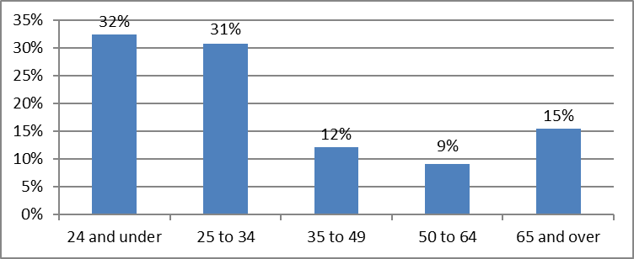

Source: 2011 Census, Table LC1110SCdz

### **Concealed Housholds on the Council’s Waiting list**

An exercise was undertaken in December 2021 to try and identify households that could be classed as concealed on the Council’s waiting list. This was undertaken by looking at the relationships codes within households on the waiting list. A estimated 17 concealed households were found by undertaking this exercise.

**Lets**

Table 3.31 provides a summary of the number of lets made between 2016 and 2021 by bedroom size. Two-bedroom properties make up the biggest proportion of lets for all year, followed by one-bedroom properties and then three. Table 3.27 highlights the small number of larger family homes that become available each year.

#### **Table 3.31: Number of lets by year and bedroom size.**

|  |  |  |  |  |  |  |
| --- | --- | --- | --- | --- | --- | --- |
| **Year** | **Bedsit** | **1 Bed** | **2 Bed** | **3 Bed** | **4+ Bed** | **Total** |
| 2016-2017 | 1 | 312 | 825 | 244 | 22 | 1404 |
| 2017-2018 | 2 | 338 | 751 | 229 | 17 | 1337 |
| 2018-2019 | 2 | 346 | 877 | 253 | 22 | 1500 |
| 2019-2020 | 4 | 297 | 704 | 245 | 19 | 1269 |
| 2020-2021 | 2 | 221 | 583 | 168 | 17 | 991 |
| **Total** | **11** | **1514** | **3740** | **1139** | **97** | **6501** |

Source: Falkirk Council Information Systems

### **Turnover**

Table 3.32 shows turnover of council stock in the last five years by housing sub market area. A high percentage can mean that sub areas have a more adequate supply of housing whereas lower percentage indicates increasing housing pressure.

Over the five years between 2016 and 2021 there have been on average 1,300 lets made annually. Between 2016-2020 turnover for the Council area as a whole was either 8% or 9% but due to Covid 19 restrictions during the first lockdown in 2020 and not being able to let any properties, turnover fell to 6% for 2020-2021. The area with the highest turnover for the majority of years is Grangemouth, this area also has the highest number of flats. The Stenhousemuir. Larbert and Rural North area has the lowest turnover and turnover has reduced from an average of 7% down to 5% in the last two years.

#### **Table 3.32: Turnover by Housing Submarket Area**

|  |  |  |  |  |  |
| --- | --- | --- | --- | --- | --- |
| **HSMA** | **2016-2017** | **2017-2018** | **2018-2019** | **2019-2020** | **2020-2021** |
| Bo'ness | 8% | 8% | 10% | 9% | 5% |
| Denny & Bonnybridge | 8% | 7% | 10% | 8% | 5% |
| Falkirk | 10% | 9% | 10% | 8% | 8% |
| Grangemouth | 11% | 10% | 12% | 11% | 7% |
| Braes & Rural South | 7% | 7% | 8% | 6% | 5% |
| Stenhousemuir, Larbert & Rural North | 7% | 7% | 5% | 5% | 4% |
| **Total** | **9%** | **8%** | **9%** | **8%** | **6%** |

Source: Falkirk Council Information Systems

Table 3.33 shows turnover by bedroom size and housing submarket area for the last two years and shows that the highest turnover is for one-bedroom properties at 11% in 2019/20 and 8% for 2020/21. The highest turnover for one bedroom was within the Denny and Bonnybridge area at just over 14% in 2019/20 and 10% in 2020/21. The bigger the bedroom size, the lower the turnover, four-bedroom properties have the lowest turnover at 4% in all two years. In 2019/20 the lowest turnover for four bedroom properties was in the Denny and Bonnybridge area but in 2020/21 it was Bo’ness and Grangemouth.

#### **Table 3.33: Turnover of Council Stock by Bedroom Size**

|  |  |  |  |  |  |  |  |  |
| --- | --- | --- | --- | --- | --- | --- | --- | --- |
|  | **19/20 1 Bed** | **19/20 2 Bed** | **19/20 3 Bed** | **19/20 4 Bed** | **20/21 1 Bed** | **20/21 2 Bed** | **20/21 3 Bed** | **20/21 4 Bed** |
| Bo'ness | 12% | 9% | 5% | 5% | 8% | 5% | 3% | 2% |
| Denny & Bonnybridge | 14% | 7% | 6% | 2% | 10% | 5% | 3% | 4% |
| Falkirk | 9% | 8% | 5% | 4% | 9% | 8% | 5% | 6% |
| Grangemouth | 12% | 10% | 13% | 7% | 8% | 7% | 4% | 2% |
| Braes & Rural South | 10% | 7% | 4% | 7% | 7% | 6% | 3% | 5% |
| Stenhousemuir, Larbert & Rural North | 10% | 6% | 3% | 3% | 4% | 5% | 3% |  |
| **Total** | **11%** | **8%** | **5%** | **4%** | **8%** | **7%** | **4%** | **4%** |

Source: Falkirk Council Information Systems

**Turnover by Applicant Type**

Table 3.34 shows the number and percentage of lets over the last five years by the applicants type for council properties. It shows that the majority of lets have been made to waiting list applicants but this has reduced since 2016/17 from 41% to 28%. Lets to existing tenants have increased from 25% in 2016/17 to 32% in 2020/21. The percentage of lets to homeless applicants has increased from 31% in 2016/17 to 37% in 2020/21. A commitment has been made by the Council in the RRTP to allocate 45% of lets to homeless applicants. The new Allocations Policy was implemented in October 2020 which has meant that this commitment is now in place.

#### **Table 3.34: Turnover by Applicant Type**

|  |  |  |  |  |  |
| --- | --- | --- | --- | --- | --- |
| **Year** | **Housing With Care** | **Existing Tenants** | **Homeless** | **Waiting List** | **Total** |
| 2016/17 | 3% | 25% | 31% | 41% | 1,404 |
| 2017/18 | 3% | 28% | 34% | 36% | 1,336 |
| 1018/19 | 2% | 28% | 30% | 39% | 1,500 |
| 2019/20 | 4% | 30% | 32% | 34% | 1,269 |
| 2020/21 | 3% | 32% | 37% | 28% | 991 |

Source: Falkirk Council Information Systems

### **Demand for Social Housing**

Demand for social housing is usually identified through the number of people on the waiting list and by looking at the areas and house sizes they have requested when they apply. The waiting list will include applicants who don’t have any housing need but there will also be people with a housing need who are not on the waiting list. As the Council doesn’t have a common housing register there may be people that aren’t on the council’s waiting list but on one of the waiting lists for the RSLs in the area. Many of the RSLs also advertise their properties for let on the Council’s website.

Demand outstrips supply with 7,300 active applicants on the waiting list in December 2021 and on average 1,300 lets made annually.

### **Demand by Housing Submarket Area**

Housing register applicants can select as many or as few letting areas on their housing application form. This means that there are many more area choices than there are actual applicants, with applicants on average selecting 3.9 letting areas. Our analysis of the housing register, as shown in chart 3.5, shows that by far the most area choices are for the Falkirk HSMA (46%) followed by Denny and Bonnybridge (15%).

#### **Chart 3.5: Demand for the Different Housing Submarket Areas by Applicants on the Waiting List**

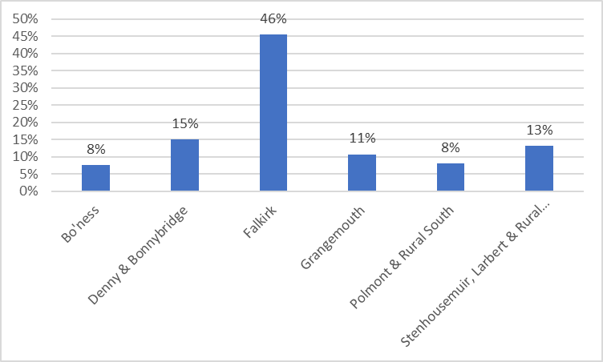

Source: Falkirk Council Information Systems

### **Demand by Bedroom Size**

Analysis carried out on the demand for housing by house size shows that across all areas, the highest demand is for two-bedroom properties at 51.3% on average. One-bedroom properties are sought by 38.2% of applicants, followed by 3 bedrooms (7.2%), bedsits (6.5%), 4 bedrooms (2.5%) and five or more bedrooms 0.8%.

#### **Chart 3.6: Demand for Different Bedroom Size by Applicants on the Waiting List**

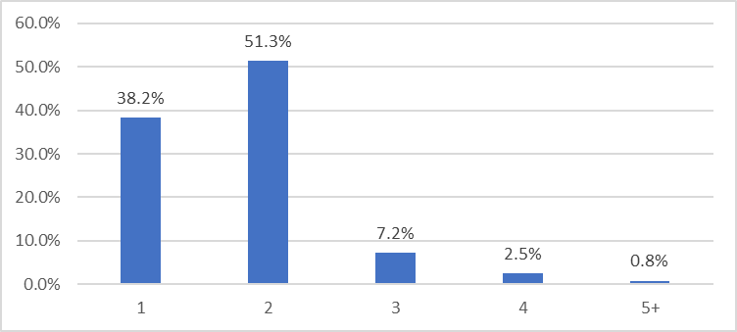

Source: Falkirk Council Information Systems

### **Applicant to Let Ratio**

To try and identify demand for specific house sizes is to look at the applicant to let ratios. These ratios will give an indication of the stock sizes that are the most pressured. As can be seen in Table 3.35, there are 11 applicants for every let. The highest ratio is for 4+ bedroom properties at 29 applicants per let and then one-bedroom properties at 18 applicants per let.

One bedroom properties account for 16% (2,729) of the Council’s stock but 51% of applicants are one person households so demand is high for this property size. In terms of 4+ bedrooms, there is very little stock of this size at only 3% (496). There are around 755 applicants on the waiting list looking for a 4+ bedroom property but when only around 20 are let annually demand for larger properties is acute. The demand for larger properties has meant that families have had to spend a lot longer in temporary homeless accommodation.

#### **Table 3.35: Number of Applicant to Let Ratio by Property Size**

|  |  |
| --- | --- |
| **Bedroom** | **Ratio** |
| 1 bedroom | 18 |
| 2 bedrooms | 10 |
| 3 bedrooms | 5 |
| 4+ Bedroom | 29 |
| **Total** | **11** |

Source: Falkirk Council Information Systems

### **Voids**

Table 3.36 shows the number of voids as at the 31st March of each year for the last five years and the number void for longer than 6 months. For the four years until 2020/21 there was on average 200 voids. In 2020/21 the number of voids increased to 355 due to COVID 19 and the restrictions imposed due to lockdown such as the suspension of allocations and non-emergency repairs. The number of properties void for longer than 6 months doubled from 6 in 2016/17 to 12 in 2019/20. There was an even bigger increase in 2020/21 due to covid restrictions.

#### **Table 3.36: Number of Properties Void as at 31st March and Void for More than 6 Months**

|  |  |  |
| --- | --- | --- |
| **Year** | **No. Voids as at 31st March** | **No. Void more than 6 Months** |
| 2016/17 | 180 | 6 |
| 2017/18 | 215 | 4 |
| 2018/19 | 200 | 8 |
| 2019/20 | 209 | 12 |
| 2020/21 | 355 | 26 |

Source: Falkirk Council Information Systems

A low demand property (empty or occupied) is a property where one or more of the following symptoms are exhibited:

* Generally, a small or non-existent waiting list for the property
* Tenancy offers on a dwelling are frequently refused for other than personal reasons.
* Higher than normal rates of tenancy turnover for a property in an area.

Within Falkirk low demand properties are identified by looking at the number of offers made. Table 3.37 shows an average of 64 low demand voids annually. The majority of these properties are flats, either tenemental, bedsit or maisonette flats and they make up between 79% of low demand voids in 2016-2017 and 58% in 2020-2021.

The Stenhousemuir, Larbert and Rural North area consistently has very few low demand properties each year. There are very few tenemental flats, 66% of the stock is houses and the majority of flats are 4-in-a-block flats with their own front door, generally more popular than tenemental flats with a communal entrance.

For the majority of the years either the Falkirk or Grangemouth area have the highest number of low demand voids. Falkirk and Grangemouth also have the highest numbers of flatted accommodation and also larger flats which are seen as less popular. Mainstream properties are assigned for allocation to Home Seekers, Home Movers and Home Starters through an automatic ‘sequencing’ process. If no bids are received for a property, it is then advertised for All Groups.

#### **Table 3.37: Low Demand Voids by Housing Submarket Area**

|  |  |  |  |  |  |  |
| --- | --- | --- | --- | --- | --- | --- |
| **Housing Submarket Area** | **2016-2017** | **2017-2018** | **2018-2019** | **2019-2020** | **2020-2021** | **Total** |
| Bo'ness | 10 | 7 | 12 | 12 | 2 | 43 |
| Denny & Bonnybridge | 13 | 10 | 10 | 16 | 4 | 53 |
| Falkirk | 30 | 17 | 22 | 9 | 11 | 89 |
| Grangemouth | 23 | 14 | 14 | 10 | 8 | 69 |
| Braes & Rural South | 6 | 11 | 20 | 10 | 8 | 55 |
| Stenhousemuir, Larbert & Rural North | 3 | 3 |  | 2 | 2 | 10 |
| **Total** | **85** | **62** | **78** | **59** | **35** | **319** |

Source: Falkirk Council Information Systems

### **Stock Management**

### **In Situ Solutions**

One of the main means by which local authorities and partner RSLs can make best use of their existing housing stock is through their allocations policies. This can be done by awarding points to applicants who are overcrowded, under-occupying and sharing facilities with another household. One of the main means by which local authorities can make best use of their existing housing stock is through transfers and mutual exchanges. If an existing tenant’s circumstances changes, then they may request a transfer to another property within the Council’s stock.

A successful transfer can support tenancy sustainment, prevent overcrowding or reduce under-occupancy. Table 3.38 shows the number and percentage of transfers over the last 5 years and highlights that between 25% and 32% of lets were made to existing tenants. A mutual exchange is a way for social rented tenants to find a move by swapping their home with another social rented tenant. The tenant can be one from their existing landlord or one from another council or RSL. Before 2020/2021, there were on average, 122 mutual exchanges made annually.

#### **Table 3.38: The number and Transfers and Mutual Exchanges made in the last 5 Years.**

|  |  |  |  |
| --- | --- | --- | --- |
| **Year** | **Transfer No.** | **Transfer %** | **Mutual Exchange** |
| 2016/17 | 346 | 25% | 113 |
| 2017/18 | 373 | 28% | 135 |
| 1018/19 | 425 | 28% | 126 |
| 2019/20 | 381 | 30% | 114 |
| 2020/21 | 316 | 32% | 59 |

Source: Falkirk Council Information Systems

### **Tenants Incentive Scheme**

The Council has a Tenant Incentive Scheme which is designed to encourage tenants who reside in properties too big for their needs to consider downsizing to a smaller property by providing practical help and/or grants. The amount of grant tenants can receive depends on the number of rooms they are losing and are shown in Table 3.39. Practical assistance is also offered in the manner of help with form filling, getting quotations from removal firms, contacting utility companies and arranging house clearances.

#### **Table 3.39: Grant amounts payable through the Tenants Incentive Scheme**

|  |  |  |
| --- | --- | --- |
| **Current Accommodation** | **Moving To** | **Grant Payable** |
| 3 Bedrooms | 1 Bedroom | £2,000 |
| 4 Bedrooms | 2 Bedrooms | £2,000 |
| 4 Bedrooms | 1 Bedroom | £3,000 |
| 5 Bedrooms | 2 Bedrooms | £3,000 |
| 5 Bedrooms | 1 Bedroom | £4,000 |

Source: Falkirk Council Information Systems

Table 3.40 shows the number of grants provided by year and highlights 41 grants have been given out in the last six years. The majority of people have moved from a three-bedroom property at 28 in total or 68% and the remaining 13 households from a four bedroom property.

#### **Table 3.40: Number of Tenant Incentive Grants Paid by Year**

|  |  |  |
| --- | --- | --- |
| **Year** | **No.** | **%** |
| 2015/16 | 10 | 24% |
| 2016/17 | 5 | 12% |
| 2017/18 | 10 | 24% |
| 2018/19 | 4 | 10% |
| 2019/20 | 9 | 22% |
| 2020/21 | 3 | 7% |
| **Total** | **41** | **100%** |

Source: Falkirk Council Information Systems

Due to the small number of grants awarded annually it was decided at the end of 2020 to pro-actively approach tenants who are under occupying larger type properties and offer people support to move through the tenant incentive scheme.

### **Extensions**

As part of the 2011-2016 LHS, one of the actions identified was to increase the supply of larger homes by adding extensions to existing properties and converting properties. Table 3.41 shows that there have been 17 extensions and attic conversions completed since 2013. Although there were 8 in 2013-2014, this has reduced down to 2 in 2020-2021.

#### **Table 3.41: Number of extensions completed between 2013-2021**

|  |  |  |  |  |  |  |
| --- | --- | --- | --- | --- | --- | --- |
| **Area** | **2013-2014** | **2015-2016** | **2017-2018** | **2018-2019** | **2020-2021** | **Total** |
| Bo'ness |  |  |  |  |  |  |
| Denny & Bonnybridge | 1 |  |  |  | 1 | **2** |
| Falkirk | 4 |  |  |  |  | **4** |
| Grangemouth |  |  |  |  | 1 | **1** |
| Braes & Rural South | 1 | 1 |  |  |  | **2** |
| Stenhousemuir, Larbert & Rural North | 2 | 2 | 3 | 1 |  | **8** |
| **Total** | **8** | **3** | **3** | **1** | **2** | **17** |

Source: Falkirk Council Information Systems

### **Reconfiguration**

We are also exploring the conversion of adjoined properties to create larger homes such as the ground floor and first floor of a 4-in-a-block property.

### **Empty Homes and Buy Backs**

Another way in which the Council can make the most use out of existing stock is through the buy backs scheme and working with empty homeowners to bring their empty properties back into use. The Council have two officers who work on the buy back scheme, empty homes and the mortgage to rent scheme.

### **Empty Homes**

There are around 700 long term empty private properties in Falkirk at any one time. Empty homes are defined as properties that have been empty for longer than 6 months. Reducing the number of empty private properties is seen as a priority for the Council and making best use of existing stock helps meet need and demand. The two officers work with owners to provide advice and information to encourage them to bring their properties back into use.

The Council has had an empty homes officer in place since 2013. As well as offering advice on a wide range of topics such as renting and selling the property and repairing the property and information on companies providing discounts, they also operate a Matchmaker Scheme. The Matchmaker Scheme aims to link the owners of empty homes with prospective purchasers looking for opportunities to develop in the area.

Since 2013, 526 long term empty properties have been brought back into use after being provided with help and information by the empty homes officer.

### **Buy Backs**

The Council also has a buy-back scheme which has been in operation since 2013 which purchases ex council properties. It gives priority to smaller properties and properties in areas of higher demand as well as properties that will give the Council majority ownership in a block. The scheme is seen as a quick method for increasing affordable housing supply in areas of demand and can be cost effective.

In the 8 years from 2013 until the end of March 2021, the Council purchased 678 properties through the buy back scheme as can be seen in Table 3.42.

#### **Table 3.42: Number of properties bought back.**

|  |  |
| --- | --- |
| **Year** | **No.** |
| 2013-2014 | 69 |
| 2014-2015 | 77 |
| 2015-2016 | 97 |
| 2016-2017 | 80 |
| 2017-2018 | 95 |
| 2018-2019 | 87 |
| 2019-2020 | 80 |
| 2020-2021 | 93 |
| **Total** | **678** |

Source: Falkirk Council Information Systems

In November 2020 Executive gave approval for officers to purchase properties at a cost of up to 10% over the Home Report value and or DV price point whichever is higher in specific circumstances. The specific circumstances are:

* Houses of four or more bedrooms
* Property types which had been adapted or had the potential to be adapted for a disabled person.

This is to meet the acute demand for larger properties and an ongoing need for properties for disabled people.

### **Adaptations**

Adapting existing stock is also a way to meet housing need in-situ. This is described in more detail in the Specialist Provision chapter of this document.

HOUSING STOCK PROFILE AND PRESSURES - Key Issues Table

|  |  |
| --- | --- |
| LHS & Development Plan | Key Issues Identified in the HNDA |
| Housing (condition) quality | According to the SHCS there is a higher level of any kind of disrepair in Falkirk (73%) compared to Scotland (71%) at a whole. Falkirk has the third highest percentage of stock with urgent disrepair and urgent disrepair to critical elements in Scotland in comparison to the other 32 local authorities. |
|  | When disrepair is broken down by tenure the social rented sector fares worse at 92% than owner occupied stock at 63%. This is also true for urgent disrepair and extensive disrepair. |
|  | Although flats rather than houses are more likely to have any type of disrepair, when urgent and extensive disrepair are looked at it is houses rather than flats where issues are more pronounced. |
|  | In terms of the household type, other households which are households with adults resident of any age and no children are more likely to be living in properties that are in disrepair than any other household type. |
|  | One of the issues with the SHCS is the lack of information for the private rented sector as the sample size is too low for a reliable estimate. This will need to be looked at in more detail in the LHS. |
|  | In terms of the SHQS, the council and RSLs in the area have invested a great deal in their stock over the years and this is shown in the information from the regulator which shows 98% of the social rented stock meets SHQS. The stock that doesn’t meet SHQS is mainly due to abeyances and exemptions. There is a significant number of abeyances due to non-participation by private owners where the council isn’t in the majority. |
| Housing stock pressures | There is a mismatch within the area between supply and demand with there being around 5.6 applicants for every council property that becomes available annually. |
|  | In terms of lets, the majority of lets each year are for 2 bedroom properties and this ranges from between 55%-59% annually. Lets to 1 bedroom properties make up just under 25% of lets, 3 bedroom around 18% and 4+ bedroom 1%. |
|  | Looking at applicants to let ratios highlights that there are 18 applicants per let for 1 bedroom properties and 29 applicants per let for 4 bedroom properties. 1 bedroom properties only make up 16% of the council stock and 4 beds 3%. |
|  | The demand for larger properties has meant that families have had to spend a lot longer in temporary homeless accommodation. |
|  | There is lower turnover and higher demand for areas such as Braes & Rural South and Stenhousemuir, Larbert & Rural South. These areas have a higher proportion of houses rather than flats. Conversely turnover is higher in Falkirk and Grangemouth where there is a higher proportion of flats. |
|  | In terms of low demand properties, flatted accommodation makes up between 58%-79% of low demand properties. In terms of housing sub market areas with the highest number of low demand properties, it is Falkirk and Grangemouth and these areas have the highest proportion of flatted accommodation. |
| Size, type, tenure and location of future social housing supply | An acute need for larger family properties has been identified. To meet the needs of larger homeless households we are exploring a range of initiatives including the conversion of adjoined properties to create larger homes, ensuring we have a better chance of securing larger buy back properties by being able to offer 10% over the DV report. Through discussions with developers who have to provide affordable housing through a section 75 agreement, we are ensuring there is a number of larger family homes planned for these developments. |
|  |  |
| Sustaining communities e.g. using tenure diversification/ regeneration | Consultation undertaken for locality plan and Place Standard consultation undertaken for the LDP found similar themes in relation to housing such as there being too many social rented tenement flats, the need for greater diversification of tenure. |
|  | Work is being undertaken on a Grangemouth Masterplan which involves different council departments as well as RSL partners. A scoring methodology was produced based on turnover, stock ownership, previous and planned investment and anti-social behaviour and environmental issues as well as the land available to identify the areas most in need of regeneration. |
|  | The options available are demolition of some blocks of flats, reconfiguration of some blocks, refurbishment of blocks, environmental improvements and tenure diversification. This will be explored further in the LHS. |
|  | The Council has a successful empty homes project which provides advice and information to owners of empty properties to help get the property back into use. |
|  | The Council’s buy back scheme ensures the council is able to buy properties in high demand areas and to buy larger properties which there is an acute need for and are expensive to build. |
|  | The Council is looking at its own Shared Equity model to identify if it is a viable option for the future. |

## **Chapter 4 Estimating Housing Need and Demand**

### **Introduction**

The aim of this chapter is to estimate the number of additional housing units required. It will combine an estimate of existing need for additional units with an estimate of future need and demand for additional units to produce a total housing need estimate. These estimates of the additional housing requirement in future years will inform housing supply targets and affordable housing policies that will be set out in the Local Housing Strategy and Development Plan.

The evidence presented is required to fulfil Core Output 2 and Core Process 4 in order to achieve “robust and credible” status for the Falkirk HNDA from the CHMA.

**CORE OUTPUT 2**

|  |
| --- |
| **Estimate of additional housing units**  This should be broken down into the number of households who can afford a) owner occupation, b) private rent, c) below market rent, or d) social rent. Estimates must be reported for each year of the projection, each five year periods within the projection and the cumulative total at the end of the projection. The Tool outputs these. The projection period and geography chosen should fit with those required for the LHS and Development Plan. |

**CORE PROCESS 4**

|  |
| --- |
| Assumptions, judgements and scenarios are well reasoned and transparent. |

To estimate the number of additional housing units required, the HNDA Tool 2021 Version 4.0 was used. The HNDA Tool estimates housing need by tenure:

* Owner Occupation,
* Private rent,
* Below market rent,
* Social rent.

The Strategic Housing Group have agreed a range of scenarios to run through the HNDA Tool which best reflects what may occur in Falkirk in the future. This chapter will describe these scenarios and provide evidence as to why these decisions were made. More information is also available in Appendix: HNDA Tool Results.

### **Demography**

The first step when using the Tool is the choice of demographic scenarios to use. The CHMA strongly recommend that NRS household projections are used. Local authorities do have a choice when deciding on the households projections to use and they are listed below:

* Using the National Registers of Scotland (NRS) Household Projections (2012 based)
* Creating and Using Falkirk Council’s own Household Projections
* Using the NRS Household Projections and adjusting these

Using in-house projections or amending existing NRS projections is not an option for Falkirk as it is so resource intensive. The Strategic Housing Group chose to use NRS projections as they are an official source, they are seen as a robust data source and will give a broad range of estimates of future housing need.

The principal projection, is the projection based on the assumptions that the NRS think are most likely to occur. The low and high migration variant population projections use the same assumptions about fertility and mortality as the principal population projection but assume varied levels of migration to and from Scotland.

Information used in the Key Market Drivers section of the HNDA highlighted that Falkirk has an increasing population and this has been the case since the mid-1990s. Between 1998 and 2020, the population of Falkirk increased by 11.6%. Since 2001, the number of households in Falkirk has increased by 16.4%.

The 2018 principal projection suggests that the number of households in Falkirk will increase by 9,523 (13%) between 2018 and 2043. This is on average an increase of 380 households every year. The high migration variant will see a 15% increase and the low variant will see a 12% increase as can be seen in Table 4.1.

#### **Table 4.1: Household Projections for Falkirk by Variant**

|  |  |  |  |  |  |
| --- | --- | --- | --- | --- | --- |
| **Area** | **2018** | **2028** | **2043** | **Change (%) 2018-2028** | **Change (%) 2018-2043** |
| Low Migration | 72,267 | 76,470 | 80,685 | 6% | 12% |
| Principal Projection | 72,267 | 76,692 | 81,790 | 6% | 13% |
| High Migration | 72,267 | 76,917 | 82,774 | 6% | 15% |

Source: NRS 2018 Household Projections

Migration is driving projected increases in population in Falkirk. It is estimated that in Falkirk between 2018 and 2043 there will be 9,986 (26%) more deaths than births in those 25 years. The projected net migration is estimated to be 19,163, with the majority of this coming from migration from the rest of Scotland.

There are a number of factors that could have a negative or a positive impact on migration into the area and these include:

* The impact of Brexit. With the UK leaving the EU, the free movement of persons between the two has also ended. Citizens have lost their right to live and work anywhere in the European Union.
* The Scottish Government announced a £50m growth deal for Falkirk in July 2021. This money will boost the local economy by creating skilled jobs and investing in infrastructure improvements to support sustainable travel, tourism and energy.

The HNDA Tool guidance recommends that a range of estimates are produced therefore the Strategic Housing Group decided that the principal population projections would be used as well as the low and high variants.

### **Existing Need**

The HNDA Tool contains a measure of existing need which includes a count of homelessness households in temporary accommodation and households that are both overcrowded and concealed (HoTOC) These households are deemed to be in need of a new unit of housing. The existing need figure for Falkirk is 370 which is the same as the existing need figure for the draft NPF4. The use of this method of identifying existing need was discussed with the Strategic Housing Group and while Falkirk Council used this figure following the NPF4 consultation, Homes for Scotland had reservations about its value in capturing all potential housing need.

Homes for Scotland suggested the Council undertake additional primary research to identify existing need in the area and provided a copy of a research report that explains the online method Homes for Scotland have devised for collecting up to date local evidence on existing need.

Undertaking additional primary research work would be resource intensive and would involve using indicators of housing need that haven’t been agreed by the Scottish Government and which don’t necessarily mean that a new home is needed e.g. households living in unsuitable properties. In this case it could be more sustainable to repair those properties and for households that are struggling financially they will not necessarily be able to afford owner occupation.

Using the HoTOC method is seen as a robust and credible method for identifying existing need and its use in the draft NPF4 was supported and was also used for the HNDA Tool.

The Strategic Housing Group also considered the number of years within which it would be reasonable to clear that backlog need. The default within the tool is set at five years. In the last HNDA the Council had used the ten year timescale to clear existing need and it was decided to use this longer timescale for this HNDA too.

The main reason for choosing the 10 years is due to the number of social rent completions in the last 5 as shown in Table 4.2. It highlights that on average there were 53.6 completions annually. If the 5 years to clear existing need was chosen 74 properties would need to be built annually to just clear the existing need. While we aim to meet housing need as quickly as possible it is considered more realistic to seek to achieve this over 10 years rather than 5.

#### **Table 4.2: Number of new build completions 2015-20120**

|  |  |  |  |  |  |
| --- | --- | --- | --- | --- | --- |
|  | **2015-16** | **2016-17** | **2017-18** | **2018-19** | **2019-20** |
| Completions | 86 | 100 | 8 | 49 | 25 |

Source: NB1 returns by local authorities to the Scottish Government, Communities Analytical Services (Housing Statistics)

### **Income Growth and Distribution**

In relation to income, the HNDA Tool is pre-populated with income data obtained from a number of different surveys and produced for the Scottish Government by Herriot-Watt University. Local authorities have the option to use the income data in the Tool or to use their own income data. Accurate income data is difficult to obtain and the Council does not hold any income data such as CACI data. As the income data in the Tool is robust it was decided by the Strategic Housing Group that it should be used.

The Tool is pre-programmed with five income scenarios that are designed to offer local authorities a range of income growth scenarios for average (median) household income.

Looking at the Key Market Drivers chapter, median incomes in Falkirk are similar to Scotland as a whole. Over the last 5 years, there have been fluctuations but generally median incomes have increased overall by around 2.2% annually. It was agreed that the two scenarios below would be chosen to run through the Tool:

* **Moderate Real Terms Growth (Tool Core/Default)** - Household income growth is assumed to grow at 2.5% per annum in nominal terms. Assuming that inflation is at 2% per annum over the forecast horizon (the Bank of England’s inflation target), then in the long run this scenario assumes that there is real terms income growth of 0.5% per annum.
* **No Real Terms Growth** - Household income growth is assumed to grow at 2% per annum in nominal terms. Assuming that inflation is at 2% per annum over the forecast horizon (the Bank of England’s inflation target), then in the long run this scenario assumes that there is no real terms growth in household income.

The Tool is pre-programmed with 3 income distribution scenarios to reflect different household income distributions. The scenarios are defined in terms of how household income of the 10th, 90th percentile grows relative to median income which is the 50th percentile and are listed below:

* **Great Equality** - The incomes of the least affluent (represented by the 10th percentile of the income distribution) increase more steeply compared to the incomes of most affluent (represented by the 90th percentile of the income distribution).
* **No change (Tool core/default)** - The incomes of the least affluent (represented by the 10th percentile of the income distribution) and the most affluent (represented by the 90th percentile of the income distribution) increase at the same rate as median household income. The gap in the income distribution between the most and least affluent will not change over time.
* **Greater inequality** - The incomes of the most affluent (represented by the 90th percentile of the income distribution) increase more steadily compared to the incomes of least affluent (represented by the 10th percentile of the income distribution).

The three scenarios were discussed at the Strategic Housing Group and there was discussion about the increase in poverty in the area and whether Greater Inequality should be run through the Tool. Unfortunately income date for Falkirk from Nomis is not available for the 90th percentile but the 80th, the 10th percentile and median incomes were looked at to see the changes in the last 5 years. The incomes of the 10th percentile have increased by 3.4% over the last 5 years and the 80th percentile and median incomes by 2.2%. It was therefore decided that No Change would be run through the Tool.

The Tool is set up to analyse affordability (incomes divided by house prices and rent prices) at the 25th percentile of income, house prices and rental prices. The 25th percentile has been chosen because, historically, this is seen to represent where First Time-Buyers enter this housing market, where housing need and demand is most critical. It was decided by the Strategic Housing Group to keep the Tool at 25%.

### **Affordability and House Prices**

The Tool is pre-programmed with 5 house price scenarios that are designed to offer a range of options and are listed below:

* **Trend Growth (Core/Default)** - House price growth is equivalent to the annualised growth rate of the average Scottish house price (UK HPI) over the last ten years, which is 1.6% per annum.
* **Moderately High** - House price growth is equivalent to the average annualised growth rate in house prices of the 16 local authorities with the highest rates of annualised house price growth over the last 10 years, which is 2.3% per annum.
* **Moderately Low** - House price growth is equivalent to the average annualised growth rate in house prices of the 16 local authorities with the lowest rates of annualised house price growth over the last 10 years, which is 0.7% per annum.
* **High** - House price growth is equivalent to the average annualised growth rate in house prices of the 8 local authorities with the highest rates of annualised house price growth over the last 10 years, which is 2.9% per annum.
* **Low** - House price growth is equivalent to the average annualised growth rate in house prices of the 8 local authorities with the lowest rates of annualised house price growth over the last 10 years, which is 0.3% per annum.

House prices in Falkirk between 2013 and 2017 really fluctuated with some years seeing increases of over 4% and other years less than 1%. Overall, there has been an annual increase of 2.5%.

Comparing Falkirk and Scotland average house prices between 2011 and 2020 from Registers of Scotland[12], Falkirk average house prices increased by 27% and Scotland by 21%. The Scottish Fiscal Commission[13] in August 2021 forecast nominal house prices to rise by 3.1 per cent in 2022-23.

The Tool is pre-populated with core/default settings which were chosen to reflect, as far as is possible, the prevailing state of the Scottish housing market and economy when the Tool was refreshed in 2020. As house prices have increased more in Falkirk in the last 10 years compared to Scotland it was decided that Trend Growth and Moderately High growth would be run through the Tool.

### **Affordability Rental Prices**

The first part of this section of the HNDA is used to decide of those who can afford to purchase in the market, what proportion will actually go on to do so. The default in the Tool has been set at 60%. The effect of increasing this percentage would be to increase the amount of housing need that would be met via owner occupation and reduce the amount that be met by the rental sector. Lowering the 60% threshold would have the reverse effect. This was discussed by the Strategic Housing Group and it was decided that the default of 60% would remain as there is no evidence locally that it is different.

Within those households who will rent the Strategic Housing Group considered the proportion which will rent in the private rented sector and those who will require social rented sector housing. In line with the HNDA Tool the group agreed that:

* If a household spends less than 25% of their income on rent the Tool assumes they can afford to rent in the private sector. This threshold has been used historically as the threshold for PRS affordability.
* If a household spends between 25% to 35% of their income on rent the Tool assumes they are suitable for below market rent.
* If a household spends more than 35% of their income (including housing benefit) on rent the Tool assumes they are suitable for social rent.

The final task for the HMP in setting the inputs and assumptions of the HNDA Tool was to decide how rental prices are likely to change over the course of the projection period. The scenarios are identical to the house price scenarios, with the assumption that over the long run rental prices are likely to track trends in house prices.

Information on private rent prices from the Key Market Drivers section of the HNDA were looked at. In terms of rents for the Forth Valley BRMA, these have seen between 2% and 8% increases annually but in the last 4 years around 4.7% increase annually. When information on private rents for the Falkirk area alone is looked at, some years have seen a 5% increase in rents and other have seen a fall but overall there has been around a 2.9% increase.

It was therefore decided that the same scenarios that were chosen for house prices would be chosen for rental price rises and are listed below:

* **Trend Growth (Core/Default)** - House price growth is equivalent to the annualised growth rate of the average Scottish house price (UK HPI) over the last ten years, which is 1.6% per annum.
* **Moderately High** - House price growth is equivalent to the average annualised growth rate in house prices of the 16 local authorities with the highest rates of annualised house price growth over the last 10 years, which is 2.3% per annum.

### **Scenario Testing**

Tables 4.3 and 4.4 summaries the scenarios and assumptions chosen to run through the Tool and agreed by the Strategic Housing Group.

#### **Table 4.3: Agreed Scenario Testing Parameters for HNDA Tool**

|  |  |  |  |  |  |
| --- | --- | --- | --- | --- | --- |
|  | **Demographic** | **Income Growth** | **Income Distribution** | **House price** | **Rental price** |
| Scenario 1 | Principal | Moderate Real Terms Growth (Core Default) | No Change | Moderately High Growth | Moderately High Growth |
| Scenario 2 | Principal | No Real growth | No Change | Trend Growth | Trend Growth |
| Scenario 3 | Low Migration | No Real growth | No Change | Trend growth | Trend Growth |
| Scenario 4 | High Migration | Moderate Real Terms Growth (Core Default) | No Change | Moderately High Growth | Moderately High Growth |

#### **Table 4.4: Agreed Assumptions for HNDA Tool**

|  |  |
| --- | --- |
| **Assumption** |  |
| Use NRS Household Projections | Yes |
| Use Income data used in the Tool | Yes |
| Use HoTOC for existing Need | Yes |
| No. of years to clear existing need | 10 |
| Use affordability model | No |
| Default threshold for house prices affordability | 3.9% & 25% |
| Proportion of market who buy | 60% |
| Upper income to rent threshold | 25% |
| Lower income to rent threshold | 35% |
|  |  |

### **Tool Results**

The HNDA Tool results are shown in four tables below to provide results for the four different scenarios. The results are shows for the area as a whole and then broken down in the six housing sub market areas as well as well as a breakdown of the requirement by social rent, below market rent private rent and owner occupation. The tables show that for Scenario 1 and 2 there is a a housing estimate of 466 new units per year in years 1 – 5 and a housing estimate of 385 units per year in years 1 -20. For scenario 3 there is a a housing estimate of 436 new units per year in years 1 – 5 and a housing estimate of 336 units per year in years 1 -20 and for scenario 4 there is a a housing estimate of 495 new units per year in years 1 – 5 and a housing estimate of 429 units per year in years 1 -20. It was agreed by the Strategic Housing Group that Scenario 1 was the preferred scenario

#### **Table 4.5: HNDA Tool Results for Scenario 1**

**Scenario 1 - All Areas**

|  |  |  |  |  |  |  |
| --- | --- | --- | --- | --- | --- | --- |
| **Tenure** | **2022-2026** | **2027-2031** | **2032-2036** | **2037-2041** | **20 yr total** | **20 yr pa** |
| Social Rent | 131 | 117 | 75 | 66 | 1,946 | 97 |
| BM Rent | 93 | 77 | 78 | 67 | 1,579 | 79 |
| PRS | 80 | 69 | 66 | 61 | 1,378 | 69 |
| Buyers | 162 | 139 | 137 | 122 | 2,801 | 140 |
| **Total** | **466** | **402** | **356** | **317** | **7,703** | **385** |

**Scenario 1 - Braes & Rural South**

|  |  |  |  |  |  |  |
| --- | --- | --- | --- | --- | --- | --- |
| **Tenure** | **2022-2026** | **2027-2031** | **2032-2036** | **2037-2041** | **20 yr total** | **20 yr pa** |
| Social Rent | 20 | 17 | 10 | 9 | 275 | 14 |
| BM Rent | 16 | 14 | 13 | 12 | 271 | 14 |
| PRS | 22 | 19 | 19 | 17 | 384 | 19 |
| Buyers | 28 | 24 | 23 | 21 | 481 | 24 |
| **Total** | **85** | **74** | **65** | **58** | **1,411** | **71** |

**Scenario 1 - Falkirk**

|  |  |  |  |  |  |  |
| --- | --- | --- | --- | --- | --- | --- |
| **Tenure** | **2022-2026** | **2027-2031** | **2032-2036** | **2037-2041** | **20 yr total** | **20 yr pa** |
| Social Rent | 41 | 35 | 24 | 21 | 609 | 30 |
| BM Rent | 26 | 24 | 22 | 20 | 458 | 23 |
| PRS | 5 | 4 | 5 | 4 | 86 | 4 |
| Buyers | 50 | 43 | 42 | 37 | 862 | 43 |
| **Total** | **122** | **105** | **93** | **83** | **2,015** | **101** |

**Scenario 1 - Denny & Bonnybridge**

|  |  |  |  |  |  |  |
| --- | --- | --- | --- | --- | --- | --- |
| **Tenure** | **2022-2026** | **2027-2031** | **2032-2036** | **2037-2041** | **20 yr total** | **20 yr pa** |
| Social Rent | 21 | 17 | 11 | 10 | 297 | 15 |
| BM Rent | 14 | 13 | 12 | 11 | 254 | 13 |
| PRS | 22 | 19 | 19 | 16 | 381 | 19 |
| Buyers | 20 | 17 | 17 | 15 | 341 | 17 |
| **Total** | **77** | **66** | **59** | **52** | **1,273** | **64** |

**Scenario 1 - Bo'ness**

|  |  |  |  |  |  |  |
| --- | --- | --- | --- | --- | --- | --- |
| **Tenure** | **2022-2026** | **2027-2031** | **2032-2036** | **2037-2041** | **20 yr total** | **20 yr pa** |
| Social Rent | 15 | 13 | 9 | 8 | 230 | 12 |
| BM Rent | 9 | 8 | 7 | 7 | 153 | 8 |
| PRS | 6 | 4 | 5 | 4 | 92 | 5 |
| Buyers | 17 | 14 | 14 | 13 | 288 | 14 |
| **Total** | **46** | **40** | **35** | **31** | **764** | **38** |

**Scenario 1 - Grangemouth**

|  |  |  |  |  |  |  |
| --- | --- | --- | --- | --- | --- | --- |
| **Tenure** | **2022-2026** | **2027-2031** | **2032-2036** | **2037-2041** | **20 yr total** | **20 yr pa** |
| Social Rent | 21 | 18 | 13 | 12 | 322 | 16 |
| BM Rent | 12 | 11 | 11 | 9 | 216 | 11 |
| PRS | 0 | 0 | 1 | 1 | 11 | 1 |
| Buyers | 21 | 18 | 17 | 15 | 358 | 18 |
| **Total** | **55** | **47** | **42** | **37** | **906** | **45** |

**Scenario 1 - Stenhousemuir Larbert & Rural North**

|  |  |  |  |  |  |  |
| --- | --- | --- | --- | --- | --- | --- |
| **Tenure** | **2022-2026** | **2027-2031** | **2032-2036** | **2037-2041** | **20 yr total** | **20 yr pa** |
| Social Rent | 19 | 16 | 10 | 9 | 268 | 13 |
| BM Rent | 14 | 13 | 12 | 10 | 245 | 12 |
| PRS | 20 | 17 | 17 | 15 | 349 | 17 |
| Buyers | 27 | 24 | 23 | 21 | 473 | 24 |
| **Total** | **80** | **69** | **62** | **55** | **1,334** | **67** |

#### **Table 4.6: HNDA Tool Results for Scenario 2**

**Scenario 2 -All Areas**

|  |  |  |  |  |  |  |
| --- | --- | --- | --- | --- | --- | --- |
| **Tenure** | **2022-2026** | **2027-2031** | **2032-2036** | **2037-2041** | **20 yr total** | **20 yr pa** |
| Social Rent | 131 | 114 | 71 | 61 | 1,882 | 94 |
| BM Rent | 92 | 79 | 78 | 68 | 1,580 | 79 |
| PRS | 80 | 69 | 68 | 62 | 1,400 | 70 |
| Buyers | 163 | 141 | 139 | 126 | 2,841 | 142 |
| **Total** | **466** | **402** | **356** | **317** | **7,703** | **385** |

**Scenario 2 - Braes & Rural South**

|  |  |  |  |  |  |  |
| --- | --- | --- | --- | --- | --- | --- |
| **Tenure** | **2022-2026** | **2027-2031** | **2032-2036** | **2037-2041** | **20 yr total** | **20 yr pa** |
| Social Rent | 19 | 17 | 9 | 8 | 267 | 13 |
| BM Rent | 16 | 13 | 13 | 11 | 266 | 13 |
| PRS | 22 | 19 | 19 | 17 | 388 | 19 |
| Buyers | 28 | 24 | 24 | 22 | 489 | 24 |
| **Total** | **85** | **74** | **65** | **58** | **1,411** | **71** |

**Scenario 2 – Falkirk**

|  |  |  |  |  |  |  |
| --- | --- | --- | --- | --- | --- | --- |
| **Tenure** | **2022-2026** | **2027-2031** | **2032-2036** | **2037-2041** | **20 yr total** | **20 yr pa** |
| Social Rent | 40 | 35 | 23 | 21 | 595 | 30 |
| BM Rent | 27 | 23 | 22 | 19 | 454 | 23 |
| PRS | 5 | 5 | 4 | 5 | 91 | 5 |
| Buyers | 50 | 43 | 43 | 38 | 875 | 44 |
| Total | 122 | 105 | 93 | 83 | 2,015 | 101 |

**Scenario 2 - Denny & Bonnybridge**

|  |  |  |  |  |  |  |
| --- | --- | --- | --- | --- | --- | --- |
| **Tenure** | **2022-2026** | **2027-2031** | **2032-2036** | **2037-2041** | **20 yr total** | **20 yr pa** |
| Social Rent | 20 | 17 | 11 | 9 | 289 | 14 |
| BM Rent | 15 | 13 | 12 | 10 | 251 | 13 |
| PRS | 22 | 19 | 19 | 17 | 387 | 19 |
| Buyers | 20 | 17 | 17 | 15 | 346 | 17 |
| Total | 77 | 66 | 59 | 52 | 1,273 | 64 |

**Scenario 2 - Bo'ness**

|  |  |  |  |  |  |  |
| --- | --- | --- | --- | --- | --- | --- |
| **Tenure** | **2022-2026** | **2027-2031** | **2032-2036** | **2037-2041** | **20 yr total** | **20 yr pa** |
| Social Rent | 15 | 13 | 9 | 8 | 223 | 11 |
| BM Rent | 9 | 8 | 8 | 6 | 152 | 8 |
| PRS | 5 | 5 | 5 | 5 | 97 | 5 |
| Buyers | 17 | 14 | 14 | 13 | 292 | 15 |
| Total | 46 | 40 | 35 | 31 | 764 | 38 |

**Scenario 2 - Grangemouth**

|  |  |  |  |  |  |  |
| --- | --- | --- | --- | --- | --- | --- |
| **Tenure** | **2022-2026** | **2027-2031** | **2032-2036** | **2037-2041** | **20 yr total** | **20 yr pa** |
| Social Rent | 21 | 18 | 13 | 12 | 316 | 16 |
| BM Rent | 13 | 11 | 10 | 9 | 214 | 11 |
| PRS | 0 | 1 | 1 | 1 | 13 | 1 |
| Buyers | 21 | 18 | 18 | 16 | 363 | 18 |
| **Total** | **55** | **47** | **42** | **37** | **906** | **45** |

**Scenario 2 - Stenhousemuir Larbert & Rural North**

|  |  |  |  |  |  |  |
| --- | --- | --- | --- | --- | --- | --- |
| **Tenure** | **2022-2026** | **2027-2031** | **2032-2036** | **2037-2041** | **20 yr total** | **20 yr pa** |
| Social Rent | 18 | 16 | 9 | 8 | 260 | 13 |
| BM Rent | 14 | 12 | 12 | 10 | 240 | 12 |
| PRS | 20 | 17 | 17 | 16 | 354 | 18 |
| Buyers | 27 | 24 | 24 | 21 | 480 | 24 |
| **Total** | **80** | **69** | **62** | **55** | **1,334** | **67** |

#### **Table 4.7: HNDA Tool Results for Scenario 3**

**Scenario 3 – All Areas**

|  |  |  |  |  |  |  |
| --- | --- | --- | --- | --- | --- | --- |
| **Tenure** | **2022-2026** | **2027-2031** | **2032-2036** | **2037-2041** | **20 yr total** | **20 yr pa** |
| Social Rent | 124 | 104 | 59 | 49 | 1,681 | 84 |
| BM Rent | 85 | 69 | 65 | 54 | 1,366 | 68 |
| PRS | 75 | 60 | 57 | 50 | 1,209 | 60 |
| Buyers | 152 | 122 | 116 | 101 | 2,454 | 123 |
| **Total** | **436** | **355** | **297** | **254** | **6,710** | **336** |

**Scenario 3 - Braes & Rural South**

|  |  |  |  |  |  |  |
| --- | --- | --- | --- | --- | --- | --- |
| **Tenure** | **2022-2026** | **2027-2031** | **2032-2036** | **2037-2041** | **20 yr total** | **20 yr pa** |
| Social Rent | 18 | 16 | 8 | 7 | 241 | 12 |
| BM Rent | 15 | 12 | 11 | 9 | 230 | 12 |
| PRS | 21 | 17 | 16 | 14 | 336 | 17 |
| Buyers | 26 | 21 | 20 | 17 | 422 | 21 |
| **Total** | **80** | **65** | **54** | **46** | **1,229** | **61** |

**Scenario 3 – Falkirk**

|  |  |  |  |  |  |  |
| --- | --- | --- | --- | --- | --- | --- |
| **Tenure** | **2022-2026** | **2027-2031** | **2032-2036** | **2037-2041** | **20 yr total** | **20 yr pa** |
| Social Rent | 38 | 32 | 20 | 17 | 529 | 26 |
| BM Rent | 25 | 20 | 18 | 15 | 393 | 20 |
| PRS | 4 | 4 | 4 | 4 | 79 | 4 |
| Buyers | 47 | 38 | 36 | 31 | 756 | 38 |
| **Total** | **114** | **93** | **78** | **66** | **1,756** | **88** |

**Scenario 3 - Denny & Bonnybridge**

|  |  |  |  |  |  |  |
| --- | --- | --- | --- | --- | --- | --- |
| **Tenure** | **2022-2026** | **2027-2031** | **2032-2036** | **2037-2041** | **20 yr total** | **20 yr pa** |
| Social Rent | 19 | 16 | 9 | 8 | 258 | 13 |
| BM Rent | 14 | 11 | 10 | 8 | 217 | 11 |
| PRS | 21 | 17 | 16 | 14 | 334 | 17 |
| Buyers | 18 | 15 | 14 | 12 | 299 | 15 |
| **Total** | **72** | **59** | **49** | **42** | **1,108** | **55** |

**Scenario 3 - Bo'ness**

|  |  |  |  |  |  |  |
| --- | --- | --- | --- | --- | --- | --- |
| **Tenure** | **2022-2026** | **2027-2031** | **2032-2036** | **2037-2041** | **20 yr total** | **20 yr pa** |
| Social Rent | 14 | 12 | 7 | 6 | 199 | 10 |
| BM Rent | 8 | 7 | 6 | 5 | 132 | 7 |
| PRS | 5 | 4 | 4 | 4 | 83 | 4 |
| Buyers | 16 | 13 | 12 | 10 | 252 | 13 |
| **Total** | **43** | **35** | **29** | **25** | **666** | **33** |

**Scenario 3 – Grangemouth**

|  |  |  |  |  |  |  |
| --- | --- | --- | --- | --- | --- | --- |
| **Tenure** | **2022-2026** | **2027-2031** | **2032-2036** | **2037-2041** | **20 yr total** | **20 yr pa** |
| Social Rent | 20 | 16 | 11 | 9 | 279 | 14 |
| BM Rent | 12 | 9 | 9 | 7 | 185 | 9 |
| PRS | 0 | 1 | 0 | 1 | 11 | 1 |
| Buyers | 19 | 16 | 15 | 13 | 314 | 16 |
| **Total** | **51** | **42** | **35** | **30** | **789** | **39** |

**Scenario 3 - Stenhousemuir Larbert & Rural North**

|  |  |  |  |  |  |  |
| --- | --- | --- | --- | --- | --- | --- |
| **Tenure** | **2022-2026** | **2027-2031** | **2032-2036** | **2037-2041** | **20 yr total** | **20 yr pa** |
| Social Rent | 17 | 15 | 8 | 7 | 234 | 12 |
| BM Rent | 13 | 10 | 10 | 8 | 208 | 10 |
| PRS | 19 | 15 | 14 | 13 | 306 | 15 |
| Buyers | 26 | 21 | 20 | 17 | 414 | 21 |
| **Total** | **75** | **61** | **52** | **44** | **1,161** | **58** |

**Scenario 3 - Stenhousemuir Larbert & Rural North**

|  |  |  |  |  |  |  |
| --- | --- | --- | --- | --- | --- | --- |
| **Tenure** | **2022-2026** | **2027-2031** | **2032-2036** | **2037-2041** | **20 yr total** | **20 yr pa** |
| Social Rent | 17 | 15 | 8 | 7 | 234 | 12 |
| BM Rent | 13 | 10 | 10 | 8 | 208 | 10 |
| PRS | 19 | 15 | 14 | 13 | 306 | 15 |
| Buyers | 26 | 21 | 20 | 17 | 414 | 21 |
| **Total** | **75** | **61** | **52** | **44** | **1,161** | **58** |

#### **Table 4.8: HNDA Tool Results for Scenario 4**

**Scenario 4 - All Areas**

|  |  |  |  |  |  |  |
| --- | --- | --- | --- | --- | --- | --- |
| **Tenure** | **2022-2026** | **2027-2031** | **2032-2036** | **2037-2041** | **20 yr total** | **20 yr pa** |
| Social Rent | 138 | 126 | 85 | 78 | 2,135 | 107 |
| BM Rent | 99 | 87 | 89 | 79 | 1,768 | 88 |
| PRS | 85 | 77 | 75 | 72 | 1,545 | 77 |
| Buyers | 173 | 156 | 155 | 143 | 3,139 | 157 |
| **Total** | **495** | **446** | **405** | **372** | **8,587** | **429** |

**Scenario 4 - Braes & Rural South**

|  |  |  |  |  |  |  |
| --- | --- | --- | --- | --- | --- | --- |
| **Tenure** | **2022-2026** | **2027-2031** | **2032-2036** | **2037-2041** | **20 yr total** | **20 yr pa** |
| Social Rent | 20 | 18 | 11 | 10 | 300 | 15 |
| BM Rent | 17 | 16 | 15 | 14 | 303 | 15 |
| PRS | 24 | 21 | 21 | 19 | 431 | 22 |
| Buyers | 30 | 27 | 27 | 25 | 539 | 27 |
| **Total** | **91** | **82** | **74** | **68** | **1,573** | **79** |

**Scenario 4 - Falkirk**

|  |  |  |  |  |  |  |
| --- | --- | --- | --- | --- | --- | --- |
| **Tenure** | **2022-2026** | **2027-2031** | **2032-2036** | **2037-2041** | **20 yr total** | **20 yr pa** |
| Social Rent | 43 | 38 | 27 | 25 | 670 | 33 |
| BM Rent | 28 | 26 | 25 | 23 | 513 | 26 |
| PRS | 5 | 4 | 5 | 5 | 97 | 5 |
| Buyers | 54 | 48 | 48 | 44 | 966 | 48 |
| **Total** | **130** | **117** | **106** | **97** | **2,246** | **112** |

**Scenario 4 - Denny & Bonnybridge**

|  |  |  |  |  |  |  |
| --- | --- | --- | --- | --- | --- | --- |
| **Tenure** | **2022-2026** | **2027-2031** | **2032-2036** | **2037-2041** | **20 yr total** | **20 yr pa** |
| Social Rent | 22 | 19 | 13 | 12 | 326 | 16 |
| BM Rent | 15 | 15 | 14 | 13 | 284 | 14 |
| PRS | 24 | 21 | 21 | 19 | 427 | 21 |
| Buyers | 21 | 19 | 19 | 18 | 382 | 19 |
| **Total** | **82** | **74** | **67** | **62** | **1,419** | **71** |

**Scenario 4 – Bo’ness**

|  |  |  |  |  |  |  |
| --- | --- | --- | --- | --- | --- | --- |
| **Tenure** | **2022-2026** | **2027-2031** | **2032-2036** | **2037-2041** | **20 yr total** | **20 yr pa** |
| Social Rent | 16 | 14 | 10 | 10 | 253 | 13 |
| BM Rent | 9 | 9 | 8 | 8 | 172 | 9 |
| PRS | 6 | 5 | 5 | 5 | 104 | 5 |
| Buyers | 18 | 16 | 16 | 15 | 322 | 16 |
| **Total** | **49** | **44** | **40** | **37** | **851** | **43** |

**Scenario 4 - Grangemouth**

|  |  |  |  |  |  |  |
| --- | --- | --- | --- | --- | --- | --- |
| **Tenure** | **2022-2026** | **2027-2031** | **2032-2036** | **2037-2041** | **20 yr total** | **20 yr pa** |
| Social Rent | 22 | 19 | 15 | 14 | 356 | 18 |
| BM Rent | 13 | 12 | 12 | 11 | 242 | 12 |
| PRS | 1 | 0 | 1 | 1 | 12 | 1 |
| Buyers | 22 | 20 | 20 | 18 | 401 | 20 |
| **Total** | **58** | **52** | **48** | **44** | **1,011** | **51** |

**Scenario 4 - Stenhousemuir Larbert & Rural North**

|  |  |  |  |  |  |  |
| --- | --- | --- | --- | --- | --- | --- |
| **Tenure** | **2022-2026** | **2027-2031** | **2032-2036** | **2037-2041** | **20 yr total** | **20 yr pa** |
| Social Rent | 20 | 17 | 11 | 10 | 292 | 15 |
| BM Rent | 15 | 14 | 13 | 12 | 274 | 14 |
| PRS | 22 | 19 | 20 | 18 | 391 | 20 |
| Buyers | 29 | 26 | 26 | 24 | 530 | 26 |
| **Total** | **86** | **77** | **70** | **65** | **1,487** | **74** |

### **HOUSING REQUIREMENT: ESTIMATING HOUSING NEED AND DEMAND - Key Issues Table**

|  |  |
| --- | --- |
| **LHS & Development Plan** | **Key Issues Identified in the HNDA** |
| Future need for additional housing broken down by  household who are likely to be able to afford:  • Owner occupation  • Private rent  • Below market rent  • Social rent | After discussions with the Strategic Housing Group it was agreed that the existing need figure of 370 in the HNDA Tool would be used.  It was agreed with the Strategic Housing Group that 4 scenarios would be run through the HNDA Tool.  The HNDA Tool results are presented for each of the scenarios at Falkirk Council level and also for each of the 6 housing sub market area, with a breakdown of the requirement by social rent, below market rent private rent and owner occupation.  A housing estimate of 466 new units per year in years 1 – 5 and a housing estimate of 385 units per year in years 1 -20 is anticipated based on Scenario 1 which uses the principal household projections. The housing estimate for the Falkirk Council area ranges from 336-429 per annum for 2022-41 and between 6710-8587 over 20-years across the 4 scenarios.  Over years 1-20 all tenure types are identified as being required across all sub-market areas with 46% of units estimated to be in the social rent or below market rent sectors and 54% in the owner occupied or private rent sectors.  Setting the housing land target in the development plan will require an additional flexibility allowance to be applied which is expected to be 25%, this will also need to meet the minimum housing land requirement in NPF4.  The HNDA identifies a need across all tenures and this will have to be reflected in the local development plan. The allocation of housing land will support the delivery of owner occupied, social rent and other types of affordable provision such as shared equity units.  In the Grangemouth and the Falkirk housing sub market area the combined requirement for social housing / below market rent outweighs that of owner-occupied / private rented. The opposite is the case for Braes and Rural South, Stenhousemuir, Larbert and Rural South, Bo’ness and Denny and Bonnybridge where the combined requirement for owner-occupied / private rented outweighs that of social housing / below market rent.    The preferred HNDA3 scenario is scenario 1. |

**Chapter 5 - Specialist Provision**

### **Introduction**

This chapter considers housing need and demand for specialist provision. The HNDA guidance notes that people have similar needs despite their individual illness, health condition or equality characteristics. Guidance highlights that the HNDA should focus on understanding and if possible, quantifying the implications for housing provision. The specialist provision analysis identifies three broad categories of need covering six types of housing or housing-related provision which are designed to support independent living for as long as possible and help enable people to live with dignity.

#### **Table 5.1: Specialist provision definitions re HNDA guidance**

|  |  |
| --- | --- |
| Category | Type of housing provision |
| 1. Property needs | 1. Accessible and adapted housing,  2. Wheelchair housing,  3. non-permanent housing, e.g., students, migrant workers, asylum seekers, refugees. |
| 1. Care and support needs | 4. Supported provision e.g., care homes, sheltered  housing, hostels, and refuges,  5. Care/support services for independent living. |
| 1. Locational or land needs | 6. Site provision e.g., sites/pitches for  Gypsy/Travellers and sites for travelling show.  people, city centre locations for student  accommodation. |

Source: Scottish Government Housing Need and Demand Assessment (HNDA) Practitioner’s Guide

To evidence need for the above, the following key groups, as a minimum, should be considered:

* older people
* people with a physical disability
* people with a mental health condition
* people with a learning disability
* homeless people
* people fleeing/ at risk of domestic abuse.
* people requiring non-permanent accommodation e.g., homeless people, students, migrant workers, asylum seekers, refugees, care leavers, ex-offenders
* armed forces communities
* minority ethnic people (including Gypsy/ Travellers)
* Travelling Showpeople

**CORE OUTPUT 3 – as per HNDA guidance**

Specialist Provision: Identifies the contribution that Specialist Provision plays in enabling people to live well, with dignity and independently for as long as possible. Identifies any gap(s)/shortfall(s) in that provision and the future level and type of provision required. Considers evidence regarding property needs, care and support needs and locational/land needs. Gives due consideration to the provisions of the Equality Act 2010.

In line with the approach taken in the preparation of this HNDA there is also an expectation that the analysis will address the role that specialist provision plays in meeting a range of housing needs.

### **Structure of the Chapter**

The Scottish Government has produced a set of six templates, one for each type of housing, to structure the evidence base and support the narrative. The chapter is structured around the template requirements, presenting the template information in full. However, the template structure has been amended slightly as follows:

The structure of the chapter is as follows:

* Evidence,
* National policies,
* Local policies,
* Key client groups.

### **Methodology Note**

Locally held data has been triangulated with national data held at local authority level, research, and stakeholder engagement. Information has been broken down further where it will be used to inform further consultation for the new Local Housing Strategy, the Strategic Housing Investment Plan, or the Housing Contribution Statement. Data has been broken down at Health and Social Care locality where it links to second refresh on the Joint Strategic Needs Assessment (JSNA) by the Health and Social Care Partnership (HSCP).

Consideration has also been given to national research. This approach has been taken to account for identified data gaps.

**Approach to Engagement – overview**

An overview to stakeholder consultation and engagement is set out set out below with more detail under each template. The relevant specialist housing provision template are noted:

* Discussions at the Housing Market Partnership known locally as the Strategic Housing Group and the HNDA working group (templates 1 -6)
* Discussions with the Housing Contribution Statement Steering Group (Template 1 template 2, template 5)
* Discussion at the tripartite meeting between Scottish Government Dundee office, Falkirk Council (strategy and development/ council new build teams) and Registered Social Landlords. This group oversees the Strategic Housing Investment Plan, and the quarterly meetings also discuss updates around the HNDA and LHS. (Template 1, template 2)
* Discussions at the quarterly Falkirk Council Housing Planning Liaison group (Template 1, template 2)

Consideration has been given to community planning consultation relating to the Falkirk Plan (Strategic Local Outcome Agreement) template 3.

Consideration has also been given to quantitative surveys with tenants and customers including:

* Falkirk Council Tenant Satisfaction Survey (Template 1,2,5)
* FC Temporary Accommodation exit strategy (Template 3)
* FC Factoring survey (Template 1)

Consideration has also been given to the Place Standard consultation carried out with Gypsy Travellers (template 6).

Within Falkirk Council we have discussions with stakeholders working with the following groups: homeless households, those in receipt of housing support, households receiving disabled adaptations, asylum seekers and refugees (Template 1-6).

**Accessible, adapted (Templates 1)**

**National Policies**

* Scottish Government Housing for Varying Needs (Templates 1 and 2)
* Mind the Step: an estimation of housing need among wheelchair users in Scotland, CIH/Horizon Housing, 2013 (Templates 1 and 2)
* Still Minding the Gap CIH/ Horizon Housing, 2018 (Templates 1 and 2)
* Scottish Building Standards and Housing for Varying Needs, Scottish Government, 1998 (Templates 1 and 2)
* Our place, our space - report published following the Disabled People’s Housing Summit in 2017 (Templates 1 and 2)
* Guidance for setting of Local Housing Strategy target to support the Delivery of more wheelchair accessible housing, Scottish Government, 2019 (Templates 1 and 2)
* Adjustments to Common Parts Regulations, Scottish Government, 2019 - this legislation came into force in February 2020
* Making the connection: Guide to assessing the housing related needs of older and disabled people, Gillian Young/Newhaven, 2015 (Templates 1 and 2)
* Housing for Disabled People, EHRC, 2018. (Templates 1 and 2)

### **Local Policies**

* Falkirk Council Local Development Plan Supplementary Guidance 06 Affordable Housing and Local Development Plan 2 policy. All tenure housing targets are set out in the 2021 revision of SG06 (template 1 and 2)
* Falkirk Council Strategic Housing Investment Plan 2022/23 – 2026/27. Information has been broken down below local authority level to inform the SHIP methodology for scoring projects (template 1 and 2)
* Falkirk Health and Social Care Partnership Joint Strategic Needs Assessment. (Template 1 and 2*) *Information has been broken down below local authority level to inform the refresh of the Joint Strategic Needs Assessment which is ongoing.*
* Falkirk Health and Social Care Partnership Joint Strategic Plan (template 1 and 2) *See above.
* Falkirk Housing Contribution Statement. (Template 1 and 2) *See above.
* Scheme of Assistance. Information has been broken down below local authority level to inform the ongoing review of the SOA. (Template 1 and 2)

### **Property Needs**

It is recognised that access to low level appliances and property adaptations can reduce the need for care and support services and reduce admission to hospital/care homes[14].

Locally accessible housing is available to meet the needs of people with limited mobility and includes those who occasionally use a wheelchair and should have easy access to and within the property. This type of housing includes amenity housing and ambulant disabled housing. Some ground floor accessible mainstream housing may also be considered within this category; and generally, all new build in the social rented sector will be designed to lifetime/varying needs standards.

### **Suitable for (client groups)**

* People whose current accommodation does not meet their physical / medical needs.
* People with limited mobility / dexterity who are otherwise able to remain in mainstream housing, with or without care or support.
* The above refers to all age groups recognising the need for such accommodation is not limited to only older people.

### **Evidence**

In relation to accessible and adapted provision the current provision and level of need come from the Scottish House Conditions Survey (SHCS). Table 5.2 indicates that 23% of all properties in Falkirk Council area have disabled adaptations around 17, 000 properties across all tenures. Although slightly higher than Scottish figures there is little statistical difference, but Falkirk is higher than other local authorities covered by NHS Forth Valley. The highest percentage of adapted properties are in the social sector at 46% which is above national figure of 33% and other Forth Valley local authorities. In relation to owner occupied properties, 15% are adapted slightly lower than the national figure but higher than other Forth Valley authorities. The 15% of Private Rented stock is the national figure as the sample size is too small to provide a local estimate. This is consistent with HNDA2.

#### **Table 5.2: Disabled adaptations by tenure and local authority 2017-2019**

|  |  |  |  |  |  |  |  |  |
| --- | --- | --- | --- | --- | --- | --- | --- | --- |
| **Area** | **Owned No.** | **Owned**  **%** | **SRS**  **No.** | **SRS**  **%** | **PRS**  **No.** | **PRS**  **%** | **All Tenures No.** | **All tenures %** |
| Clacks | 2, 000 | 11% | 3, 000 | 36% | * | * | 5,000 | 20% |
| Stirling | 3, 000 | 9% | 2,000 | 21% | * | * | 5,000 | 12% |
| Falkirk** | 7,000 | 15% | 9,000 | 46% | * | * | 17,000 | 23% |
| Scotland | 255,000 | 17% | 213,000 | 33% | 48,000 | 15% | 516, 000 | 21% |

Source SHCS *Sample size too small for accurate result. **Confidence limits for owner occupied households between 4, 400 and 9, 500. Social housing households 95% confidence level between 6, 400 and 11, 000 households. 95% confidence rate for Total see Total figures are between 12, 900 and 20, 000.

In relation to household type, the figure for older households with adaptations is above the national figure and other Forth Valley authorities. Families locally who have adaptations are lower than national figures and Stirling Council. There is no statistical difference locally with other households (all adult) who have disabled adaptations however this is higher than other Forth Valley authorities.

#### **Table 5.3: Disabled adaptations by household type and adaptation 2017-2019**

|  |  |  |  |  |  |  |  |  |
| --- | --- | --- | --- | --- | --- | --- | --- | --- |
| **Area** | **Older  No.** | **Older  %** | **Families No.** | **Families %** | **Other**  **No.** | **Other  %** | **All  No.** | **All  %** |
| Clacks | 2, 000 | 33% | n/a | n/a | 2, 000 | 17% | 5,000 | 20% |
| Stirling | 2, 000 | 17% | 1, 000 | 12% | 2,000 | 9% | 5,000 | 12% |
| Falkirk | 9, 000 | 34% | 2,000 | 11% | 6, 000 | 21% | 23,000* | 23% |
| Scotland | 241, 000 | 30% | 70, 000 | 12% | 205, 000 | 19% | 516, 000 | 21% |

Source SHCS * Figures do not add to total. Confidence limits are 95% that the number of older households in Falkirk with adaptations is between 6, 400 to 11, 500, families between 600 and 3, 400, other households between 3, 500 and 8, 000. Total see table above.

Chart 5.1 indicated the types of adaptations carried out by Falkirk Council. The following chart highlights that most adaptations carried out by Falkirk Council are minor adaptations and or for grab rails and handrails. Larger adaptations were predominately for showers or bathroom adaptations.

#### **Chart 5.1: Falkirk Council Disabled Adaptations 2019-20**

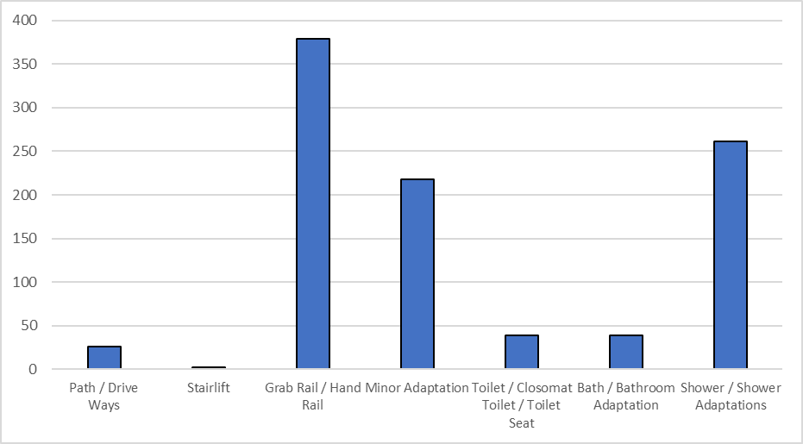

Source: Falkirk Council Information Systems

The following table indicated that the number of disabled adaptations completed has remained relatively constant over the period 2015/16 to 2019/20 but covid has impacted on 2020/21.

#### **Table 5.4: Number of adaptations completed 2015-2021**

|  |  |
| --- | --- |
| **Year** | **Number** |
| 15/16 | 877 |
| 16/17 | 741 |
| 17/18 | 744 |
| 18/19 | 877 |
| 19/20 | 1087 |
| 20/21 | 319 |

Source: Scottish Housing Regulator

Table 5.5 highlights that 3% of households in Falkirk require adaptations which is not statistically different from Scottish figure. In relation to other Forth Valley local authorities this is slightly higher than Stirling and like Clacks. *Therefore, although more households have disabled adaptations in Falkirk a similar percentage still need adaptations when compared to national and neighbouring councils.*

#### **Table 5.5: Proportion of households reporting need of Disabled Adaptations 2017-2019**

|  |  |  |  |  |
| --- | --- | --- | --- | --- |
|  | **Falkirk** | **Stirling** | **Clacks** | **Scotland** |
| % Household’s reporting requiring adaptation | 3% | 2% | 3% | 3% |
| Equivalent number of households | 2000 | 1000 | 1000 | 82, 000 |

Source: Scottish House Condition Survey 2017-2019

In relation to household type who report requiring disabled adaptations this is compared to the national figure in Table 5.6, sample sizes are too small to compare to other Forth Valley Councils. Older households (5%) and other households (4%) reporting they require adaptations are above the national figure with the figure for families lower than the national figure (3%).

#### **Table 5.6: Household type reporting requiring disabled adaptations 2017-2019**

|  |  |  |  |
| --- | --- | --- | --- |
| **Falkirk** | **% Report requiring adaptations** | **Equivalent number of households in Falkirk** | **Scotland % report requiring adaptations** |
| Older households | 5% | 1000 | 3% |
| Families | <0% | <1000 | 3% |
| Other | 4% | 1000 | 3% |

Source: Scottish House Condition Survey 2017-2019

Table 5.7 highlights that a higher percentage of tenants in the social rented sector in Falkirk require disabled adaptations than the national figure.

#### **Table 5.7: Households reporting need for adaptations by dwelling type or tenure 2017-2019**

|  |  |  |  |  |
| --- | --- | --- | --- | --- |
| Tenure | Falkirk | **Stirling** | **Clacks** | **Scotland** |
| House | 3% | 2% | 2% | 3% |
| Flat | 3% | n/a | n/a | 4% |
| Owner-occupied | 3% | n/a | n/a | 3% |
| Social Housing | 7% | n/a | n/a | 3% |
| Private Rented | n/a* | n/a | n/a | 3% |

Source SHCS, *data not available due to small sample size

There is need for adaptations in 3% of the housing stock (2000 properties) locally. This is higher than HNDA 2 which also used Scottish House Condition Survey data (2011-16) to estimate a need for adaptations in 2% of properties (1380 properties).

Table 3.7 chapter 3 sets out the current provision of social rented accessible housing locally. This estimates that 2, 510 are amenity or ambulant.

Table 5.8 considers applicants who have applied for accessible housing and have lower-level medical points.

#### **Table 5.8: Falkirk Council applicants with medical priority (bands 2-4) 2021**

|  |  |
| --- | --- |
| **Current Location** | **Number** |
| Central | 141 |
| East | 109 |
| Not available | 18 |
| Outwith Area | 32 |
| West | 92 |
| **Total** | **392** |

Source: Falkirk Council Information Systems

There is no comprehensive data locally on the need for accessible and adapted provision as there is no Common Housing Register. Therefore, consideration has been given to other data sources such as the Scottish House Condition Survey and the Falkirk Council Tenant Satisfaction Survey.

Table 5.9 highlights households who report that their property limits their day-to-day activities. It is significant to note that the percentage of households in Falkirk Council area reporting their dwelling restricts their movement is higher than neighbouring Forth Valley Councils and Scotland.

#### **Table 5.9: The proportion of households in each Local Authority that report some aspect of their dwelling limits their day-to-day activities 2017-2019**

|  |  |  |  |  |
| --- | --- | --- | --- | --- |
| **Dwelling restricts movement** | **Falkirk** | **Stirling** | **Clacks** | **Scotland** |
| % Of household | 9% | 4% | 8% | 7% |
| Equivalent number | 7000 | 2000 | 2000 | 167, 000 |

The HNDA considers need across tenures therefore the following table sets out by tenure the percentage of households who report their dwelling restricts their day-to-day activities. It is significant to note the percentage is higher in Falkirk for social housing than the Scottish percentage.

#### **Table 5.10: The proportion of households by Local Authority and sub-group that report that some aspect of their dwelling limits their day-to-day activities 2017-2019**

|  |  |  |  |
| --- | --- | --- | --- |
| **Households report restriction of movement** | **Falkirk** | **Equivalent number** | **Scotland** |
| Owner-occupied | 4% | 2000 | 4% |
| Social Housing | 22% | 4000 | 14% |
| Private Rented | n/a | n/a | 3% |

Source: SHCS 2017-19

### **Engagement**

Further to the overview on engagement (paragraph 5.1.9), the Tenant Satisfaction Survey (TSS) is most relevant to templates 1 and 2. This was carried out December 2021/ January 2022.

The TSS included a question asking people if they would like to move over the next 2 years and why. Of those surveyed, 20% (200) wanted to move. Of those 14% referred to the physical layout of their current property. This is broken down in Table 5.13 by housing hub.

#### **Table 5.11: Tenent Satisfaction Survey 2021/2 - Question would like to move in the next two years**

|  |  |  |  |  |
| --- | --- | --- | --- | --- |
| Reason | Central | East | West | Total |
| Physical features of property | 13% | 17% | 10% | 14% |

Source: Falkirk Counicl Tenant Satisfaction Survey carried out by Research Resource[15]

The TSS also asks tenants if they consider themselves to have a disability, 25% of tenants report they have a physical disability.

#### **Table 5.12: Tenent Satisfaction Survey 2021/2 – Tenant advises that they have a disability or health condition**

|  |  |  |  |  |
| --- | --- | --- | --- | --- |
| **Illness or Disability** | **% Central total** | **%**  **East total** | **%**  **West total** | **%**  **FC total** |
| Deaf | 1% | 1% | 0.30% | 1% |
| Blind | 1% | 0.30% | 1% | 1% |
| Learning disability, development disorder | 4% | 2% | 3% | 3% |
| Physical Disability | 29% | 25% | 20% | 25% |
| Mental health condition | 9% | 6% | 8% | 8% |
| Chronic illness | 18% | 9% | 13% | 14% |
| Other | 2% | 14% | 4% | 6% |
| Prefer not to say | 1% | 7% | 8% | 5% |
| No condition | 34% | 35% | 43% | 37% |
| **Total** | **100%** | **100%** | **100%** | **100%** |

Source: Falkrik Counicl Tenant Satisfaction Survey carried out by Research Resource

Initial discussions took places with Homes for Scotland at the Strategic Housing Group around need and supply of private wheelchair accessible properties. The view given at meetings with the private sector was this would be market led but they could potentially adapt new build properties to some extent if advised early in the build stage. This will be progressed through the Strategic Housing Group as we develop the new LHS.

Discussions with RSLs on disabled adaptations have indicated the budget allocation from Scottish Government is often in the second quarter of the financial year which can present challenges. This will be explored by the Strategic Housing Group and as part of the new LHS.

Engagement took place in 2021 with Falkirk Council tenants living in the older peoples’ housing development at Salmon Court Bo’ness. This considered use of common rooms and tenants’ perspectives on potential to reconfigure as additional adapted properties. On the basis of this consultation an additional adapted property will be provided at Salmon Court. This will be progressed through the SHIP. Previously tenants in Falkirk Council’s Greenbank Court were consulted on the use of communal facilities and an adapted property was provided there.

### **Shortfall in need and provision**

There is a need for adapted or accessible provision with the following estimates made.

* Disabled adaptations - 3% households report needing an adaptation. This equates to approximately 2000 dwellings. HNDA 2 projected 2% with 1,380 dwellings.
* The following section considers Still Minding the Gap (2018) research modelling of this locally indicates need for a further 1, 427 mobility devices by 2024/5.
* Amenity or accessible housing - 392 are on the housing register with lower-level medical points.
* The SHCS estimates 7000 households whose dwelling limits their day-to-day activity. This equates to circa 4000 social rented households and 2000 owner -occupiers.
* Tenant Satisfaction Survey highlights 20% of tenants want to move in the next 2 years. The SHR highlights there are 20, 266 social rented properties, if it is assumed 20% want to move this equates to circa 4, 053 social rented properties. The TSS identified that 14% of tenants want to move due to the physical difficulties with their property. If this applied to the social rented sector this equates to circa 567 tenants.

Information gaps and how they will be progressed are set out below.

1. A lack of robust data on private sector accessible /wheelchair accessible housing. This is explored further in the following section.
2. There is a lack of clarity on terms used for accessible housing. For the HNDA, we have used Scottish Housing Regulator data. However as highlighted not all information in SHR data matches working knowledge of stock from discussions with partners.
3. In relation to new build housing in future, we recognise that Scottish Government are reviewing Housing for Varying Needs Standards.
4. In the Housing Contribution Statement, we agreed an action around definitions of housing for older people. This work was delayed due to covid but will be progressed with partners on the Housing Contribution Statement Steering Group and the Strategy Housing Group.
5. There is a lack of comprehensive information on the need for adapted/ accessible and wheelchair social rented housing as there is not a Common Housing Register locally. We took account of this by considering a range of data sources. As we develop the next LHS, we will explore further with RSL partners.
6. RSL disabled adaptations. Although we have had limited discussions with RSL partners we will also progress in detail through the Strategic Housing Group for the next LHS.
7. Information used from the SHCS estimates properties with adaptations. However, there is a lack of information where adaptations have been removed.
8. There has been a reduction in Disabled Adaptations carried out due to the covid pandemic which is likely to impact on need in future years. A working group is considering disabled adaptations which come under Health and Social Care Integration and the findings will be reported in the LHS.

### **Future Need**

The need for accessible and adapted housing will increase long term. See tables 5.9, 5.10 from the SHCS and tables 5.11 and 5.12 from the TSS. It is important to highlight that the need for accessible and adapted housing comes from all age groups. See tables 5.19, 5.20, 5.21, which indicate a need for older people however notably from people of working age and children. More detailed work on need from younger groups is a gap which requires future consideration at the Strategic Housing Group and the Housing Contribution Statement Steering Group but especially through consultation for the new LHS. This is explored further in the following section.

### **Wheelchair Housing**

**National and local policies are as with template 1.**

### **Property Needs**

There is currently no universally agreed housing standard on housing for wheelchair users. Often terms such as Wheelchair Accessibility/ Liveability or Wheelchair Exemplar are used to refer to properties that are suitable for wheelchair users to live in and to distinguish them from properties that may be accessible for wheelchair users to visit and / or capable of being adapted for wheelchair users.

The Scottish Government published guidance on setting targets for wheelchair housing in March 2019[16]. The guidance states that the responsibility for setting housing target(s) for wheelchair accessible homes sits with the local authority as the statutory authority for housing of all tenures but should be taken forward as a corporate responsibility.

The guidance makes it clear that the provision of targets to support the delivery of Wheelchair Accessible homes across all tenures means homes suitable for wheelchair users to live in and should as a minimum comply with the design criteria indicated as a ‘basic’ requirement for wheelchair users, as outlined in Housing for Varying Needs (HfVN) (column ‘B’ in ‘Summary of Design Criteria’). Local authorities are strongly encouraged to include the design criteria indicated as ‘desirable’ (column ‘D’ in ‘Summary of Design Criteria’) wherever possible.

As with the previous section we have triangulated local data with national surveys and research. In this section we have also considered benefits data. This is to take account of data gaps.

### **Suitable for (client group)**

This type of accommodation will be suitable for wheelchair users. This includes all wheelchair users including families with disabled children; young adults; disabled parents with dependent children; adults who acquire a disability and use a wheelchair because of an accident, incident, or illness; and older wheelchair users.

### **Evidence - the current type and level of needs and provision**

Table 3.2 chapter 3 highlights that there are 189 Falkirk Council wheelchair properties and 69 RSL wheelchair properties giving a total of 258. Table 5.13 below highlights 391 applicants who have the highest medical banding for a wheelchair property.

#### **Table 5.13: Falkirk Council applicants with medical priority (band 1F) 2021**

|  |  |
| --- | --- |
| **Current Location** | **Number** |
| Central | 133 |
| East | 97 |
| Not available | 20 |
| Out with Area | 34 |
| West | 107 |
| **Total** | **391** |

Source: Falkirk Council Information Systems

If Table 5.13 is considered along with Table 5.9 lower-level medical points (392), it is estimated that there are 783 applications with a medical priority for accessible/ adapted and wheelchair properties.

To take account of local data gaps, the national methodology on wheelchair users and housing need has been modelled locally in the following tables.

The research Still Minding the Gap[17] was published in 2018. This estimated that 3.6% of Scottish households include a wheelchair user therefore 87,340 households in total. In HNDA 2 the national methodology from Minding the Gap (2012) was applied locally and triangulated with local data from housing records where available.

The starting point for Still Minding the Gap is that 3.6% of households include someone who uses a wheelchair. If this percentage is applied to the 2018 based household figure for Falkirk Council (74, 1760) there are 2,670 households locally which include someone who uses a wheelchair. The Still Minding the Gap methodology differentiates between types of wheelchair users as in the table below. The revised methodology makes use of additional questions asked in the English household survey. These questions are not asked in Scotland, but the researchers estimate the ratios would be comparable with Scotland. Table 5.15 applies the above national methodology to Falkirk Council area.

#### **Table 5.14: Still Minding the Gap 2 Methodology applied to Falkirk Council area.**

|  |  |  |  |
| --- | --- | --- | --- |
| Steps | Calculation | % Applied | No. |
| All households in Falkirk |  |  | 74,176 |
| 1: Calculate the number of indoor wheelchair user households | Assume EHS ratio. 0.4% of all households | 0.40% | 297 |
| 2: Calculate the number of outdoor user households | Assume EHS ratio. 2.3% of all households | 2.3% | 1,706 |
| 2b: Calculate the total number of wheelchair user households | Assume EHS ratio of 0.9% of all households for both users | 0.90% | 668 |
|  | Indoor wheelchair users +outdoor wheelchair users + those who use indoor and outdoor = total wheelchair user households |  | 2,670 |
| 3: Calculate the unmet housing need among indoor wheelchair user households | Assume 25.6% (all of those in SHS requiring adaptations and accommodation unsuitable) | 25.6% | 76 |
| 4: Calculate the unmet housing need among wheelchair user households using wheelchairs all the time | Assume 19% (all of those in EHS requiring adaptations and accommodation unsuitable) | 19% | 127 |
| 5: Calculate all unmet housing need among wheelchair user households | Unmet need indoor wheelchair users+ unmet need outdoor wheelchair users +unmet need both indoor and outdoor wheelchair users |  | 527 |

The Still Minding the Gap methodology highlights the importance of giving ranges for estimates.

*Range of estimates using Still Minding the Gap methodology*

High unmet need: Assuming unmet need is 1.3% higher.

Baseline unmet need: Assuming the rates in Steps 1 to 5 above

Low unmet need: Assuming unmet need is 2% lower.

#### **Table 5.15: Application of ranges to Falkirk Council area**

|  |  |  |  |
| --- | --- | --- | --- |
|  | **% Change** | **Falkirk**  **Wheelchair**  **Users** | **Falkirk**  **Unmet need** |
| Total number of wheelchair users and unmet need + 1.3% higher | 1.3% | 2,705 | 537 |
| As above | n/a | 2,670 | 527 |
| Total number of wheelchair users and unmet need -2% lower | 2% | 2,636 | 516 |

Still Minding the Gap research acknowledges that it is unlikely that the numbers of future wheelchair users in housing need will grow at a constant rate and instead will be affected by the health of the population which will be impacted on by:

* The prevalence of illnesses such as strokes, diabetes, cancers, Alzheimer’s, and arthritis, all of which are associated with higher rates of wheelchair use.
* An aging population which is also living for longer.
* Improvements and innovations in healthcare.
* The supply of adapted accommodation.

### **Future Need**

Still Minding the Gap develops a methodology for estimating a future need which has been modelled locally.

#### **Table 5.17: Scenarios to estimate future estimates of wheelchair users and unmet housing need.**

|  |  |
| --- | --- |
| Scenario 1 | improving population health where there is a decline in risk factors, particularly smoking and obesity, and in the prevalence of disabling diseases. |
| Scenario 2 | where current health trends continue – continuation of current trends in chronic conditions associated with disability, which results in increasing disability prevalence rates among older age groups |

Therefore, it is estimated that there are 2, 670 wheelchair users in 2022 of those 527 have a housing need. If health trends improve this will be 3,302 wheelchair users by 2027 with 652 in housing need and by 2032 there will be 3, 929 wheelchair users with 775 in housing need by 2032. Current health trends estimate 3, 433 wheelchair users by 2027 with 677 in housing need and by 2032 the estimate is for 4, 188 wheelchair users with 821 in housing need.

#### **Table 5.18: Estimate of national and local number of wheelchair users.**

|  |  |  |  |
| --- | --- | --- | --- |
| **Estimated number of wheelchair users in Falkirk** | **2022** | **2027** | **2032** |
| Scenario 1: Improved Health Trends | 2, 670 | 3,302 | 3,929 |
| % Increase future years |  | 24% | 19% |
| Scenario 2: Current Health Trends | 2,670 | 3,433 | 4,188 |
| % Increase |  | 29% | 22% |
| **Estimated Unmet Household Need from wheelchair users in Falkirk** | **2022** | **2027** | **2032** |
| Scenario 1: Improved Health Trends | 527 | 652 | 775 |
| % Increase future years |  | 24% | 19% |
| Scenario 2: Current Health Trends |  | 677 | 821 |
| % Increase future years |  | 29% | 22% |

Source: Still Minding the Gap estimates using census 2011 and household projections

Still Minding the Gap Research has been correlated with Benefits data. Firstly, consideration is given to Personal Independence payments (PIP) for daily living and mobility needs. Each component can be paid at standard rate, or enhanced rate for those with the greatest needs. To qualify for **enhanced** **rate** **PIP** **mobility**, based purely on physical problems, a claimant would need to have mobility limited to less than 20 meters. The DWP ran a scheme transferring people from Disability Living Allowance (DLA) to PIP. As of April 2021, there were 3,692 people in Falkirk Council area who received PIP enhanced mobility rate.

#### **Table 5.19: Enhanced mobility awards of PIP April 2021**

|  |  |  |  |
| --- | --- | --- | --- |
| **Number and %** | **Below pension age** | **Pension age** | **Total** |
| “ | 3, 279 | 687 | 3, 962 |
| “ | 83% | 17% | 100% |

Source DWP

This is significantly higher than the modelled data based on Still Minding the Gap. Therefore, the higher range figures are used for future projections**.**

**This is 3, 433 wheelchair users by 2027 with 677 in housing need and by 2032 the estimate is for 4, 188 wheelchair users with 872 in housing need.**

It is significant to note that although 22% of the UK population are disabled, this is 25% for Scotland. If the Scottish figure was applied to Falkirk, this could account for 40,223 people. If the percentage of children disabled was applied to Falkirk this could account for 2,249 children.

The following table sets out types of disability. This highlights that where 49% of disabled people have a mobility impairment this is 68% of people of state retirement age. In relation to children if 19% are disabled due to mobility, this could account for 429 children.

#### **Table 5.21: Disability prevalence (%) by impairment type 2019/20**

|  |  |  |  |  |
| --- | --- | --- | --- | --- |
| **Impairment type** | **All disabled people** | **Children** | **Working-age adults** | **State Pension age adults** |
| Mobility | 49% | 19% | 41% | 68% |
| Stamina/breathing/fatigue | 36% | 24% | 32% | 44% |
| Dexterity | 25% | 8% | 21% | 32% |
| Mental health | 29% | 31% | 42% | 10% |
| Memory | 16% | 11% | 16% | 17% |
| Hearing | 13% | 8% | 8% | 23% |
| Vision | 12% | 7% | 9% | 18% |
| Learning | 14% | 35% | 15% | 8% |
| Social/ behavioural | 9% | 45% | 9% | 2% |
| Other | 17% | 16% | 18% | 16% |

Source Family Resources Survey

*These factors are important for social rented landlords within Falkirk Council area to consider in their allocations policies to ensure adapted/ accessible and wheelchair properties go to those in most need, not just to those who fit a specific age band.*

### **Gaps**

The lack of comprehensive data on wheelchair users across housing, health and social care data means there is a necessity to triangulate available information which has led to the use of national research, benefits data, and Council housing register data. This will be considered by the Housing Contribution Statement Steering Group which includes health, Social Work, RSL and Council housing representatives. We will explore with partners a focus group around need for wheelchair housing as part of consultation for the new LHS.

From a housing perspective there is no obvious data source which indicates all tenure need for wheelchair housing and this is an area which will require future consultation as part of the development of the new LHS.

The lack of a Common Housing Register locally means that there is likely to be duplication on the need for wheelchair users across Council and RSL waiting lists. This is an issue which will be explored through the Strategic Housing Group (Falkirk Housing Market Partnership) as part of LHS development.

It has been difficult to access information on disabled children. Stakeholders including colleagues attending the Housing Contribution Statement Steering Group and those involved in disabled adaptations have advised this is increasing. This led to consideration of the Family Resources Survey which has confirmed this.

Consideration of benefits data such as PIP along with health and wellbeing factors relating to obesity, smoking, disability conditions and poverty highlight the need to explore further through the Falkirk HSCP Joint Needs Assessment Update and new Strategic Plan. Initial indications are that there will be a significant future need for specific property types.

### **External stakeholder consultation and engagement**

Discussions with stakeholders including colleagues in the Access to Housing Team advise there continues to be need locally for wheelchair housing. Colleagues advise this is particularly the case in relation to the need for larger wheelchair properties and properties for bariatric patients. This relates to a lack of provision locally.

The Tenant Satisfaction Survey is also of relevance.

### **Non-permanent housing (Template 3)**

### **National Policies**

* Housing (Scotland) Act 2001 (template 1 -6)
* Homelessness etc. (Scotland) Act 2003 (templates 3,4)
* The Homeless Persons (Provision of Non-permanent Accommodation) (Scotland) Regulations 2010 (templates 3,4)
* The Homeless Persons (Unsuitable Accommodation) (Scotland) Order 2004 (templates 3,4)
* Licensing of Houses in Multiple Occupation Statutory Guidance for Scottish Local Authorities (templates 3)
* Housing (Scotland) Act 2006
* Children and Young People (Scotland) Act 2014 (template 3, 4,5)
* Youth Homelessness Prevention Pathway (template 3, 4,5)
* Equally Safe: Scotland's strategy to eradicate violence against women (template 3, 4,5)
* Housing Options Protocols for Care Leavers (Scottish Government 2013) (template 3, 4,5)
* Staying Put Scotland (Scottish Government 2013). (template 3, 4,5)

### **Local Policies**

* Falkirk Council RRTP 2019-2024 (template 3,4,5)
* Falkirk Council Temporary Accommodation Plan (template 3,4,5)
* Falkirk Council Closer to Home Strategy (templates 3,4,5)
* Falkirk Council’s Children’s Services 5-year Strategy (template 3,4,5)

Local policy continues to be to secure non-B&B accommodation which is cost–effective (for both client and for the Council) for use as temporary accommodation.

### **Property Needs**

This section covers some of the accommodation needs of people who may require accommodation whilst in education, preparing to enter owner occupation / social renting, experiencing homelessness or other housing crisis. This section considers the requirement for transitional accommodation, mainly single-person or single-parent family flats.

The provision includes self-contained, dispersed temporary accommodation flats and houses in both the private and social sectors, supported accommodation units and serviced accommodation units across the local authority area. Generally non-permanent housing is delivered locally through existing properties as opposed to new build and there is no property or land requirements.

### **Client Group**

The main client groups are likely to be people experiencing homelessness, fleeing domestic abuse, refugees, and other groups such as students, economic migrants and asylum seekers. included.

### **Evidence**

Falkirk Council has received an average 1,109 homelessness applications each year in the last 10

years, including 2020-21. There was a 7.7% reduction in homeless applications in 2020/21 however, this was in contrast to a 15.2% increase in applications in the previous financial year whilst nationally the average was a zero variance.

When we look at the percentage of the population in Falkirk that is homeless this is around 0.46%, well below the national average (0.65% based on 2019/20 national homelessness data and population at 5.6 million).

The number and percentage of applicants being assessed as homeless/potentially homeless fell in 2020/21 in line with the number of applicants to 79% of assessments. This compares to 83% of applicants in 2019/20 that were assessed as homeless/potentially homeless.

#### **Chart 5.2: Number of homeless applications compared to homeless/potentially homeless assessments 2012-2021**

***Chart, line chart

This line graph shows the number of homeless presentations between 2012 and 2021, it also shows the number of applicants assessed as homeless/potentially homeless. ***

Source: Scottish Government Annual Homeless Report 2020-2021

Table 5.22 shows that in 2020-2021 single applicants remained the largest group presenting as homeless at 755 (70.5%), a 2.8% increase on the percentage of homeless applications in 2019/20. 47.5% of all homeless applicants were single males, a 3.1% increase on 2019/20. Single person households along with childless couples, make up 75.2% of applications which is 2.1% higher than 2019/20. This places an even greater demand on finding suitable permanent housing solutions, particularly as there is a shortage of one-bedroom properties in Falkirk.

#### **Table 5.22: Homeless applicants by household 2016/7-2020/1**

|  |  |  |  |  |  |
| --- | --- | --- | --- | --- | --- |
| **Applications by household type** | **16/17** | **17/18** | **18/19** | **19/20** | **20/21** |
| Single Person | 780 | 743 | 719 | 787 | 755 |
| Single Parent | 202 | 222 | 176 | 230 | 212 |
| Couple | 72 | 67 | 52 | 64 | 51 |
| Couple with Children | 63 | 67 | 49 | 62 | 38 |
| Other | 13 | 8 | 8 | 10 | 10 |
| Other with Children | 8 | 8 | 6 | 11 | 6 |
| **All** | **1138** | **1115** | **1010** | **1164** | **1072** |

Source: Scottish Government Annual Homeless Report 2020-2021

As shown in Table 5.23, “Asked to leave” has consistently been one of the main presenting reasons for homelessness in the last 5 years however, this is closely followed by “dispute within household: violent or abusive” which was the highest presenting reason in both 2016/17 and 2020/21.

#### **Table 5.23: Reason for homelessness 2016/7-2020/1**

|  |  |  |  |  |  |  |
| --- | --- | --- | --- | --- | --- | --- |
| **Reason for homelessness** | **16/17** | **17/18** | **18/19** | **19/20** | **20/21** | **%** |
| Asked to leave. | 309 | 275 | 245 | 379 | 321 | 27.8 |
| Dispute within household: violent or abusive | 281 | 311 | 241 | 301 | 335 | 26.7 |
| Other reason for leaving accommodation/household | 165 | 181 | 182 | 194 | 145 | 15.8 |
| Other reason for loss of accommodation | 184 | 177 | 153 | 159 | 85 | 13.8 |
| Dispute within household/ relationship breakdown: non-violent | 109 | 122 | 114 | 73 | 127 | 9.9 |

Source: Scottish Government Annual Homeless Report 2020-2021

The provision of temporary emergency accommodation is one of the core functions of the Council’s homelessness service. As well as seeing a reduction in the number of homeless applications in 2020/21, there was a 6% decrease in the number of homeless households provided with temporary accommodation. In 2019/20 well over half of homeless applicants (59.5%) required temporary accommodation and 91.6% of the offers of temporary accommodation made were accepted. In comparison, the numbers requiring temporary accommodation during 2020/21, was 49% with 91.9% of offers being accepted.

As can be seen in Table 5.24, the majority (70%) of homeless accommodation is provided through the use of the Council’s own stock. Other properties are provided through the private sector leasing scheme as well as some RSL properties.

#### **Table 5.24: Temporary accommodation provision 2016/7-2020/21**

|  |  |  |  |  |  |
| --- | --- | --- | --- | --- | --- |
|  | **16/17** | **17/18** | **18/19** | **19/20** | **20/21** |
| LA ordinary dwelling | 300 | 237 | 365 | 329 | 299 |
| Housing association / RSL dwelling | 75 | 52 | 52 | 50 | 51 |
| Hostel - local authority owned | 0 | 2 | 0 | 2 | 2 |
| Hostel – RSL | 0 | 0 | 0 | 0 | 0 |
| Hostel – other | 1 | 0 | 1 | 0 | 2 |
| Bed and breakfast | 0 | 0 | 3 | 0 | 1 |
| Women’s refuge | 0 | 0 | 0 | 0 | 0 |
| Private sector lease | 74 | 72 | 58 | 46 | 45 |
| Other placed by authority | 44 | 46 | 28 | 27 | 27 |
| **Total** | **494** | **409** | **507** | **454** | **427** |

Source: Scottish Government Annual Homeless Report 2020-2021, Multiple responses allowed

Table 5.25 highlights that Falkirk Council is making greater use of temporary accommodation when compared to the national figures. It shows that the numbers in temporary accommodation have been increasing since 2016 but since 2020 there has been a significant increase in the use of temporary accommodation This is due to all new mainstream lets being suspended for several months during the first lockdown which meant that the backlog of households in temporary accommodation continued to grow. From 23rd March 2020 to 31st March 2021, the Council had to bring an addition 114 properties from the mainstream pool of stock to use as temporary accommodation.

#### **Table 5.25: Temporary accommodation homeless households 2015-2021**

|  |  |  |  |  |
| --- | --- | --- | --- | --- |
| **As Of 31st March** | **Falkirk** | **Scotland** | **% Change From Previous Year – Falkirk** | **% Change From Previous Year – Scotland** |
| 2021 | 378 | 13,097 | 34.0% | 12% |
| 2020 | 282 | 11,665 | 33.6% | 6.1% |
| 2019 | 211 | 10,989 | 14.0% | 0.5% |
| 2018 | 185 | 10,933 | -5.0% | 0.5% |
| 2017 | 195 | 10,873 | 4.8% | 0.0% |
| 2016 | 186 | 10,872 | -44.0% | 2.8% |
| 2015 | 334 | 10,567 | 15.9% | 2.7% |

Source: Scottish Government, Homeless Statistics

As well as an increase in the number of units the last two years has also seen an increase in the average number of days spent in temporary accommodation. In 2018/19 the average number of days spend in temporary accommodation was 80.9 days, it increased to 89.9 days in 2019/20 but in 2020/21 it increased to an average of 140.7 days.

The reasons for time spent in temporary accommodation increasing is influenced by a number of factors including:

* a reduction in the turnover of available accommodation
* an increase in the numbers who the Council have a duty to rehouse
* a decrease in stock from the new build programme and refusals of first offers (the Council currently have two offers for our statutory homeless clients who presented prior to 1st October 2020)
* need from households with physical disabilities including larger households with disabled member (s) e.g., children.

To reduce time spent in temporary accommodation a package of measures was approved by the Council’s Executive committee. These included:

* increasing the quota of vacancies ring-fenced for homeless applicants. This was increased from 33% to 45% but at the end of 2021 this was increased to 70% for a 3-month period. This has been extended for a further three-month period (March 2022)
* capping the period during which (choice-based) bids can be made before direct matching takes place and
* introducing a ‘one offer only’ policy.

Table 5.26 highlights the increasing number of households with dependent children and pregnant women in temporary accommodation. On average, 26% of households in temporary accommodation in the last 5 years have had children and/or pregnant women. Despite the impact of the pandemic on the backlog of households within temporary accommodation, this percentage has remained similar to 2019/20 (24% on 31st March 2021 compared with 26% at the same point in 2020). Time in temporary accommodation being longest for households with disabled member (s) including larger households with member (s) with physical disabilities (housing needs team)

#### **Table 5.26: Number of households with dependent children or pregnant women in temporary accommodation 31st March 2017-2021**

|  |  |  |  |  |  |
| --- | --- | --- | --- | --- | --- |
|  | **2017** | **2018** | **2019** | **2020** | **2021** |
| Local authority furnished | 29 | 45 | 25 | 54 | 75 |
| Housing association | 0 | 0 | 0 | 0 | 0 |
| Hostel: Local authority | 0 | 3 | 7 | 3 | 3 |
| Hostel: Other | 0 | 0 | 0 | 0 | 0 |
| Bed & Breakfast | 0 | 0 | 0 | 0 | 0 |
| Women’s refuge | 0 | 0 | 0 | 0 | 0 |
| Other | 17 | 18 | 17 | 15 | 14 |
| **Total** | **46** | **66** | **49** | **72** | **92** |

Source: Scottish Government Annual Homeless Report 2020-2021

The increasing number of households with dependent children and pregnant women is partly as a result of a number of larger families requiring assistance and there being a limited number of larger properties becoming available for let in either the social or private rented sector in the area. Turnover within these properties is also much lower than in smaller properties.

To meet the needs of larger homeless households the Council is exploring a range of initiatives including the conversion of adjoined properties to create larger homes as well as ensuring buy backs of former council stock, and new builds include provision for larger households. The following initiatives have been implemented:

* **Private Rented Sector (PRS).** We are promoting PRS housing options where appropriate and supporting lower income families to access larger homes in the sector via discretionary housing payments towards upfront costs (until the relaunch of our deposit guarantee scheme) and making use of the increased LHA rates.
* **Tenant Incentive Scheme**. To assist us to free up larger properties we introduced the ‘Tenant Incentive Scheme’ to provide assistance through financial incentives and support with moving to encourage those who are under-occupying their homes to move into smaller properties. We will be promoting this scheme further during the lifetime of the plan to ensure that we are able to utilise our stock to the best of our ability.
* The Council’s temporary accommodation ranges from self-contained dispersed local authority and private sector leased properties as well as two supported accommodation units (for young people and mixed family households) and a unit for complex and multiple needs which are shown in Table 5.27. The Castings unit offers short-term low-level support (56 days) for single males who are undergoing their homeless assessment.

#### **Table 5.27: Supported temporary accommodation 2021.**

|  |  |  |
| --- | --- | --- |
| **Supported Accommodation** | **No. of Units** | **Type of resource** |
| Seaforth House | 17 | Mixed 16 – 35 years |
| Kingseat | 19 | Mixed – families, single, couples and 3 “crash pads” for  emergency out of hours provision. |
| Castings | 24 | Males over 25 years |
| Inchyra | 12 | Mixed over 16 singles |

Source Falkirk Council – Housing Needs’ team

The Council’s supported accommodation services are focused on the delivery of support that works alongside the individual to help them to learn the necessary skills that will build their confidence to manage their own home independently. Working with an outcome approach, individuals are guided to understand the support that they need by working with a strength based, co-production approach to understand and acknowledge their journey towards independent living.

### **Young People Leaving Care**

The RRTP shows that the journey for care experienced young people is challenging, their outcomes are much poorer than their peers and recent policy and legislative developments acknowledge the need for care experienced young people to be supported until adulthood. Their rights have been extended to allow them to remain in their care placement to the age of 21, to receive aftercare support to the age of 26 and for joint social work and housing protocols to be established to help achieve the best outcomes for care leavers.

In November 2016, Falkirk Council Children’s Services and Corporate and Housing Services laid out their commitments for the provision of housing and support for young people leaving care. The commitment puts forward solutions to overcome the challenges of providing accommodation, a dedicated protocol for housing options, the need to continue support and how this is provided, the role and remit of the leaving care service and how support is provided to older young people in line with the Council’s obligations.

The ‘Housing options Protocol for Care leavers,’ developed as part of this commitment, looks at the wider range of housing options to stop a crisis homeless presentation. This is reviewed on an annual basis and a performance framework has been implemented to ensure that the Council can monitor the progress of the plan in achieving its key objectives.

Table 5.28 highlights the number of looked after children that have applied as homeless in the last 5 years. It highlights the number presenting has fallen since 2016/17.

#### **Table 5.28: Number of applicants looked after as a child by year 2016/7-2020/21.**

|  |  |  |  |  |  |
| --- | --- | --- | --- | --- | --- |
|  | **16/17** | **16/18** | **18/19** | **19/20** | **20/21** |
| Less than 5 years ago | 46 | 28 | 26 | 38 | 34 |
| 5 or more years ago | 77 | 70 | 61 | 73 | 59 |
| Not looked after | 982 | 984 | 894 | 1045 | 979 |
| Not known/refused | 32 | 31 | 29 | 7 | 0 |
| **Total** | **1137** | **1113** | **1010** | **1163** | **1072** |

Source: Scottish Government Annual Homeless Report 2020-2021

Falkirk Council’s Children’s Service has also launched a five-year ‘Closer to Home’ strategy in 2019 that aims to deliver better outcomes for children and young people on the edges of care or care experienced. The Closer to Home strategy specifically looks at housing options for young people to ensure that they have effective transitions into adulthood where they become valued members of our communities with fair and equal access to housing, employment, and lifelong learning.

In order to facilitate resettlement back to the area, Children’s Services have opened up a dedicated unit of 12 one-bedroom self-contained flats with support that will support young people during this transition. This model is seen as both flexible and affordable. This offers young people a Short Scottish Secure Tenancy with support.

### **Victims/ survivors of Domestic Abuse**

There are higher than average instances of domestic abuse in Falkirk compared to Scotland as a whole as shown in Table 5.29. It shows the rates of domestic abuse recorded by the police per 10,000 population. It highlights the rates are significantly higher in Falkirk compared to Scotland and have increased in the last two years.

#### **Table 5.29: Rates of domestic abuse recorded by police per 10,000 population 2016/7-2020/21.**

|  |  |  |  |  |  |
| --- | --- | --- | --- | --- | --- |
| **Area** | **2016-17** | **2017-18** | **2018-19** | **2019-20** | **2020-21** |
| Falkirk | 136 | 132 | 124 | 132 | 137 |
| Scotland | 109 | 110 | 112 | 115 | 119 |

<https://www.gov.scot/publications/domestic-abuse-recorded-police-scotland-2020-21/documents/>

Scottish Government HL1 homelessness statistics provide data on homeless presentations where domestic abuse has been cited as the reason for the application, this mirrors the trend for the number of domestic abuse incidents in the area reported to Police Scotland. Table 5.30 shows that despite a reduction in overall homeless applications in Falkirk, 335 homeless applications were received from victims of domestic abuse in 2020/21 compared with 301 in 2019/20. Domestic abuse was greater than the “asked to leave” reason for homelessness for the first time in nearly a decade as the main cause for households presenting as homeless.

#### **Table 5.30: Number of homeless presentations due to domestic abuse 2016/7-2020/21**

|  |  |  |  |  |  |
| --- | --- | --- | --- | --- | --- |
|  | **16/17** | **17/18** | **18/19** | **19/20** | **20/21** |
| Dispute within household: violent or abusive | 281 | 311 | 241 | 301 | 335 |

Source: Scottish Government Annual Homeless Report 2020-2021

Table 5.31 shows the number of people presenting as homeless due to domestic abuse and the difference each year between Scotland and Falkirk. It highlights that in the last year in Falkirk the number presenting has increased by 24% in 2019/20 and then 12% in 2021/21, this compares to 5% for Scotland in 2019/20 and -1% in 2020/21.

#### **Table 5.31: Number of homeless applications due to domestic abuse in Falkirk compared to Scotland 2015/6-2020/1.**

|  |  |  |  |  |  |  |
| --- | --- | --- | --- | --- | --- | --- |
|  | **Falkirk Homeless Application Dispute in household: violent / abusive** | **Scotland Homeless Application Dispute in household: violent / abusive** | **Falkirk Change No.** | **Scotland Change No.** | **% Change Falkirk** | **% Change Scotland** |
| 2015/2016 | 253 | 4,159 |  |  |  |  |
| 2016/2017 | 281 | 4,188 | 28 | 29 | 11% | 1% |
| 2017/2018 | 311 | 4,467 | 30 | 279 | 11% | 7% |
| 2018/2019 | 241 | 4,614 | -70 | 147 | -23% | 3% |
| 2019/2020 | 300 | 4,845 | 59 | 231 | 24% | 5% |
| 2020/2021 | 335 | 4,811 | 35 | -34 | 12% | -1% |

Source: Scottish Government Annual Homeless Report 2020-2021

The Council are working with domestic abuse partners, Police Scotland, and other bodies such as health services and the Scottish Government to develop a policy to tackle domestic abuse and reduce the impact of homelessness. The Council are looking to explore working with the Revive project: an enhanced add-on option to Homefinder UK case management service, focused on relocating domestic abuse survivors specifically designed to provide move-on housing options for those fleeing domestic abuse with no outlet to escape. Revive offers a wrap-around support and guidance for domestic abuse survivors to ensure people suffering domestic abuse get rehoused and can start a new life without fear.

Statutory and third sector partners recognise rates of domestic violence are increasing locally and it is recognised by all partners that consideration requires to be given to future arrangements. Work is currently ongoing to develop a Domestic Violence Policy. The Falkirk Community Planning Partnership have recognised six priority themes or areas, in the Falkirk Plan 2021-2030. One of the themes being gender related violence. These themes will be a focus of sustained joint working to make a positive difference to communities.

There is no refuge accommodation available in the Falkirk area, accommodation for anyone fleeing domestic abuse is available through our temporary accommodation pool. Support is provided by Committed to Ending Abuse (CEA) which was formerly Falkirk & District Women’s Aid. Falkirk and District Women’s Aid was established in 1976 as part of the Scottish Women’s Aid network. CEA advertise that they are an inclusive service committed to ending all forms of abuse providing support and advice to anyone regardless of age, beliefs, ethnicity, faith, gender, sexual orientation, and race.

CEA offer individual support as well as group work. Additionally, CEA provide support networks, creative and expressive arts workshops, parenting workshops and training for other organisations. CRE provide a confidential service includes keeping people safe, helping them to make decisions and supporting them with accommodation, legal advice, and access to benefits. Their staff are trained in above areas and the service is accredited by The Care Inspectorate.

People may self-refer but equally CEA accept referrals from all other agencies including the Police, Housing, Health, Social Work services and voluntary organisations.

Locally the Children and Young Person's Service offers one to one support and group sessions to children and young people. This support helps them to deal with any issues they are having because of living with domestic abuse. A phone line is available during office hours.

### **Refuges and asylum seekers**

Falkirk Council has over a number of years provided permanent accommodation to people fleeing conflict from its existing housing stock. Through the Syrian Vulnerable Persons Re-Settlement Scheme, the Council has supported 13 families. The majority of these families still remain in Falkirk with only one moving away from the area.

The Syrian Vulnerable Persons Re-Settlement Scheme has ended, and the new UK Resettlement Scheme (UKRS) has now replaced it. This scheme will have a global focus beyond the Middle East and North Africa. The aim to support those who would most benefit from resettlement in the UK, which could include:

* those requiring urgent medical treatment.
* survivors of violence and torture.
* women and children at risk.
* those living in formal refugee camps, informal settlements, and host communities.

The Council have pledged to take 15 people in the first year of this scheme and 2 families are arriving under that scheme at the end of March 2022.

The council has also pledged to take two Afghan families under the Afghan Relocation Assistance Programme (ARAP), but the Council has not been matched with families yet.

Policy is evolving daily on the Ukraine crisis and the Council is in the process of awaiting further information with regard to Council’s role but it’s likely the Council will offer properties to the Scottish Government “super sponsor” scheme in the coming weeks.

Support is in place to help individuals access further education, employment, and voluntary work. The Resettlement Team currently comprises of a Resettlement Officer and a Resettlement Support Worker as well as a temporary support worker.

In 2021, the Westminster government Home Office department took the decision to accommodate 54 asylum seekers in a hotel in Falkirk with support provided by Mears.

At the start of the covid pandemic, asylum seekers were housed in hotels in Glasgow as an emergency measure. However, the Home Office is now using hotel accommodation as standard provision, with little or no consultation with local authorities. Stakeholders including Positive Action in Housing[18] have expressed serious doubts about the Home Office’s choice of hotel accommodation, as have health, social care, housing and other third sector partners. Concerns have been raised about the mental health of vulnerable people living in hotels[19].

### **Student accommodation**

Table 5.32 shows the number of students in further education in Falkirk, Stirling, and Scotland and their accommodation. From the figures it is apparent that the numbers of students in Falkirk tend to reside with parents (79%) with only 1% residing in all student accommodation. It is likely this relates to there being no university in the area.

#### **Table 5.32: Accommodation of students in further education 2011**

|  |  |  |  |  |  |
| --- | --- | --- | --- | --- | --- |
| **Area** | **Living with parents** | **Living in communal establishment** | **Living in all student household** | **Student living alone** | **Other** |
| Falkirk No. | 5,272 | 21 | 68 | 183 | 1,161 |
| Falkirk % | 79% | 0% | 1% | 3% | 17% |
| Stirling No. | 2,870 | 2,701 | 1,945 | 336 | 937 |
| Stirling % | 33% | 31% | 22% | 4% | 11% |
| Scotland No. | 186,482 | 35,533 | 63,130 | 22,005 | 53,743 |
| Scotland % | 52% | 10% | 17% | 6% | 15% |

Source: 2011 Census, table LC6108

Discussions were carried out with Forth Valley college in Falkirk for HNDA2 which highlighted there was no need for separate student accommodation and staff advised on options for accommodation where required for short stays. Subsequent discussions with Falkirk College for this HNDA have indicated that Brexit has resulted in fewer overseas students and a reduction in need for accommodation even short term.

### **Future Need**

The Falkirk RRTP aims to reduce *temporary accommodation for homeless households* through prevention and Housing First. However as with a number of local authorities in recent years the use of temporary accommodation has increased due to range of factors set out page 110-112 tables 5.26 and 5.27. Medium term it is expected that there will continue to be a need for temporary accommodation particularly for larger households and households including someone with physical disabilities.

The lower numbers of larger accommodation properties and accommodation for those with physical disabilities in the social rented stock will mean a continued reliance on temporary accommodation until more permanent suitable properties are available. We will set out in the LHS how we plan to address such issues. Targets for increasing larger and adapted/ accessible/ wheelchair accommodation will be reviewed and reported on in the new LHS and annual updates.

The war in Ukraine has seen increasing need for accommodation for *refugees.* We expect this to continue short to medium term. The dispersal of asylum seekers throughout the UK by the Westminster government means an ongoing need for provision short to medium term.

### **Gaps**

The lack of information from Westminster government in relation to accommodation locally for asylum seekers is a key gap. The Falkirk Community Planning Partnership will continue to engage and explore with Westminster and other local authorities through the Association of Chief Local Housing Officers (ALACHO), the Society of Local Authorities Chief Executives (SOLACE) and continue to engage with third sector partners who are providing support to asylum seekers.

Work is ongoing around accommodation for people fleeing the war in Ukraine. This will be reported in the new LHS.

Exit surveys from households leaving temporary accommodation highlight a high level of satisfaction with temporary accommodation. The RRTP and the LHS Update will also provide updates around measures to address the length of time homeless households are spending in temporary accommodation. This specifically relates to the interim increase to 70% of housing allocations to homeless households.

Consultation was carried out with Falkirk College which confirmed that there was no need for student accommodation.

### **Supported provision (Template 4)**

Supported provision refers to care homes and sheltered housing. Hostel and supported homeless provision is included in template 3 also accommodation for people fleeing domestic violence. The need for services relating to people with dementia is included in template 5 (care and support for independent living). However, it is recognised in the later stages of dementia people may require supported care provision.

### **National Policies**

* Scotland’s National Dementia Strategy 2017-2020, Scottish Government (template 4)
* Keys To Life – improving quality of life for people with learning disabilities (template 3,4,5):
* Implementation Framework 2019–2021, SCLD, 2019 (template 3,4,5):
* The Carers’ Strategic Policy Statement, Scottish Government 2019 (template 3,4,5):
* Mental Health Strategy for Scotland 2017-2027, Scottish Government, 2017 (template 3,4,5):
* Regulation of Care (Scotland) Act 2001 and Community Care and Health (Scotland) Act 2002 (template 4,5)
* Health and Social Care Delivery Plan, Scottish Government’s 2020 Vision. (template 3,4,5):

### **Local Policies**

* Falkirk Plan (template 1-6)
* Falkirk HSCP Strategic Plan 2019 – 2022 (template 1-6)
* Falkirk Joint Strategic Needs Assessment *Information has been broken down below local authority level to inform the refresh of the Joint Strategic Needs Assessment which is ongoing (template 4,5)
* Buchan Research Master Plan on Bedded Care (template 4)
* Falkirk Housing Contribution Statement *See above. (Template 1-6)
* Falkirk Strategic Housing Investment Plan (template 1-6)

### **Property Needs**

The supply of supported provision currently consists of care homes and sheltered housing. Accommodation for those who are homeless or fleeing domestic violence is explored under non-permanent housing. There are often variations and overlaps across the range of definitions and terminology used by different landlords and providers.

### **Client Group**

This relates people who require some form of support which is linked with the property or scheme and may be met partly on-site from, for example, a key worker or warden, with additional support from a community psychiatric nurse, or general nurse, social worker, physiotherapist, care assistant, or housing support officer among others.

### **Evidence**

The Falkirk Health and Social Care Partnership are taking a systems wide approach with Buchan Associates currently carrying out a strategic assessment on primary care and a masterplan on the use of the Falkirk Community Hospital site. This will inform the Joint Strategic Needs Assessment and the Strategic Plan. This steers the HNDA in relation to care homes. Information on current provision is set out below.

#### **Table 5.33: Supply of bedded care including residential care homes 2021.**

|  |  |  |
| --- | --- | --- |
| **Location** | **Beds** | **Comment** |
| Falkirk Community Hospital | 16 | Provides specialised dementia care in an NHS setting. Majority have Adults with Incapacity, awaiting guardianship to move to care home. Patients with delirium given time to resolve and discharge home. In reality very few discharged home |
| Bo’ness Community hospital | 40 | 24-bedded rehab unit for frail elderly and 16 for patients with dementia. Discharge to nursing home or care packages home. |
| Intermediate care | 34 | Short-term (6-week) rehabilitation-/ reablement focussed interventions. |
| Care homes | 1081 |  |
| Specialist rehab | 16 | 10-bedded unit for Forth Valley-wide specialist rehabilitation within the Bellfield centre in Stirling; co-located with an 8 bedded stroke unit which also delivers a Forth Valley-wide service. |
| Hospice | 18 | Strathcarron near Denny |
| Hospital at home | 15 | Target 25 |

Source Buchan Associates

### **Occupancy rates for residential care homes**

Table 5.34 highlights high occupancy levels for older peoples’ care homes nationally and in neighbouring Forth Valley local authorities. The impact of the covid pandemic highlighted challenges with occupancy rates. This highlights the importance of a system wide approach being taken by the Falkirk Health and Social Care Partnership.

#### **Table 5.34: Percentage Occupancy rates for older peoples’ care homes 2015-2020**

|  |  |  |  |  |
| --- | --- | --- | --- | --- |
| **31 March** | **Stirling** | **Clacks** | **Falkirk** | **Scotland** |
| 2015 | 87 | 94 | 88 | 86 |
| 2016 | 87 | 95 | 87 | 88 |
| 2017 | 85 | 95 | 84 | 88 |
| 2018 | 83 | 91 | 90 | 86 |
| 2019 | 65 | 94 | 88 | 87 |
| 2020 | n/a* | n/a* | n/a* | n/a* |

*Postponed due to covid pandemic.

**Supported housing for older people.**

The following table sets out supported housing for older people locally. Locally the health and social care partnership provide onsite support in 4 older people’s developments owned by Falkirk Council equating to 232 properties. On site staff support is provided early morning to late evening with the development switched over to Mobile Emergency Care Alarm overnight.

#### **Table 5.35: Falkirk Council Supported Housing for Older People 2021**

|  |  |  |
| --- | --- | --- |
| **Office** | **Very Sheltered** | **Sheltered** |
| Falkirk (Camelon) | 27 | 0 |
| Falkirk (Glenfuir/ Glenbrae) | 0 | 169 |
| Denny | 0 | 36 |
| **Total** | **27** | **205** |

Source: Falkirk Council Information Systems

The following table sets out demand for the above older peoples supported accommodation. The criteria being people over sixty-five with high medical points or assessed by social work with an indicator of relative need. Area of choice is also provided below. However, it is recognised that there is demand in areas which do not provide this type of accommodation.

#### **Table 5.36: Area Analysis of supported housing for older people waiting list 2021.**

|  |  |
| --- | --- |
| **Area Preference** | **Number of applicants** |
| Bo'ness | 6 |
| Polmont & Rural South | 12 |
| Denny & Bonnybridge | 28 |
| Grangemouth | 22 |
| Larbert & Stenhousemuir | 25 |
| Falkirk | 46 |
| **Total** | **139** |

### **Other housing models**

The housing submission to Buchan Associates masterplan for the Falkirk Community Hospital site advised consideration may want to be given to a housing solution including both health and care for older people. This could be similar to that provided in Moray by Hanover and partners who provide higher end accommodation, support, care and in some scheme’s healthcare. However early discussions would be required between Falkirk Council strategic housing, a specialist RSL and the Health and Social Care Partnership. This is important for several reasons. Firstly, if funding was required from the Strategic Housing Investment Plan, this would need to be considered as early as possible along with other potential projections. Secondly RSL partners require to carry out a financial viability assessment to ascertain whether they could participate in such a model. Thirdly extensive dialogue would be required by the RSL and the Health and Social Care Partnership around procurement.

The provision in Moray is a level above Very Sheltered housing, one term being used is Extra Care housing. However, there is no such provision locally therefore identifying people who need Extra Care housing “cannot be done directly consequently proxies must be found” (Bale 2010 p10). One proxy is the number of people eligible for Attendance Allowance (Fenton and Markkanen 2009). Attendance Allowance is paid by the Department of Work and Pensions (DWP) and available to older people, who need help with personal care or have needed supervision because of a physical or mental disability for at least 6 months.

Taking account of the research previously quoted, Attendance Allowance could be used as a proxy as it is an independent assessment and data is available at a range of data zones. As indicated in Table 5.37, there has been an increase in Attendance Allowance locally and nationally over the period 2001-2010. This increase in Attendance Allowance is greater than the increase in those aged over sixty –five and over locally (11%) and nationally (8%). The disadvantage with Attendance Allowance is that it is not a measure of housing need therefore consideration is given in this section to triangulating with other data sources such as population projections, health/ ill health expectancy rates, older population by tenure, demand for adaptations, housing list information and occupancy rates for care homes.

#### **Table 5.37: Attendance Allowance comparison 65+ 2009-2019**

|  |  |  |  |  |
| --- | --- | --- | --- | --- |
| **Falkirk** | **2009** | **2019** | **Increase** | **% Increase** |
| Attendance Allowance | 3,778 | 3,988 | 210 | 5.3% |
| Population 65+ | 24,644 | 30,499 | 5,855 | 23.7% |
| % In receipt of AA | 15.3% | 13.1% |  |  |
| **Scotland** | **2009** | **2019** | **Increase** | **% Increase** |
| Attendance Allowance | 145,581 | 146,578 | 997 | 0.6% |
| Population 65+ | 868,512 | 1,044,145 | 175,633 | 20.20% |
| % In receipt of AA | 16.8% | 14.0% |  |  |

Source: DWP & NRS

The following table indicates the following:

* Over the period 2019-29 there will be an increase of 13.8% in the number of households between 65 to 74 and a 21.6% in those over 74.
* Over the period 2019-2039 there will be an increase of 22.8% in households between 65 to 74 and a 37.3% in those over 74

#### **Table 5.38: Household projections for older people**

|  |  |  |  |  |  |
| --- | --- | --- | --- | --- | --- |
| **Age Band** | **2019** | **2029** | **2039** | **% Change 2017-22** | **% Change 2019-39** |
| 65-74 | 17209 | 19953 | 22278 | 13.80% | 22.80% |
| 75+ | 13270 | 16916 | 21161 | 21.60% | 37.30% |
| Both | 30479 | 36869 | 43439 | 17.30% | 29.80% |

Source: NRS

Age is not an indicator of the need for services. It is relevant to consider healthy life.

expectancy (the length of time someone continues to live free from ill-health/ disability) and subsequently the time “not healthy”. It is the latter which impacts on the need for services. Chart 5.3 highlights that life expectancy rates have increased, people are spending a greater number of years in poor health.

#### **Chart 5.3: Life expectancy and healthy life expectancy at birth in Falkirk 2016-2018**

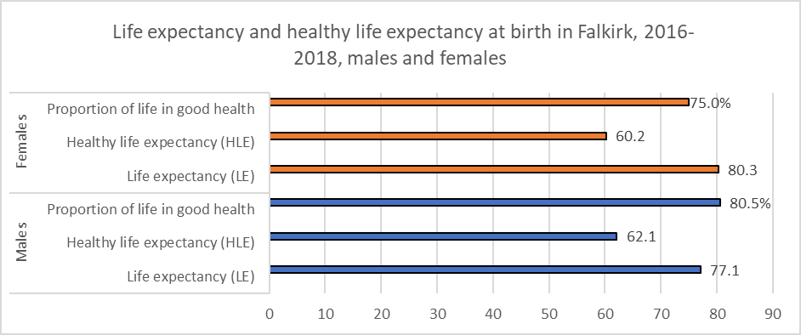

<https://www.nrscotland.gov.uk/statistics-and-data/statistics/statistics-by-theme/life-expectancy/life-expectancy-in-scottish-areas/2016-2018>

### **Future Need**

We recognise that there may be a need to explore an alternative model of housing, support and care for older people. The HSCP commissioned an independent consultant to carry out research around use of the former Falkirk Royal Infirmary site. One option for future consideration provided by housing relates to a model of housing and care. Falkirk Council housing colleagues continue to feed into this research. We will include progress on this work in the new LHS.

### **Gaps**

One of the key gaps is identifying if there is a housing model which could provide enhanced care, support, and housing for older people in most need to enable them to live in a homely environment. This is one of the options for the community hospital site being considered by the Buchan Associates research for the HSCP.

**Care and Support for Independent Living at Home (Template 5)**

HNDA guidance highlights this section should include the following which enable independent living at home; telecare, Home Help (Home Care), Carer, Handy person/ Care & Repair, Support Worker or Social Worker, Community Alarm.

### **National Policies**

* Scotland’s Mental Health Strategy: 2017 – 2027
* Scottish Government National Suicide Prevention Strategy
* Scotland’s National Dementia Strategy: 2017 – 2020
* Scotland’s Carers Strategic Policy Statement
* Scotland’s National Performance Framework
* National Telehealth and Telecare Delivery Plan for Scotland
* Keys To Life – improving quality of life for people with learning disabilities.
* Regulation of Care (Scotland) Act 2001 and Community Care and Health (Scotland) Act 2002
* Scottish Strategy for Autism
* [The Community Care (Personal Care and Nursing Care) (Scotland) Amendment Regulations 2019](http://www.legislation.gov.uk/sdsi/2019/9780111040614) or “Frank’s law”

### **Local Policies**

* Falkirk Plan - mental health and wellbeing was raised the most during conversations with residents for the Falkirk Plan.
* Falkirk HSCP Integration Joint Board Strategic Plan 2019-2022
* Falkirk HSCP Joint Strategic Needs Assessment (JSNA) Refresh
* Falkirk Council Housing Contribution Statement
* Falkirk Council Affordable Housing Policy Supplementary Guidance 06
* Falkirk Council Strategic Housing Investment Plan 2022/23 – 2026/27

### **Need for care and support services.**

People who require care and support to help live independently at home include those with a mental health problem, drug or alcohol misuse, confusion or dementia, physical disability or frailty, sensory impairment and learning disability.

This section is influenced by the Joint Strategic Needs Assessment for the Health and Social Care Partnership Strategic Plan and the Community Planning Partnership Falkirk Plan. Information is presented at both geographies, and challenges of this are explored further within this section.

There are broad key themes explored in this section:

* Mental health and wellbeing including vulnerable young people and prison discharge.
* High numbers receiving care services locally versus the impacts of the ageing workforce providing such services.

### **Mental Wellbeing**

The RRTP suggests around 51 people, about 5.6% of all homeless applicants each year would fit the criteria of a Housing First Model. These are individuals with complex and multiple issues as they have a prevalence of homelessness, substance misuse and criminal justice involvement. They are classed as homeless with severe and multiple disadvantage (SMD).

Chart 5.4 sets out alcohol related hospital admissions over the period 2002/3 to 2019/20. These figures are presented at Scotland, Falkirk Council (FC) and health and social care (HSC) locality. Although Falkirk Council is below national figures, the FC trend has been increasing since 2013/14 although dropping in 2019/20. However, there are clear differences between HSC localities with Falkirk Central being consistently above other localities and increasing since 2012/13. In 2018/19, Falkirk Central was higher than the national figure falling below in 2019/20.

#### **Chart 5.4: Alcohol – related hospital admissions 2002/3 - 2019/20 national, council, locality**Chart 5.4: Alcohol – related hospital admissions 2002/3 - 2019/20 national, council, localitySource ScotPHO profiles

Chart 5.5 sets out alcohol related deaths over the same time period and geographies as previous. Nationally alcohol related deaths are falling however there are more fluctuations locally. Overall FC deaths were falling but started increasing in 2012. Falkirk Central has been above the national figure since 2006/7, falling to the national figure in 2019/20.

#### **Chart 5.5: Alcohol -specific deaths 2002/3 to 2019/20 at national, council, locality**

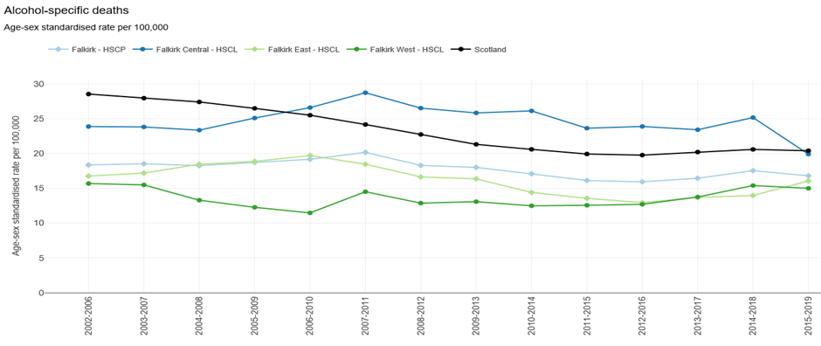

Source ScotPHO profiles

Public health data indicates there are clear differences in alcohol related deaths by gender. Consistently male alcohol related deaths are higher approaching national figures from 2013 with female deaths falling from 2013.

Long term consideration of public health data confirms local stakeholder engagement and the strategic direction from the Falkirk Plan highlight the importance of considering alcohol misuse particularly at sub area level.

**Drug misuse[20]**

Chart 5.6 highlights that drug related hospital admissions began an upward trend nationally from 2006/7. Locally there have been fluctuations with FC figures remaining below national figures for most HSC localities. However, at FC level there has been an upward trend since 2020/11 across all HSC localities and by 2019/20 the FC figure approached the national average. It is significant to note that locally drug related hospital admission in Falkirk Central has been above the national average since 2013/4.

#### **Chart 5.6: drug related hospital admissions 2002/3 to 2019/20 national, locality[21]**

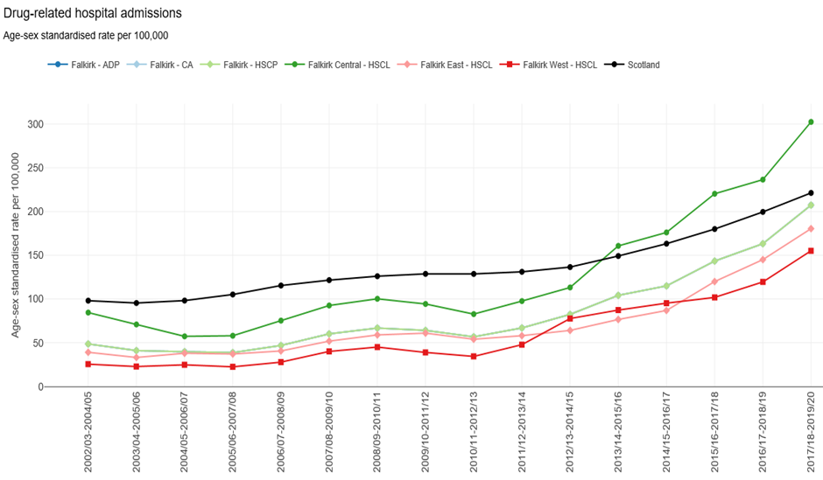

Chart 5.7 highlights that drug related deaths have increased nationally since 2006. FC drug deaths have also inceased since then, but there has been fluctuations with specific points being above the national figures (2016, 2018, 2019)

**Chart 5.7: Drug related deaths 2002/3 to 2019/20 at national, council, locality*[22]***

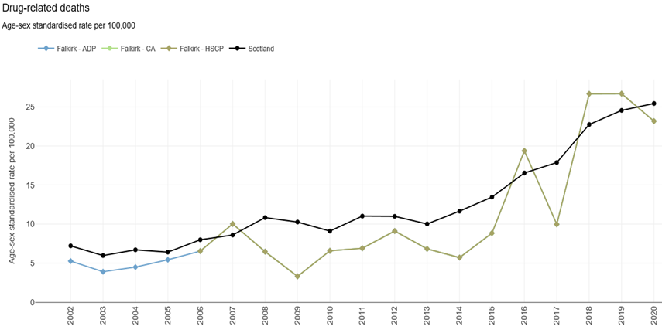

Source ScotPHO profiles

Chart 5.8 highlights that the population prescribed drugs for anxiety, depression and psychosis has been on an upward trajectory nationally since 2010/11. Of specific concern is that local rates are above the national trend across all HSC localities. Rates are highest in Falkirk Central.

#### **Chart 5.8: Population prescribed drugs for anxiety, depression, psychosis 2010/11 -2019/20 national, council and locality.**

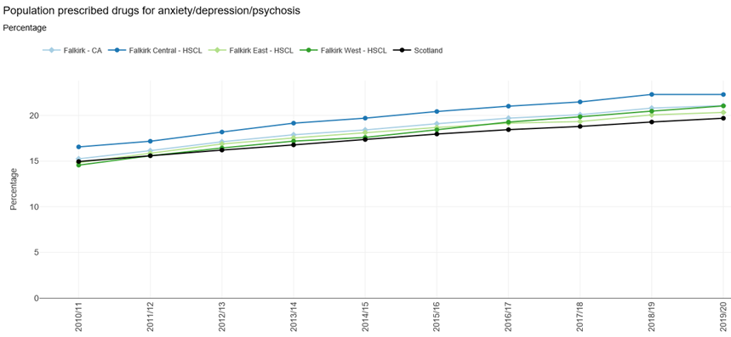

Chart 5.9 highlights, psychiatric patient admissions are on a downward trend nationally. However locally, rates have fluctuated, with all localities being above the national rate in 2015/16 to 2017/18. Despite this all localities have been falling since 2014/15 to 2016/17. Rates are highest in Falkirk Central.

#### **Chart 5.9 Psychiatric patient admissions 2002/3 to 2017/18 -2019/20 national, council. locality**

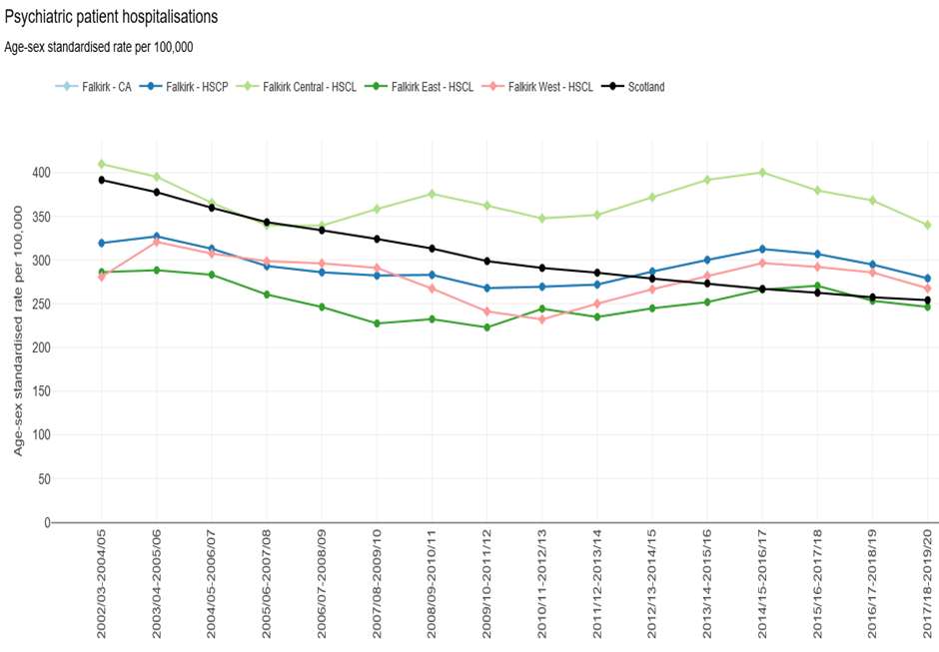

Chart 5.10 provides information on deaths from suicide. Nationally deaths from suicide have been falling from 2009/13 however at FC level such deaths have been rising. Indeed, deaths from suicide in all HSC localities have been above the national average from 2013/17. Falkirk Central is significantly above national and local figures.

**Chart 5.10 Deaths from suicide 2002/6 to 2015/19 at national, FC and locality**[23]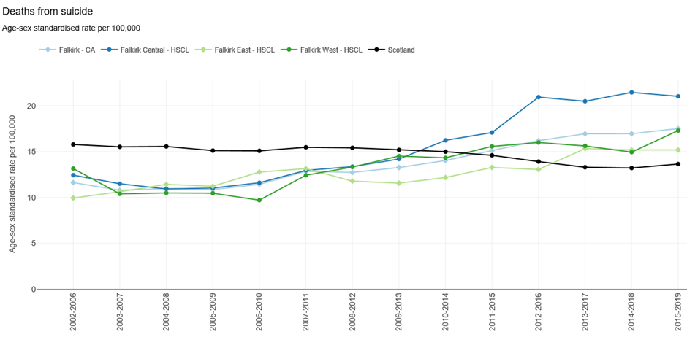

Source ScotPHO profiles

### **Prison leavers**

Chart 5.11 shows the number of homeless applications by prison leavers and highlights how the numbers fell from a high of 61 in 2012/13 to 4 in 2017/18. In response to the pandemic prisoners were released early under emergency powers used by the Scottish Government. Prisoners were released early from custody where it was considered necessary to support the continued operation of the prison service, or to protect the health of prison staff and prisoners. This can be seen in the number of applications for 2020/21 which increased to 64.

#### **Chart 5.11: Number of applications from people leaving prison 2011/12-2020/21.**

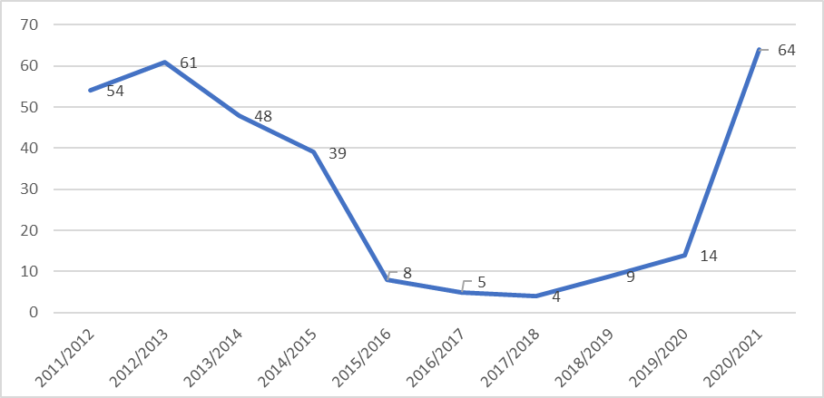

Source: Scottish Government Annual Homeless Report 2020-2021

### **Mobile Emergency Care Service**

Mobile Emergency Care Service (MECS) helps someone live independently at home. Falkirk Health and Social Care Partnership and Falkirk Council has safeguarded this life and limb service allowing vulnerable people live independently at home. MECS traditionally relied on analogue phone lines to operate, is now the first telecare service provided by a Scottish Council to be digitally enabled end to end.

MECS helps people live independently at home and is available to someone with:

* Confusion or dementia
* A physical disability or are frail.
* A sensory impairment
* Predisposition to falls / accidents at home over the last 5 years.  (257 falls monitors 10/ 2021)
* Been in a violent or abusive relationship numbers by year over the last 5 years.

Referrals for MECs come via social work who prioritise assisting vulnerable and those in the greatest need. There are3792 Service Users (Oct 2021).  Usually about 3800 and 3900.

Telecare services can provide a range of equipment which can work in a preventative monitoring mode for people with a variety of conditions. These services help 413 people in total, with a combination of: Smoke Alarms (243) Gas Safety devices (7), Door contacts (73), Heat Alarms (160), Bogus Callers (27), Bed exits (27), GPS location devices (21), Deaf smoke kits (11) and an epilepsy monitoring service is provided to ensure early help in the event of seizure (19).

### **Need for homecare**

Table 5.39 shows that of those people who receive home care the largest proportion (41%) receive 4 -10 hours of care. The last JSNA refresh advised that of those receiving home care 25% were under 65 (2008-2017), figures for 2018 highlight this has increased to 27%.

Table 5.39 shows in 2018, 42% of under 65s received 10 hours plus of home care, up from the figure of one third reported in the JSNA (2008-17).

#### **Table 5.39: Home care hours received by age banding 2018.**

|  |  |  |  |  |  |  |
| --- | --- | --- | --- | --- | --- | --- |
| **Age Range** | **0 - <2 hours** | **2 - <4 hours** | **4 - <10 hours** | **10+ hours** | **Total** | **% Age band** |
| 18-64 years No. | 70 | 70 | 245 | 275 | 660 | 27% |
| 18-64 % of age band | 11% | 11% | 37% | 42% | 100% |  |
| 65-74 years No. | 55 | 60 | 155 | 105 | 375 | 15% |
| 65-74 years % of age band | 15% | 16% | 41% | 28% | 100% |  |
| 75-84 years No. | 105 | 135 | 305 | 170 | 715 | 29% |
| 75-84 years % of age band | 15% | 19% | 43% | 24% | 100% |  |
| 85+ years No. | 95 | 140 | 290 | 165 | 690 | 28% |
| 85+ years % of age band | 14% | 20% | 42% | 24% | 100% |  |
| Unknown No. | 0 | 4 | 6 | 6 | 20* | 1% |
| Unknown % of age band | 0% | 25% | 38% | 38% | 100% |  |
| **Total No.** | **326** | **410** | **1003** | **722** | **2460** | **100%** |

Source: Scottish Public Health *includes 4 hours unknown

The higher percentage of people and hours of Homecare reported locally have been compared to the Scottish House Condition Survey in the following tables. This highlights that a higher proportion of households in Falkirk receive care when compared to neighbouring authorities and the Scottish figure as set out in the following tables.

**Table 5.41: Percentage of households where one more receiving care service 2017-19**

|  |  |  |  |  |
| --- | --- | --- | --- | --- |
|  | **Falkirk** | **Stirling** | **Clacks** | **Scotland** |
| % Household | 11% | 4% | 8% | 7% |
| Equivalent number | 8, 000 | 2,000 | 2,000 | 175,000 |

Source: SHCS 2017-19

**Table 5.42: Household type receiving care 2017-19**

|  |  |  |  |
| --- | --- | --- | --- |
| **Household member receiving care** | **% Of households** | **Equivalent number** | **Scotland** |
| Older households | 19% | 5,000 | 12% |
| Families | 5% | 1,000 | 3% |
| Other | 7% | 2,000 | 5% |

Source: SHCS 2017-19

**Table 5.43: Care received by tenure 2017-19**

|  |  |  |  |
| --- | --- | --- | --- |
| Household member receiving care | Falkirk | Equivalent number | Scotland |
| Owner- occupied | 4% | 2000 |  |
| Social housing | 29% | 6000 |  |
| Private rented | n/a | n/a |  |

Source: SHCS 2017-19

Falkirk Health & Social Care Partnership commissioned a needs assessment on unpaid **carers** in the local area in March 2018. This report considered current service provision and the factors which may impact on demand. The following key points were highlighted. In 2016/17 there were 2,047 adult carers across Falkirk known to the Falkirk and Clackmannanshire Carers Centre.

* The Young Carers Project is currently in contact with 171 young carers.
* The Carers Centre completed 273 Adult Carer Support Plans for Falkirk Carers and there were 1,624 Carer Assessments carried out by Falkirk Council (includes carer assessments incorporated into client assessment).
* As of February 2017 there were 3,572 carers entitled to Carers Allowance in Falkirk.
* The 2011 Census showed there is a greater proportion of carers in the most deprived areas in Falkirk and the highest number of carers and proportion of the population providing unpaid care was in the East locality.
* An increasing number of carers in Falkirk are accessing information and/or support from the Carers Centre and the number claiming carers allowance has been increasing.
* Many factors will impact on demand and indications are the cared for population in Falkirk is likely to grow. Falkirk’s older age population is expected to increase considerably, and people are living for longer. Long term conditions including dementia, diabetes, and stroke as well as those with multiple long-term conditions are all projected to increase. The majority of people with a physical disability are also older. The potential for the number of people providing unpaid care in turn is likely to increase as will the number who may require help and support.

The following tables on dementia are relevant for both the sections of the HNDA on supported provision (template 4) and care and support for independent living at home (template 5). These have been included under template 5 under the assumption that people with dementia are supported at home as long as possible. The Strategic Needs Assessment (SNA) indicates that it is well known that Dementia rates are likely to increase due to the increasing older population. Due to the nature of Dementia, it is very difficult to quantify the true population who have a type of Dementia. Different types of dementias can affect people in different ways and therefore people will experience different symptoms with different degrees of severity. The SNA highlights that Alzheimer Scotland estimated the prevalence of Dementia in the Scotland and have used this to estimate numbers in Falkirk.

#### **Table 5.44: Strategic Needs Assessment (5.1a) estimate dementia population – Falkirk 2017**

|  |  |
| --- | --- |
| **Population Group** | **Estimated Number of People with Dementia** |
| Males | 914 |
| Females | 1,684 |
| **Total** | **2,598** |

Source: Alzheimer Scotland

Information has been collected by Scottish Government on Dementia post diagnostic support. This is set out in the following table. This does not reflect the level of demand for Dementia PDS services in Falkirk. As of October 2018, there were approximately 115* people awaiting PDS services. The Strategic Needs Assessment highlights that it is important the HSCP considers the current situation and projections on Dementia Prevalence when drafting the new strategic plan.

**Table 5.45: JSNA Post diagnosis support referals (5.1b) – dementia 2014/5-2017/8**

|  |  |
| --- | --- |
| **Financial Year** | **Number of Dementia PDS Referrals** |
| 2014/15 | 233 |
| 2015/16 | 241 |
| 2016/17 | 268 |
| 2017/18 | 199* |

Source: NSS Public Health and Intelligence National Dementia PDS Team (*2017/18 figures are provisional)

Table 5.46 shows the need for services relating to property condition. Firstly, consideration is given to tenure by age. Table 5.46 shows 68% of the 65-74 age group are owner occupiers which is higher than the overall average of 65% and higher percentage at 29% in social rented sector. In comparison, there is a smaller than average percentage of the 75+ age group in owner occupation at 61%, a higher percentage in social rented accommodation, at 33% and a lower-than-average percentage in private rented accommodation at 6%. Rates of older people in the private rented sector are lower than the total percentage.

#### **Table 5.46: Tenure by age of household reference person 2011**

|  |  |  |  |  |  |  |  |
| --- | --- | --- | --- | --- | --- | --- | --- |
| **Age Group** | **Owner Occupier No.** | **Owner Occupier %** | **Social Rented No.** | **Social Rented %** | **Private rented or other No.** | **Private rented or other %** | **All No.** |
| <25 | 405 | 19% | 1,099 | 50% | 685 | 31% | 2,189 |
| 25-49 | 19,564 | 64% | 7,646 | 25% | 3,374 | 11% | 30,584 |
| 50-64 | 13,445 | 71% | 4,562 | 24% | 816 | 4% | 18,823 |
| 65-74 | 5,912 | 68% | 2,534 | 29% | 299 | 3% | 8,745 |
| 75+ | 5,156 | 61% | 2,754 | 33% | 481 | 6% | 8,391 |
| **Total** | **44,482** | **65%** | **18,595** | **27%** | **5,655** | **8%** | **68,732** |

Source 2011 Census Table DC4111

Table 5.47 indicates:

* 74% of households who live in properties with disrepair are pensioners.
* 28% of households in fuel poverty are pensioners.

#### **Table 5.47: Disrepair and fuel poverty by household type 2017-19**

|  |  |  |
| --- | --- | --- |
|  | Disrepair by Household Attributes | Fuel Poverty by Household Attributes |
| Families | 73% | 18% |
| Pensioners | 74% | 28% |
| Adults Only (Other) | 79% | 21% |

Source: 2017-2019 SHCS

There are currently Falkirk citizens accommodated and cared for out with the Falkirk Council area for which there is not an accommodation and care option locally, or where an individual has chosen to move out of area for some other reason. This includes clients from the following groups: learning disabilities, mental health difficulties, physical disabilities also drugs and alcohol misuse. This also includes people who have been delayed in Loch View Hospital. It is estimated this could relate to around 70 individuals. An officer has been appointed by the Partnership to review out of area placements. It is assumed when reviews are carried out an accommodation and care option within the area may be a solution for some service users currently housed out with Falkirk. Work in this area is ongoing.

### **Current services provision**

The **Rapid Rehousing Transition Plan** and annual updates provides an overview on services for the most vulnerable. The following is a summary of services.

|  |
| --- |
| **Transform Forth Valley** is a partnership between statutory agencies and the voluntary sector. |
| **Social Inclusion Project (SIP) / Tackling Inequalities & Improving Outcomes Project (TIIOP)**  The Social Inclusion Project works with individuals over 16 within the area to access support and engage with community services. Those accessing the service have experience of problematic substance misuse, are currently offending or involved with anti-social behaviour and are not on a Justice Order. TIIOP work with the same criteria except for individuals are on a Justice Order. |
| **Assertive Outreach + Service -** The Assertive Outreach and Service works across Forth Valley Area to support individuals over 16, their families, and the local community to reduce the impact of problematic substance use. They will work with other individuals too but 99% of clients identified have substance use issues. This is short term intensive intervention (approx. 4 Weeks) to encourage individuals and their families to identify and reduce barriers to engage with relevant services. |
| **Housing First Service** for Falkirk has been set up. This is designed for people who need significantlevels of support to enable them to leave homelessness. This includes people who are homeless with   * entrenched street homelessness, repeat service use (not just homeless services but Police/A&E/mental health) * severe mental illnesses or mental health problems, * history of drug and alcohol use, * poor physical health, limiting and persistent interrelated health and/or social care needs and disabilities.   A harm reduction approach is used. Naloxone champions are in place.  Support aims to help people maintain a tenancy and to address any other needs they identify however an individual’s housing is not conditional on them engaging with support. Service launched in January 2021. 45 referrals with 86% accepted. 10 tenancies realized by November 2021. Service is registered with the Care Commission.  Independent consultation exercise carried out and the recommendations have been incorporated into the RRTP Update. |
| **Housing Support** – a support assessment called tenancy start is carried out for new and current tenants. Housing support is provided by Loretto Care with an assessment being carried out at the start of support provision and at the end. This allows progress to be measured. In 2019/20 there were 689 referrals and in 2020/21 there were 919. The number of people that the support service works with is calculated by taking out “task 30 closures” i.e., where the client has not engaged with the support service, or the client has advised that they do not want or feel they need support. When this is considered Loretto worked with 523 people in 2019/20 (or 76% of those referred) and 653 in 2020/21 (or 71% of those referred). Support provision includes the following general housing support including looking at housing options, setting up utilities, council tax accounts etc. liaising with other agencies where appropriate (i.e., health, addictions etc), help applying for benefits and look at other income streams, help with debt/arrears, support to manage household tasks, support to identify resources in the area. The annual budget for housing support is £350, 000.  Publicity plan and awareness of homelessness will be rolled out to secondary schools. |
| Dedicated **Mental Health post** seconded to the Housing Service. |
| Since the development of the **SHORE standards (Sustainable Housing on Release for Everyone)** Falkirk Council has embraced its ethos and has a dedicated Housing Outreach Officer to ensure that the Council is able to assist any individuals entering or leaving a prison establishment. Homelessness and future rent arrears are prevented by providing housing advice on current and future housing options and ensuring that on release an appropriate housing solution is sought. Engagement with the customer is sought at the earliest opportunity through a person-centred approach and is focused on a seamless comprehensive joint planning for the individual taking account of needs and vulnerabilities.  A multi-agency approach is taken; consulting with staff, stakeholders, third sector services, customers, and their families, to improve the preparation and support for those leaving custody and ultimately, reduce the risk of reoffending, repeat homelessness whilst reducing trauma and promoting mental wellbeing. The result of having a dedicated Housing Outreach Officer and engaging with customers at the earliest opportunity can clearly be seen in the previous graph.  Highlighting numbers of homeless applications from prison leavers pre covid.  Housing options plans for all new customers are being introduced as part of the new allocations policy. |
| The **Family Mediation Service** has been relaunched. This aims to prevent homelessness and facilitate family relationships.  It is recognised that the need for such services will be long term. Work is ongoing to explore how to mainstream housing first service which will be reported through the annual updates of the RRTP. This will also link in to updates of the Joint Strategic Needs Assessment for the Health and Social Care Partnership Strategic Plan currently underway and the LHS.  The Falkirk Health and Social Care Partnership are working to address lower level needs in other ways as set out in the following page on the Living Well Falkirk website.  Alternative methods are being promoted in relation to people who require lower levels of care. This is set out in the following table from Living Well Falkirk which provides more details. |

**Living Well Falkirk** (livingwellfalkirk.lifecurve.uk) is a guided self-management web based service. It offers people an opportunity to find support, advice and solutions about their health, wellbeing, and self-management. Anyone can access the website 24 hours, 7 days a week, 365 days a year.

* 3211 people have used the site, with a total of 4733 visits – an increase of 1.6% on users from the previous year
* Most visits to the site were from within Falkirk (1060), followed by Glasgow (583), Edinburgh (492), London (400), then other areas. So as well as local people logging on, this indicates there continues to be a significant number of family members or friends from outside Falkirk visiting the site on behalf of their relative or friend who lives in the Falkirk area.
* 244 Lifecurve assessments were completed – we would hope to see increased use of this assessment type as people emerge from restrictions and start to look at ways to overcome the deconditioning that can happen with lack of activity, exercise, and movement.
* Self-assessment relating to a specific difficulty are broken down into “areas of need”. The most popular areas of need assessments are bathing, walking and stairs or steps.

### **Small Repairs and Handyperson Service**

The following chart sets out the number of completed jobs and requests to the small repair and handypersons services. This indicates that requests exceed work carried out indicating a demand for this service however the covid pandemic has impacted on service delivery from the last quarter of 2019/20 to present.

The following charts shows joinery is the work type most requested and the average days to complete have decreased in recent years.

#### **Chart 5.12: Small repairs and handyperson works requested and completed 2016-2021.**

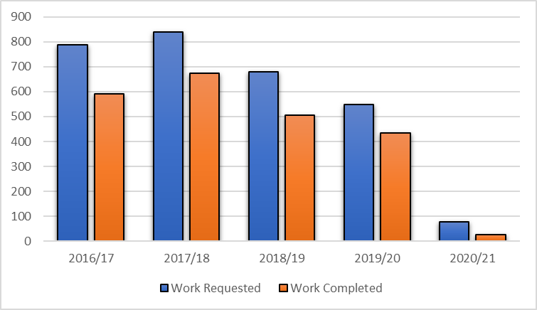

Source: Falkirk Council Information Systems

#### **Chart 5.13: Small repairs and handyperson works completed by type 2016-2021.**

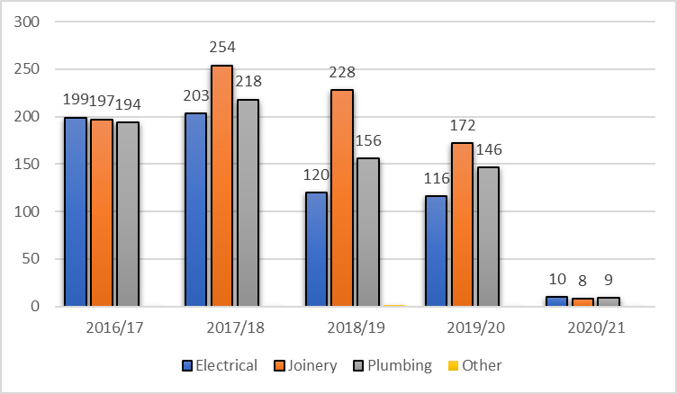

Source: Falkirk Council Information Systems

#### **Chart 5.14: Small repairs and handyperson works, average days to complete jobs 2016-2021.**

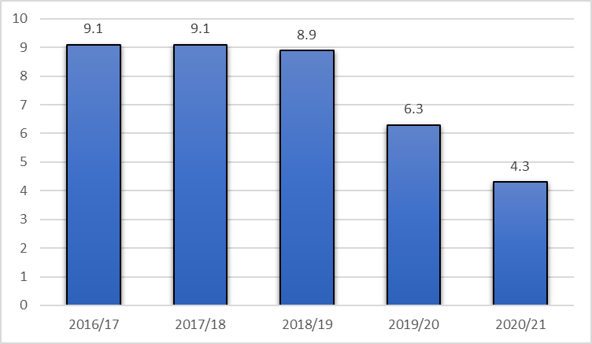

Source: Falkirk Council Information Systems

### **Future need**

We highlighted a need for a core and cluster model of supported accommodation when preparing the last Housing Contribution Statement (2019-2023). This highlighted 76 people with high care packages were housed out with Falkirk Council area due to a lack of options locally. This need was referenced in the current HNDA (pages 130, 146). The Health and Care Partnership provided further information in the table below which highlighted that there are now 100 people aged under 65 with high care and support needs who are housed out with area due to a lack of local options. It is therefore projected there is a future need for a core and cluster model of housing, care and support.

**Table 5.48: Service Users with high care and support needs < 65 and housed out with FC area July 2022**

|  |  |  |
| --- | --- | --- |
| **Client category** | **Number** | **%** |
| Learning disability | 28 | 28% |
| Mental Health | 34 | 34% |
| Physical Disability | 22 | 22% |
| Alcohol/ substance misuse | 5 | 5% |
| Sensory impairment | 2 | 2% |
| Dementia | 4 | 4% |
| Other | 5 | 5% |
| **Total** | **100** | **100%** |

Source Falkirk Health and Social Care Partnership

We are working with partners through the Housing Contribution Statement Steering Group to explore new build housing models for people previously accommodated out with Falkirk Council area or delayed in hospital who have high care and support needs. Council new build accommodation has been provided to people delayed in Loch View Hospital. Work is nearing completion to provide accommodation for another 4 people. This will be similar to a **core and cluster model** provided by Kingdom Housing Association and Kingdom Care to provide accommodation for 4 people.

We expect the need for support for *people with mental health issues, people with substance misuse and people fleeing domestic violence to remain long term*. The current need being identified pages 122 to 126. Extensive consultation was carried out for the Falkirk Plan (2021- 2030) which identified as priorities for the Falkirk Community Planning Partnership. The Falkirk Plan being the Local Outcome Local Improvement Plan. We also anticipate the need for support to continue long term for older people and those with physical disabilities. The challenges recruiting care workers are highlighted in the HNDA page 144 which will put additional pressure on the need for care and support long term.

Consideration of long-term public health data indicates that high needs for care and support provision is not caused by the covid pandemic but likely exacerbated by it. It is recognised that the need for current services will remain extremely high, short to medium term. The strategic direction from the Falkirk Plan recognises this through the priory given by the community planning partnership to mental wellbeing and substance misuse. There will be a need to mainstream services which will be set out in the annual updates to the RRTP, the final LHS Update and the new LHS.

### **Gaps**

1. Mainstreaming of services Housing First funding.
2. Local sub area geography differs between partners. Community Planning, Health and Social Care Partnership and strategic housing sub areas differ.
3. Local feedback for the Falkirk Plan including research and face to face engagement suggests that people with substance issues may have been unable to access mental health services due to their inability to manage their substance misuse. It is noted that for some they may not have the capacity to remain sober or reduce drug use until given appropriate support to do so.

The Falkirk Plan highlights that there is a lack of awareness and understanding of what it is like to have an addiction.

### **How gaps will be addressed**

1. The Mental Health Planning Group and Falkirk Alcohol and Drug Partnership are currently working together to create more integrated services for people experiencing alcohol and substance misuse issues.
2. Drug and alcohol misuse –a new fatal overdose team and health reduction outreach team have been set up.
3. Falkirk Community Planning Partnership will work alongside the local recovery community to design services around preventing death relate to drug misuse.
4. Falkirk Alcohol and Drugs Partnership has a workforce development programme and learning and training opportunities which the Community Care Partnership will promote. Sensitivity training will be rolled out for front line staff.
5. The Rapid Rehousing Transition Plan updates will set out how to mainstream services after Scottish Government funding is reduced.

### **External stakeholders**

Consultation in 2021 for the Falkirk Plan highlighted that “mental health and wellbeing was raised most during conversations with residents …”[24]. Further the Falkirk Plan highlighted the “causal link between mental health and substance abuse…”. It was highlighted that Forth Valley has the highest weekly alcohol consumption for all health boards in Scotland, and a higher percentage of adults exceeding weekly limits than Scotland as a whole[25].

Stakeholder consultation and the strategic direction from the Falkirk Plan have led to consideration over a long-term period of public health data relating to alcohol and drug misuse and mental health. This enabled detailed consideration whilst taking account of (hopefully) short term impacts of covid.

### **Site provision (Template 6)**

### **National policy**

* Scottish Government Equality Outcome (Equality Act 2010)
* Race Equality Action Plan, Scottish Government, 2017
* Social Housing Regulator/ Scottish Social Housing Charter & ARC
* Equal Opportunities Committee inquiries
* Scottish Planning Policy
* Improving Gypsy/Traveller Sites: Guidance on minimum site standards and site tenants’ core rights and responsibilities, Scottish Government, May 2015
* Improving the lives of Gypsy/Travellers: 2019-2021 -– joint action plan Scottish Government & COSLA, October 2019.
* The COVID-19 Framework to support Gypsy/Traveller communities, Scottish Government, December 2020
* Housing to 2040, Scottish Government, 2020/21
* Evidence Review: Accommodation Needs of Gypsy/Travellers, Scottish Government, October 2020
* Guidance for Local Authorities on Managing Unauthorised Camping by Gypsy/Travellers in Scotland, 2017
* The Equality Act, 2010
* Gypsy/Travellers in Scotland: Twice Yearly Count – January 2009 and July 2009

The Social Housing Charter includes a range of outcomes which set out what service users and tenants should expect from their social landlord. These outcomes include equalities, communication, participation, and value for money and apply to residents of Gypsy/Traveller sites[26]

This includes Outcome 16 which relates to the accommodation and services to Gypsy Travellers and ensures:

“Local councils and social landlords with responsibility for managing sites for Gypsy/Travellers should manage the sites so that sites are well maintained and managed”[27].

The Scottish Housing Regulator (SHR) has regulatory responsibility for social landlords who manage Gypsy/Travellers sites. The SHR is now the main source for reporting on Gypsy/Traveller sites providing data on the number of pitches, satisfaction levels on site quality and average weekly rents.

Scottish Planning Policy 2014, in relation to Gypsy Travellers reads as follows:

“HNDAs will also evidence need for sites for Gypsy/Travellers and Travelling Show people. Development plans and local housing strategies should address any need identified, considering their mobile lifestyles. If there is a need, local development plans should identify suitable sites for these communities. They should also consider whether policies are required for small privately-owned sites for Gypsy/Travellers, and for handling applications for permanent sites for Travelling Show people (where account should be taken of the need for storage and maintenance of equipment as well as accommodation). These communities should be appropriately involved in identifying sites for their use.”[28]

### **Local policy**

* Falkirk Local Housing Strategy 2017-2022
* Falkirk Local Development Plan 2

Falkirk Council has specific unauthorised encampment procedures in place to deal with encampments which are either illegal or unauthorised and include multi-agency involvement from several agencies such as Police, Housing, Health, Roads, Environmental Health, Education and Planning.

The Local Development Plan 2015 draws attention to the needs of Gypsy/Travellers and the requirement to set out guidance when dealing with applications for small privately owned sites. This is provided by Policy HSG08 of the current Local Development Plan whereby:

‘Policy HSGO8 Gypsy Traveller Sites

1. The site satisfies policies in the LDP relation got the protection of the built and natural heritage (Policies GN02-05 and Do-14 and the protection of public open space (Policy INF03),
2. The site can be appropriately landscaped, such that there will be no adverse effect on the character, appearance, and amenity of the area,
3. The site affords an appropriate level of residential amenity and access to community facilities: and
4. Access, park and other servicing can be provided to a satisfactory standard, and the site is not at significant risk from flooding, in terms of Policy RW06’[29]

### **Property Needs**

### **Gypsy/Travellers**

A nomadic lifestyle is the most notable aspect of Gypsy/Traveller culture. Some Gypsy/Travellers are always on the move, while many may only have seasonal movement and a permanent base for the rest of the year. Others still for various reasons, such as age or health issues, have ceased to travel and reside full time in ‘bricks and mortar’ housing

Guidance produced by Planning Aid for Scotland (PAS)[30] noted that there are three principle types of Gypsy/Traveller site:

* Permanent sites provide residents with permanent accommodation. These can be run by Local Authorities or registered social landlords, or privately owned by their residents. Gypsy/Travellers typically stay on-site for the majority of the year, only travelling for a few weeks.
* Transit sites are permanent developments which are only used temporarily by their residents, usually when they are enroute between more long-term locations. They provide more basic amenities than permanent sites.
* Stopping places are pieces of land where Gypsy/Travellers have traditionally stayed for short periods of time.

### **Client Group**

### **Gypsy/Traveller**

Scottish Government term for people in the Travelling community is Gypsy/Traveller who are recognised as a distinctive ethnic group. Not all members of the Travelling community accept or identify with this term, which covers Scottish, English, Irish and Welsh Travellers. Many in Scotland choose to go by the term ‘Scottish Traveller’, or simply ‘Traveller’. Travelling Communities in Scotland are not a single group but a diverse set of communities with different histories, cultures, lifestyles, and ways of identifying themselves. Each community is made up of extensive family networks, who may have little connection with other Travelling Communities. Scottish Travellers have a belief in the importance of extended family bonds and family descent, a preference for self-employment and a strong commitment to a nomadic lifestyle, even when full-time travelling may not be possible.

### **Travelling Show people**

Travelling Show people are a distinct group from Gypsy Travellers but not classed as an ethnic group. Travelling Show people are self-employed with their distinctive culture, traditions and accommodation needs. They travel, attending fairs traditionally throughout the summer and stay on more permanent sites during the winter.

### **Evidence**

Table 5.48 shows numbers of gypsy travellers.

#### **Table 5.48 Gypsy/Traveller Population by Local Authority area 2011**

|  |  |  |  |
| --- | --- | --- | --- |
| Local Authority | All People | Gypsy/ Travellers | % of Gypsy/ Travellers |
| Falkirk | 155,990 | 145 | 0.09% |
| Stirling | 90,247 | 68 | 0.08% |
| Clackmannanshire | 51,442 | 68 | 0.13% |
| Forth Valley Total | 297,679 | 281 | 0.09% |
| % of Scotland | 5.62% | 6.67% |  |
| Scotland | 5,295,403 | 4,212 | 0.08% |

Source: Scotland’s Census 2011 – National Records of Scotland – Table KS201SC – Ethnic Group All People

### **Council site provision**

Falkirk Council has one purpose-built site with fifteen hard standing pitches. Each pitch has access to a chalet with shower/toilet and washing facilities with one of the chalets adapted for wheelchair use. Each caravan can be connected to an electricity supply and the site has a CCTV system in operation.

Facilities on site include access to a communal room with a computer and internet provision. Other services available on site include Welfare benefit advice, health visitors, mid-wives, Social Work, liaising with the local schools and classes on healthy living. For any service required enquiries are made to try and accommodate the residents through the Travelling Person Officer who is onsite to provide assistance and liaise with the residents.

The site offers all year-round accommodation and tenants are permitted a ‘leave of absence’ for up to 12 weeks per year. The main reasons for this leave of absence can be work related, visiting family, attending family occasions and vacations. There is no RSL site provision for Gypsy Travellers in the Falkirk Council area.

### **Private Sites for Gypsy/Travellers**

From initial discussion with the Travelling Person Site Officer, it became evident that private sites are used by Gypsy/Travellers who did not necessarily want to use Council/RSL sites or wait on the waiting list. Therefore, private sites are established by Gypsy/Travellers themselves to cater for specific or extended families.

There are currently 5 private family sites in the Falkirk Council area providing a total of 24 units. This means that land has been purchased by Gypsy/Travellers and has gone through the planning process. There are no commercial holiday or touring sites which accept Gypsy Travellers in the Falkirk Council area.

Falkirk Council officers advise that increases in encampments in the area usually take place due to a wedding, bereavement, an illness in the family or visiting family. Previously there would have been encampments travelling through the area between Easter and September, but this trend has changed with encampments appearing all year round. Table 5.49 highlights low number of encampments.

#### **Table 5.49: Number of encampments from 2016-2020**

|  |  |
| --- | --- |
| **Year** | **Encampments** |
| 2016 | 12 |
| 2017 | 18 |
| 2018 | 15 |
| 2019 | 8 |
| 2020 | 7 |

Source: Falkirk Council Information Systems

The number of homeless applications cited by Gypsy Travellers has remained low between 2015-2021 as highlighted in table 5.50. Applications peaked during 2016/17 and 2020/21 with 11 applications received.

#### **Table 5.50: Number homeless applications from Gypsy Travellers by year 2015/6-2020/21**

|  |  |
| --- | --- |
| **Year** | **Gypsy Traveller** |
| 2015/16 | 6 |
| 2016/17 | 11 |
| 2017/18 | 6 |
| 2018/19 | 8 |
| 2019/20 | 5 |
| 2020/21 | 11 |

Source: Falkirk Council HL1 annual report

Falkirk Council includes Gypsy/Traveller as an ethnic group when applying for housing and has a separate list for pitch allocation as detailed above. The following table considers applications from Gypsy Travellers over the period 2015-2020.

#### **Table 5.51: Number of Gypsy Traveller housing applicants by year 2015-2021**

|  |  |  |
| --- | --- | --- |
| **Year** | **Council** | **RSL** |
| 2015 | 8 | 0 |
| 2016 | 26 | 0 |
| 2017 | 21 | 0 |
| 2018 | 22 | 0 |
| 2019 | 22 | 0 |
| 2020 | 4 | 5 |
| 2021 | 30 | 0 |

Source: Falkirk Council Information System

### **Travelling Show People**

It is evident that travelling patterns of Travelling Show people are changing with the travelling pattern more continuous to include Christmas fairs and more localised events. This demonstrates the Travelling Show people community is becoming increasingly settled and looking towards more permanent sites instead of temporary sites solely for ‘winter quarters’[31]

Falkirk Council does not have an official permanent site for Travelling Show people however it is noted that Travelling Show people do pass through the Falkirk Council area attending various fairs and events throughout the year. For Falkirk Council the general practice is that all applications for fair provision and on-site accommodation are applied for through the appropriate licence application whereby the Licence Department grant licences and co-ordinate the arrival and departure dates of Travelling Show people.

Any Travelling Show people’s site is temporarily gained through the Licence process for the purpose of fairs throughout the summer months and appears to meet the level of current need required. To date there has been no planning applications received from Travelling Show people for a private site.

#### **Stakeholder engagement**

Following discussions with fire and rescue consideration has been given to fire regulations which highlight pitches on the current Council site need to be 6 metres apart. This will mean going to 12 or at most 13 pitches. Currently 10 pitches are occupied, and there is no waiting list.

Consultation was carried out summer 2021 using the place standard tool by the Travelling Persons’ Tenant Participation Group, FC housing officers and architects. Development Services have drawn up plans and a project will be progressed through the Strategic Housing Investment Plan.

Travellers on site advised that older residents with disabilities do not want to move as their support networks are on site.

As part of the Place Standard consultation travellers have advised that there is a need for a transit pitch onsite which would assist when relatives or friends need to visit to provide care and support for a longer period of time. Currently although relatives and friends can visit and stay for a period of time there is no provision for them to bring their own caravan.

Discussions with the Gypsy Travellers’ Tenant Participation highlighted the need for a card dispenser and an electric barrier. This is currently being progressed.

As identified in the Place Standard consultation the following gaps were identified:

* 6 metre distance between pitches on the Council site
* A transit pitch.
* Provision for future need from older and disabled travellers.

Plans are being drawn up and this will be progressed through the SHIP. Further consultation will continue with the Travelling Persons’ Tenant Participation Group to progress the site redesign.

As with the previous HNDA consultation has taken place with the Scottish Showmen’s Guild which suggests that Travelling Show people are not looking for permanent sites in the Falkirk Council area.

### **Future Need**

We have identified a need to provide improvements to the Falkirk Council gypsy traveller’s site. We will provide further information in the LHS and annual updates. Officers advise that recent months have seen a reduction in the number of families on the site. We do not see a need for additional provision and the priority will be improving and consolidating current provision.

In terms of Travelling Showpeople, Falkirk does not have a history of Travelling Showpeople wishing to reside in the area, and no data to suggest demand for site provision from this group.

#### **Table 5.8 Specialist Provision – Key Issues Template**

|  |  |
| --- | --- |
| **LHS** | **Key Issues Identified in the HNDA including future requirements** |
| Accessible / adapted | 1. 17, 000 adaptations (23% of properties). Falkirk Council has a higher number of disabled adaptations than the national average and neighbouring Forth Valley authorities. (SHCS) 2. Despite a higher number of adaptations, 3% circa 2, 000 households report requiring disabled adaptations (SHCS) 3. The Falkirk Health and Social Care Partnership provide a range of equipment and adaptations supporting independent living based on need. It is anticipated that this need will continue see below*. We will further model this need longer term for the new LHS and HCS. 4. 2, 510 amenity or ambulant social rented properties (SHR) 5. 392 Falkirk Council applicants for accessible properties (FC IHMS) 6. No Common Housing Register locally so triangulated Council housing register date with other data sources SHCS, FRS, DWP and TSS. 7. 7000 households whose home limits their day-to-day activity equates to circa 4000 social rented and circa 2000 owners (SHCS). This will inform future need for services which support someone in their own home (e.g., the Small Repairs Service) which will be explored in the LHS and new HCS with HSCP colleagues. 8. Estimated 567 social rented tenants self-report wanting to move due to physical difficulties with their home (TSS) 9. People with mobility difficulties comes from all age groups including working age and children. Data has been compared using more than one source see tables 5.19-5.21 (DWP, FRS). Percentage increases being higher over time period considered from working adults and children than those over retirement age. 10. Stakeholders advise that there is an acute need from a range of household types including those with physical disabilities, larger families, and larger families with physically disabled children for permanent adapted and accessible housing. (FC housing needs team) 11. There is a need for a range of sizes of accessible/ adapted housing* from a range of household types including younger households (table 5.22, 5.25, para 5.4.15). It is anticipated that this will continue longer term, and this will be further developed as part of the LHS process and the new HCS. 12. The increasing older population is set out in section 2. 13. Taking account of the points above it is estimated that the need for accessible and adapted properties will increase long term. 14. We have no accurate data on assessable and adapted properties in the private sector. We continue to have discussions with private developers who advise they will develop such accommodation on sites which come under the AHP. We will report progress through the LHS process via the SHIP.   We will set out in the LHS (in conjunction with colleagues from the Falkirk HSCP) plans for how the need for accessible and adapted housing will be met in the short, medium, and long term. We will also carry out further research as part of the new HCS aligning with the work of colleagues at the Falkirk HSCP. |
| Wheelchair housing | 1. 258 wheelchair properties -189 FC and 69 RSL (SHR) 2. 391 FC applicants require wheelchair housing (FC IHMS) 3. No CHR so triangulated with Still Minding the Gap CIH research, benefits data, FRS, and local data from the Council housing register and TSS. 4. 2,705 wheelchair users with 537 requiring wheelchair housing across tenure (CIH Still Minding the Gap) 5. By 2027 estimated 3,433 wheelchair users with 627 in housing need. By 2032 4,188 wheelchair users with 872 in housing need (CIH) 6. As with the section above we have used several data sources as there is no CHR. For c comparison 3,962 people receive enhanced mobility award PIP (DWP) 7. Stakeholders advise that there is an acute need from a range of household types including those with physical disabilities, larger families, and larger families with physically disabled children for permanent wheelchair housing table 5.22, 5.25, para 5.4.15. (FC housing needs team) 8. There is a need for a range of sizes of wheelchair housing from a range of household types including younger households (table 5.22, 5.25, para 5.4.15). It is anticipated that this will continue longer term, and this will be further developed as part of the LHS process and the new HCS. 9. All tenure housing supply target of 5-10% (FC AHP)   As with accessible and adapted housing we will set short, medium, and long targets in the LHS. We will carry out further research through the HCS and align with the new HSCP Strategic Plan. |
| Non-permanent housing | 1. Average of 1, 109 homeless applications per year annually over the last 10 years. Largest group single people. 2. FC making greater use of temporary accommodation and some householders are spending longer in temporary accommodation particularly those with physical disabilities, larger householders including those with family member(s) with a disability for example children. There is an acute need for permanent larger and or adapted/accessible/ wheelchair properties tables 5.22, 5.25, para 5.4.15. 3. FC have been increasing allocations to homeless households. 4. We will set out in the new LHS how we will manage the supply of temporary accommodation for households who find themselves homeless or at risk from homelessness. 5. Rates of domestic abuse higher than national average 6. Support provided by Committing to Ending Abuse. The community planning partnership identify domestic abuse as a key priority in the Falkirk Plan (Local Outcomes Local Improvement Plan 2021-2030). We will report ongoing need through the LHS. 7. Accommodation and support are provided to Syrian families. We participate in the UK resettlement scheme including Afghan Relocation Assistance Programme and we are involved in the Ukraine crisis scheme. We will set out further information through the LHS process as policy in relation to refugees and asylum seekers is developed further by Scottish and UK governments and set out our role in this through the LHS process.   There is no need for student accommodation. This has been identified in the previous 2 HNDAs. We will continue to consider relevant data for example the census and if such a need is identified in future, it will be reported in the annual LHS update. |
| Supported provision | 1. There are 1081 care home beds. 2. There are also 34 intermediate short-term beds for rehabilitation/ reablement (usually 6 weeks). 3. Occupancy rates for care homes remain high, impacted on by covid 4. Falkirk Health and Social Care Partnership (HSCP) commissioned Buchan Associates to carry out a systems wide approach to bedded care and master planning for the Falkirk Community Hospital site. Housing is involved in the ongoing multi-agency planning for bedded care and we will set out future plans through the LHS strategic process including in the HCS. 5. There may be a need for an enhanced housing model including health and care for older people this will be set out in the LHS strategic process as per the point above. 6. Significant increase in uptake of benefits e.g., Attendance Allowance, increasing household projections in older age groups, numbers with dementia and years in poor health support the need for a systems wide approach. This links to key priorities within the Falkirk Plan around poverty, mental health. We will report through the Falkirk Plan updates and the new LHS and in the new HCS. 7. There are 27 Council (housing with care 1 similar to very sheltered) and 205 (housing with care 2 sheltered) properties for older people with HSCP staff on site early morning to late evening daily generally weekdays. 8. There are 139 applicants for such properties on the Council housing register 9. We anticipate there will be no return to RSL very sheltered or sheltered accommodation locally. This fits with the national direction. We have no future plans for more of this model of accommodation.   We will progress through the new LHS, agreement between providers on differing terms used for older peoples’ accommodation linking with RSL partners and the HSCP. |
| Care/ support services for independent living | 1. There are 51 people with severe and multiple disadvantage who would benefit from a Housing First approach. 2. A Housing First service has been set up and registered with the care commission supporting 10 people as at Nov 2021 3. There is a significant need from people experiencing issues around mental wellbeing, alcohol, and drug misuse. 4. Housing support is provided via Loretto with increasing numbers of people supported 5. Mental health and well-being and substance misuse are key priorities for the Community Planning Partnership in the Falkirk Plan 2021-2030. We will report on progress through the new LHS making links to the Falkirk Plan updates and actions in the new LHS re housing support and housing options. 6. There are higher levels of people receiving care and support than the national average and in neighbouring authorities. 7. There are increasing numbers of people living in properties in disrepair and or in fuel poverty 8. There will continue to be a need for services which maintain people in their current accommodation, reduce social isolations and prevent or delay use of formal health and care services. These include Small Repair and Handypersons’ Service, adaptation grants, access to Repair grants via the Scheme of Assistance, use of low level or digital options such as Living Well Falkirk potentially a digital café working with voluntary sector, partners, or community learning development colleagues, telecare, and telehealth. We will report plans in the new LHS (HCS) linking with colleagues in the HCS Partnership and Community Learning and Development. It is anticipated need for such services will be longer term and this will be set out in the new LHS, HCS. 9. Increasingly care workers are older and some have left the sector due to the impact of the covid pandemic. Incentives for people to remain in or join the care sector will be continuing to be explored by partners. From a housing perspective, care workers are now identified in the Affordable Housing Policy as a priority group. We will continue to explore options through the new LHS via the SHIP and with our HSCP colleagues via the HCS. 10. There are people who are delayed in hospital or housed out with the local area. There is a need for a core and cluster model of housing potentially with a staff base on site as currently being developed by Kingdom Housing Association, their support and care arm and HSCP. |
| Site provision | 1. There is one purpose-built site for gypsy travellers with 15 hard standing pitches. 10 of the pitches are occupied and there is no waiting list 2. Fire and Rescue have advised that pitches require to be 6 metres apart which will mean the site reducing to 10 pitches. 3. Consultation was carried out in 2021 using the place standard tool with the Travelling Persons’ Tenant Participation group, Council officers including those from housing and architects. 4. In addition to changes re Fire and Rescue it was identified that there is a need for a transit pitch and facilities for people with disabilities. This will be progressed through the LHS process via SHIP. 5. There are 5 private sites for gypsy travellers. 6. There are low levels of illegal encampments.   Homeless applications and housing applications from gypsy travellers remain low |
| LDP | Key Issues identified in the HNDA including future requirements |
| Planning for Specialist Provision housing | 1. There is a need for accessible and wheelchair housing. 2. The above need informed the all-tenure target of 5-10% on sites coming under the Affordable Housing Policy. This will be reported on through the LHS and the SHIP. 3. There is a need for core and cluster housing for people with severe learning disabilities and or mental health difficulties with potential for a staff base. This will be explored though the LHS process via the SHIP.   The community hospital site is an allocated housing site under LDP2 (H43). The ongoing hospital masterplan will impact on use (paragraph 5.5.5). |
| Site provision | There is a need to take account of the Place Standard tool consultation in relation to changes on the current purpose-built site for gypsy travellers |

1. Newhaven Research (2007) Falkirk Council Affordable Housing Needs
2. <https://www.gov.uk/guidance/equality-act-2010-guidance>
3. Registers of Scotland and Scottish Government, Property Market Report 2020-2021, June 2021
4. Registers of Scotland, Property Market Report 2020-2021, <https://www.ros.gov.uk/__data/assets/pdf_file/0019/189001/Property-Market-Report-2020-21.pdf>
5. Bank of Scotland Press release January 2020
6. Bank of Scotland press release September 2020
7. Scottish Housing Market Review, January 2021, Scottish Government
8. <https://www.bankrate.com/uk/mortgages/bank-of-england-base-rate/>, accessed 17/2/21.
9. Other are generally retirement properties provided for older people.
10. Research into the impact of short-term lets on communities across Scotland, Scottish Government, 2019
11. Scottish Government, November 2020, Estimating concealed family rates with overcrowding using Scottish survey data (2016-2018)
12. Registers of Scotland, Property Market Report 2020-2021, <https://www.ros.gov.uk/__data/assets/pdf_file/0019/189001/Property-Market-Report-2020-21.pdf>
13. Scottish Fiscal Commission, Scotland’s Economic and Fiscal Forecast, August 2021.
14. Envoy Partnership, (2011) Measuring the Social Return on Investment of Stage 3 Adaptations and Very Sheltered Housing in Scotland (SROI), Edinburgh, Biedl Hanover and Trust Housing Associations
15. The TSS has a sample size of 1000. 200 wanted to move with 27 re physical layout of property.
16. Scottish Government, MHDGN 2019/02 – Guidance for Setting of Local Housing Strategy targets to support.

    the delivery of more Wheelchair Accessible housing.
17. Chartered Institute of Housing, Horizon and North Star (2018) Still Minding the Gap A New Estimate of Wheelchair Users in Scotland
18. 9/12/21 www.path.org Positive Action in Hsing accessed 15/12/21.
19. COSLA December 15/12/21
20. Terminology used comes from HNDA guidance and public health data
21. General acute inpatient and day case stays with diagnosis of drug misuse in any position, 3-year rolling average number and directly age-sex standardised rate per 100,000 population. All rates have been standardised against the European standard population(ESP2013) and 2011-base population estimates.
22. Number of drug-related deaths: actual number and European age sex standardised rate per 100,000 population, single years.
23. Deaths from suicide and undetermined intent. 5-year rolling average number and directly age-sex standardised rate per 100,000 population
24. Falkirk Community Planning Partnership (2021) The Falkirk Plan 2021-2030
25. As above page 22
26. Scottish Planning Policy (2014)
27. <https://housingcharter.scotland.gov.uk> accessed 03/05/15.
28. <http://www.falkirk.gov.uk/services/planning-building/planning-policy/local-development-plan> accessed 07/04/15.
29. [http://www.falkirk.gov.uk/services/planning-building/planning-policy/local-development-plan accessed 18/12/15](http://www.falkirk.gov.uk/services/planning-building/planning-policy/local-development-plan%20accessed%2018/12/15) p45.
30. PAS, 2015, Gypsy Travellers and the Scottish Planning System – A Guide for Local Authorities,
31. <http://www.lknowsley.gov.uk/pdf/PG12> accessed 17/04/15.