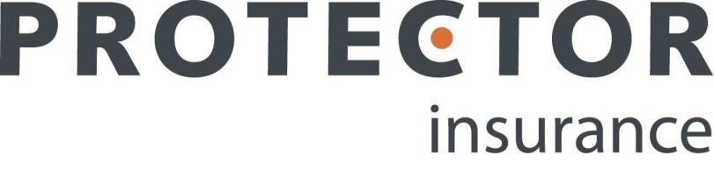

Falkirk Council

Contents

Summary of Cover 3
Claims Section 4

Summary of Cover
This document provides you with a summary of the Property Section of the policy arranged for and issued to Falkirk Council in respect of cover provided to “Right to Buy” leaseholders by the Protector Insurance Leasehold policy. It is intended for information only as evidence of insurance cover and does not form part of the policy. The full terms, conditions or exclusions are shown in the Policy Document, which can be obtained from Falkirk Council.

Policy Number: | 3178266
Policy Holder: | Falkirk Council and Leaseholders (for their respective rights and interests)
Period of Insurance: | 15/05/2023 – 14/05/2024
Insured Premises: | Any residential property in where the Local Authority has sold a leasehold or shared ownership interest and which we have accepted the risk. The terms of the policy apply separately to each property as though each had been insured by a separate policy
Insured Risks and Excess: | The insured buildings are indemnified against loss or damage caused by the following perils:  Fire, explosion, lightning, earthquake or smoke, storm or flood, riot, civil unrest, strikes, or labour or political disturbances, malicious persons or vandals, impact by aircrafts, vehicles or animals, escape of water from water tanks, pipes, equipment or fixed heating systems, water freezing in tanks, equipment or pipes, heating fuel leaking from a fixed heating system, theft or attempted theft, falling radio or television aerials, solar panels, wind turbines and security equipment, their fittings and masts, falling trees or branches, telegraph poles, pylons or lamp posts, subsidence or heave of the land on which the buildings stand, or landslip, accidental damage to drains, pipes, cables and underground tanks used to provide services to or from the buildings, and accidental breakage of glass in doors or windows, or ceramic hobs, sanitary ware and solar heating panels fixed to an forming part of the buildings and Accidental Damage.  Policy Excesses:  - General Excess - £nil  - Accidental Damage - £75  - Subsidence - £1,000  - Property Owners Liability - £nil  These apply to each insured property for each and every loss.  For full details of policy cover and all terms and conditions, please refer to the Leasehold Buildings policy document.
Property Owners Liability: | £5,000,000 any one occurrence inclusive of all costs and expenses
Terrorism | Not Included

How to Report a Claim
Claims are to be notified as soon as possible, with full details to be provided within 30 days of the claim (7 days in respect of riot or malicious damage) including supporting evidence in writing.

The Police must be notified as soon as possible in the event of theft or malicious damage.

Claims Route:

- Phone: during office hours 9am-5pm Monday to Friday telephoned through to your dedicated claim line: 0161 823 1912.
- Email via protectorclaims@uk.sedgwick.com

For calls made out of office hours, please dial the above number and your call will be redirected to the out of hours office.

Complaints:

We aim to provide the highest standard of service. If the service we provide does not meet your expectations please contact us and provide the policy/claim number and Insured name to help us deal with your comments.

You can refer your complaint to us via phone on 0161 823 1912 or email: protectorclaims@uk.sedgwick.com, or alternatively, you can contact us at the following address: International UK, Oakleigh House, 14-16 Park Pl, Cardiff CF10 3DQ.

If we can resolve your complaint to your satisfaction within the first few days of receipt, we will do so. Otherwise, we will keep you updated with progress and provide you with our decision as quickly as possible.

If you are unhappy with our response and you are an eligible complainant you may be entitled to refer it to the Financial Ombudsman Service.

For more information about the ombudsman, eligibility and the types of complaints they deal with, please refer to the Financial Ombudsman Service at: https://www.financial-ombudsman.org.uk/

Financial Services Compensation Scheme (FSCS)

We are covered by the Financial Services Compensation Scheme (FSCS). You may be entitled to compensation should we be unable to meet our obligations. You may contact the FSCS on 020 7892 7300 or further information is available at www.fscs.org.uk

Cancellation Rights:

This policy does not entitle you to a cooling-off period.

